Aberdeen School District



Crisis and Emergency Response Plan

Updated 8-21-17

Approved _______

**Aberdeen School District**

**Mr. Jeff Clay** P.O. Box 607

Superintendent of Education 205 Highway 145 North

Aberdeen, Mississippi 39730

(662) 369-4682 (p)

(662) 369-0987 (f)

August 9, 2017

To: Aberdeen School District Employees

The Aberdeen School District is dedicated to ensuring that a safe environment is provided for our students and employees. The Aberdeen Board of Trustees and the administration of the Aberdeen School District are also dedicated to ensuring that all employees are provided with a safe work place and appropriate safety training. We are hereby officially implementing the safety programs outlined in this School Occupational Safety and Crisis Response Plan Manual. These written programs are directed by the Aberdeen School District Safety Program Policy adopted by the Aberdeen Board of Trustees. *This plan is compliant with National Incident Management System and Joint Incident Command recommendations.*

All employees are expected to comply with the minimum safety requirements outlined in this program. Administrators and Principals may develop and implement additional detailed programs for their campuses as needed upon approval by the Superintendent. All employees are required to annually review the programs outlined in this policy manual. All employees shall review the manual as part of their orientation. Upon completion of review, employees will fill out and sign a copy of the Employee Review and Compliance Certification Form.

Safety is an important and integral component in each of our duties and is considered the single most important phase of everything we do. It is the goal of the Aberdeen School District to provide a safe and healthy environment for all students, employees, parents and visitors. I appreciate each of your efforts in keeping the Aberdeen School District the safest District ever.

Sincerely,

Jeff Clay

Superintendent

SECTION I

|  |  |
| --- | --- |
| **CONTENTS** |  |
| Introduction | **5** |
| School Board Policy | **6** |
| Mission Statement | **7** |
| Section I Occupational Safety Plan | **8** |
| District Occupational Safety And Crisis Response Plan Committee | **9** |
| Responsibilities Of School Personnel | **10** |
| Conservator (Ms Code 37-9-14) | **10** |
| District Safety Director | **10** |
| Occupational Safety And Crisis Response Plan Committee | **11** |
| Site Administrator (Principal, Director, Supervisor, And/Or Manager) | **11** |
| School Safety Committee | **12** |
| Employees | **12** |
| Safety Procedures | **13** |
| Inspection | **13** |
| Safety Inspections | **14** |
| Record Keeping | **14** |
| Appendix I-A School Safety Assessment Instrument | **15** |
| Accident Investigation | **22** |
| Accident Reports – Employees And Students | **22** |
| appendix I-B Supervisors’ Accident Investigation Report | **23** |
| Supervisor’s Accident Investigation Report (Continued) | **24** |
| Appendix I-C Employee Accident Report | **26** |
| Student Accident Report | **27** |
| Employee Orientation | **28** |
| Training | **28** |
| First Aid | **28** |
| Resources: (I.E. Cpr, First Aid, Fire) | **29** |
| Blood Borne Pathogens Exposure Control | **30** |
| Needles | **32** |
| Contaminated Equipment | **32** |
| Regulated Waste Disposal | **34** |
| Hazard Communication & Hazardous Materials Control | **37** |
| Employee Information, Education, And Training | **39** |
| Appendix I-E MSDS Inventory | **42** |
| Material Safety Data Sheet Inventory Form | **43** |
| Hazard Communication Program | **44** |
| Material Safety Data Sheet (Msds) Inventory | **44** |
| Fire Response, Fire Safety, And Fire Prevention | **45** |
| Appendix I-F | **46** |
| Fire Extinguisher List | **47** |
| Fire Extinguisher Maps | **47-57** |
| Severe Weather Plan | **58** |
| General Safety Rules | **58** |
| Disciplinary Action | **59** |
| Cafeteria Safety Rules | **59** |
| Kitchen Safety | **59** |
| Food Protection | **60** |
| Food Equipment And Utensils | **60** |
| Food Temperature Requirements | **60** |
| Insect And Rodent Control | **60** |
| Toilet And Handwashing Facilities | **60** |
| Other Operations | **61** |
| General School Building Safety Rules | **61** |
| Face And Eye Protection | **61** |
| Lifting And Material Movement | **62** |
| Hot Surfaces And Items And Energized Electrical Equipment | **62** |
| Construction/Renovation Safety | **62** |
| Motor Vehicles And Mobile Equipment | **63** |
| Commercial Vehicle Drivers: | **63** |
| Requirements For School Bus Drivers: | **64** |
| Equipment Usage | **66** |
| Appendix I-G | **67** |
| Driver’S Inspection Form | **68** |
| Report Any Unsafe Condition Immediately | **69** |
| Penalties Of Unsafe Work Practices: | **70** |
| Appendix I-I Unsafe Work Practice Form | **71** |
| Report Of Employee-Employer Interview | **72** |
| Emergency Drills | **73** |
| Emergency Drill Forms | **75** |
| Field Trips And Excursions | **77** |
| Section II School Crisis Response Plan | **79** |
| Section III School / Community Response Plan | **148** |
| Index | **190** |
|  |  |

# INTRODUCTION

**The foundation that is used to maintain a safe and secure educational environment is the School Safety Plan. Listed below are the three components to a comprehensive school safety plan:**

1. Policies and procedures that afford a safe school environment.
2. The Crisis Response Plan.
3. Programs that promote a safe school environment.

The Aberdeen School District’s School Occupational Safety and Emergency Response Plan is a composite of the best plans the Division of School Safety has reviewed. It represents the first two of the three components necessary for comprehensive safe school planning. Please be reminded that this is the District’s plan. Every school and district is different. Therefore every plan will be different. The intent of this plan is to provide solid guidance in school safety.

The Aberdeen School District’s Safety plan utilized the model developed and set forth by the Mississippi State Department of Education, Office of Safe and Orderly Schools.

21 August 2017

# School Board Policy

|  |  |  |
| --- | --- | --- |
| Aberdeen School District (Aberdeen , Mississippi) | Description Code:  EBBAA | Approved/Review |
| **School Occupational Safety & Crisis Response Plan** | Rescinds Policy: | Originally Approved:  8-10-200 |

The Board of Trustees of the Aberdeen School District is committed to the belief that students should be afforded a safe and orderly learning environment. This learning environmentincludes traveling to and from school; within all school facilities, classroom, assembly, cafeteria, and gymnasium; on the school grounds; and, while participating in or attending activities sponsored by the school, e.g., academic competition, athletic events, extra-curricular activities, and field trips.

Every effort shall be made to provide all reasonable precautions to protect the safety of all students, employees, visitors, and those present on district property or at school-sponsored events.

The Superintendent of Schools is directed to appoint a district-wide School Safety and Emergency Preparedness Committee, consisting of school personnel (administrators, teachers, and support staff), parents and community leaders, and representatives from health providers, law enforcement and civil defense. This *ad hoc* committee shall have the responsibility of developing a **School Occupational Safety and Crisis Response Plan**, which shall include but not be limited to the following:

1. Assessment of building and grounds security.

2. Current and proposed safety procedures.

3. List of agencies and contact persons who can provide assistance when a crisis situation occurs.

4. Working with the media.

5. Staff training.

The practice of safety shall be considered an aspect of the instructional program of the school district, and instruction shall be provided, as appropriate to subject areas and grade-levels, in accident and fire prevention, emergency procedures, and vehicular and pedestrian safety.

Responsibility for safety is a primary role of all personnel. However, the oversight and management of the Safety Program is assigned to the Aberdeen School District Safety Manager. The Safety Manager is authorized and empowered to oversee and coordinate a school system safety program that meets the intent and requirements of this policy and appropriate federal, state, and local safety or safety – related standards.

All administrators, school principals, department managers/supervisors, etc., are responsible for ensuring that hazard-specific safety measures and programs consistent with the requirements of this policy and appropriate standards and regulations are implemented and enforced within their areas of operations. Further, that employees are aware of the hazards associated with their duties.

**The plan shall be reviewed and updated annually prior to the beginning of the school year**. The Superintendent of Schools, or designee, shall make a report to the Board, on an annual basis, regarding the implementation of the plan.

Mission Statement

The mission of the Aberdeen School District is to provide a quality education for every child every day in a safe, supportive environment where there is respect for individual differences and community values.

#### SECTION

**I**

**Aberdeen School District**

# OCCUPATIONAL SAFETY PLAN

Aberdeen School District

P. O. Box 607

205 Highway 145 North

Aberdeen, Mississippi 39730

# District Occupational Safety and Crisis Response Plan Committee

Jeff Clay, District Superintendent.…….…………………………………………..Central Office

Temeka Shannon…………………………………………….Director of Academics & Planning.

Martha Jackson, Principal.…...……………………………………Belle/Shivers Elementary School

Mickey Miller, Assistant Principal...…………………………………….....Aberdeen High School

Bobby Eiland, Deputy Superintendent.……..……..................Director Operations-Safety Director

Charles Beene, Principal……………………………………………….…Aberdeen High School

Kristen Fondren, Principal...................................…………………..Aberdeen Elementary School

Barbara Vasser…...........................................................................................Food Service Director

Tony Tillman….……………………………………………………………………Campus Police

Cafeteria Managers………………………………………………..All School Cafeteria Locations

Lead Custodians (GCA)…………………………….………………...All School Sites with Leads

**SCAT TEAM**

**(School and Community Action Team)**

Bobby Eiland………………………………………………………………Deputy Superintendent

El’Lane Gilmore……..…………………….Aberdeen Elementary School, SCAT TEAM Director

Ursula Wilson……………………………………………………….Aberdeen Elementary School

Karen Poindexter………………………………………..……………Belle Shivers Middle School

Karen Howard………………………………………………………………Aberdeen High School

Kimberly Lenoir……………..…………………………………………..Aberdeen School District

# Responsibilities of School Personnel

**Under The School** **Safety Plan**

### Superintendent (MS Code 37-9-14)

The Superintendent will:

* Appoint a district-wide safety and emergency preparedness committee.
* Appoint a district-wide safety director who will have the responsibility and authority

to develop, oversee and implement a district-wide safety program.

* Demonstrate a commitment to safety by endorsing the district safety and emergency management plan and enlisting school board approval.
* Provide resources for purchasing personal protective equipment and training employees to use safe behaviors.
* Review accident reports.
* Review inspection reports.
* Delegate the responsibility and authority for the program to each school principal and the appointed safety director.

### District Safety Director (SCAT TEAM Director)

The safety director advises the superintendent, staff, principals and supervisors who are responsible for the district’s safety plan. The safety director monitors the implementation of the safety plan and tracks measurable improvements.

General responsibilities of the district safety director are as follows:

* Establish a structure and process for administering a district-wide safety plan.
* Advise the superintendent, safety committees and school principals.
* Assist principals in establishing a school safety committee.
* Review incident investigation reports for content. Assist the investigation process, if necessary, in complicated cases.
* Assist in developing an appropriate corrective action plan indicated by the incident investigation.
* Attend incident investigations as required.
* Monitor incident reports and records. Provide timely reports to the superintendent and the district safety committee.
* Establish routine, periodic inspections to monitor the districts and each school’s safety program effectiveness. Ensure that school employees receive the necessary training to conduct their job safely.
* Conduct site safety assessment.

### Occupational Safety and Crisis Response Plan Committee

The occupational safety and crisis response committee includes representatives from health care providers (both mental and physical), law enforcement, emergency management, welfare agencies, non-profit service agencies such as the American Red Cross and the Salvation Army, parents, students, teachers, and other school personnel.

The general functions of the district committee are to:

* Formulate safety policies and recommend approval by school board.
* Review unsafe conditions and practices as reported by school or department safety teams.
* Make site visits to schools.
* Review corrective action plans and make recommendations as appropriate. Review school/department safety plan.
* Conduct district-wide safety inspections on scheduled basis.
* Plan and conduct regular drills of various emergency scenarios involving as many agencies as possible.

### Site Administrator (Principal, Director, Supervisor, and/or Manager)

While the district is accountable for the success of the safety plan, it is the responsibility of the site administrator to implement the program at his or her location. The site administrator is the most knowledgeable about the employees’ attitudes, work habits, and equipment use. The site administrator as the safety director at the school level will serve the school in an advisory capacity and monitor the application of the safety plan.

The site administrator will:

* Act as the facilitator for the school safety committee.
* Track incidents.
* Make recommendations to the district safety committee.
* Hold safety meetings.
* Develop safety objectives.
* Schedule training.
* Schedule safety/housekeeping inspections.
* Ensure that all full-time and part-time employees, including substitute teachers, receive a safety orientation prior to assuming the duties of the job.
* Complete accident reports, workers compensation reports, and accident investigation reports.
* Conduct site safety assessment.
* Ensure full participation of the school in drills and training.
* Maintain effective liaison with local emergency services and law enforcement.

### School Safety Committee

The school safety committee, facilitated by the site administrator, assists in developing the school safety program and monitors the process. Representatives on the school safety committee include personnel from instruction, food service, custodial and support services.

General functions of the school safety committee include:

* Establish a safety plan at the school location to include the following:
* Develop a school safety policy.
* Develop and implement a training program including drills.
* Inspect school equipment, school grounds and school buildings to determine safety needs.
* Identify hazards and take corrective action.
* Review incidents and ensure that the first report of injury, the accident investigation report, the physician of choice form and the medical authorization form have been properly completed and filed with the personnel department.
* Contact and provide encouragement to injured employees.
* Develop a process for tracking safety work orders.
* Ensure that policies and procedures are in place for efficient handling of incidents.
* Provide safety information to each employee. Conduct a safety orientation program for new employees.
* Train first aid providers and provide medical supplies for minor injuries not requiring the services of a doctor.
* Implement recommendations from the district safety committee. Listen to employees and follow up on suggestions.
* Review and update fire prevention and emergency procedures.

### Employees

Each employee is expected, as a condition of employment, to work in a safe manner. He/she is also expected to exercise maximum responsibility for the prevention of accidents and the safe use of machinery and equipment entrusted to his or her care.

Employee responsibilities include the following:

* Attend training sessions. Learn safe work procedures.
* Maintain good housekeeping in work area.
* Wear proper dress and use appropriate Personal Protective Equipment as required by the job.
* Keep machine guards in place.
* Report unsafe conditions or unsafe acts to the supervisor.
* Report all accidents and injuries to immediate supervisor at once.
* Know fire prevention and emergency procedures designed for your area.
* Obey established rules of conduct and adhere to the safety plan.
* Be concerned about the safety of others. Refrain from horseplay or pranks while on the job.
* Identify and properly control hazardous materials within area of responsibility.

# Safety Procedures

### Inspection

* The district safety director will conduct periodic inspections of school facilities using the School Safety Assessment Instrument (Appendix I- A) as an interim guide to detect and correct unsafe conditions and practices before injuries occur.
* Each school or facility will develop a safety checklist for each work area.
* After each inspection, a copy of the safety checklist will be reviewed with the building principal, and corrective action, if necessary, will be taken to correct any hazards as identified.
* The district safety director will review the result of safety and housekeeping inspections with school principals to determine corrective follow-up action.
* Results of safety and housekeeping inspections, reports of unsafe act and safety policies and procedures will be communicated to employees as needed.

**Techniques**

* Regular safety and housekeeping inspections will serve to encourage employees to inspect their own work areas.
* The district safety director will determine the frequency for holding inspections, but will schedule at least two annually.
* The school safety committee will determine means of securing employee and student interest and encouraging cooperation in the Aberdeen School District safety program.

**Inspection Procedures**

Inspection procedures will vary in accordance with the type of inspection required. The responsibility of the district is to ensure that all inspectors are familiar with federal standards, state laws and local ordinances affecting the safety and health of workers.

A safety checklist will be developed around the avoidance of the following eleven basic work hazards:

* Pinch points, shear points
* Flying objects
* Falling objects
* Electricity
* Gas/vapors
* Chemical/flammable
* Heavy objects
* Hot/cold objects and radiation
* Sharp and pointed objects
* Slippery surfaces
* Trip/fall hazards

### Safety Inspections

The district safety director and risk management are authorized to enter, inspect, and investigate at any time, any work site or establishment to insure that all safety rules and regulations are being followed. Principals and department heads are expected to cooperate.

Regular site inspections are the responsibility of the site administrator. Inspections may vary in type and frequency. Inspections may be conducted on an area basis, or an entire facility basis, or on a specific operation basis. The site administrator, the district safety director, and risk management may conduct them with or without advance notice.

Safety citations may be issued to principals, department heads, supervisors, or employees for unsafe acts or for allowing unsafe conditions to exist. Recipients of safety citations are subject to disciplinary action, which shall be determined and assessed by the Risk Management Director.

Scheduled inspections are conducted no less than twice yearly by the district safety director. Equipment such as boilers and fire extinguishers will be inspected at required intervals as required by state law. Results should be submitted to the district safety committee. Personal protective equipment will be inspected constantly to make certain that it is in safe working condition. Intermittent inspections are conducted by site administrator or department supervisors and are held on irregular intervals. These inspections serve to determine the need for regularly scheduled inspections in a particular department or work area.

Monitoring inspections are designed to observe equipment that is in continuous operation and are conducted by department supervisor.

Special inspections are held when new equipment is installed or during construction of new buildings or during the remodeling of old buildings, or because some change has created new hazards. Special inspections are the responsibility of the site administrator or the department supervisor.

### Record Keeping

The following records must be retained for a period of not less than one year:

* Injury and Accident Reports
* Accident Investigation Forms and Reports
* Inspection Reports and Follow Up Reports
* Training Records
* Safety Citations or Disciplinary Actions regarding unsafe practices

**Remember Always---DOCUMENT, DOCUMENT, DOCUMENT**

**APPENDIX I-A**

**SCHOOL SAFETY ASSESSMENT INSTRUMENT**

# SCHOOL SAFETY ASSESSMENT INSTRUMENT

**School ____________________________School District_____________________Date_____________________**

**Student Population_____________Teaching Staff_______________Support Staff ________________________**

**I. Crisis Response Plan**

**_____1.Does the school have a Crisis Response Plan? (Process Standard 62)**

**_____A. Does it incorporate responses to the following areas?**

* 1. **Fire**
  2. **Tornado**
  3. **Hurricane**
  4. **Bomb Threat/Explosion**
  5. **Intruder**
  6. **Earthquake**
  7. **Threats unique to the school such as HAZMAT spills, train derailment, et al.**

**_____2. Does the response plan include a protocol for primary staff**

**Responsibilities?**

**_____3. Does the school have a crisis response team?**

**_____A. Training level**

**_____B. Drills**

**_____ 4. Has the school coordinated emergency response procedures and protocols**

**with:**

**_____A. Police/Sheriff's Office**

**_____B. County/City Emergency Management**

**_____C. Medical Services**

**_____D. Media Agencies**

**_____E. Utilities**

**_____F. Parents**

**_____G. Transportation**

**_____5. Are staff and students trained in the Crisis Response Plan?**

**_____6. Evacuation Policies and Procedures (Crisis Response Plan)**

**____A. How often are fire and tornado drills conducted?**

**____B. Are there marshalling areas for students to be counted?**

**____C. Is the bomb evacuation area at least 1000 feet from the school?**

**____D. How does the administrator account for all students (missing**

**students)?**

**____E. Reunification Points**

**____F. Triage Stations**

**____G. Emergency Transportation Plans**

**____H. Emergency Evacuation Kits**

**II. Policies and Procedures (MDE School Safety Manual)**

**_____1. Are parents and students informed of disciplinary policies and procedures**

**in accordance with Section 37-11-53 of the Mississippi State Code?**

**_____2. Does the school have policies and procedures addressing the following**

**areas:**

**____A. Code of Conduct**

**____B. Student Discipline**

**____C. Dress Codes**

**____D. Electronic Equipment (cell-phones, pagers etc.)**

**____E. Gangs**

**____F. Sexual Harassment**

**____G. Gun Free Schools Act of 1994**

**_____3. Does the school have a discipline plan in accordance with MSC 37-11-53?**

**_____4. Does the school maintain statistical data regarding student discipline?**

**_____5. Does the school maintain information on incidents reported in accordance?**

**With 37-9-14 and 37-11-29?**

**____A. Are all crimes reported?**

1. **Law Enforcement Agency**
2. **Youth Court**
3. **MDE**

**_____6. Are there policies for playground utilization?**

**_____7. Are there adequate procedures for visitor control?**

**____A. Are procedures in place to challenge unidentified visitors?**

**____B. Are visitors required to sign in and issued badges?**

**____C. Are badges recovered?**

**____D. Are visitor parking spaces prominently marked and in close**

**proximity to the main office?**

**____E. Are directional signs designating the office area posted?**

**_____8. Search Policy**

**____A. Is there a policy for searching students?**

**____B. Is there a policy for searching vehicles?**

**____C. Is there a policy for searching lockers and personal effects?**

**____D. Are signs posted advising visitors that visitors and packages**

**may be searched on entrance/egress to the building?**

**_____9. Does the school have a restraint or use of force policy for staff and**

**Enforcement personnel?**

**_____10. Does the school have a dress code?**

**_____11. Is there an Internet policy and computer crime policy in place?**

**III. Facility Assessment**

**____1. Clinic or aid supplies available?**

**____A. Is there a Nurses Station?**

**____B. Is there a Physicians-Desk Reference available?**

**____C. Medication Monitored?**

**____2. Shops**

**____3. Laboratories**

**____A. Chemicals labeled and secured?**

**____B. Eye wash station?**

**____4. Kitchen**

**____A. Temperature charts, on freezer doors?**

**____B. Food stored on shelves and pallets (and covered) in freezers?**

**____C. Vents cleaned on a regular basis?**

**____D. Adequate fire extinguishers that are inspected annually?**

**____5. Does the school have an operational fire alarm, burglar alarm and**

**emergency lighting system?**

**____6. Signage**

**____A. Signs directing, visitors to the office.**

**____B. Signs designating that weapons, tobacco and drugs are prohibited on**

**campus.**

**____C. Signs, for school name.**

**____7. Fencing for the campus.**

**____8. Ingress/Egress**

**____A. Do ingress/egress doors have panic bars?**

**____B. Does the school control ingress points around the campus?**

**____9. Classrooms**

**____A. Do classrooms have doors that lock?**

**____B. Do classrooms have evacuation routes posted?**

**____10. Communications**

**____A. Does the school have an unlisted telephone number?**

**____B. Does the school have cell phones and two-way radios?**

**____C. Does the school have two-way intercoms between the main office and**

**teaching stations?**

**____11. Utilities**

**____A. Are utility cutoffs located for:**

**____(1) Electricity**

**____(2) Gas**

**____(3) Water**

**____B. Are building schematics available on site?**

**______12. Walkways**

**____A. Are sidewalks in good repair?**

**____B. Are additional sidewalks needed?**

**____C. Are they compliant with ADA?**

**______13. Traffic**

**____A. Proper control devices in place?**

**____B. Is traffic thru school property controlled?**

**____C. Is neighborhood traffic controlled?**

**______14. Lighting**

**____A. Interior**

**____B. Exterior**

**____C. Exit signs**

**______15. Heating/AC**

**____A. Units inspected annually.**

**____B. Plants clean and secure.**

**______16. Stairs**

1. **Handrails**
2. **Width**
3. **Traffic ability**
4. **Physical Security**

**____1. What type of position does the district use for physical security?**

1. **School Resource Officer**
2. **Campus Enforcement Officer**
3. **School Safety Officer**

**____2. What is the training level for these personnel? ___________________**

**____3. District, or Local Law Enforcement Agency Employed?**

**____4. Is the campus security entity operating in accordance with generally**

**accepted standards of security /law enforcement practice?**

**____A. Reporting**

**____B. Investigations**

**____(1) Criminal**

**____(2) Administrative**

**____C. Training**

**____D. Equipment**

**____E. Deployment (Does the district properly use the officers?)**

**____F. Crime Prevention/Drug Mitigation Operations**

**____5. What type of Key Control System is utilized?**

1. **Programs for Student Compliance**

**____1. Does the district have any specific programs that generate compliance by**

**students?**

**____2. Does the district have any programs that generate positive citizenship**

**principles?**

**____3. Does the district afford special education students a privileged status**

**regarding compliance with criminal laws?**

1. **Community Observations**

**_____1. Law Enforcement**

**_____2. Youth Court**

**_____3. Emergency Services**

**_____4. Gangs operational in the community.**

**_____5. Do gangs pose a threat to the school district?**

1. **Emergency Management**

**____1. Where is the Emergency Operations Center (EOC) for the**

**school located? ___________________________**

**____(A) Adequate phones?**

**____ B) Additional communication equipment?**

**____(C) Status boards (flip charts/chalk board, etc.)**

**____2. Who mans the EOC?**

**____(A) Maintenance personnel**

**____(B) School Resource Officer**

**____(C) School Administrator**

**____(D) Attendance Officer**

**____(E) Nurse**

**____(F) Pupil Transportation Director**

**____(G) Counselor**

**____(H) Other Personnel as circumstances warrant**

**VIII. Collateral Observations**

**VIV. Impression**

# Accident Investigation

The first step in preventing a recurrence of an accident is to investigate and analyze one that has happened and take positive actionto remove its causes. The injured employee’s immediate supervisor should investigate each accident. These findings should constitute a portion of the complete accident report. The investigator should:

* Determine the act or condition that triggered the accident.
* Cite any procedure or action that was not in accordance with standard safety policies.
* Indicate any corrective or disciplinary action that would prevent another accident of this type.

# Accident Reports – Employees and Students

Accident reports are required for any accident occurring on school property or at school activities. All accidents, illnesses, and/or injuries shall be reported immediately to the appropriate principal, manager, or supervisor who will complete and forward an incident/accident report to the Aberdeen School District Workers’ Compensation Coordinator. The same report may be used to report incidents where hazards exist but where no injury or damage has occurred. Accident reports involving employees should be filed in the Workers’ Compensation office and accident reports involving students should be filed in the Superintendent’s Office. There are a number of forms, which may be used to report accidents (Appendix I-A , I-B and I-C are recommended), but the items listed below should be considered minimum information:

* Name, age, sex of the injured person.
* Occupation at time of accident-What he or she was actually doing.
* Nature and exact description of injury.
* Date and time of accident.
* Estimate of number of days that will be lost as a result of accident.
* Description of accident: Identify objects, operation, or substances most closely associated with the occurrence of the accident.
* Unsafe acts or conditions that contributed to the accident.
* Corrective action proposed in order to prevent the re-occurrence of a similar accident.
* Remarks, comments, or sketches.
* Date report was completed.
* Signature of supervisor.
* Signature of safety coordinator.

**Appendix I-B**

**Supervisors’ Accident Investigation Report**

NOTE TO SUPERVISOR

REMEMBER, AN ACCIDENT INVESTIGATION IS NOT DESIGNATED TO FIND FAULT OR BLAME. IT IS AN ANALYSIS TO DETERMINE CAUSES THAT CAN BE CONTROLLED OR ELIMINATED.

WHEN COMPLETING THE INVESTIGATION, TRY TO ANSWER THESE QUESTIONS

How did the accident occur?

Where did it happen?

What materials, machines, equipment, or conditions were involved?

Who was injured?

When did it happen?

MAKE RECOMMENDATIONS

NO INVESTIGATION IS COMPLETE UNLESS CORRECTIVE ACTION IS SUGGESTED.

FOLLOW-UP

Determine what action is being taken on your recommendations.

**Aberdeen School District**

# Supervisors’ Accident Investigation Report

DATE ___________________________ TIME _____________________________________

EMPLOYEE INVOLVED ___________________________________ AGE ____________________

POSITION _________________________________ DATE EMPLOYED __________________________

SUPERVISOR _____________________________________ DEPARTMENT _______________________

HOW LONG WAS EMPLOYEE PERFORMING THIS OPERATION? _______________________________

WAS THE EMPLOYEE INSTRUCTED? ______________________________________________________

DID THE ACCIDENT RESULT IN INJURY? __________________________________________________

NATURE AND EXTENT OF INJURY ________________________________________________________

_______________________________________________________________________________________

DATE INJURY REPORTED __________________________ LOSS OF WORK DAYS _______________

Yes or No

IF SO, WHEN, AND BY WHOM? ___________________________________________________________

HOW DID ACCIDENT OCCUR? ____________________________________________________________

___________________________________________________________________________________________________

___________________________________________________________________________________________________

___________________________________________________________________________________________________

CAUSE OF ACCIDENT ____________________________________________________________________________

___________________________________________________________________________________________________

___________________________________________________________________________________________________

RECOMMENDATIONS TO PREVENT A RECURRENCE _____________________________________________

___________________________________________________________________________________________________

___________________________________________________________________________________________________

WHAT ACTION HAS BEEN TAKEN? _______________________________________________________________

___________________________________________________________________________________________________

___________________________________________________________________________________________________

SIGNED _______________________________________ DEPT. ________________________________

**SAFETY COMMITTEE COMMENTS**

RECOMMENDATIONS ____________________________________________________________________________

___________________________________________________________________________________________________

SIGNED ______________________________________ DATE ____________________________________________

**EXECUTIVE**

SPECIAL ORDERS ________________________________________________________________________________

SIGNED ______________________________________ DATE ____________________________________________

Appendix I-B

# SUPERVISOR’S ACCIDENT INVESTIGATION REPORT (continued)

|  |  |  |
| --- | --- | --- |
| **CAUSES** | **DEFINITION OF CAUSE** | **SUGGESTED CORRECTIVE MEASURES** |
| **ENVIRONMENTAL**  1. Unsafe procedure | Hazardous process; management failed to make adequate plans for safety. | A. Job analysis  B. Formulation of safe procedure |
| 2. Equipment  Defective  Through Use | Machines or equipment that have become rough, slippery, sharp-edged, worn, cracked, broken, or otherwise defective through use or abuse. | A. Inspection  B. Proper maintenance. |
| 3. Improperly  Guarded  Equipment | Machines or equipment that are unguarded or inadequately guarded. | A. Inspection.  B. Checking plans, blueprints, purchase orders, contracts, and materials for safety.  C. Include guards in original design, order, and contract.  D. Provide guards for existing hazards. |
| 4. Equipment  Defective  Through Design | Failure to provide for safety in the design, construction, and installation of building, machinery, and equipment, too large, too small, not strong enough. | A. Source of supply must be reliable.  B. Checking plans, blueprints, purchase orders, contracts, and materials for safety.  C. Correction of defects. |
| 5. Unsafe Dress or  Apparel | Management’s failure to provide or specify the use of goggles, respirators, safety shoes, hard hats, and other articles of safe dress or apparel. | A. Provide safe dress or apparel or personal protective equipment if management could reasonably be expected to provide it.  B. Specify the use or non-use of certain dress or apparel or protective equipment on certain jobs. |
| 6. Unsafe  Housekeeping  Facilities | No suitable layout or equipment that are necessary for good housekeeping-shelves, boxes, bins, aisle markers, etc. | A. Provide suitable layout and equipment necessary for good housekeeping. |
| 7. Improper  Ventilation | Poorly ventilated or not ventilated at all. | A. Improve the ventilation. |
| 8. Improper  Illumination | Poorly illuminated or no illumination at all. | A. Improve the illumination. |
| **BEHAVIORISTIC**  9. Lack of  Knowledge or  Skill | Unaware of safe practice, unpracticed, unskilled, not properly instructed or trained. | A. Job training. |
| 10. Improper Attitude | Worker was properly trained and instructed, but s/he failed to follow instruction because s/he was willful, reckless, absentminded, excitable, or angry. | A. Supervision.  B. Discipline.  C. Personnel work. |
| 11. Health  Impairments  (Physical) | Worker has poor eyesight, defective hearing, heart trouble, hernia, etc. | A. Pre-placement physical examinations.  B. Periodic physical examinations.  C. Appropriate job assignment of employees.  D. Identification of workers with temporary health impairments. |

**APPENDIX I-C**

# Student Accident Report

# Student Accident Report

# Employee Orientation

The Aberdeen School District will seek to avoid or lower the rate of injury to its employees by providing each new employee with instruction regarding district safety methods and procedures.

These instructions will include:

* An overall orientation program to familiarize the employee with the function or his or her job with the school district.
* Testing and observing to ascertain the employee has mastered safety work habits
* A training period to ascertain the capabilities of the employee.

# Training

Appropriate safety training shall be conducted and documented in the employee’s training file. General required training will be provided to all employees upon initial hire and when required thereafter to include at the minimum the following:

* Safety Policies and any task related safety requirements.
* Hazard Communication and Hazardous Materials Management
* Blood-borne Pathogens Exposure Control Plan (annually)
* Emergency Crisis Response Plan (annually)
* Fire Safety Plan (annually)
* Warning Signs and Devices
* General Workplace Hazards
* Emergency Medical Response
* Drug Testing Policy Training (annually)

Other Function/Hazard Specific Training will be provided to the affected employees by the

responsible department manager/supervisor upon assignment and/or when new equipment or

procedures are introduced, and as part of periodic staff meetings.

# First Aid

The site administrator will:

* Maintain a list of first aid providers for his or her building.
* Ensure the providers obtain first aid training. Obtain an approved first aid kit.
* Obtain an infection control kit.
* Maintain an adequate employee record that identifies family members and next of kin.
* Maintain an adequate (hard copy) student record that identifies family members and next of kin.

# Resources: (i.e. CPR, first aid, fire)

|  |  |  |  |
| --- | --- | --- | --- |
| **Name** | **Skill/Training** | **Room Number** | **Contact Number** |
|  |  |  |  |
|  |  |  |  |
|  |  |  |  |
|  |  |  |  |
|  |  |  |  |
|  |  |  |  |
|  |  |  |  |
|  |  |  |  |
|  |  |  |  |
|  |  |  |  |
|  |  |  |  |
|  |  |  |  |
|  |  |  |  |
|  |  |  |  |
|  |  |  |  |
|  |  |  |  |
|  |  |  |  |
|  |  |  |  |
|  |  |  |  |
|  |  |  |  |

# Blood borne Pathogens Exposure Control

**Exposure Determination**

* The exposure determination is made without regard to the use of personal protective equipment (i.e. employees are considered to be exposed even if they wear personal protective equipment). This exposure determination is required to list all job classifications in which all employees may be expected to incur such occupational exposure, regardless of frequency. At Aberdeen School District’s facilities, the following job classifications are in this category:

**Job Classification Task/Procedures**

* School Nurse Student illness & accidents
* First Aid Responders Medical cuts/abrasions, etc. involving first aid
* Security Personnel Accident and injury response
* Coaches Sports injuries

* In addition, if the employer has job classifications in which some employees may have occupational exposure, then a listing of those classifications is required. This listing should include tasks or procedures what would cause these employees to have occupational exposure in order to clearly understand which employees are affected. The job classifications and associated tasks/procedures for these categories are as follows:

**Job Classification Task/Procedures**

* Teachers & staff First aid
* Secretaries First aid
* Maintenance Personnel Sewerage compounds/system repairs
* Bus Drivers First aid
* Custodial Personnel Needles, spills, injury cleanup
* **Implementation Schedule and Methodology**-
* **Review & Update** – This Plan will be reviewed and updated under the following
* Annually, on or before the anniversary date of this policy.
* Whenever new or modified tasks and procedures and implemented which could affect the occupational exposure of our employees.
* Whenever our employee’s jobs are revised so that new instances of occupational exposure may occur.
* Whenever we establish new functional positions within our facility that may involve exposure to blood borne pathogens.

Additionally, an annual review will be held to consider and implement appropriate commercially available and more effective/safer medical devices designed to eliminate or minimize occupational exposure (e.g. sharps containers). This review process shall involve solicitation of input from non-managerial employees potentially exposed to injury from contaminated sharps. This input shall be pertinent to the identification, evaluation, and selection of effective engineering and work practice controls. This evaluation process shall be documented and included with each annual update of the plan.

**Compliance Methods**

* Universal precautions will be observed at all facilities in order to prevent contact with blood or other potentially infectious material. All blood or other potentially infectious material will be considered infectious regardless of the perceived status of the source individual.
* Engineering, administrative and work practice controls will be utilized to eliminate or minimize exposure to employees at this facility. Where occupational exposure remains implementation of these controls, personal protective equipment shall also be utilized. Throughout Aberdeen School District, the following engineering and administrative controls will be utilized:
* Portable sharps containers what are puncture resistant, bio- hazard labeled, and leak proof
* Hand washing facilities
* Nurse’s office
* Blood spill kits
* Policy enforcement
* The Lead Nurse will examine the above controls on a monthly schedule to ensure that they are properly maintained.
* Hand washing facilities are also available to the employees who incur exposure to blood or other potentially infectious materials. These facilities are readily accessible after incurring exposure. Hand washing facilities are located in each staff restroom, student restrooms, and employee break areas
* After removal of personal protective gloves, employees shall wash hands and any other potentially contaminated skin area immediately, or as soon as feasible, with soap and water. If employees incur exposure to their skin or mucous membranes, those areas shall be washed or flushed with water as appropriate, as soon as feasible, following contact.

### Needles

* Any needles, syringes, etc. will be handled as if known to be contaminated. When needles/syringes/sharps are found, they will be disposed of in approved Sharps containers. The employee finding the needle/syringe will notify their immediate supervisor who will see that the Sharps container for that area is retrieved from its location, brought to the needle/syringe/sharp, the needle/syringe/sharp placed in the Sharps container, and the container returned to its normal location. Under no circumstances shall an employee attempt to carry the needle/syringe/sharp to the Sharps container or otherwise dispose of it. Needle/syringe/sharps shall not be bent, recapped, sheared or broken. All employees shall receive training on this procedure, and this training shall be documented and the records kept in the centralized training files.
* *Containers should be transported to the needle or other devices for disposal, never transport the needle to the container*. Containers will be checked monthly by the School Nurse and removed and disposed of when full.

### Contaminated Equipment

* Equipment which has become contaminated with blood or other potentially infectious materials shall be examined prior to servicing or disposal and shall be decontaminated as necessary unless the contamination of the equipment is not feasible.

**Personal Protective Equipment (PPE)**

* All personal protective equipment used at this facility will be provided without cost to employees. Personal protective equipment will be chosen based on the anticipated exposure to blood or other potentially infectious materials. The protective equipment will be considered appropriate only if it does not permit blood or other potentially infectious materials to pass through or reach the employees’ clothing, skin, eyes, mouth, or other mucous membranes under normal conditions of use and for the duration of time for which the protective equipment will be used.
* ***Protective clothing will be provided to employees by their department***. Employees will sign for reusable PPE. PPE will be issued as follows:
* School Nurse: latex gloves, lab style overcoats, plastic aprons, & eye shields.
* Maintenance Personnel: latex gloves, protective outerwear (as needed)
  + - * ***The use of PPE is not an option. Employees are required to wear PPE when conditions warrant****.*
      * All personal protective equipment will be cleaned, laundered, and/or disposed of by Aberdeen School District at no cost to employees. All repairs and replacements will also be made at no cost to employees.

All garments (including personal attire) which are penetrated by blood while on duty at Aberdeen School District shall be removed immediately or as soon as feasible.

All personal protective equipment will be removed prior to leaving the work area.

The following protocol has been provided to facilitate leaving the equipment at the

work area:

* Place contaminated clothing in a plastic bag, label the bag as contaminating a biohazard and deliver it to the administrator. Clothing contaminated with blood or other body fluids will be cleaned at the expense of the employer.
* Gloves shall be worn where it is reasonably anticipated that employees will have hand contact with blood, other potentially infectious materials, not-intact skin, and mucous membranes. Gloves will be available from the administrative offices for each facility.
* Disposable gloves used are not to be washed or decontaminated for re-use and are to be replaced as soon as practical when they become contaminated or as soon as feasible if they are torn, punctured, or when their ability to function as a barrier is compromised. Utility gloves will be discarded if they are cracked, peeling, torn, punctured, or exhibit other signs of deterioration or when their ability to function as a barrier is compromised.
* Masks in combination with eye protection devices, such as goggles or glasses with solid side shields, or chin length face shields, are required to be worn whenever splashes, spray, splatter, or droplets of blood or other potentially infectious materials may be generated and eye, nose, or mouth contamination can reasonably be anticipated. Situations that would require such protection are as follows:
* Cleaning large blood/body fluid spills.
* First aid for injuries generating a large quantity of blood or bodily fluids.
* Appropriate protective clothing is to be used, such as lab coats, gowns, aprons, clinic jackets, or similar outer garments. The following situations require such protective clothing be utilized:
  + Cleaning large blood/body fluids spills.
  + Working on sewerage system components/equipment.
* Decontamination of areas soiled by blood/body fluids, will be accomplished by
* Utilizing the following materials:
  + A standard commercial disinfectant or a 50/50 household bleach/water solution.
  + A Tuberculosis disinfecting solution will be also be used.
* All contaminated work surfaces will be decontaminated after completion of

procedure's and immediately, or as soon as feasible, after any spill of blood or other potentially infectious materials, as well as the end of the work shift if the surface may have become contaminated since the last cleaning.

* All bins, pails, cans, and similar receptacles shall be inspected and decontaminated monthly.
* Any broken glassware that may be contaminated will be picked up directly with the hands. The following procedures will be used:
* Utilize a broom and dustpan to collect all glassware sharps, wear durable protective outer gloves and latex glove liners. Place glass in a hard container appropriately labeled for biohazards.

### Regulated Waste Disposal

* All contaminated sharps shall be discarded as soon as feasible in sharps containers located in each facility. Sharps containers are located at School Nurse offices.
* Regulated waste other than sharps shall be placed in appropriate containers. Such containers are not currently in use, but if a need for them is determined in the future, they shall be located at School Nurse offices.

**Post-Exposure Evaluation and Follow-Up**

* When the employee incurs an exposure incident, it should be reported to the Immediate Supervisor.
* All employees who incur an exposure incident will be offered post exposure evaluation and follow-up.

**This follow-up will include the following:**

* Documentation of the route of exposure and the circumstances related to the incident.
* If possible, the identification of the source individual and the status of the source individual. The blood of the source individual will be tested (after consent is obtained) for HIV/HBV infectivity.
* Results of testing of the source individual will be made available to the exposed employee with the exposed employee informed about the applicable laws and regulations concerning disclosure of the identity and infectivity of the source individual.
* The employee will be offered the option of having their blood collected for testing of HIV/HBV serological status. The blood sample will be preserved for at least 90 days to allow the employee to decide if the blood should be tested for HIV serological status. However, if the employee decides prior to that time that testing will be conducted, and then the appropriate action can be taken and the blood sample discarded.
* The employee will be offered post-exposure prophylaxis in accordance with the current recommendations of the U.S. Public Health Service and/or as directed by the attending physician.
* The employee will be given appropriate counseling concerning precautions to take during the period after the exposure incident. The employee will also be given information on what potential illnesses to be alert for and to report any related experiences to appropriate personnel.
* The Lead Nurse has been designated to assure that the policy outlined here is effectively carried out as well as to maintain records related to this policy.

**Interaction with Health Care Professionals**

* A written opinion shall be obtained from the health care professional who

evaluates employees of Aberdeen School District. Written opinions will be obtained in the following instances:

* When the employee is sent to obtain the Hepatitis B vaccine.
* Whenever the employee is sent to a health care professional following an exposure incident.
* Health care professionals shall be instructed to limit their opinions to:
* Whether the Hepatitis B vaccine is indicated and if the employee has received the vaccine, or for evaluation following an incident.
* That the employee has been informed of the results of the evaluation, and
* That the employee has been told about any medical conditions resulting from exposure to blood or other potentially infectious materials. (Note that the written opinion to the employer is not to reference any personal medical information.)

**Training**

* Training for all employees will be conducted prior to initial assignment to

tasks where occupational exposure may occur. Training will be conducted in the following manner:

* Training for employees will include the following explanations/coverage:
* Epidemiology and symptomatology of blood borne diseases
* Modes of transmission of blood borne pathogens
* This Exposure Control Plan, i.e. points of the plan, lines of responsibility and how the plan will be implemented, etc.
* Procedures that might cause exposure to blood or other potential infectious materials at this facility.
* Control methods that will be used at the facility to control exposure to blood or other potentially infectious materials.
* Personal protective equipment available at this facility and who should be contacted concerning post-exposure evaluation and follow-up.
* Signs and labels used at this facility
* Hepatitis B vaccine program at the facility
* Employees with occupational exposure to blood or other potentially infectious materials will receive annual refresher training. (Note that this training is to be conducted within one year of the employee’s previous training.)
* Training shall be conducted using videotapes, written material, and stand-up lectures. The District Custodial Supervisor is responsible for conducting training for housekeepers, and the Safety Director is responsible for conducting training for all personnel.
* All employees will receive annual refresher training. (Note: This training is to be conducted within one year of the employee’s previous training.)
* The outline for the training material is located within the particular training material and stored in the Administrative Offices for each school or facility.

**Record keeping**

* Risk Management and Safety Director will maintain all records.
* **Review** – Risk Management shall review and update this plan at least annually and whenever necessary to reflect new or modified tasks and procedures that affect occupational exposure and to reflect new or revised employee positions with occupational exposure.

Hazard Communication & Hazardous Materials Control

* This Hazard Communication Program has been developed to ensure that the employees of the Aberdeen School District are informed concerning chemical hazards in the workplace.

**Approach**

* The methods used to effectively inform employees include:
* Employee orientation, education, and training.
* Container labeling and other forms of warning.
* Material Safety Data Sheets (MSDS)

**Application**

* This program applies to chemical and /or material hazards known to be present in the workplace in such a manner that employees may be exposed under normal conditions of use or in a foreseeable emergency.

**Determining Chemical Hazards**

* The Aberdeen School District Safety Director is responsible for ensuring that this

program is properly implemented:

* Chemical hazards known to be present in the workplace are identified, and an alpha indexed inventory listing is maintained.
* Material Safety Data Sheets (MSDS) for each hazardous chemical or product are readily available and accessible to all employees.
* Materials are periodically inventoried and appropriate MSDS are present.
* The program is periodically reviewed and maintained.

School Principals and Department Heads shall:

* MSDS must be in English and contain:
* The identity of the chemical.
* The physical and chemical characteristics.
* Physical and health hazards.
* Primary routes of entry.
* Exposure limits.
* Precautions for safe handling.
* Controls to limit exposure.
* Emergency and first aid procedures.
* Name of manufacturer or distributor.
* MSDS Availability – Copies of MSDS for hazardous materials/products known to be present in the workplace are readily accessible to all employees on duty. Employees may review the MSDS for the materials they work with by contacting their immediate supervisor for a copy or by reviewing the MSDS in the “Employee Right To Know Stations” located in each school or work area. Employees may request copies of MSDS for the materials they work with, if desired. Upon request, designated representatives of the employees have access to the MSDS.
* Materials Inventory – A list of the hazardous materials/chemicals products used or stored at each site is available at the “Employee Right To Know Station” for each site or facility. The list of materials/chemicals is referred to their appropriate MSDS. Appendix I-F in this manual provides samples form that can be used for this inventory.
* Labels And Other Forms Of Warnings – Chemical manufacturers, importers, and distributors provide labels, tags, or other markings for containers of hazardous chemicals. Proper identification includes the following information:
* Identify of the hazardous chemical.
* Appropriate hazard warnings.
* Name and address of the chemical manufacturer, distributor, or other responsible party.
* Containers of products which contain hazardous ingredients shall be labeled, tagged, or marked with:
* The identity of the product and the hazardous chemical.
* Warnings/signals appropriate to the hazard.
* In some cases signs, placards, process sheets, batch tickets, operating procedures, or similar accessible written materials are used, instead of affixing labels to individual containers.
* A container into which a hazardous material/chemical is transferred that is not intended/labeled for that hazardous material/chemical shall be manually labeled by permanent marker or by affixing appropriate hazard labels to the container. All labels on incoming containers must not be defaced in any way. Missing or defaced labels must be immediately reported to the appropriate supervisor so proper labels can be reapplied immediately.

### Employee Information, Education, and Training

* General Hazard Communication education and training is provided to all new employees as part of their orientation. The department manager or supervisor as needed by the employee reviews specific hazards.
* Training includes information about hazardous materials and processes in the department. Training is accomplished through the use of printed materials, videotape, and classroom instruction. Specific information in the safety and health training includes:
* General chemical hazards
* Hazards associated with routine and non-routine tasks.
* Recognition, evaluation, and control of hazardous chemicals.
* Chemical labeling.
* Hazards associated with unlabeled piping and processing systems.
* MSDS
* Access to information on hazardous chemicals.
* Compliance with safety and health rules and procedures.
* Requirements of federal hazardous communication regulations.
* The location and availability of this written hazard communication program and all supporting information.
* The measures employees can take to protect themselves from hazards, including pertinent work practices, emergency procedures, and personal protective equipment.

### Required Training

Required Training/In Service is as follows:

* All effected employees.
* Time of initial assignment.
* Changes in processes, products, procedures, or other hazards.
* Annually for general programs, i.e. Aberdeen School District Hazard Communication Program.
* Annually for department specific materials/chemicals.

Employee Information-Workers need to know about the regulation:

* + - * That it exists
      * That employers must have a hazard communication program that includes:
      * A Written Program
* A Chemical Inventory
* MSDS
* Employee Training

Workers need to know where hazardous chemicals are found in their workplace and where written materials will be kept.

**Documentation**:

* Worker understanding of program.
* Worker attendance at training/in-service sessions.
* Test scores and training certificates
* Their supervisor concerning the Hazard Communication Program and an explanation of labeling requirements, MSDS, and how employees may obtain appropriate hazard information informs all employees.

Retraining – Additional employee training concerning workplace hazards is required when:

* New materials or processes are introduced into the workplace.
* Process or equipment changes are made that could cause new or increased
* Employee exposure.
* Procedures or work practices are introduced, changed, which could cause
* Changes in the employee’s exposure.
* Employees are transferred from one work area to another where different
* Hazards are present.
* The supervisor conducting the retraining will make a written record of the training provided and request the employee receiving the training to take a simple, true-false and/or multiple choice test and sign and date the record. A permanent record of all employees training is maintained in the employee’s personnel folder.

**Trade Secrets**

* Special regulations make it possible to withhold the chemical identity of specified “trade secret” materials. The specific chemical identity will be made available to health professionals.

**Non-Routine Tasks**

* The supervisor of an employee performing a non-routine task such as cleaning up a spill of a hazardous material/product is responsible for properly training the employee concerning the potential hazards associated with the task. The employee also shares in this responsibility by making sure that his or her immediate supervisor knows that the non-routine task will be performed.
* Special work permits may be required for certain tasks such as cutting & burning, welding in certain locations, etc. The appropriate supervisor or manager must be contacted to ensure any special requirements. Also, employees are required to wear/use appropriate personal protective equipment while performing work that presents a risk of injury from exposure or contact.

**Contractors/Vendors**

The responsible supervisor of hazardous materials/chemicals to which the contractor’s employees may be exposed, and the appropriate control measures needed to limit such exposure shall notify contractors and vendors working in Aberdeen School District areas/spaces.

* + - Proper controls will be established to ensure that Aberdeen School District Operations do not expose the contractor’s employees to safety and health hazards.
    - Copies of MSDS for materials the contractor’s employees may be exposed to during the course of their work at Aberdeen School District, will be made available to the contractor by the responsible principal or department head.
    - The responsible principal or department head shall obtain MSDS for all hazardous materials/chemicals brought into the district by the contractor in the course of the contracted work.

**Program Availability**

This written Hazard Communication Program is available, upon request, to the following:

* Employees
* Designated employee representatives

### Appendix I-E

### Material Safety Data Sheet Inventory Form

**APPENDIX I-F**

# Hazard Communication Program

# Material Safety Data Sheet (MSDS) Inventory

**Aberdeen School District**

This MSDS inventory reflects the chemicals/products utilized by employees of Aberdeen School District that are known to be present in the workplace. This inventory is a component of the Aberdeen School District Hazard Communication and Hazardous Materials Control Program. The MSD Sheets for the products reflected in this inventory are retained in the Employee Right To Know Stations, indexed by the common use name, and are available for employee review at any time while on duty (GCA will have to provide this information).

|  |  |  |
| --- | --- | --- |
| PRODUCT  (COMMON USE NAME) | USE | DEPARTMENT |
|  |  |  |
|  |  |  |
|  |  |  |
|  |  |  |
|  |  |  |
|  |  |  |
|  |  |  |
|  |  |  |
|  |  |  |
|  |  |  |
|  |  |  |
|  |  |  |
|  |  |  |
|  |  |  |
|  |  |  |
|  |  |  |
|  |  |  |

# Fire Response, Fire Safety, and Fire Prevention

These are primary responsibilities of all employees at all times.

* **Fire Response** – IN THE EVENT OF FIRE – **R.A.C.E.**

**R** - **Rescue** – escorts all personnel away from danger into a safe area.

1. **Alert** – announce the fire to alert others, **PULL THE NEAREST FIRE**

**ALARM PULL STATION,** and/or **DIAL 911 AND REPORT THE FIRE.**

1. **CONTAIN-** close doors, windows, cover the fire, etc., if safe to do so.

**E- Extinguish-** if safe to do so **and if properly trained.**

**FIRE EXTINGUISHERS ARE LOCATED** in all schools and facilities. Know the location of fire extinguishers in your area. (See Appendix-E). To operate a fire extinguisher, remember-**PASS**

**P** – **Pull the pin**. Pull firmly; the pin should be strapped on.

**A** – **Aim at the base of the fire**. Point the nozzle at the base of the fire.

Extinguishing medium placed on top of the fire can evaporate easier and may

Not help extinguish the fire.

**S** – **Squeeze the handle**. Use a firm and steady pull.

**S** – **Sweep the flame**. Use a side-to-side motion.

Fire Extinguisher Training. Key employees will attend familiarization training upon hiring and at

least annually thereafter.

Fire Safety and Fire Prevention. Specific measures and practices to help prevent fires include:

* Properly store all combustible/flammable materials. Do not use flammable products, such as gasoline, indoors.
* Smoking is not permitted at Aberdeen School District or other facilities.
* Do not allow combustible materials to accumulate
* Do not overload electrical circuits.
* Ensure that electrical appliances & power cords are in good repair, and there is no evidence of damage.
* Do not use open flame devices with express approval and a hot work permit.
* Know the location and use of fire equipment near your work area(s).
* Never obstruct fire/emergency exit corridors/routes with stored items, equipment, materials, or furniture.
* Do not store any items, equipment, or materials in stairwells or under stairs.
* Regularly inspect all fire/smoke detection and alarming equipment and components, and all fire fighting equipment and fire extinguishers to ensure proper operating condition. The Maintenance Department shall ensure that such equipment is on a regular inspection/testing program meeting appropriate fire code requirements.
* Do not allow grease/oils to accumulate on fire extinguishing equipment, exhaust grills, or fire system-operating components.
* Keep lint/dust collection systems cleaned and do not allow lint/dust to accumulate on equipment or in adjacent areas, such as laundry rooms, etc.
* Keep paper storage to a minimum, and when stored for long periods in a closed box. An appropriate heat/smoke sensor for maximum safety should monitor storage areas that are used for paper storage.
* All exit doors must be unlocked at all times that a building is occupied.
* Know the location of any medical oxygen tanks in use by students or staff.
* Burning of candles is prohibited on Aberdeen School District property.

# Appendix I-F

**Fire Extinguisher** **Inventory Form**

**Aberdeen School District**

# Fire Extinguisher List

|  |  |  |  |  |  |  |  |  |
| --- | --- | --- | --- | --- | --- | --- | --- | --- |
| **Make** | **Type** | **Size** | **Model** | **Serial Number** | **Location** | **Building** | **Inspected**  **Last** | **Comments** |
|  |  |  |  |  |  |  |  |  |
|  |  |  |  |  |  |  |  |  |
|  |  |  |  |  |  |  |  |  |
|  |  |  |  |  |  |  |  |  |
|  |  |  |  |  |  |  |  |  |
|  |  |  |  |  |  |  |  |  |
|  |  |  |  |  |  |  |  |  |
|  |  |  |  |  |  |  |  |  |
|  |  |  |  |  |  |  |  |  |
|  |  |  |  |  |  |  |  |  |
|  |  |  |  |  |  |  |  |  |
|  |  |  |  |  |  |  |  |  |
|  |  |  |  |  |  |  |  |  |
|  |  |  |  |  |  |  |  |  |
|  |  |  |  |  |  |  |  |  |
|  |  |  |  |  |  |  |  |  |
|  |  |  |  |  |  |  |  |  |
|  |  |  |  |  |  |  |  |  |
|  |  |  |  |  |  |  |  |  |
|  |  |  |  |  |  |  |  |  |
|  |  |  |  |  |  |  |  |  |
|  |  |  |  |  |  |  |  |  |
|  |  |  |  |  |  |  |  |  |
|  |  |  |  |  |  |  |  |  |
|  |  |  |  |  |  |  |  |  |
|  |  |  |  |  |  |  |  |  |
|  |  |  |  |  |  |  |  |  |
|  |  |  |  |  |  |  |  |  |
|  |  |  |  |  |  |  |  |  |
|  |  |  |  |  |  |  |  |  |

# Fire Extinguisher Map

# Aberdeen Elementary School

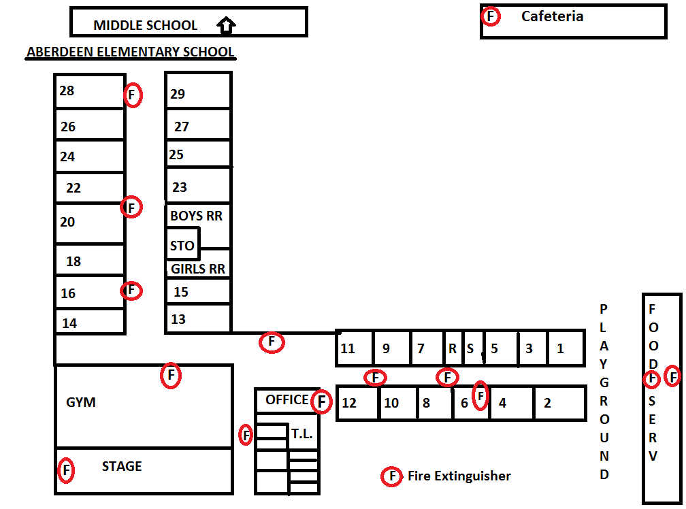

# Fire Extinguisher Map

# Belle Elementary School

# H:\My Documents\Buildings Sq Ft and Maps\Building Maps\Shivers and Belle Maps\Building Map Belle Elementary NEW FIRE EXTNG..png Fire Extinguisher Map

# Shivers Middle School

# H:\My Documents\Safety, Security, Emergency\safety plans 2016 - 2017\Building Maps\Shivers and Belle Maps\Building Map SMS NW RM TCH NAME FIRE EXT.png Fire Extinguisher Map

# Fluker Reed Building

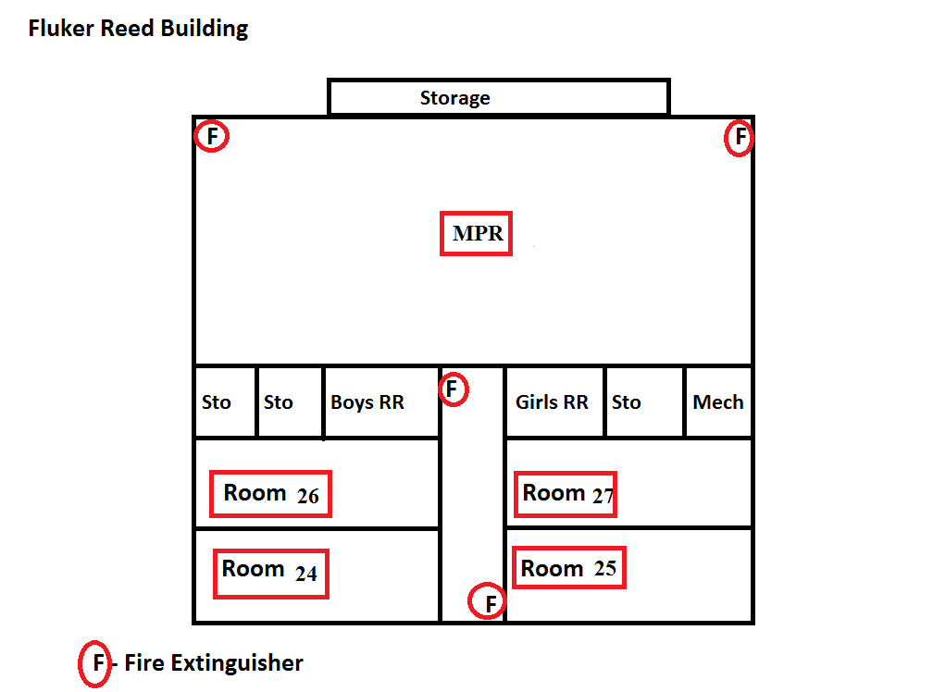

# Fire Extinguisher Map

# Aberdeen High School

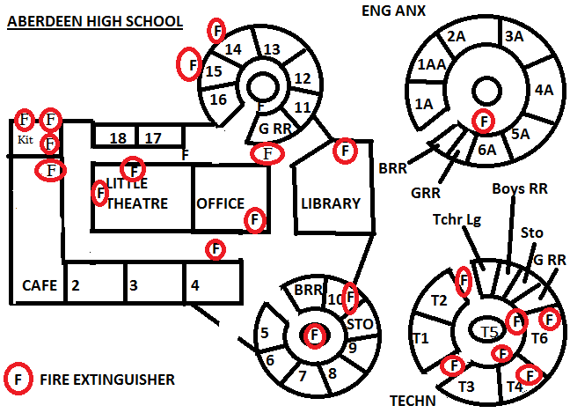

# Fire Extinguisher Map

# Aberdeen High School Gym

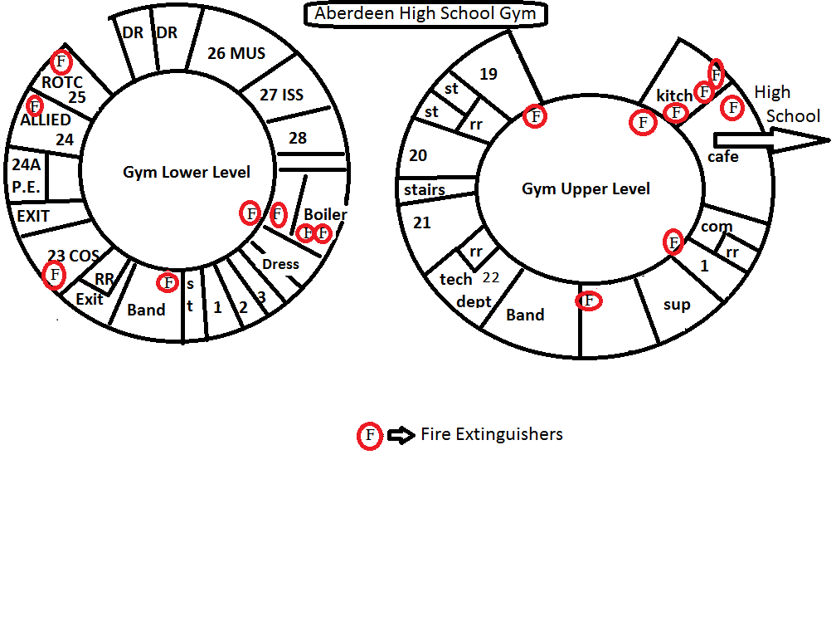

# Fire Extinguisher Map

# Aberdeen Resource Center

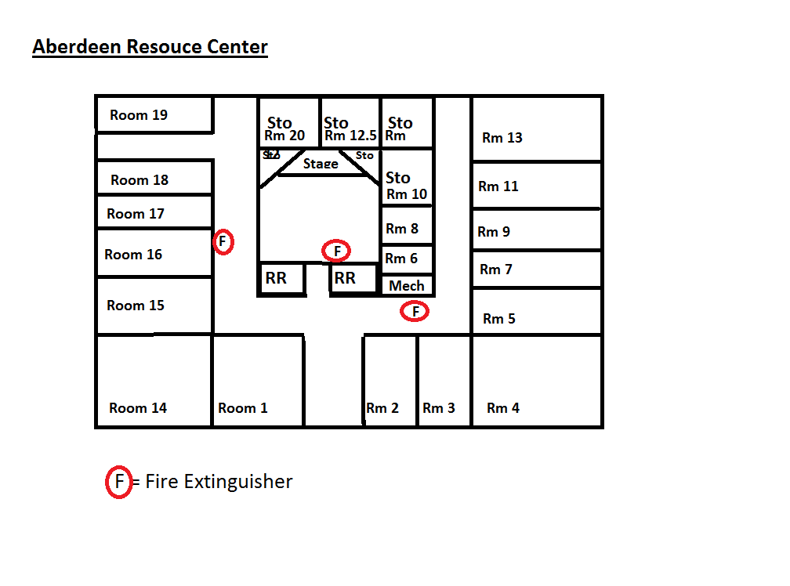

# Fire Extinguisher Map

# Parent Center

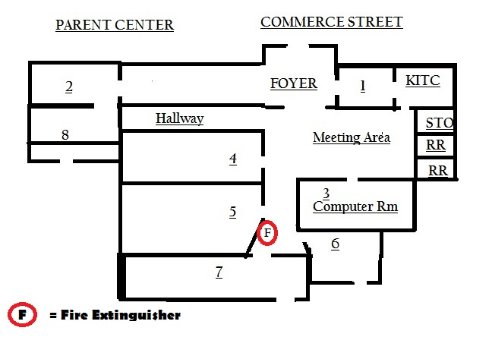

# Fire Extinguisher Map

# Thomas Pierce Field House

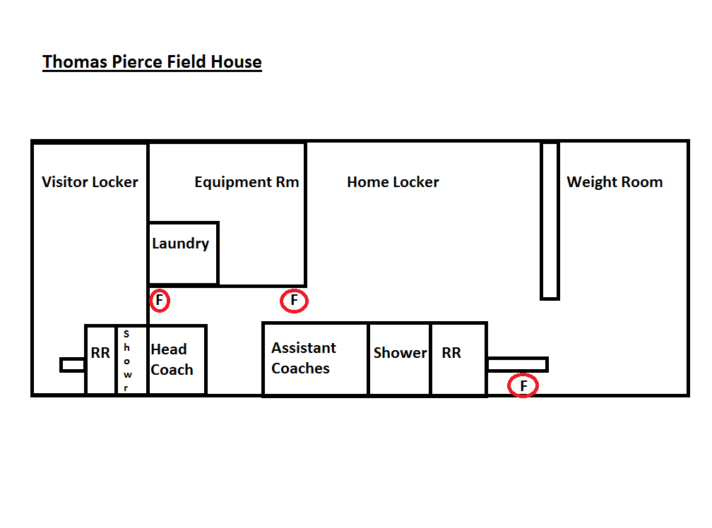

# Fire Extinguisher Map

# John Curlee Early Learning Center

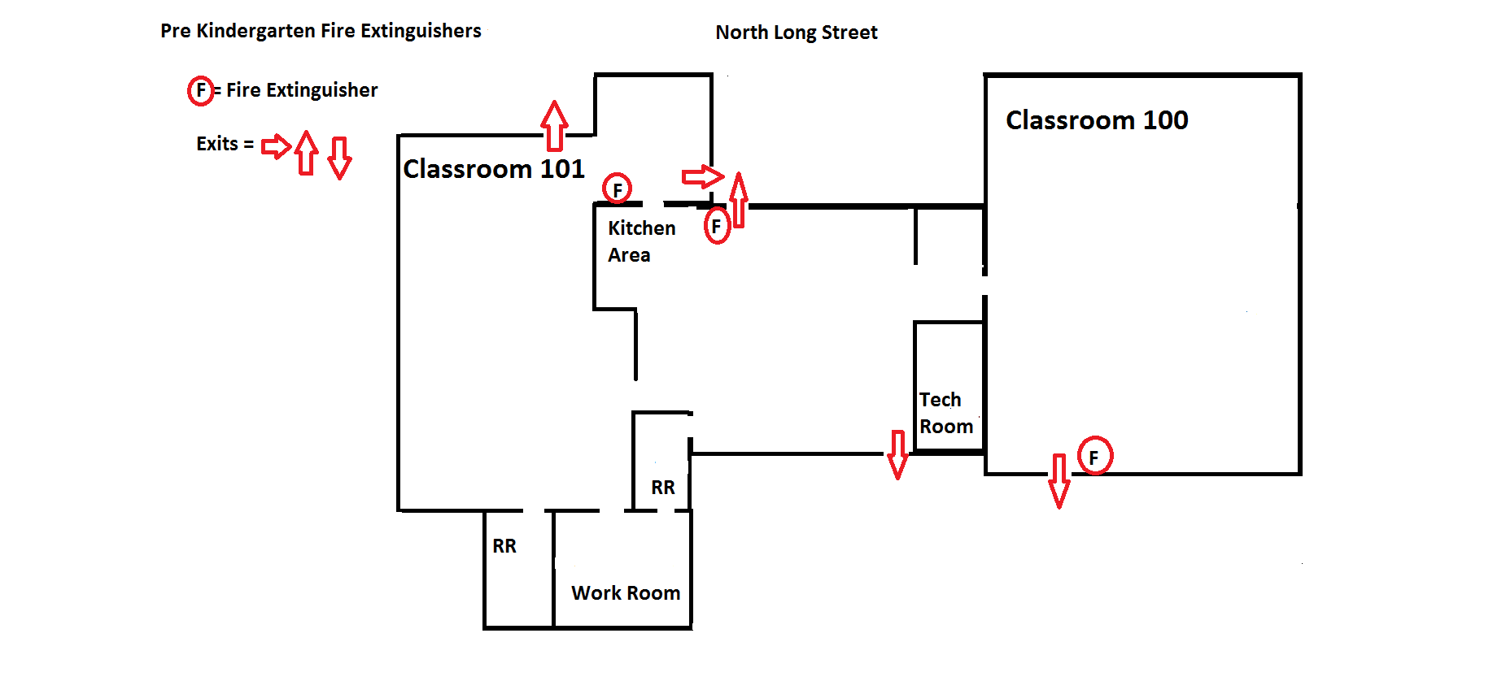

# Fire Extinguisher Map

# Bus Shop / Maintenance Building

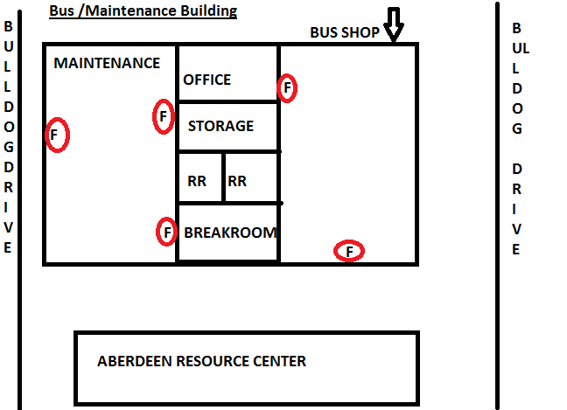

# Severe Weather Plan

**Severe Thunderstorms/Tornados/Water Spouts** are common along the Mississippi Gulf Coast and will normally have accompanying high winds, rain, lightning, and occasionally hail. In most cases the National Weather Service will issue a Severe Storm Watch or a Tornado Watch or Warning. When such watches or warnings are issued, or if conditions indicate the presence or potential for high winds and/or damaging conditions, the following actions should be taken –

**AS LONG AS IT IS SAFE TO DO SO!**

* Secure items/furnishings that can become missile hazards in high winds.
* Close all open doors and windows.
* Advise all employees, students, and visitors to remain indoors until the storm passes.
* Secure outdoor facilities if open.
* Remain indoors until conditions are safe to exit.
* Be attentive to deteriorating weather conditions, waterspouts, funnel clouds, etc. in the immediate vicinity.
* Should a tornado warning be issued for the immediate vicinity of Aberdeen School District, each school/facility will notify all personnel in accordance with its supplementary plan.
* The Superintendent of Education and/or School Principal should utilize normal reporting procedures should the facilities or any employees, students, or visitors, be damaged or injured by the storm.

### General Safety Rules

* The following are considered basic safety rules for all employees:
* Follow instructions. If you do not understand, ask for additional explanation.
* Correct unsafe conditions and report them promptly.
* Keep your work area clean.
* Use the proper tools or equipment for each job.
* Operate only the equipment you are authorized and qualified to use.
* Immediately report all accidents to immediate supervisor.
* If injured even slightly, get prompt first aid.
* If personal protective equipment is required by your job, wear it.
* Avoid fighting, horseplay, or other situations that could cause unnecessary injuries and distractions.
* Obey all safety rules and practices.
* Always walk when on school property.
* Never run even during emergencies.
* Always be safety conscious when on school grounds.
* Do not use defective tools. Safety awareness and a proper attitude will save lives, prevent disabling injuries, increase job effectiveness, and reduce costs.

### Disciplinary Action

Failure to comply with safe standards and/or practices may result in disciplinary actions up to and including termination. However, all efforts will be taken first to correct deficiencies or unsafe practices, including training and counseling workers to ensure they are aware of expected behaviors and practices.

### Cafeteria Safety Rules

The following cafeteria rules provided by the Mississippi School Board Association and Worker’s Compensation Trust, should be adhered to at all times:

* Wear cut resistant gloves when using or cleaning machines and knives.
* Keep floors clean and free of grease residue. Food or liquid spills should be cleaned up promptly in kitchen and dining areas.
* Report any item of equipment that appears defective or unsafe, or any unsafe act observed.
* Wet floors must be posted with “WET FLOOR” signs.
* High traffic areas must be cleaned in such a fashion that provides a dry walk surface at all times.
* Report any accident, no matter how slight.
* Safety guards should never be removed or modified.
* Use proper lifting techniques.
* Horseplay, running, and practical jokes are not permitted.
* Machinery and tools must be used only for their intended purposes.
* Fire extinguishers are not to be removed from their location or used for any purpose other than control of a threatening fire.
* Wear only approved non-slip safety shoes.
* Cafeteria Employees only are allowed in Kitchen except for repair men or other person essential to the operation of the cafeteria
* Emergency and backdoor lighting shall be kept operational at all times.
* Employee Family, Members shall not be allowed in the kitchen. If they must come to visit, the individual must obtain a pass from the office and visit in the dining area only.
* MSDS sheets are kept updated and located in a highly visual location. All personnel are to be trained to access this information.
* First Aid Supplies are to be available and well maintained in each facility.

### Kitchen Safety

### PERSONNEL

* Clean clothes and good hygienic practices.
* Hair covered
* No infections.
* Smoking, eating and drinking restricted.
* Short clean nails. Acrylics and Nail polish prohibited.
* No dangling earrings, bracelets or necklaces allowed.

### FOOD PROTECTION

* Original containers properly labeled.
* Thermometer, provided and conspicuous, accurate.
* Potentially hazardous food properly thawed.
* Food protection, during serving, storage, transportation, display, and preparation.
* Handling of food minimized; proper utensils provided and used.
* Food dispensing utensils properly stored when not in use.
* Food handling gloves required during food preparation. Gloves are to be changed often
* Chemicals of any kind shall be kept in a separate area from the food storage area.
* Temperatures shall be recorded daily for the cooler, freezers and serving lines. Temperatures shall be recorded every 48 hours when cafeteria is not in operation.
* All management to be serve safe certified.

### FOOD EQUIPMENT AND UTENSILS

* Accurate, thermometer, chemical test kits available for Chlorine and Quaternary Ammonia.
* Wash; rinse water clean and proper temperature (170 degrees F.).
* Wiping cloths, clean and stored properly.
* Food contact surfaces clean and free of detergents.
* No re-use of single service articles.
* Plumbing: proper and well maintained, no cross-connections, backflow or back siphon age.
* Knives shall be sharp and in good condition, properly stored in a knife holder.
* When moving hot food, use carts as much as possible to prevent burns.
* Cut resistant gloves shall be used when slicing with a knife or sliver.
* Burn guards shall be worn when cooking and removing hot items from the oven.

### FOOD TEMPERATURE REQUIREMENTS

* Cooling procedures.
* Rapidly reheat to 165 degrees F.
* Cooking temperature.
* Hot holding temperature (140 degrees F.)
* Cold holding temperature (45 degrees F.)

### INSECT AND RODENT CONTROL

* There shall be no evidence of insects.
* Regular Pest Control Maintenance Plan.
* Outer openings protected.

### TOILET AND HANDWASHING FACILITIES

* Paper Towels.
* Clean.
* Soap, and drying devices.
* Room enclosed.
* Proper waste, receptacles.

**OTHER OPERATIONS**

* Lighting provided as required: fixtures shielded, end caps.
* Proper, ventilation of rooms and equipment.
* Clean and or soiled linen properly stored.
* Complete separation from living/sleeping quarters, laundry.
* Overall well-organized, clean, litter free environment.

### General School Building Safety Rules

The following safety rules should be observed in the office and classroom:

* Desk and cabinet drawers should be kept closed.
* Tipping back on chairs can result in overbalancing.
* Office workers or instructional personnel should not move heavy furniture or cabinets nor carry heavy items from place to place. Trimming boards and paper cutters are dangerous. Blades should be locked down when not in use.
* Sharp pointed objects such as shears, knives, and pencils can cause injury if used incorrectly.
* Cleanliness and orderliness contribute to safety.
* Broken furniture and equipment should be removed and repaired promptly.
* Stairwells should be maintained with secure handrails and level, no-slip tread surfaces on the steps.
* Restrooms should be clean and well maintained.
* Wet floors must be posted with “WET FLOOR” signs.
* Horseplay, running, and practical jokes are not permitted.
* The site administrator will assure that all containers of hazardous products are appropriately marked and labeled. The label should identify the product and provide appropriate information and warnings.
* The site administrator will ensure that all containers of hazardous products are appropriately stored out of the reach of students.
* Keep walkways and exits clear.

### Face and Eye Protection

Face and eye protection will be used for any task where there is reasonable probability of injury. Employees assigned to perform tasks, which require eye protection, must wear the protector provided. The consequences of failure to use eye protection at appropriate times are so serious that no exception to this policy is permitted.

Face and eye protection will be usedwhen performing the following procedures:

* Grinding, cutting, milling, or drilling.
* Using impact wrenches and compressed air tools.
* Chipping, scraping, sanding.
* Using punches, chisels.
* Cutting rivets.
* Cutting or breaking glass.
* Cutting or breaking concrete.
* Using power tools.
* Cleaning dust or dirt from vehicles or equipment.
* Using metal cutting lathe, drill presses, power hack- saws and other metal working tools.
* Using corrosive or reactive liquid and/or solid chemicals.
* Using power woodworking machinery.
* Operating in the vicinity of machinery where there is a danger of falling objects or dust.
* When working on any overhead object which requires the face of the worker to be turned upward.
* Operating or while in the immediate vicinity of line trimmers.
* While riding on or operating a vehicle without the benefit of a windshield.
* Portable welding screens should be used to protect the eyes of others in the vicinity.
* Helpers and observers should also wear safety glasses or goggles with proper filter lenses.

### Lifting and Material Movement

* Lift, push or pull only reasonable amounts of weight.
* Do not lift over 50 pounds without help.
* Lift correctly to prevent injury.

### Hot Surfaces and Items and Energized Electrical Equipment

* Exercise caution when working around hot surfaces or items. Use insulating protective equipment (gloves, aprons, etc.) to prevent burns.
* Do not touch or work on any equipment which you suspect is energized (electrical shock hazard). De-energize first.
* Qualified maintenance personnel should perform any electrical repairs beyond resetting or replacing fuses.

### Construction/Renovation Safety

All construction and renovations in the Aberdeen School District will be under the direction of the board appointed architect or maintenance supervisor. The architect or maintenance supervisor will supervise all construction and ensure that it complies with all safety standards.

# Motor Vehicles and Mobile Equipment

This Fleet Safety Program has been developed in concert with Aberdeen School District’s minimum safety standard and Department of Transportation standards to ensure that employees of the Aberdeen School District are informed concerning safe work practices and regulations in the operating of district motor vehicle assets. The methods used to effectively inform employees include:

* Employee orientation, education, and classroom plus practical training.
* Various forms and written guidelines.
* Hands-On observation and checkout.

This Program applies to the safe operation and maintenance of Aberdeen School District motor vehicle assets, to include; school buses; maintenance vehicles, trucks, and equipment; and other district owned vehicle assets. This policy pertains to all vehicles owned by Aberdeen School District, which are operated by district employees.

* Only persons with a current operator’s license issued by the State of Mississippi, for the level/type of motor vehicle to be operated, shall be employed to operate motor vehicles for the district. This shall include any and all vehicles intended for operation on streets and/or highways.
* Any prospective employee under consideration for hiring as a motor vehicle operator shall undergo a motor vehicle record (MVR) check prior to being hired.
* Minimum requirements:

**All Drivers:**

* No DUI/DWI convictions in past 2 years.
* No record of drug/alcohol abuse in past 2 years.

### Commercial Vehicle Drivers:

* + - A current commercial driver’s license issued by the State of Mississippi.
    - No more than 2 moving violations in the past year, neither of which

can be for driving under the influence or reckless driving.

* + - No at fault accidents in the past year.
      * No record of discontinued auto insurance or motor vehicle.

### Requirements for School Bus Drivers:

A person may not drive a school Bus for transportation of school children or be employed as a school bus monitor unless the person satisfies the following requirements:

* + - * Is of good moral character.
      * Does not consume intoxicating liquor during school hours or 8 hours prior to shift.
      * Does not consume intoxicating liquor to excess at any time.
      * Is not addicted to any narcotic drug.
      * Is at least 21 years of age (drivers) or 18 years of age (monitors)?
      * Holds a valid public passenger chauffeur’s license or commercial driver’s license issued by the state of Mississippi (except monitors).

**Possesses the following required physical characteristics:**

* Must be able to pass D.O.T. physical.
  + - * Sufficient physical ability to be a school bus driver, as determined by any

state school bus regulatory authority that may exist.

* + - * Possession and full normal use of both hands, both arms, both feet, both legs, both eyes, and both ears.
      * Freedom from any communicable disease that may be transmitted through airborne or droplet means or requires isolation of the infected person.
      * Freedom from any mental, nervous, organic, or functional disease, which might impair the person’s ability to properly operate a school bus.
      * Visual acuity, with or without glasses, of at least 20/40 in each eye and a field of vision with 150-degree minimum and with depth perception of at least 80%.

***Note for School Bus Monitors: If/When utilized, every attempt will be made to use school monitors who are 21 years of age. When insufficient applicants exist to meet needs, this age requirement can be lowered to 18 years of age.***

**District Requirements for School Bus Drivers:**

* Before the District enters into a contract with a school bus driver or a fleet contract for contracted bus driving services, it shall obtain a copy of the school bus driver’s driving summary for the last seven (7) years as maintained by the Bureau of Motor Vehicles of the state of Mississippi and/or other states maintaining such records.
* Every person who is or intends to become a school bus driver shall obtain a certificate that he possesses the physical characteristics required by section 1 (g) of this chapter. A Mississippi physician shall make the certificate after the physician has conducted a physical examination of the driver or prospective drivers. The driver or prospective driver who shall pay for the examination shall choose the physician.
* Every school bus driver shall be required to attend an annual safety meeting or workshop. No safety meeting or workshop shall exceed two (2) days in duration in any one (1) calendar year.

**Operators shall conduct a safety check of the vehicle at the beginning of their shift or before operating a vehicle, to include the following:**

* Check wheels and tires.
* Check for any broken or loose parts.
* Check fuel level, crankcase oil level, radiator water level (if applicable), engine air cleaner, fan belt, hydraulic fluid level, battery water level and other points required by the particular model.
* Check headlights, taillights, warning lights, and other lights.
* Check the oil pressure gauge, water temperature gauge, amp meter. These will also vary by model and fuel used.
* Check the clutch, hydraulic and other controls.
* Ensure that any backup warning device is operational.

**(See Appendix-I-H)**

**School Bus Operators- School Bus Drivers shall perform all of the safety checks outlined above plus the following additional checks**:

* Ensure that all warning lights and flashers work correctly.
* Ensure that the safety bar on the front of the bus works correctly.
* Ensure that all door operating mechanisms and safety features work correctly for both the front door and all emergency doors.
* Ensure that all equipment, seats, and other interior features of the bus are in good repair and present no safety hazard to the children.

**(See Appendix-I-H)**

**Operators shall report any safety or repair issues discovered during their inspections of the actual operation of the vehicle to the maintenance shop for correction.**

**Minimum Bus Driver Training Requirements:**

* Any individual without a minimum of thirty (30) days experience in driving a school bus during the three (3) year period immediately preceding the effective date of the individual’s assignments as the driver of a school bus shall satisfactorily complete a pre-service school bus driver safety education-training course.
* All vehicle operators shall receive initial orientation and vehicle familiarity training upon hire, and shall receive annual refresher training thereafter.
* Complete documentation of all training, requirements compliance, licensing, and other pertinent information shall be kept for each vehicle/bus operator.

**The following safety rules will be followed when operating a motor vehicle or mobile equipment:**

* An employee will immediately notify the police department and his or her supervisor any time a vehicle is involved in an accident.
* No motor vehicle should be operated if it is defective or in malfunctioning condition to an unsafe degree.
* All persons driving or using vehicles or mobile equipment shall wear seat belts where provided and follow all local, state, and federal laws.
* All operators should visually inspect the perimeter of his or her vehicle prior to putting the vehicle in motion in any direction. The driver walking around the vehicle to insure that the area in the rear, sides, and front are clear of hazard(s) or people before starting the vehicle should accomplish this.
* All drivers should give an audible warning (horn or backup alarm) and check mirrors before backward movement is made.
* All drivers should drive cautiously and always be on the alert for any unexpected event.

# Equipment Usage

* Check to be sure equipment you are using is in safe condition.
* Ladders should be properly secured (i.e. use on level surface, tie off extension ladders).
* Dollies or hand-trucks should be used to move heavy loads-do not use make-shift equipment.

**Appendix I-G**

Vehicle Inspection Form

# Driver’s Inspection Form

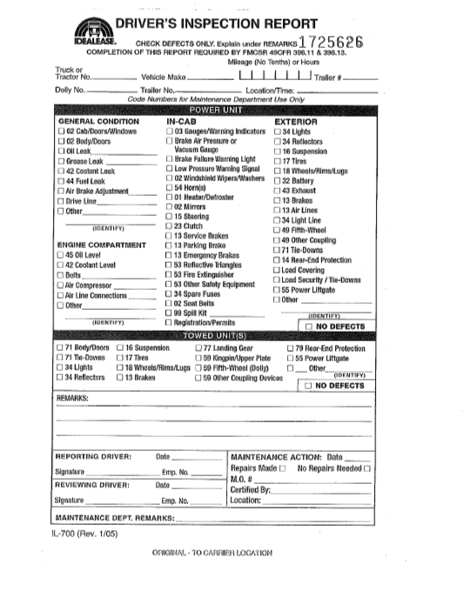

# Report Any Unsafe Condition Immediately

* Notify an administrator as soon as possible.
* Remain on-site at the unsafe location if needed to prevent accidents, or barricade the area if necessary to leave the unsafe location.
* Medical care after hours requires authorization by an administrator.
* File a Safe-Work Report signed by injured employee and your immediate manager.
* In an emergency, notify the assistant superintendent, risk manager or superintendent as soon as possible by phone.

**The Rule**

If you think or suspect an unsafe condition or equipment may reasonably cause bodily injury, call your immediate supervisor, administrator or safety committee member. Do not perform any task that may cause personal harm without supervisory direction. Be prudent. Think about the safe way to do a task before starting. Get help when needed. Do not improvise just to get the job done.

**Managers/Supervisors/Directors**

Managers and supervisors are personnel assigned responsibilities to assess and make decisions about safety. Failure to comply or perform in accordance with a manager’s directive regarding safe practice constitutes cause for termination of employment. If a manager’s judgment is questioned, an employee must (1) explain concerns to the manager, and (2) if a solution is not identified, request an immediate review by the manager’s administrator or supervisor. Manager and administrators are:

Superintendent Assistant Superintendent Directors

Principals Cafeteria Managers Supervisors

**Reports and Investigation:**

If an employee is injured in any way, it is the responsibility of the employee to immediately notify their administrator who will complete an Incident/Accident Report. **(Refer to Appendix I-B).** The administrator will file the report with the Workers Compensation Coordinator. Violation of this requirement constitutes cause for termination of employment. The site administrator responsible for the area of work where the incident occurred or suspected to have occurred, even if suspected and not reported, shall conduct an investigation of each incident. Procedures are listed below:

* An administrator shall, within two working days after an incident or receipt of report, interview the person who was injured and others who may provide information.
* An administrator shall complete an Incident/Accident Report citing summary statement(s) of testimony by name(s), findings and recommendations. **(Refer to Appendix I-A).**
* An administrator shall submit the Incident/Accident Report to the Workers Compensation Coordinator within one working day after completion of the investigation.
* The administrator will notify the Workers Compensation Coordinator by phone or radio as soon as possible.
* Workers Compensation Coordinator will at his/her discretion direct another investigation to obtain additional information or verify the report.
* Workers Compensation Coordinator will review the manager’s recommendations and information regarding an incident and prescribe appropriate corrective action and/or penalties.

### Penalties of Unsafe Work Practices:

For unsafe work practices, an employee will be issued a warning for the first offense. For the second offense, a three-day suspension without pay will be issued, and for the third offense, termination of employment or extended suspension will be issued at the discretion of the Superintendent**. A flagrant violation of a written regulation constitutes cause for immediate suspension or termination without a warning**. **(See Appendix I-J)**

# Appendix I-I

**Unsafe Work Practice** **Form**

**Aberdeen School District**

# Report of Employee-Employer Interview

Employee Name: ___________________________________________________

**Date: _______________________________________Time: __________________**

**( ) Verbal Counseling ( ) Written Reprimand ( ) Suspension (letter attached)**

**( ) Dismissal (letter attached)**

**Reason For Interview**

__________________________________________________________  
__________________________________________________________

**Corrective Action Agreement**

**Employee Comments**

_________________________

**Signature of Employee**

_________________________

**Signature of Supervisor**

**XC: Assistant Superintendent/ Personnel Director**

**Risk Management Director/ Safety Director**

# Emergency Drills

**The following emergency drills will be conducted**:

* Bus Evacuation Drills........................………… 2 times per year.
* Fire Evacuation Drills..........………………… 11 times per year.
* Tornado Drills..................................…………. 3 times per year.
* Earthquake Drills................……………..…… 1 time per year.
* Bomb Search Drills.............……………..……. 1 time per year.
* Lock Down Drills/Intruder/Violent Incident...... 3 times per year.

**See Appendix - I-J – Document all Drills**

**Appendix I-J**

**Emergency Drill**

**Form**

Emergency Drill Forms

|  |  |  |  |  |  |  |  |
| --- | --- | --- | --- | --- | --- | --- | --- |
| Please place an X in the box to the left of the School conducting the drills | | | | | |  |  |
|  | Aberdeen Elementary School | |  |  |  |  |  |
|  | Belle Elementary School | |  |  |  |  |  |
|  | Shivers Middle School | |  |  |  |  |  |
|  | Aberdeen High School | |  |  |  |  |  |
|  |  |  |  |  |  |  |  |
|  | **Fire Drill - one required each month (TWO during the first month)** | | | | | |  |
|  |  | Date | Time Alarm was Sounded | Time when all Students Were Out | Total Time |  |  |
|  | August |  |  |  |  |  |  |
|  | September |  |  |  |  |  |  |
|  | October |  |  |  |  |  |  |
|  | November |  |  |  |  |  |  |
|  | December |  |  |  |  |  |  |
|  | January |  |  |  |  |  |  |
|  | February |  |  |  |  |  |  |
|  | March |  |  |  |  |  |  |
|  | April |  |  |  |  |  |  |
|  | May |  |  |  |  |  |  |
|  |  |  |  |  |  |  |  |
|  | **Tornado Drill - Three required each year** | | | |  |  |  |
|  | Date | Time Alarm was Sounded | All Students in Safe Place - Time | Total time |  |  |  |
|  | 9/10 & 9/22/15 |  |  |  |  |  |  |
|  | Date | Time Alarm was Sounded | All Students in Safe Place - Time | Total time |  |  |  |
|  |  |  |  |  |  |  |  |
|  | Date | Time Alarm was Sounded | All Students in Safe Place - Time | Total time |  |  |  |
|  |  |  |  |  |  |  |  |
|  |  |  |  |  |  |  |  |
|  | **Bus Evacuation Drills - Two required each year (these will be handled by the bus shop)** | | | | | | |
|  |  |  |  |  |  |  |  |
|  | **Bomb Search Drills - One required each year** | | | |  |  |  |
|  | Date |  |  |  |  |  |  |
|  |  |  |  |  |  |  |  |
|  | **Intruder / Violent Incident / Lockdown Drills - Three required each year** | | | | | | |
|  | Date | Date | Date | Date |  |  |  |
|  |  |  |  |  |  |  |  |
|  | **Earthquake - One required each year** | | |  |  |  |  |
|  | Date |  |  |  |  |  |  |
|  |  |  |  |  |  |  |  |

# All Schools should have a one page form that looks very similar to this form. The one page form will have a place for the principal to print his or her name and will have a place for the principal to sign and date the form.

# Field Trips and Excursions

Field trips or excursions have long been a part of the educational program of the school district. The board approves the continuation of such trips under regulations established by the superintendent and reported to the Board of Education.

Field trips must be planned in advance and designed to augment lesson plans of the teacher. Field trips must have the approval of the principal and the office of the superintendent. It should be clearly understood that field trips are educational in nature and not recreational.

**Field trips should follow the following guidelines:**

* All trips must be well planned, properly timed, and related to regular learning activities. Prior approval from the principal must be secured before any commitments to a vendor can be made on behalf of the school. Field trips and other out-of-district activities cannot conflict with the state testing program schedule or with the district’s grading period testing program.
* No field trips will be approved during the last (20) days of the school year. When possible, trips should be scheduled so as not to interfere with the regular instructional day, i.e., scheduled during holidays.
* The school principal must approve field trips and written notification must be obtained within fifteen (15) days in advance.
* All request forms must be turned in to the transportation department five (5) days prior to the field trip.
* Field trip request form must be filled out completely and signed by the principal.
* Request for a field trip must be writing, and the superintendent must give approval.
* A field trip must be related specifically to the instructional program.
* Field trips, which are scheduled during the school day, are frowned upon. Such trips will require extensive justification for approval.
* School sponsored out-of-state student travel must be approved by the board of trustees prior to any initial arrangements by the sponsor, advisor, coach, or school.
* All trips, and the arrangements thereto, must be within budgetary allotment for such purpose.
* Costs incurred will come from the instructional budget of the school or from the sponsoring school organization.
* The conservator, or designee must approve field trips, which require pupils to participate
* in fund-raising activities or to pay a fee to defray expenses, in advance. Money collected for a specific field trip may not be in excess of the actual cost of trip, and all money collected shall be receipted and deposited as prescribed by board policy.
* Each student who goes on a field trip must have written parental/guardian permission. In addition, this form should include, but not limited to, the following information: (1) name of student: (2) date of birth; (3) social security number; (4) name, address, and telephone of parent/guardian; (5) emergency contact other than parent/guardian; (6) medical insurance policy provider and number; (7) list of allergies and/or medication, including dosage and schedule.
* The trip’s sponsor/advisor/coach must provide the school’s principal the following information: (1) date of trip; (2) destination of trip; (3) educational objectives; (4) sponsoring group/organization; (5) names(s) of sponsor/advisor/coach; (6) time of departure and estimated time of return; (7) route to be followed with proposed stops; (8) method of transportation, e.g., school bus, school van, commercial carrier; (9) name(s), address, telephone number of chaperones; (10) list of students with emergency information, list of students and adults for each vehicle.
* The principal and trip sponsor will review safety plan and procedures before each trip.
* A copy of the travel packet will be filed with the principal with at least two other staff members having access in case of emergency.

**SECTION** **II**

Aberdeen School District

**SCHOOL CRISIS RESPONSE PLAN**

**PROCEDURES AND RESPONSIBILITIES**

**SECTION II**

**Contents**

|  |  |
| --- | --- |
| Section II | **79** |
| Preparing for Crises: Essential Activities | **82** |
| Partnerships with Local Emergency Response | **84** |
| STAFF TELEPHONE NUMBERS | **86** |
| Emergency Telephone Chain | **87** |
| Community Emergency Numbers | **88** |
| Crisis Management Team Emergency Telephone Numbers | **89** |
| After Hour Contacts | **92** |
| Responsibilities of Personnel During and After Emergency | **93** |
| Principals (MS code 37-9-15) | **93** |
| Assistant Principals (MS code 37-9-15) | **94** |
| Teachers | **94** |
| Counselors / Psychologist | **94** |
| Custodians/Maintenance | **94** |
| Secretarial Staff | **95** |
| Class List Generation | **95** |
| Food Services | **95** |
| Bus Drivers | **95** |
| Central Office Staff | **95** |
| Coordinator of Public Relations | **96** |
| School Nurse | **96** |
| Security Director | **96** |
| Emergency Management Director | **97** |
| GENERAL CRISIS PROCEDURES | **97** |
| COMMAND CENTER | **98** |
| Communication | **98** |
| Communication Chain of Command | **98** |
| Incident Command System | **99** |
| Aberdeen School District Crime Scene Management | **100** |
| How to avoid contaminating crime scene evidence | **100** |
| Abduction/Student Runaway | **102** |
| Emergency Procedure: | **103** |
| Accident/Serious Injury/Illness | **103** |
| After Hours Emergency Plan | **104** |
| Altercation: Violence Between Two or More Individuals | **105** |
| Assault of a Student | **106** |
| Bomb Threat | **107** |
| APPENDIX A – Bomb Threat Call Procedure | **109** |
| Building Collapse | **11** |
| Building Evacuation Plan | **112** |
| Evacuation Location | **113** |
| Bus Accident | **114** |
| Caring for Special Needs Students | **115** |
| Individuals Requiring Special Assistance | **116** |
| Child Abuse/Neglect | **117** |
| Confrontation with Person in Possession of a Weapon | **119** |
| Death of a Student/Staff Member at School | **120** |
| Death of Student or Faculty Member Outside of School | **121** |
| Earthquake | **123** |
| Emergency Release of Students | **124** |
| Emergency Team At Student Reunification Site | **125** |
| Crisis Site Student Release Form | **126** |
| SITE STATUS REPORT/MISSING/INJURY REPORT | **127** |
| Emergency Release List for Parents | **128** |
| Explosion | **129** |
| Fallen Aircraft | **130** |
| Fire | **131** |
| Hazardous Materials Incident | **132** |
| Within The Facility Hazardous Materials Release | **133** |
| Intruder – Armed Intruder or Active Shooter | **133** |
| Lock Down Procedure | **136** |
| Hostage | **137** |
| Working with the media | **139** |
| Media Staging Area | **140** |
| Medical Emergency | **141** |
| Phone Numbers MDE, Local Responders, Law Enforcement, Media | **142** |
| Natural Gas Emergency | **143** |
| Nuclear Warning Procedures | **143** |
| Public Assembly Emergency Plan | **144** |
| Severe Weather | **145** |
| Visitors in the Schools | **146** |
| Section III School / Community Response Plan | **148** |

**CRISIS MANAGEMENT PLAN**

**Preparing for Crises: Essential Activities**

A school that is prepared before a crisis occurs will be much more likely to deal with students and staff effectively. An unprepared school is asking for chaos. The Aberdeen School District has set up a Crisis Management Plan, and the following activities have been designed in this plan to ensure safety of adults and students in crisis situations:

**1. Decide who will be in charge during a crisis.**

A crucial first step in crisis management planning is to decide who will be in charge during a crisis. Assign one person to provide leadership during emergency situations, to organize activities, and to disseminate information. Usually the person in charge is the principal or assistant principal. Designate a substitute in the event that the designated person is unavailable at the time of the emergency. It is extremely important that all staff and students know who these people are. Identification badges can be helpful.

**2. Select your Crisis Response Team.**

A second important step is to recruit members for your Crisis Response Team. Typically, the Crisis Response Team will consist of an administrator, nurse, psychologist, school social workers, teachers, counselors, support staff representative, and others with skills appropriate to the tasks to be performed. Sometimes forgotten, but important in crises, are the school secretary/office manager and the head custodian. Most, if not all, of your team members must be present full time at the school—or able to respond immediately to a phone call.

The team includes adjunct members who can be called, as needed. These include police juvenile/school liaison officers, health or mental health crisis services.

**3. Develop clear and consistent policies and procedures.**

It is absolutely critical to develop policies and supporting procedures that provide all staff with clear guidelines for tasks and responsibilities during crises and emergencies. This also ensures that all staff will respond consistently in each situation. It is important to include policies and procedures by which children will be released to their caregivers.

**4. Provide training for the Crisis Response Team**

Suggested content and sample agendas for training the team are provided such as CPR, First Aid, Fire Safety and Crisis Management.

**5. Establish a law enforcement liaison.**

This is often established at the school division level. One person from the school system is designated with whom the police can communicate. This person can be telephoned night or day to report a crisis and to exchange relevant information that can be relayed. This person, in turn, will contact key people in the schools. Having accurate information from the police allows school personnel to quell rumors that frequently arise when a crisis occurs.

**6. Establish a media liaison and identify suitable facilities where**

**reporters can work and news conferences can be held.**

Many school districts have a community or public relations spokesperson to which all media requests are referred. Know who this person is, and communicate with him/her to establish procedures for responding to the media in times of crisis. The Aberdeen School District has such a person who speaks for the District, the Superintendent of Education.

**7. Establish a working relationship with community health agencies and**

**other resource groups.**

To facilitate quick collaborative responses, strong relationships with community agencies must be established prior to a crisis. A list of suggested community support services is included below.

**8. Set up “phone trees.”**

Critical information needs to be communicated as quickly as possible to those in need. The complexity of the phone tree will depend on the size of the community and its school system.

**9. Plan to make space available for community meetings and for outside**

**service providers involved in crisis management.**

Designate school sites and include potential alternative sites in the community when space is not available at the school.

**10. Develop necessary forms and information sheets.**

Develop records keeping forms to assist in the management of crisis situations. A variety of sample forms, letters, etc., are included in this Resource Guide. *Having accurate information from the police allows school personnel to quell rumors that frequently arise when a crisis occurs.*

**11. Develop a plan for emergency coverage of classes.**

Teachers who will play significant roles in a crisis response need to be assured that their classrooms will be covered. Consider Central Office and your PTA as possible sources of assistance in coverage.

**12. Establish a code to alert staff.**

Establish a code (call the situation what it is, “This is a lock down”, “This is an evacuation”) that can be used over the public address system or in notes to alert staff as to the nature of a crisis without unduly alarming the rest of the school.

**13. Develop a collection of readings.**

The district office or school librarian should develop a bibliography of books pertinent to crisis situations for students and staff.

**14. Have school attorney review crisis response procedures and forms.**

Adjust procedures to comply with any liability concerns.

**15. Hold a practice “crisis alert” session.**

Prepare staff members for their responsibilities in a real crisis. Through role-playing, staff can become aware of potential problems and discuss how to respond to them.

**16. Hold an annual in-service meeting on general crisis intervention.**

Annual in-service meetings need to be conducted for all school staff. Such in-service meetings should include information on building procedures, suicide, rape, and natural disasters.

***“The worst time to prepare for a crisis is after it has already occurred.”***

***from Staying Safe at School: Survival Skills for Teachers***

**Partnerships with Local Emergency Response**

For safety’s sake, it is critical that school administrators understand and use the capabilities of area emergency responders. School officials should strive to foster the ideal that fire, police, and other agencies that can assist schools in prevention, intervention, and crisis management are “one large team” working together to maintain safety and security in our schools.

An effective partnership between the Aberdeen School District and emergency responders like the police and fire department have been developed in a collaborative effort to work together for the overall safety of children in the Aberdeen School District. In building such a partnership, the district has taken the following four steps:

**1) Provide local police and fire departments with blueprints of the school floor plan, including the main shut-off points for gas, water, and electricity**.

* Provide copy of current plans.
* Create videotaped walking tour of each school in the district to increase the police and fire departments’ understanding of the schools’ design.
* Show school exteriors, with their door numbers, and pinpointing physical locations with compass directions and noting proximity to particular streets.
* Provide slow scan of the halls to show classroom numbers and entryways to such key areas as the library, cafeteria, main office, and boiler room.
* Show central shut-offs for the fire alarm systems, boiler room and main electrical plant imaging.
* Give partners a complete library of the school videos for their command use.
* Use videos in agency’s training, at command posts, etc.

**2) Ask police and fire officials to agree to “scene security,” so that our populations can travel safely to evacuation sites**.

* District Safety Coordinator provides in service experiences to police and fire personnel in which evacuation routes and primary and secondary evacuation sites are discussed.
* Include maps that show routes of travel in presentations.
* Obligate services of police and fire officials to agree to “scene security” so that our populations can travel safely to these sites.
* Discuss lockdown procedures for both inside and outside threat scenarios.
* Encourage input from agencies/partners in developing and creating these procedures.
* District Safety Coordinator collaborates with partners frequently to discuss current school safety topics and plans.
* Collaborate with police department to make sure the concept of “rapid deployment” is understood and a plan is created to confront and deal with active shooters.

**3) Involve our county emergency management coordinator**.

* Involve County Emergency Management Coordinator in planning drills and emergency training.
* Plan practice drills with emergency management scenario each year.
* Set aside a day and time to get together to exercise a current issue related to school safety, and work to resolve it together.
* Practice latest techniques.
* Involve other public agencies in the scenario that can really help with the crisis.
* Share such technologies as telephone messaging systems that broadcast emergency or informational messages to homes, security camera installations, and door access systems (how do police get in if the officer cannot open the door?).

**4) Hold tabletop exercises**.

* Simulate crisis training by bringing together in classroom settings those who would be involved in handling a crisis.
* Assume roles in simulation in learning to respond to many issues of school safety-from bomb threats to hostage taking, to attacks.
* Include representatives from the police and fire departments, the hospital, Red Cross, city, and county wherever possible.

Appendix II-A

**STAFF TELEPHONE NUMBERS**

|  |  |  |
| --- | --- | --- |
| Superintendent  Mr. Jeff Clay | Office: 662-369-4682 | Cell: 662-436-9508 |
| Deputy Superintendent  Mr. Bobby Eiland | Office: 662-369-6262  Home: 662-319-0500 | Cell: 662-319-0500 |
| Director of Federal Programs, Curriculum,  and Professional Devt.  Mrs. Tameka Shannon | Office: 662-369-4682  Home: | Cell: 662-251-2690 |
| Safety Director  Ms. El’Lane Gilmore | Office: 662-369-6886  Home: n/a | Ex. 502  Cell: 205-712-6617 |
| Campus Police  Chief Tony Tillman | Office: 662- 640-1328  Home: 662-694-1226 | Ex. 801  Cell: 640-1328 |

|  |  |  |  |  |  |
| --- | --- | --- | --- | --- | --- |
| **Aberdeen School District Emergency Telephone Chain** | | | | |  |
|  |  |  |  |  |  |
| **Superintendent** | Mr. Jeff Clay | 662-436-9508 |  | **Emergency Service Organizations** |  |
| **Exec. Sec.** | Ms. Sharon Gladney | 662-369-2853 | MS Highway Patrol | 662-369-4003 662-842-1122 |
| |  | | --- | |  | |  | |  | | --- | |  | |  | Aberdeen Police Dept. | 662-369-6454 |
|  |  |  |  | MCSD Superintendent | 662-257-2176 |
|  |  |  |  |  |  |
| **Deputy Superintendent** | |  |  |  | **Food Service**  **Barbara Vasser** |
| Bobby Eiland | 662-319-0500 |  |  |  | 662-251-5833 |
|  | 662-386-5486 |  |  |  | |  | | --- | |  | |
| Kim Lenoir | 662-813-3444 | Lauren Fondren |  | **Support Staff** |  |
|  |  | 662-832-6222 |  | W. Brandon 662-436-0939 |  |
|  |  |  |  | A. Brewer 662-369-6813 |  |
| |  | | --- | |  | |  |  |  | D. Frembgen 662-574-4335 |  |
|  | Maintenance- Frank Walker |  |  | J Dobbs 662-422-2178 | **Cafeteria Managers** |
|  |  | Martha Jackson  662-931-3161 |  | S Falkner 662-494-9442 |  |
|  | Waters Transportation |  |  | C Gettis 662-436-6954 |  |
|  | Greg Jones | Charles Beene |  | T. Shannon 662-871-2237 |  |
|  | 662-251-6980 | 662-603-4469 |  | M Lowe 662-369-6538 |  |
|  |  |  |  |  |  |
| **Media** |  |  |  | J. O'Neal 601-594-6020 |  |
| WCBI | 662-327-4444 |  |  | J Oliver 662-661-0126 |  |
|  | 662-328-1224 |  |  |  |  |
|  | 662-841-0044 |  |  | E Gilmore 205-712-6617 |  |
| WTVA | 662-842-7620 |  |  | A. Sims 662-640-1132 |  |
|  | 662-327-6464 |  |  | L Straughter 662-436-9488 |  |
| WLOV | 662-842-7620 |  |  | T Tillman 662-640-1328 |  |
|  | 662-328-2727 |  |  | B. Vasser 662-251-5833 |  |
| WAFM | 662-256-9726 |  |  |  |  |
| WWZQ | 662-369-8561 |  |  |  |  |
|  |  |  |  |  |  |
| **Notes:** | Bobby Eiland will make a report by 6 am to the Conservator concerning road conditions. | | | | |
|  | The Conservator will make a decision no later than 6:40 am. If schools are to close, | | | |  |
|  | notification will be made according to the emergency chain above. | | | |  |
|  | All administrators, supervisors and head custodians will report to work unless | | | |  |
|  | otherwise notified or there is undue danger to their personal welfare. | | | |  |
|  | The Conservator's office will remain open to disseminate pertinent information unless there is | | | | |
|  | undue danger to their personal welfare. | | |  |  |
|  | The principal, head custodian, and maintenance staff are responsible for checking the | | | | |
|  | physical facilities and taking necessary precautions. | | | |  |

**Community Emergency Numbers**

**Ambulance…Fire…Police………CALL…911**

**Mississippi Department of Education**

**Crisis Response Team**

**Robert Laird**

**Office……………601-359-1335**

**Pager…………….601-929-2895**

**Cell………………601-942-2445**

**Home…….………601-732-2192**

Fire Coordinator………………………………………….. 369-9551

Police Department (Aberdeen )……………………………. 369-6454

Sheriff’s Department……………………………………... 369-2468

Civil Defense……………………………………………...

**Health**

Pioneer’s Community Hospital …………………………… 662-369-2455

Gilmore Memorial Hospital……………………………… 662-256-7111

Department of Human Services…………………………… 662-369-2907

Monroe County Health Department……………………… 662-369-8132

American Red Cross……………………………………… 662-369-5710

Poison Control Center…………………………………….. (800)222-1222

**Law Enforcement**

F.B.I.………………………………………………………. 662-328-5299

Mississippi Highway Patrol……………………………….. 662-323-5214

U.S. Marshall’s Office 369-4892

United States Border Patrol

Gulf Port …………………………………………… 1-228-863-3582

Mobile ……………………………………………. 1-334-441-6139

**Utilities**

Aberdeen Electric Power Company……………………… 662-369-4724

Atmos Gas…………………………………………………… 662-842-1122

**Media**

WCBI ……………………………………………………….. 662-327-4444

662-328-1224

662-841-0044

WTVA …………………………………………………….. 662-842-7620

662-327-6464

WLOV ……………………………………………………… 662-842-7620

662-328-2727

WAFM ……………………..……………………………… 662-256-9726

WWZQ …………………………………………………….. 662-369-4561

**Important Numbers**

**Crime Stoppers Hotline**

Local 1 (800) 530-7151

**CONNECTIONS HOT LINE** 1 (888) 827-4637

**Rape Crisis Hotline**

(24 hours)

1 (601) 960-1234

Jackson

**Shelter (for Abused and**

**Neglected Children)**

1 (800) 422-4453

**ANIMAL SHELTER**

1 (662) 369-2188

Appendix II-A

**Crisis Management Team Emergency Telephone Numbers**

**(Aberdeen) School District**

|  |  |  |  |  |
| --- | --- | --- | --- | --- |
| **Name** | **Position** | **Work No.** | **Home No.** | **Cell No.** |
| Eiland, Bobby | Athletic Director | 662-369-4682 | 662-386-5486 | 662-319-0500 |
| Cantrell, Cecil | Sherriff | 662-369-2468 |  | 662-315-2454 |
| Chandler, Regina | Parent |  | 662-369-6517 | 662-319-6225 |
| Vasser, Barbara | Food Service | 662-369-6886 | 662-251-5833 | 662-640-1336 |
| Cook, James-Pastor | Clergy |  | 662-369-0402 | 662-386-0319 |
|  |  |  |  |  |
| Clay, Jeff | Superintendent | 662-369-4682 |  |  |
| Eiland, Bobby | Director of Operations | 662-369-6262 | 662-319-0500 | 662-319-0500 |
| Gladney, Danny-Pastor | Clergy | 662-680-1129 | 662-369-2853 | 662-346-9025 |
| Hodges, Fred | Fire Chief | 662-369-2011/9552 |  |  |
| Goza, Bunky | Emergency Management | 662-369-3683 |  | 662-319-7301 |
| Graves, Donna | Emergency Management | 662-369-3683 |  | 662-315-6906 |
| Howard, Maurice-Pastor | Clergy |  | 662-369-0191 | 662-497-1153 |
| Shannon, Tamecka | Director of Fd Prg, Curr, PD | 662-369-4682 #8 |  | 662-251-2690 |
| Jones, Greg | Transportation | 662-369-6262 | 662-329-3552 | 662-251-6980 |
| Dowdy, Dave-Pastor | Clergy | 662-369-9366 |  | 601-479-1600 |
| Jones, Greg | Transportation | 662-251-6980 |  | 662-364-1752 |
| Randle, Henry | Police Chief | 662-369-6454 (PD) |  | 662-436-4940 |
| Lenoir, Kim | Parent | 662-661-0404 |  |  |
| Sims, Alforzinie | Campus Police | 662-640-1132 |  | 662-640-1132 |
| Tillman, Tony | Campus Police | 662-640-1328 | 662-694-1226 | 662-640-1328 |
|  |  |  |  |  |

ADD Officer Franks with contact information

**After Hour Contacts**

|  |  |  |
| --- | --- | --- |
| School | Contact | Phone Number |
| Aberdeen School District | Mr. Bobby Eiland | 662-319-0500/386-5486 |
| Aberdeen Elementary | Chief Tony Tillman, SRO  Sgt. Alforzinie Sims, SRO  Mrs. Kristen Fondren, Principal  Mrs. Sally Harrell, Secretary | 662-640-1328/694-1226  662-640-1132  662-832-6222  662-436-5250/369-4123 |
| Aberdeen High School | Chief Tony Tillman, SRO  Sgt. Alforzinie Sims, SRO  Mr. Charles Beene, Principal  Mr. Jaworski Rankin, Assistant Principal | 662-640-1328/694-1226  662-640-1132  662-603-4469  662-229-5599 |
| Aberdeen Learning Center | Sgt. Alforzinie Sims, SRO  Chief Tony Tillman, SRO  Mr. Bobby Eiland | 662-640-1132  662-640-1328/694-1226  662-319-0500/386-5486 |
| Aberdeen Middle School | Sgt. Alforzinie Sims, SRO  Mrs. Martha Jackson, Principal | 662-640-1132  662-369-4123 |
| Aberdeen Resource Center | Sgt. Alforzinie Sims, SRO  Mrs. Tameka Shannon, Director Cur, Fed Prg, PD  Latasha Campbell | 662-640-1132  662-871-2237  662-640-1268  662-436-9488 |
| Belle Elementary | Chief Tony Tillman, SRO  Sgt. Alforzinie Sims, SRO  Ms. Martha Jackson, Principal  Ms. Tameka Lewis, Secretary  Mrs. Bessie McGee, Secretary | 662-640-1328/694-1226  662-640-1132  662-931-3161  662-661-0983  662-369-8018 |
| Curlee Parent Center | Sgt. Alforzinie Sims, SRO  Mrs. Jennifer Oliver, School Att. Officer  Mr. Bobby Eiland, Dep. Supt. | 662-640-1132  662-661-0126  662-319-0500 |
| Fluker- Reed Building | Mr. James Lenoir, GCA Services  Mrs. Bessie McGee, Secretary  Sgt. Alforzinie Sims, SRO | 662-346-6417  662-369-8028  662-640-1132 |
| Prairie Elementary | Sgt. Alforzinie Sims, SRO | 662-640-1132 |
| Shivers Middle School | Chief Tony Tillman, SRO  Sgt. Alforzinie Sims, SRO  Ms. Martha Jackson  ,Custodian | 662-640-1328/694-1226  662-640-1132  662-931-3161 |
| Superintendent’s Office | Sgt. Alforzinie Sims, SRO | 662-640-1132 |

**Responsibilities of Personnel During and After**

**Emergency**

**Principals (MS code 37-9-15)**

The principal/designee is responsible for the overall direction of emergency procedures at the school site. The principal will:

* Develop an emergency procedures plan designated to minimize injury and the loss of life and to protect property for his or her school site.
* Arrange for a faculty meeting during the first month of school for the purpose of reviewing the validity of the plan and to update the staff regarding new procedures.
* Post in the school office a chain of command including the names and phone numbers of the persons to succeed the principal in the event of his or her absence or incapacitation.

Principal

Asst. Principal

Lead Teacher

Secretary

* Maintain a list of first aid providers for his or her site.

Coach

SRO

* Direct evacuation of building in accordance with procedures.
* Arrange for transfer of students and other individuals when their safety is threatened by a disaster.
* As certain names of injured and send staff member with students if transported from school.
* Keep the names of students who are picked up by parents or persons acting for the parents.
* Notify the superintendent’s office.
* Prepare fact sheet to help those answering phones.
* Communicate event to district media spokesperson.
* Notify first aid providers to report to site of emergency.
* Take any other steps deemed necessary to ensure the safety of students, staff, and other individuals.
* Maintain control and accountability of students and staff.
* Assist as directed by the superintendent.

**Assistant Principals (MS code 37-9-15)**

The assistant principal will :

* Help secure buildings.
* Assure that multi-handicapped students are accounted for and safe.
* Report injuries and damage to the principal.
* Coordinate communication between principal, faculty, and staff.
* Communicate with parents.
  1. Phone calls should be brief and professional.
  2. Use lists to contact parents of the students involved.
  3. Give them factual information.
  4. Provide them with the locations on campus that they have access to.
  5. Give them the names of the spokesperson that will be keeping them informed once they have arrived on campus.
  6. Advise them to only give information to school and EMS officials.
* Assist as directed by the principal.

**Teachers**

Teachers will:

* Provide for the supervision of students and will remain with students until directed otherwise.
* Direct evacuation of students in their charge to designated areas in accordance with school crisis response plan.
* Render first aid if necessary.
* Take grade book and call roll after evacuation.
* Report missing students and staff to principal.
* Assist as directed by the principal.

**Counselors / Psychologist**

Counselors will:

* Maintain list of high-risk students throughout the year.
* Identify ‘at risk’ students in current emergency.
* Provide assistance to students and staff.
* Communicate with parents.
* Designate a location for counseling center.
* Assist as directed by the principal.

**Custodians/Maintenance**

Custodians/Maintenance will:

* Be responsible for the use of emergency equipment, for the handling of school supplies, and for the safe use of available utilities.
* Survey and report damage to the principal.
* Assist rescue operations as directed.
* Assist fire-fighting efforts until regular fire-fighting personnel take over.
* Control main shut-off valves for gas, water, and electricity and ensure that no hazard results from broken or downed lines.
* Assist in disbursement of supplies and equipment.
* Conserve usable water and other supplies.
* Assist as directed by the principal.

**Secretarial Staff**

The secretarial staff will:

* Be responsible for reporting emergency. Call ___-911.
* Take enrollment cards and sign-out sheets for off-site student release.
* Recorder.
* Utilize telephones and monitor emergency radio broadcast.
* Assist as directed by the principal.

**Class List Generation**

* Office Manager**/**Office secretaries manage this responsibility.
* Pull list(s) of those classes involved and make 5 copies.
* Check absence**/**specials**/**schedules to affirm who is in attendance in affected classes.
* Collect parent contact numbers.
* Check list with school nurse.
* **List should remain with School Law Enforcement Officials at all times.**

**Food Services**

Food Service personnel will:

* Prepare and serve food to students and staff when necessary during an emergency.
* Assist as directed by principal.

**Bus Drivers**

The bus drivers will:

* Supervise students if emergency occurs while students are on the bus.
* Transport students and staff to new location when directed.
* Assist as directed by the principal.

**Central Office Staff**

The central office staff will:

* Assist in all emergencies.
* Set up an emergency communication post at the central office.
* The central office will notify the proper MDE departments.

**Coordinator of Public Relations**

The public relations coordinator will:

* Prepare statement for the media.
* Aid the principal in preparing fact sheet to help those answering phones.
* Develop accurate and complete information regarding the incident and will coordinate with the superintendent the release of all information.
* Facilitate and conduct press conferences.
* Maintain communication post at the central office during emergency incident.

**School Nurse**

The school nurse will:

* Report to the emergency scene.
* Provide first aid services to injured **/**casualties in a secure location.
* Provide information to school officials.
* Provide information to emergency personnel.
* Assist as directed by the principal.
* Establish triage as needed and coordinate medical evacuation.

**Security Director**

Thesecurity director will:

* Report to the emergency scene.
* Provide cell phones as needed.
* Help control the flow and direction of traffic.
* Help secure student, staff, and visitors involved with emergency.
* Help conduct interviews with witnesses and those involved with the crisis.
* Assist as directed by the principal.

**Emergency Management Director**

The Aberdeen School District emergency management director will assist school officials in disaster planning. This assistance will include the four phases of emergency management, which are:

* Mitigation: Activities, which eliminate or reduce the probability of disaster.
* Preparedness: Activity, which can be taken prior to a disaster to save lives and minimize damage.
* Response: Activities that follow a disaster and are designed to prevent loss of lives and property, relieve suffering, and provide emergency assistance.
* Recovery: Short and long-term activities which return systems to normal or improved standards.

The emergency management director will also organize other resources in the Aberdeen School District as needed to assist the school district in disaster planning or response. Responsibilities include:

* Collection, analysis, and dissemination of information concerning potential disasters.
* Establishment of warning system to assure school officials receive immediate word of any situation that may cause a threat to the school or their students.
* Assistance in training of school personnel who may require special training as a result of their disaster response assignment.
* Assistance in dealing with state or federal officials during the recovery phase.

**GENERAL CRISIS PROCEDURES**

1. Call - 911.
2. Give police your name, school name and location, situation and then stay on line.
3. Announce Code, repeat 3 times. Stay calm.
4. Designate command center to Crisis Response Team through 2-way radios/individual room calls.
5. Secure CRT binder and set plan in action according to situation at hand.
6. Call – Superintendent’s office at 369-4682
7. If necessary notify at Superintendent at 369-4682 of additional staff needs.
8. Document the entire incident. Include names, times, steps taken and results. Refine this information in the post intervention.
9. Conduct emergency staff meeting to facilitate flow of information.

**COMMAND CENTER**

1. Site administrator conducts operations from one location and does not leave that location.
2. Crisis Response Team members should report immediately to Command Center and initiate responsibilities.
3. Secure CRT binder. (This contains specific member assignments, maps of school, evacuation plan, emergency numbers and master keys).
4. If EMS officials replace CRT members they should await further instructions from site administrator.
5. Follow through with designated PARENT waiting area.
6. Follow through with designated PRESS/MEDIA area.
7. Facilitate distribution of maps, keys, assignments, information and communication devices from a central location.
8. Facilitate district participation and flow of information with EMS officials.
9. No unauthorized individuals should be allowed in the command center.

**Communication**

The superintendent will be the official spokesperson for the district. The superintendent’s designee will be responsible in the superintendent’s absence. Comments in a crisis situation will be made under the supervision of the superintendent.

The boardroom will be the location for the emergency communication post. Interviews will not be conducted at the school site. Media permission to interview students must be given by parents and be conducted off site.

**Communication Chain of Command**

* Superintendent Mr. Jeff Clay
* Director of Risk Management Chief Tony Tillman
* Director of Safety Ms. El’Lane Gilmore
* Deputy Superintendent Mr. Bobby Eiland

Communication is crucial during an emergency situation. The mechanism for contacting members of the faculty and members of the crisis management team needs to be determined immediately. Principals should develop a “telephone tree”. This plan should have a back-up system in the event individuals cannot be reached or are personally involved in the crisis event. All members of the faculty should have a copy of the “telephone tree” so that they can assist in contacting personnel and serve as back-up personnel in contacting individuals. Copies of the “telephone tree” should be maintained at home and at work.

**Incident Command System**

**School**

**Principal**

**Conservator**

Recorder

Assistant

Principal

**Crisis**

**Team**

**Secretary**

**Custodian**

**911**

Nurse

Safety

Officer

**Red Cross**

**And Certified**

**Personnel**

**Emergency**

**Point**

**Coordinator**

**Cafeteria**

**Staff**

**Personnel**

**Auxiliary**

**Team**

Post

**Evacuation**

Team

**Teachers**

**With**

**Students**

Teachers

Without

Students

**Aberdeen School District Crime Scene Management**

The purpose of this policy an*d* procedure is to secure and restrict access to a crime scene in order to preserve evidence in cases of crimes occurring on school property.

**How to avoid contaminating crime scene evidence**

Crime scenes often have some of the most important evidence, evidence that is critical in criminal cases. Only trained professionals, should collect and preserve the evidence. Crime Scene Investigators say the biggest problem that they encounter is, crime scene contamination. Therefore, before the professionals arrive, it is paramount that the crime scene remains as uncontaminated as possible.

There are steps that can be taken by people who are the first to arrive at the scene to help protect the evidence. School Resource Officers are trained by the Department of Education in securing any school crime scene.

Since school employees will be first at a school crime scene, it is recommended that a person from the school staff be designated to manage the crime scene prior to police arrival. This should be the School Resource Officer, Assistant Principal or Lead Teacher.

The acronym "RESPOND" should help Aberdeen School District Personnel remember how best to manage a school crime scene to minimize contamination. The letters in the acronym represent the words **R**espond, **E**valuate, **S**ecure, **P**rotect, **O**bserve, **N**otify and **D**ocument.

**Respond**

* Personal safety - Your safety comes first! You can't help others if you are injured.
* Organize your thoughts and formulate a plan on how to handle the situation.
* Make mental notes of your observations.

**Evaluate**

* Evaluate the severity of the situation. Is the crime/incident in progress or not? School Emergency Response Team should be calling 9-1-1 if appropriate.
* Identify all involved and uninvolved individuals in the area. Emergency response personnel should be offering aid to the victims.
* Be aware of weapons and hazards.
* Be aware of potential evidence.
* Don't touch anything unless necessary.

**Secure**

* Clear away uninvolved people.
* Establish a perimeter with survey or custodial tape, cones, desks.
* School Resource Officer/Police/Sheriff Departments will adjust the perimeter if they need to.

**Protect**

* Safeguard the scene - limit and document any people entering the area.
* Don't use phones or bathrooms within the scene area.
* Don't eat, drink or smoke in the area of the scene.

**Observe**

* Write down your observations - These notes will be utilized to report crime scene management to responding police. Your notes could possibly be used at a later date in criminal court.
* Record detailed information - don't rely on your memory.

**Notify**

* **Call 911** (Police/Sheriff Department/EMS/Fire Personnel), if not already called or there.

**Document**

* Take good notes - Such as: time, date, people at scene, weather, doors open or closed, lights on or off and position of furniture.
* Be prepared to provide your notes and information to police.

**Abduction/Student Runaway**

Definition: Abduction occurs when a person unlawfully and without consent restricts another person’s movements, and there is knowledge by the person of the restriction and a substantial interference of the liberty of the person restricted. This does not have to be removal of a person from the site but can be the detaining of a person on a school site by an unauthorized person. Abduction also occurs when a stranger or family member abducts student.

Definition: Runaway occurs when student runs away from the school building during school hours.

**Emergency Procedure:**

* Call 911 for immediate assistance. Identify yourself, the school, and nature of the emergency. Give all the information available, i.e., description of the child and the abductor, names if you know them, description of the vehicle when appropriate, as well as the place and time the student was last seen. If possible, stay on the telephone line until you are instructed to disconnect by the emergency operator.
* The principal will safeguard siblings at any/or all schools.
* The principal will have security secure the area of conflict to prevent contamination of site evidence.
* The principal will assist law enforcement (have a copy of the student’s file and pictures, if available).
* The principal will notify the superintendent’s office who will immediately notify the proper departments (security coordinator, crisis coordinator, and public relations coordinator).
* The crisis coordinator will assess needs and convene the crisis management team if necessary.
* The principal will notify parent(s) of the situation and steps being taken.
* The principal will keep witnesses separated to prevent sharing information.

**Plan of Action:**

* The principal will meet with faculty, if possible. Advise teachers about sharing information with students.
* A member of the crisis team will visit missing child’s classroom.
* The crisis team or the school counselor will provide counseling when necessary.
* The public relations coordinator will prepare statement for the media.
* The principal will prepare a fact sheet to help those answering phones.
* Teachers will prepare classmates to be supportive when the child is returned.
* The school counselor will provide follow-up counseling as needed.
* The principal will document actions and decisions concerning abduction incident.

**Accident/Serious Injury/Illness**

Definition: An accident occurs when an individual is unintentionally injured or an emergency where one or many are sick or injured.

**Immediate concern is to aid the injured or sick student, staff member, or visitor.**

**Emergency Procedure:**

* If serious contact or have some call 911 immediately.
* The principal will assess nature and extent of injuries.
* The principal will contact first aid providers.
* First aid responders will initiate prompt first aid/medical services with the following:
* Check person for airway blockage, breathing, etc.
* Control severe bleeding, treat for shock if necessary.
* Check for poisoning or ingestion of chemicals.
* Provide CPR/first aid as necessary until back up medical services arrives at the scene.
* Call 911 for emergency assistance. Alternate emergency numbers:
* Gilmore Memorial Hospital 662-256-7112
* Pioneer’s Community Hospital 662-369-2455
* Ambulance 911
* School security will remove uninjured students from accident site. If evacuation is necessary, verify that all students and staff are out of the building at a distance for maximum safety.
* If evacuation is necessary, each teacher must take class list and grade book.
* The principal will notify the superintendent’s office who will immediately notify the proper departments (security director, crisis coordinator, and public relations coordinator).
* The crisis coordinator will convene local crisis team, if needed.
* The principal will notify parents of the nature and extent of injury.
* The public relations coordinator will prepare statement for the media (if needed).
* The principal will document actions and decisions concerning accidents.

**NOTE : Proper Protective Equipment Must Be Worn At All Times.**

**After Hours Emergency Plan**

Definition: This plan should address all functions (PTA/booster club meetings, outside agencies using school facilities, school activities, etc.) performed after normal working and office hours. Further defined as an emergency occurring before or after the regular school day.

**General Procedure:**

All facilities that have functions or personnel working after regular school hours need to devise an emergency plan that addresses this particular situation, especially notification of building/facility occupants. The specific procedures to be implemented should be those identified based on the nature of the incident and cited elsewhere in this publication.

When an emergency occurs, follow the procedure as specified in this manual for the particular type of incident.

**Notify: Mr. Jeff Clay , Superintendent, at 662-202-7701 or**

**Mr. Bobby Eiland, Deputy Superintendent, at 662-319-0500 -cell**

**Altercation: Violence Between Two or More Individuals**

Definition: An altercation occurs when there is a fight between two or more individuals. The fight might include fist fighting or the use of weapons. (**MS Code 97-3-7**)

**Emergency Procedure:**

* Notify a principal immediately.
* Walk briskly to fight location-Do not run.
* Ask for assistance from nearby staff members.
* Instruct students to disperse.
* Yell out to combatants, names and order them to stop. Use ladies or gentlemen if students’ names are not known.
* Approach students from the side. Restrain in accordance with policy. Do not step between combatants.
* Separate all combatants and refer to an administrator.
* Principal will assess danger and request assistance from law enforcement if necessary.
* All staff are obligated by law **(MS Code 37-9-14)** to pitch in and take an active role in ceasing any and all hostile activities.
* The principal will notify the central office of all fights.
* The principal will notify the police and youth court of all fights.
* The public relations coordinator will prepare a statement for the media if needed.
* **Plan of action to prevent retaliation or further campus violence:**
* Custodial staff will remove graffiti on school property.
* Administration/faculty will enforce dress code to reduce gang identification.
* The principal will notify probation officers, as necessary.
* The principal will notify parents of involved students and have them come to the school to discuss concerns leading to the violence.
* The school will enforce a zero tolerance policy concerning violence and threats of violence.
* Report all rumors of violence to principal.

**Assault of a Student**

Definition: Physical assault is considered to be any intentional act of hitting, pushing, sexual assault, scratching, biting, kicking, or any other such physical contact engaged in, by, or directed toward another student, staff, or visitor to the facility, which results or is intended to result in death, physical injury, or emotional damage. (**MS Code 97-3-7**)

**Emergency Procedure:**

* The principal will notify law enforcement by calling -911 or 369-6454, sheriff’s department; 369-2468, police department.
* The principal will notify the victim’s parents.
* The first aid responder will provide medical attention if there are injuries.
* The principal will protect the identity of the victim.
* The school counselor and/or the crisis team will provide counseling for the victim and the victim’s family.
* If the alleged assailant is a student, the principal will notify his or her parents and request a conference.
* The principal will follow board policy and due process procedures regarding disciplinary action, questioning of student, and students taken into custody.
* The principal will notify the superintendent’s office.
* The principal will document actions and decisions concerning assault incident.
* Must notify law enforcement, Youth Court and the parents of the assault **(MS Code 37-9-14)**.

**Bomb Threat**

**(MS Code 97-37-21)**

**Utilize Bomb Threat Report Form**

Definition: A bomb threat usually occurs when the school receives an anonymous telephone message advising that a bomb has been placed somewhere on the school site.

A bomb threat may be a prelude to attempted robbery, hostage taking, kidnapping, or just a student trying to get out of a test at school. However, a threat must be taken seriously at all times.

Most bomb threat telephone calls are very brief; the message is stated in a few words and then the caller hangs up the telephone. Every effort should be made to obtain detailed information from the caller, such as the five questions listed below. If possible, use the BOMB THREAT form to record information and record identifying qualities of the caller.

1. When is the bomb going to explode?

2. What kind of bomb is it?

3. What does the bomb look like?

4. Where did you place it? (Attempt to get the caller to identify the building or location.)

5. Why did you place the bomb in the school?

**Emergency Procedure:**

* Clerical staff will immediately notify the principal/designee of the bomb threat.
* Clerical staff will document the threat (use the bomb threat checklist).
* The principal will notify law enforcement by calling 911 and security coordinator.
* The principal will decide whether to evacuate immediately and search the facility or to make a preliminary search prior to any other action.
* Principal will instruct teachers and staff as they are evacuating their classrooms and building, they must be watchful for anything that they don’t recognize as being “normal”, i.e. briefcases, bags in unusual places, pipes laying in unusual places. If they don’t observe anything unusual in the classrooms, close the door after the last student is out. (The closed door will indicate to the police that nothing unusual was observed in the classroom.) Do Not Lock The Doors!
* The principal will evacuate the building, if warranted (1000 feet or more).
* A search team composed of police officers and staff members will conduct a visual search of the building and report to the principal any items or containers that are unusual or foreign to the normal operation. Do not handle the item under suspicion.
* The principal will notify the superintendent’s office who will immediately notify the proper departments.
* The principal will be responsible for controlling the use of two-way radios and cell phones during a bomb threat.
* The principal will be responsible for developing and maintaining a visual search plan designed to meet the specific needs of his or her building.
* The principal will be responsible for conducting a search plan drill at least once each semester.
* The clerical staff will close all vaults and secure all records.
* Secretarial staff will take enrollment cards and sign-out sheets for off-site student release.
* Teachers will take class roll and notify the principal if someone is missing.
* The principal will make the decision for the students and other personnel to re-enter the building. If possible, the principal should seek the advice of Policy/Fire Departments.
* In the case of inclement weather or delayed reentry into the school building(s), the principals will notify the transportation department of the need for buses to transport students/staff to an alternate location. The superintendent/designee must be informed prior to moving students/staff to predetermined location.
* Public relations coordinator will prepare statement for the media.
* The principal will prepare fact sheet to help those answering phones.

What not to do if a bomb is found:

* **Do not** touch suspected explosives.
* **Do not** move suspected bombs.
* **Do not** place suspected bomb in water.
* **Do not** cut or pull any wires attached to suspected explosives.
* **Do not** attempt to cut strings, pull fuses, or release hooks attached to a suspected device.
* **Do not** use or pass metallic tools near suspected bombs.
* **Do not** smoke or allow open flames near suspected bombs.
* **Do not** use two-way radio or cellular phones near scene of suspected bomb.
* **Do not** investigate a suspected bomb too closely. Leave that to experts!

What to do if a bomb is found: (**MS Code 97-37-25**)

* Evacuate the area IMMEDIATELY according to school plan.
* Secure a perimeter of 1000 feet or more around the location.
* Call or 9-911. Make sure the 911 operators understand that you have located a suspected explosive device. If possible, stay on the line until you are instructed to disconnect by the 911 operators.
* The principal will notify the superintendent’s office who will immediately notify the proper departments.
* Members of the explosive ordinance disposal team will remove the bomb.
* The principal will document actions and decisions concerning bomb incident.

**APPENDIX A – Bomb Threat Call Procedure**

**(Front side of yellow card)**

**Aberdeen School District**

**BOMB THREAT CALL PROCEDURE**

**\*\*DO NOT GIVE OUT YOUR NAME TO CALLER\*\***

**Questions to Ask Caller**… **Complete as Caller Responds.**

**1. When is bomb going to explode? ______________________________________________**

**2. Where is it right now? _______________________________________________________**

**3. What does it look like? ______________________________________________________**

**4. What kind of bomb is it? _____________________________________________________**

**What will cause it to explode? _________________________________________________**

**5. Did you place the bomb? _____ No _____ Yes (If No, who did?) ____________________**

**Why? ____________________________________________________________________**

**6. What is your name? _________________________________________________________**

**7. What is your address? _______________________________________________________**

**Sex of Caller _________________ Age _________ Race __________________**

**Length of Call ___________________________**

**(OVER)**

**APPENDIX A – Checklist**

**(Back side of yellow card)**

**CHECKLIST**

**CALLER’S VOICE (Check all that apply)**

**_____ Calm _____ Laughing ______ Lisp _____ Disguised**

**_____ Angry _____ Crying ______ Raspy _____ Accent**

**_____ Excited _____ Normal ______ Deep _____ Familiar**

**_____ Slow _____ Distinct ______ Ragged _____ If voice is**

**_____ Rapid _____ Slurred Clearing familiar, who**

**_____ Soft _____ Nasal ______ Throat did it sound**

**_____ Loud _____ Stutter Deep like?**

**Cracking ______ Breathing _____________**

**_____ Voice _____________**

**BACKGROUND SOUNDS:**

**_____ Street Noises _____ House Noises _____ Factory Machinery**

**_____ Crockery _____ Motor _____ Animal Noises**

**_____ Voices _____ Music _____ Office Machinery**

**_____ PA System _____ Clear _____ Static**

**_____ Local _____ Long Distance _____ Booth**

**Other______________________________________________________________________________________________________________________________________________________**

**THREAT LANGUAGE:**

**_____Well Spoken _____ Foul _____ Incoherent**

**(Educated) _____ Irrational _____ Message Read by**

**_____ Taped Caller**

**REMARKS:_________________________________________________________________________________________________________________________________________________**

**\*\*\*\*\*\*\*\*\*\*\*\*\*\*\*\*\*\*\*\*\*\*\*\*\*\*\*\*\*\*\*\*\*\*\*\*\*\*\*\*\*\*\*\*\*\*\*\*\*\*\*\*\*\*\*\*\*\*\*\*\*\*\*\*\*\*\*\*\*\*\*\*\*\*\*\*\*\***

**Report call immediately to Principal/Designee.**

**Complete checklist immediately after bomb threat and give this card to Principal/Designee.**

**Date: ______/______/_____**

**Call received on Phone No. ___________________________ Location: ___________________**

**Name: ______________________________________ Position: _________________________**

**Building Collapse**

Definition: A building collapse occurs when the structural integrity of the building is lost due to over stressed conditions.

**Emergency Procedure:**

* Principal will initiate evacuation plan.
* Teachers will call roll to account for all students and report missing students to the principal.
* The principal will call 911 and describe what has happened.
* The principal will contact first aid responder to provide first aid if necessary.
* The principal will notify the superintendent’s office who will notify the proper departments.
* In the case of inclement weather or delayed reentry into the school building(s), the principals will notify the transportation department of the need for buses to transport students/staff to an alternate location. The superintendent/designee must be informed prior to moving students/staff to predetermined location.
* Secretarial staff will take enrollment cards and sign-out sheets for off-site student release.
* Public relations coordinator will prepare statement for the media.
* The principal will prepare fact sheet to help those answering phones.
* The principal will make the decision for the students and other personnel to re-enter the building only after being advised to do so by the civil defense office and/or the school architect/engineer.
* The principal will document actions and decisions concerning building collapse incident.

**Building Evacuation Plan**

The principal will update and post evacuation plans in each room of his or her building annually. This plan will be used for fire, bomb threat, explosion, loss of a building’s structural integrity, hazardous materials and other crises requiring evacuation.

Evacuation is considered a last line of defense and should only be implemented when the life and/or health of students, employees, guests, or visitors is threatened. Exits are highly visible and exit pathways labeled with appropriate EXIT signs. Know the route to the nearest exit from your location. In the event of a fire or other condition which necessitates evacuation of the building, do the following as outlined in site/school specific evacuation plans:

**Emergency Procedure:**

* Students and staff will calmly and quickly move to assigned evacuation locations.
* Teachers will follow students out and stay with students.
* Stay together and gather at a safe distance (minimum 500 feet for fires and 1000 feet for bomb threats) from the building at designated gathering points. See the plan for each location.
* Teachers will call roll to determine if any students are missing.
* Teachers will report missing students to principal.
* If it cannot be determined that all persons have safely exited the building, the responding fire team, or other designated emergency response team must be notified.
* Unattached students will report to the nearest teacher. Teachers should note student additions and send this information to principal.
* Secretarial staff will take enrollment cards and sign-out sheets for off-site student release.
* Designate a specific location for medical personnel to conduct triage.

**Training**

School Principals and Department Heads shall ensure that employees receive information and training on the elements of the emergency crisis and response plan during orientation and at least annually thereafter. Training shall include, but not be limited to:

* School/facility layouts and escape routes
* Awareness of handicapped individuals who may need extra assistance
* Hazardous areas to be avoided during emergencies
* Rooms and other spaces that need to be checked for visitors and employees who may be trapped or otherwise unable to evacuate the area during an emergency.
* Any duties/responsibilities the employee may have in support of plan.

**Evacuation Location**

**Evacuation:** A minimum safe distance of 500 feet is required during fire evacuation, 1000 feet for bomb threats and other hazards. Students and staff must all be accounted for during evacuations. Fire evacuation routes must be posted in each classroom.

**On-Site Evacuation Location** (i.e. fields, parking lot, etc.)

**Below are alternate locations for each school in the event that students are relocated to another site. Buses will take student to the alternate site.**

**Plan A Alternate School Site**

|  |  |  |  |
| --- | --- | --- | --- |
| **Schools** | **Alternate School Site** | **Contact Person** | **Phone Number** |
| Aberdeen Elementary | Belle Elementary | Martha Jackson | 369-2649 |
| Belle Elementary | Aberdeen Elementary | Lauren Fondrern | 369-4782 |
| Shivers Middle. | Aberdeen Middle Gym | Lauren Fondren | 369-4782 |
| Aberdeen High | American Legion | Betty Kendrick | 369-4913 |

**Plan B Off Campus Site**

Relocation of students and staff will be determined by administrator and Superintendent. Announcement will be made to parents and media by Superintendent.

|  |  |  |
| --- | --- | --- |
| **Alternate Location Site** | **Contact Person** | **Phone Number** |
| First Baptist Church | Bro. Dave Dowdy | 369-9366/601-479-1600 |
| First M.B. Church | Pastor Davis  Bernice Hodges | 369-1793/319-7905  369-6729 |
| Park & Recreation | Janet Parks  Fire Department  Jackie Benson | 369-9562  369-9552  369-8588 |
| High Street Comm. Center | Bobby Smith  James Young | 436-1040  436-0897 |
| Pilgrim Rest Church | Sanford Clay | 369-4906 |
| American Legion | Betty Kendrick | 369-4913 |
| National Guard  Walker Union Hall | Sgt. Willie Head  Willie Wilson | 369-2931  256-7484 c213-5442 bldg. 369-6604 |

**Bus Accident**

**Emergency Procedure:**

* Bus driver will stay with students.
* Bus driver will ensure that law enforcement is notified.
* Bus driver will ensure that transportation supervisor is notified.
* Bus driver must immediately check all student passengers for injury and ask whether anyone is hurt or injured. If so, first aid shall be administered, if appropriate.
* The students should be evacuated from the school bus in accordance with standard procedures only if the condition or position of the school bus creates a further hazard to the student passengers.
* Transportation supervisor will go to the scene of accident.
* Transportation supervisor will notify central office and building principals. Central office will notify public relations, security coordinator, director of operations, and crisis management team coordinator.
* Principal will go to the scene of accident if students are injured.
* Principal or designee will notify parents.
* Principal will send staff member with the injured students if transported from accident site.
* Principal and supervisor of transportation will make list of all students on the bus at the time of accident.
* Principal and supervisor of transportation will document actions and decisions concerning bus accident.

**Caring for Special Needs Students**

The schools in the Aberdeen School District prepare students with disabilities for disasters and/or emergencies through frequent training drills to alleviate safety problems in the event of a real emergency. Teachers and principals’ responsibility has greatly increased as students move into least restrictive environment (LRE).

To ensure the safety of differently abled students, we realize the critical need for principals and teachers to have emergency procedures for students who need assistance to evacuate.

The following procedures should be followed:

1. Make sure students with disabilities understand and will carry out actions

required in an emergency. Each school is required to provide 30 minutes of

safety instruction and conducts at least one fire drill a month.

2. A team will be in place to assist students with disabilities during the

emergency. A team of adults has been organized to help meet the need of the

special needs children to ensure better student safety. This team is made up of

teachers, aides, and the school nurse.

3. Select a classroom that is close to an exit for location to place students with

disabilities. Special attention is given to handicap accessibility of nearby

exits to ease emergency evacuations for students in wheelchairs and braces.

4. Determine the ways students need help during and after an emergency based

upon one or all of the following.

* difficulty hearing a warning or instructions concerning evacuations
* difficulty with a seeing-eye or hearing-ear dog that may become

confused during emergency

* difficulty operating a wheelchair or walker
* difficulty understanding instructions while under stress, or having an

illness aggravated by stress

A list is maintained in the principal’s office and the nurse’s station of important items that a student might need in an emergency, such as medication administration, phone numbers for the parent or doctor, or special equipment needs. Special medical alert tags are also available that identify the student’s needs in case of injury or the inability to communicate.

**Aberdeen School District**

**Individuals Requiring Special Assistance**

**During Emergency**

**Name**: _________________________________Homeroom/Location:_______________

Assistance required:_______________________________________________________

_______________________________________________________________________

_______________________________________________________________________

Person assigned to assist:___________________________________________________

Special issues/notes:_______________________________________________________

________________________________________________________________________

________________________________________________________________________

________________________________________________________________________

**Name**: _________________________________Homeroom/Location:_______________

Assistance required:_______________________________________________________

_______________________________________________________________________

_______________________________________________________________________

Person assigned to assist:___________________________________________________

Special issues/notes:_______________________________________________________

________________________________________________________________________

________________________________________________________________________

________________________________________________________________________

**Name**: _________________________________Homeroom/Location:_______________

Assistance required:_______________________________________________________

_______________________________________________________________________

_______________________________________________________________________

Person assigned to assist:___________________________________________________

Special issues/notes:_______________________________________________________

________________________________________________________________________

________________________________________________________________________

________________________________________________________________________

**Name**: _________________________________Homeroom/Location:_______________

Assistance required:_______________________________________________________

_______________________________________________________________________

_______________________________________________________________________

Person assigned to assist:___________________________________________________

Special issues/notes:_______________________________________________________

________________________________________________________________________

________________________________________________________________________

**II-A**

**Child Abuse/Neglect**

**(MS CODE 97-5-39)**

Definition: Child abuse is an act of commission. Child neglect is an act of omission. An abused or neglected child (anyone under 18 years of age is defined as a child) whose health or welfare is harmed or threatened with harm when his or her parent, guardian, or other person exercising custodial control or supervision of the child inflicts or allows to be inflicted upon the child physical or emotional injury by other than accidental means; creates or allows to be created a risk of physical or emotional injury to the child by other accidental means; commits or allows to be committed an act of sexual abuse, sexual exploitation, or prostitution upon the child; abandons or exploits such child; or does not provide the child with adequate care, supervision, food, clothing, shelter, education, or medical care necessary for the child’s well-being.

The most common forms of abuse are physical (i.e., assault or contact that causes physical injury or emotional injury; (abandonment; stalking, hate crimes, harassment) and sexual abuse (i.e., touching, handling, etc., of a child for lustful purposes sexual exploitation, e.g., pornographic photographic, rape, molestation, incest, prostitution).

A child’s parent, guardians, or other person who has permanent or temporary care, custody, or responsibility for the supervision of a child, including school personnel, can cause abuse or neglect. Also, a stranger or someone outside the school setting can cause by another child or abuse. Regardless of who is reported to have caused the abuse or neglect, you should report it immediately to the proper authorities and let them handle the investigation.

In accordance with the laws of the State of Mississippi regarding child abuse, any person who has reasonable cause to suspect that child abuse or neglect is occurring shall report such information to the director of social services in the county in which the child resides.

Law from civil liability protects persons making reports if they act in good faith.

It is not necessary that one have absolute poof before reporting. It is the responsibility of the Department of Human Services to make its own investigation.

**Procedure:**

Faculty and staff members should notify the administrator. DHS will be notified @ 369-2907

Monroe County Department of Human Services

Social Services

104 1/2 Matubba Street

Aberdeen, MS 39730

If the telephone number is busy, keep calling until you talk with someone at the agency, do not wait until the next day.

**Provide the following information:**

* Name of child.
* Name of child’s parents, address, and telephone.
* Child’s age.
* Name and address of person whom you suspect is responsible for the abuse or neglect.
* Any other pertinent information.
* Do not notify the suspected abusers.
* Faculty and staff members should inform the principal of the report in writing, including date and time of the report.
* Principal shall permit interview with the child by authorized, properly identified officials.
* School counselor will provide follow-up counseling, when appropriate.
* The principal will document actions and decisions concerning child abuse/neglect incident.

**Confrontation with Person in Possession of a Weapon**

**(MS Code 37-11-18)**

Definition: An armed offender is a person possessing a weapon capable of deadly force, whose intent is to pose a threat, inflict harm, or carry out a personal objective. The armed person may be a student, staff member, parent, or community member.

A weapon is any instrument, which may produce bodily harm or death. Weapons include, but are not limited to, any knife, firearm, air gun, sword, spear, ax, tomahawk, club, explosive device, fireworks or other incendiary device, throwing instrument, firearm silencer, ammunition, blackjack, night stick, screwdriver, homemade weapon, or any other device classified as an unlawful weapon, or which may produce bodily harm or death, or any instrument possessed with the intent to use for the above purpose.

**Emergency Procedure:**

* Immediately report situation to principal.
* The principal will determine if the situation is an emergency.
* Call 911. Make sure the 911 operator understands that there is an armed person inside the school; and give his or her last known location; give a description and any other information you may have. If possible, stay on the line until you are instructed to disconnect by the emergency operator.
* Notify all teachers that you have an emergency situation. Pass the emergency signal over the PA system and then announce “Please keep all students inside your classroom until further notice”. All classroom doors should be locked at the sound of the emergency signal.
* Students and staff should move away from doors and glass.
* Notify the central office immediately; they will notify the proper departments.
* Notify all students outside their classroom (including those outside the school building) to report to the nearest safe classroom. All students should be brought into a locked area.
* Teachers should call roll and list the names of missing students on index card to be reported to principals later. Also list the names of students in room and not on roll, to be given to the principal later.
* If the hostage taker or armed person can be contained in one section of the building, students and staff should be evacuated from the building to a designated safe area.
* Students and staff will not reenter the building until the building has been evaluated and determined safe by the police department.
* If safety permits, a staff member should be directed outside the building to warn all approaching visitors of the danger.
* Do not attempt to disarm any individual with a weapon.
* Do not panic. Establish a psychological advantage by remaining calm.
* Do not make threats, challenges, or in any way antagonize the person in possession of the weapon.
* Constantly assess the situation. Does the individual vacillate concerning the intended use of the weapon, or does he/she seem to want attention?
* Do not condone the individual’s actions.
* In a calm voice and mannerism, try to talk to the individual. Make reasonable suggestions. For example, if other individuals are present, request that they be allowed to leave the area.
* Observe the weapon carefully and try to obtain enough information about it so that a description can be given to school security/law enforcement officers.
* Attempt to isolate the individual if possible.
* Move slowly and with confidence.
* Comply with the individual’s demands as long as they are reasonable.
* The principal will document actions and decisions concerning weapon incident.

**Death of a Student/Staff Member at School**

**Emergency Procedure:**

* Principal will call 911. Make sure the 911 operators understand that there has been a death at your school.
* If possible, stay on the line until you are instructed to disconnect by the 911 operators.
* The building principal should be notified as soon as a death occurs and should document all information as soon as it is available.
* The principal will notify the superintendent’s office that will immediately notify the proper departments.
* The crisis coordinator will convene the local crisis team, if needed.
* The principal will notify the deceased person’s next of kin.
* The principal will be responsible for controlling the release of all information concerning death of staff member or student.
* The details of funeral should be shared with the entire staff.
* The deceased family’s wishes should be followed and the school liaison appointed by the principal should be in direct contact with the family.
* Issues regarding confidentiality and student’s right to privacy should be maintained.
* Security personnel will secure the area and clear effected classroom(s)/hallway(s) of students.
* The personal belongings of the deceased should be removed and protected so that they can be given to the family at a later date.
* Dispel rumors and refer all rumors to the principal so that they can be addressed in the debriefing session.
* Evacuate the immediate area, segregate witnesses and protect the scene of the event.

**Death of Student or Faculty Member Outside of School**

**Emergency Procedure:**

* The principal should initiate a chain phone calling system to inform all faculty and staff members of the tragedy and schedule an early morning meeting (faculty and staff). The phone call and morning meeting reduce the risk of faculty arriving at school uninformed. The purpose of the faculty/staff meeting is three fold:
* To be sure faculty members are informed of the incident.
* To ensure that faculty/staff members know the facts surrounding the incident so they can dispel rumors and horror stories that may crop up during the day, and
* To announce any special schedule and/or events of the day.
* Assemble the school district’s crisis counseling team and other resource persons so they can plan to assist at the school.
* Substitute teachers, as necessary, need to be scheduled. They, too, need training before meeting with students.
* An end-of-the-day meeting should be held to evaluate and debrief the day’s procedures as well as to identify further concerns for the days to come.

**Classroom Procedure:**

* The principal should announce the death of the teacher/student and the known facts of the death to the first class of the day (or to the entire student body). Teachers should follow-through on the announcement as dictated by reaction by students in their respective classes.
* Although distraught, faculty and staff members should remain as calm as possible and serve as a “source of strength” for students. Teachers, dealing with their own grief, may not know what responses to offer or may try to do too much. Students rarely expect perfect answers or controlled indifference, but find teachers most helpful as emphatic listeners. Do not attempt to explain why a person dies (or has committed suicide).
* In the case of a suicide situation, simply say, “Sometimes a person becomes distraught and depressed. When this occurs, she/he oftentimes can’t see a resolution to a problem (or situation) other than taking his or her own life. There is an overwhelming feeling of hopelessness. This is tragic. If you are ever in a similar situation, discuss your problem(s) with someone you trust-preferably an adult (with counseling training). No problem is as great that you should consider committing suicide”.
* Refer all rumors to the principal so that they can be addressed in the debriefing session.
* Not all students will grieve or respond to death/suicide in the same manner. Some will want to relieve the hurt by discussion, others by avoiding the issue. Each person will experience a grieving process that is “normal” for him/her. These reactions are typical and should be affirmed by teachers/counselors. Time should be allowed to express their grief reactions in the classrooms and discussions. Students should be allowed to express their grief and discuss openly their feelings, fears, and concerns that surround the events.
* Teachers should refer to the crisis counseling team any student who appears to have difficulty coping with the death of the teacher/student. (Teachers must know the location of the special crisis center which they can send extremely upset students throughout the day for special counseling or help in dealing with the tragedy.)
* Funeral arrangements should be explained and students should be informed that they will be allowed to attend the funeral if they a have a note from home. The administration of a school might consider holding a memorial assembly program based on the students’ response to the death. (Some authorities do not support having a memorial program when death results from suicide. If a memorial program is conducted, the emphasis should focus on how to develop appropriate coping strategies. The act of suicide should not be glorified.)
* The school should return to its regular schedule, even abbreviated as it relates to activities and assignments, as soon as possible. Teachers need not turn class sessions into group therapy or recreation times, but may scale down expectations in response to change in energy levels.
* The personal belongings of the deceased should be removed and protected so that they can be given to the family at a later date.

**Days Following a Death/Suicide Procedure:**

* Individual and group responses to loss may remain intense for extended periods. Teachers should remain on the lookout for students who might show signs of depression related to the recent death/suicide. These students should be referred for counseling. Parents of the depressed students should be contacted and invited to a special meeting to help their children understand and cope with his or her feelings. Warning signs that could suggest further difficulty for their children might be discussed, as well as sources for help.
* It is necessary for teachers and counselors to be alert for months after a suicide. Some students will deal with the loss and grief immediately, while others will let it fester and grow within themselves for months. The aftermath of suicide will often continue for up to two years. It is important that “high risk” students be carefully monitored for at least six months, with less intense, but continual, concern for one to two years thereafter.
* Suicide is on the rise, and it is unfortunate that school systems need to plan in advance for this type of event, but they must! Post-vention taken seriously can aid the students, staff, administration, and community in dealing with such a tragedy. Suicide post-vention, when carefully dealt with and openly planned for, can help prevent further tragedies in the aftermath of suicide.

**Media Coverage Procedure:**

* The superintendent will be the official spokesperson for the district. All staff members should refer news personnel to the superintendent or his designee.
* It is extremely important to have honest, accurate coverage of the incident reported to the media. Any personal references to the deceased should be checked and cleared with the family to avoid any problems in the community. The school’s sympathy should be reported, but, regarding a suicide situation, the idea should be conveyed that a life was cut short that could have been saved if the individual had reached out for help. Do not allow student interviews by the media without parent’s permission and then only off campus.

**Earthquake**

Definition: An earthquake is the oscillating movement of the earth’s crust caused by the rupturing of great masses of rock miles beneath the surface of the earth. This generally takes the form of slipping or sliding along a rupture plane (a weakness in the earth’s crust) called a fault. There are three major types of earthquakes: Volcanic, Plutonic, and Tectonic. Tectonic is the most common and most destructive.

Earthquakes can occur at any time with no advance warning. The onset of a large earthquake is initially signaled by a deep rumbling or by disturbed air making a rushing sound. Probably the most disheartening feature in the aftermath of a damaging earthquake is the reported occurrence of aftershocks.

**Emergency Procedure:**

* Students and staff should stay put until tremors stop.
* Students and staff should duck and cover until tremors stop.
* Students and staff should take cover under desks and tables, against inside walls, or under doorways.
* Students and staff should be alert for possible after shocks.
* Shut off any electrical or gas operated appliances.
* Students and staff should evacuate the building through nearest safe exit if instructed to do so. The earthquake evacuation signal is FIRE DRILL SIGNAL.
* Students should avoid overhead wires and utility poles.
* Teachers should call roll and report missing students to the principal.
* The secretarial staff will take enrollment cards and sign-out sheets for off-site student release.
* Unattached students should report to the nearest teacher. Teachers should report student additions to the principal.
* The principal will make the decision for the students and other personnel to re-enter the building only after being advised to do so by the civil defense office and/or school architect/engineer.

**Emergency Release of Students**

An emergency team is designated at each location for the release of students during and/or after an emergency.

The functions of the team are as follows:

1. Account for all students and staff. Get Injury and Missing Persons Report

from each teacher and report to Emergency Operations Coordinator. (See

forms)

2. Check student emergency card for name of persons authorized to pick up

student. (See form)

3. Release student only to an authorized person.

4. If in doubt, ask for identification.

5. Complete Student Release Log. (See form)

**Aberdeen School District**

**Emergency Team**

**At Student Reunification Site**

**TEAM LEADER**

*__________________________________ *_____________________________

**Alternate**

**TEAM MEMBERS**:

*__________________________________ *_____________________________

*__________________________________ *_____________________________

*__________________________________ *_____________________________

**LOCATION**

**\*Inside:** ______________________________________

**\*Outside** ______________________________________

**FUNCTIONS**

1. Account for all students and staff. Get Injury and Missing Persons Report

from each teacher and report to EOC.

2. Check student emergency card for name of person(s) authorized to pick up

student.

3. Release student only to an authorized person.

4. If in doubt, ask for identification.

5. Complete Student Release Log.

II-B

**Aberdeen School District**

**Crisis Site Student Release Form**

Student’s name: __________________________________________________________

Teacher: ________________________________________ Grade: _________________

Student release requested by: _______________________________________________

Proof of identification: ____________________________________________________

If the person requesting release is not listed on the Parental Permission for Student Release Form, release of the student will be denied until direct parental contact has been made.

**STUDENT’S STATUS**:

□ Present □ Receiving First Aid

□ Absent □ Evacuated to emergency department

□ Missing

Requester’s signature: _____________________________________________________

Destination: _____________________________________________________________

Date: __________________________________________________________________

Time: __________________________________________________________________

Staff member approving release (please initial): _________________________________

II-C

**Aberdeen School District**

**SITE STATUS REPORT/MISSING/INJURY REPORT**

TO:________________________ FROM: (name)_____________________ LOCATION:____________

DATE:______________ TIME:_________ PERSON IN CHARGE AT SITE:_____________________

Message via: 2-way Radio_____ Telephone_____ Messenger_____

**EMPLOYEE/STUDENT STATUS**

|  |  |  |  |  |  |  |  |  |
| --- | --- | --- | --- | --- | --- | --- | --- | --- |
|  | Absent | Injured | #Sent to Hosp./Med | Dead | Missing | Unaccounted for (away from site) | #Released to parents | #Being supervised |
| Students |  |  |  |  |  |  |  |  |
| Site Staff |  |  |  |  |  |  |  |  |
| Others |  |  |  |  |  |  |  |  |

**STRUCTURAL DAMAGE** Check damage/problem and indicate location(s).

|  |  |  |
| --- | --- | --- |
| **Check**  √ | **Damage/Problem** | **Location(s)** |
|  | Gas leak |  |
|  | Water leak |  |
|  | Fire |  |
|  | Electrical |  |
|  | Communications |  |
|  | Heating/cooling |  |
|  | Other (list): |  |

II-D

**Aberdeen School District**

**Parental Permission**

**Emergency Release List for Parents**

Student name: ___________________________ Teacher name:___________________

Parent name:_____________________________ Phone number:__________________

Parent signature:__________________________________________________________

**NAMES OF PEOPLE I WILL ALLOW MY CHILD TO GO WITH IN CASE OF EMERGENCY:**

Name:___________________________________ Phone number:__________________

Name:___________________________________ Phone number:__________________

Name:___________________________________ Phone number:__________________

Name:___________________________________ Phone number:__________________

Name:___________________________________ Phone number:__________________

Name:___________________________________ Phone number:__________________

Name:___________________________________ Phone number:__________________

Name:___________________________________ Phone number:__________________

Name:___________________________________ Phone number:__________________

Name:___________________________________ Phone number:__________________

Name:___________________________________ Phone number:__________________

Name:___________________________________ Phone number:__________________

It is important for you to send the completed form back as soon as possible. Your child’s teacher will keep this with his or her emergency kit, and it will only be used in emergencies.

Thank you so much for taking the time to complete this form and returning it to your child’s teacher.

**II-E**

**Explosion**

Definition: An explosion is a sudden violent release of energy from its contained environment.

**Emergency Procedure:**

* The principal will determine if the explosion endangers the school population.
* The principal will notify law enforcement by calling 911.
* The principal will evacuate the building, if warranted (1000 feet or more).
* The principal will notify the superintendent’s office who will immediately notify the proper departments.
* First aid responder will render first aid, if necessary.
* The clerical staff will close all vaults and secure all records.
* The clerical staff will take the check out cards for off campus check out of students.
* Teachers will take class roll and notify the principal if someone is missing.
* The principal will make the decision for the students and other personnel to re-enter the building. If possible, the principal should seek the advice of Police/Fire Departments.
* In the case of inclement weather or delayed re-entry into the school building(s), the principals will notify the transportation department of the need for buses to transport students/staff to an alternate location. The superintendent/designee must be informed prior to moving students/staff to predetermined location.
* Public relations coordinator will prepare statements for the media.
* The principal will prepare fact sheet to help those answering phones.
* The principal will document actions and decisions concerning explosion incident.

**Fallen Aircraft**

**(Call 911)**

Definition: A fallen aircraft emergency occurs when an aircraft falls near a school or on a portion of the school building.

**Emergency Procedure:**

* Call -911. Make sure the 911 operator understands the nature of the emergency. If possible, stay on the line until you are instructed to disconnect by the emergency operator.
* Keep staff and students at a safe distance, upwind from the fallen aircraft. Note in case of jet aircraft, the minimum safe distance is **1000** feet.
* Notify the central office immediately; they will notify the proper departments.
* Take actions as necessary to prevent injury or death to survivors.
* Determine if the aircraft is military or civilian.
* Render first aid, if necessary.
* The principal will document actions and decisions concerning fallen aircraft.

**Fire**

**(Call 911)**

Definition: A fire occurs when combustible materials ignite in the presence of oxygen and heat. A fire, in the building, or on the premises requiring evacuation.

**Emergency Procedure:**

* Sound the fire alarm or fire drill bell. This will implement the fire drill evacuation procedures.
* Call -911. Make sure the 911 operators understand the nature of the emergency. If possible, stay on the line until you are instructed to disconnect by the emergency operator.
* Evacuate immediately. Exit through the nearest safe exit using all available doors.
* Secretarial staff will take enrollment cards and sign-out sheets for off-site student release.
* Teachers will follow students out and stay with students.
* Teacher will call roll and report missing students to the principal.
* Notify the central office immediately. They will notify the proper departments.
* Students and staff should not return to the building until Fire Department officials declare the area safe.
* Any fire at a school facility must be reported to the Fire Department, even if it is a very small fire or the fire has already been extinguished.
* The principals will update and post evacuation routes in each room annually.
* Extinguish small fires if it is possible to do so without endangering lives, but notification of the Fire Department is mandatory for all fires.
* Render first aid, if necessary.
* The building principal will be responsible for conducting one fire drill each month after the first month of school.
* The principal will document actions and decisions concerning fire incident.

**Hazardous Materials Incident**

Definition: A hazardous material is any substance chemical, biological, radiological, or explosive in a quantity of form, which may be harmful to humans, domestic animals, wildlife, economic crops or property when released into the environment.

Hazardous materials are commonly used and transported through Monroe County therefore, hazardous materials accidents may occur as the result of human error or natural disaster. Disasters involving hazardous materials are likely to happen without warning. They are usually confined to a localized area and action should be taken to contain resultant spills as promptly as possible.

Off-Property Hazardous Materials Release

**Emergency Procedure:**

* Call -911. Make sure the 911 operator understands that there is a hazardous materials emergency. If possible, stay on the line until you are instructed to disconnect by the 911 operators.
* The principal will initiate shelter in-place plan. The alert signal is **GO TO LOCKDOWN**.
* Tune into the emergency radio system regarding any type of emergency situation.
* The principal will notify the superintendent’s office who will immediately notify the proper departments.
* Close all windows and doors. Stay in the building. Disable heating, ventilating, and air conditioning, including the exhaust system in the kitchen.
* Do not proceed outside unless directed. If required, take action to evacuate the building and if necessary, the school site. Stay upwind of the hazardous materials.
* Transfer of school-site must be approved, in advance, by the superintendent/designee or local authority having jurisdiction (i.e., fire department, civil defense, law enforcement).
* The off campus alternative site for student transfer is as follows: **(See alternate locations)**
* If evacuation becomes necessary, each teacher should call roll to account for students under his or her supervision and report missing students to the principal.
* First aid providers will render first aid if necessary.
* Do not approach a hazardous material area until a positive identification of material has been made.
* The site of a hazardous materials incident is to be isolated to the extent necessary as soon as possible.
* If positive identification of the material cannot be made, assume the material to be dangerous.
* The fire chief will be the on-scene commander during a hazardous material incident.
* The fire chief will notify other emergency agencies and the Monroe County emergency management director.
* The principal will determine if evacuation is necessary. If so, initiate evacuation procedure immediately.
* Keep all people upwind to avoid smoke, fumes, and dusts.
* The principal will document actions and decisions concerning hazardous materials incident.

**Within The Facility Hazardous Materials Release**

**Emergency Procedure:**

* Evacuate the contaminated area and seal it off.
* Attempt to identify the chemical.
* Determine the hazard level presented as reflected in the MSDS sheet
* The principal will notify the superintendent’s office who will immediately notify the proper departments.
* If decontamination can be conducted with school assets, do so.
* If not, Call-911. Make sure the 911 operators understand that there is a hazardous materials emergency. If possible, stay on the line until you are instructed to disconnect by the 911 operators.
* The principal will initiate evacuation plan, **if necessary**. The Alert Signal is: FIRE DRILL SIGNAL.
* If necessary, evacuate the school site.
* The principal will notify the superintendent’s office who will immediately notify the proper departments.
* Transfer of school-site must be approved, in advance, by the superintendent/designee or local authority having jurisdiction (i.e., fire department, civil defense, law enforcement).
* Off campus alternative site: **(See alternate locations)**
* If evacuation becomes necessary, each teacher should call roll to account for students under his or her supervision and report missing students to the principal.
* Secretarial staff will take enrollment cards and sign-out sheets for off-site student release.
* The building shall not be re-entered until authorization is given by the fire department.
* First aid providers will render first aid if necessary.
* The principal will document actions and decisions concerning hazardous materials incident.

**Armed Intruder / Active Shooter**

Active Shooter – An individual Actively Engaged in killing or attempting to kill people in a confided and populated area: in most cases, active shooters use firearms and there is no pattern or method to their selection of victims.

Active Shooter situations are unpredictable and evolve quickly. Typically, the immediate deployment of law enforcement is required to stop the shooting and mitigate harm to victims.

Because active shooter situations are often over within 10-15 minutes, before law enforcement arrives on the scene, individuals must be prepared both mentally and physically to deal with an active shooter situation.

Good Practices to Cope with an Active Shooter Situation

1. Be aware of your environment and any possible dangers.
2. Take note of the two nearest exits in any facility you visit.
3. If you are in an office, stay there and secure the door.
4. If you are in a hallway, get into a room and secure the door.
5. As a last resort, attempt to take the active shooter down. When the shooter is at close range and you cannot flee, your chance of survival is much greater if you try to incapacitate the active shooter.

**Preventive Measures**

* Keep exterior doors Locked at all times
* Never prop open exterior doors
* Keep classroom doors Locked at all times
* Only the teacher answers the classroom door at all times
* All personnel report any suspicious activity to the office
* Office personnel report any suspicious activity to School Resource Officers
* School Resource Officers investigate any suspicious activity and take action as needed
* All personnel know and follow preventive measures
* Office personnel monitor security cameras
* Conduct effective employee screening and background checks

Preparations

* Office radios with the capability to contact SRO’s
* Radios in each separate building capable of communicating with the office and SRO’s
* All Teachers have an emergency bag containing:
  + School Floor Plan
  + Class Rosters for all classes with emergency contact information on each student
  + Flashlight
  + First aid kit
* Emergency Floor Plans available for First Responders
* Develop an Emergency Action Plan (EAP)
* Make certain all personnel understand the EAP
* Practice the EAP in conjunction with first responders – law enforcement, medical professionals, alternate site personnel, utility company reps.

**Emergency Action Plan**

* Evacuate immediately if possible
  + Do not necessarily follow the evacuation plan but when evacuating move away from the threat.
  + If possible all must evacuate.
  + Leave belongings behind
  + Help others to escape if possible
  + Never enter the area where the active shooter is located
  + Never allow others to enter the area where the active shooter is located
  + Keep your hands open and visible at all times
  + Follow Instructions of School Resource Officers, Police Officers, and Sherriff’s Deputies.
  + Do Not attempt to move wounded people
  + Account for all students
  + Call 911 when you are safe
  + District Personnel will provide transportation to the off campus reunification site
  + Teachers remain with their students to the reunification site and while there
  + School Administrators designate school personnel to go early to the reunification site for supervision
* Hide Out
  + If evacuation is not possible find a place to hide that:
    - Is Out of the Active Shooter’s View
    - Provides protection if shots are fired in your direction
    - Does not trap you or restrict your options for movement
  + Actions
    - Lock the door to your hiding place
    - Blockade the door to your hiding place with heavy furniture
  + If the Shooter is nearby
    - Lock the Door
    - Silence all people present
    - Silence all cell phones, pagers, etc.
    - Turn off any noise source – computers, radios, t.v.’s etc.
    - Hide away from windows
    - Hide behind large items
    - Remain Quiet
* If hiding out and evacuation are not possible
  + Remain Calm
  + Dial 911 if it is safe to do so
  + If you cannot talk on the 911 call leave the line open allowing the dispatcher to listen
* Last Resort Actions – **if your life is in imminent danger**
  + Attempt to disrupt and/or incapacitate the Active Shooter
  + Act as Aggressively as Possible
  + Throw Items at the Active Shooter
  + Improvise Weapons – use whatever is available to attack the Active Shooter
  + Yell
  + **FIGHT** – fight hard, fight dirty, fight with all You have to disable the Active Shooter

**Post Event**

* Release students only to those authorized to pick them up
* Notify families with as much information as allowed by the Conservator
* Only the Conservator is authorized to give information to the media
* Document all activities
* Provide counseling for all those that need it

Do an analysis of the event and make plans for improvement

**Lock Down Procedure**

* **Prevention/Control Procedures**
* Visitor passes-Required for all visitors and properly utilized
* Signing in and out-Required for all visitors upon each visit to the school
* Access doors-Equipped with proper signs directing visitors to the main entrance
* Classroom doors-Locked at all times
* Viewing windows-Free from obstructions
* Exterior classroom windows-Room numbers posted to see from outside of building
* Weapons notice-Publicizing the possession, carrying, or use of any type of weapon on school property is prohibited.
* Management
* Listen to what students have to say and take them seriously.
* Procedures
* Notify school administrator immediately using the emergency 2 way intercom in the classroom or area that the emergency is occurring.
* office personnel will contact 9-1-1 and Superintendent immediately.
* **Lockdown Code**-An announcement will be made via the intercom: ***“This is a lockdown. This is a lockdown. This is a lockdown.”***

***\*Lockdown Process***

* Students outside should be brought inside to the nearest classroom.
* Lock classroom door and exterior door (if not already locked).
* Keep students away from doors and glass
* Have students lie flat on the floor closest to the interior wall out of sight from door.
* Keep student calm and take roll immediately
* Access the situation in your room and slide the appropriate Alert Card underneath the door.
* Red Card-Life threatening situation or injuries in the classroom
* Green Card-Non-life threatening situation or no injuries
* Raise shades if they are closed.
* Classrooms will remain secure until the All-Clear Signal is given.
* Do not allow students to use the restroom.
* **School Personnel Responsibilities**

*Teachers*

* + - Follow lockdown procedures outlined in the Emergency Management Plan.
    - Remain with students and do not release them without specific directions from the principal or designee.
    - Assist in student traffic control if it becomes necessary to evacuate the building.
    - If evacuation is necessary, Fire Evacuation procedures will be employed.

*Custodial Staff*

* Custodians will report to the principal’s office for specific directions in securing the building.
* Assist wherever assigned

*Cafeteria Staff*

* Close and lock doors to the cafeteria
* Remain in the cafeteria to ensure that all students and workers are secure.
* Secure any monies if possible.

*Clerical Staff*

* Remain at workstation to monitor phone calls and to relay instructions and information as it becomes available.
* Lock and secure all files in the vault.
* Secure front and back doors to the main office

**Hostage**

**(MS Code 97-3-53)**

**(Call 911)**

Definition: Hostage-taking is a violent criminal offense involving the holding of individual(s) hostage, or exercising or attempting to exercise control over the individual(s) by the use of force or threat of force, or by other violent behavioral/verbal actions, which if carried out, would result in a departure from the organization’s normal course of action by using the threat of violence to secure the fulfillment of certain demands. These situations are probably the least predictable and the most dangerous of the emergency situations that may confront the school principal.

**Emergency Procedure:**

* Call 911. Make sure the 911 operators understand that there is a hostage situation. If possible, stay on the line until you are instructed to disconnect by the emergency operator.
* Notify all teachers that you have an emergency situation. The emergency signal is **GO TO LOCKDOWN**. Please keep all students inside your classroom until further notice”. All classroom doors should be locked at the sound of the emergency signal.
* Students and staff should move away from doors and glass.
* Notify the central office immediately; they will notify the proper departments.
* Notify all students outside their classroom (including those outside the school building) to report to the nearest safe classroom. All students should be brought into a locked area.
* Teachers should call roll and list the names of missing students on index card to be given to the principal later.
* If the hostage taker or armed person can be contained in one section of the building, students and staff should be evacuated from the building to designated safe area.
* Students and staff will not re-enter the building until the building has been evaluated and determined safe by the police department.
* If safety permits, a staff member should be directed outside the building to warn all approaching visitors of the danger.
* The principals will document actions and decisions concerning hostage incident.
* Don’t attempt to negotiate with the hostage taker, leave this to the professionals
* Don’t allow any school or district leader on the phone with the hostage taker.

**If Taken Hostage:**

* Get word to the office (via word, note, or hand signals to passerby).
* If possible, remove students from the area.
* Do not try to disarm intruder.
* Keep calm.
* Direct students to be quiet and to sit away from intruder, windows, and exits.
* Police may be able to hear what is taking place and may enter the room at any time.

**Intruder**

Definition: An intruder is an individual in the building who has not followed established visitor procedures.

Any school personnel who observes a visitor in the building or on the school campus without a visitor’s badge should call the office. The principal/designee will determine if it is a serious situation.

**General Procedure:**

* Staff to stop strangers.
* Inquire as to their business in building.
* Direct stranger to the office and explain visitor’s policy.
* If stranger refuses to cooperate break contact and call the office.

**Emergency Procedure:**

* Call 911. Make sure the 911 operator understands that there is an intruder inside the school, whether the person is armed, his or her last known location, a description, and any other pertinent information. If possible, stay on the line until you are instructed to disconnect by the 911 operator.
* Notify all teachers that you have an emergency situation. The emergency signal is **Go Lock Down** please keep all students inside your classroom until further notice.
* Teachers will account for students and put a red card under the door if a student is injured or required medical assistance.
* Teachers will put a green card under the door if all students are accounted for and OK.
* List the names of missing students on an index card. Security personnel will collect cards.
* Principal will notify the central office at 369-4682.
* The central office will notify public relations, security coordinator, director of operations, and crisis management team coordinator.
* All classroom doors should be locked at the sound of the emergency signal.
* Teachers and students should move away from door and remain quiet and seated.
* Notify all students outside their classrooms to report to the nearest safe classroom.
* All doors should remain locked. Students and staff should remain seated and quiet until the all-clear signal is given or other instructions are forthcoming.

**Working with the media**

* Make sure all employees know the location of the emergency communication post so they can direct inquiries.
* Have at least two secretaries available to the coordinator of public relations.
* Have at least one cell phone available to the coordinator of public relations.
* Coordinator of public relations should maintain close contact with reporters.
* Build a positive relationship with the news media by providing information in an organized manner.
* Develop a list of newspapers and television and radio stations in advance, including the key contact people, phone numbers, and deadlines.
* Eliminate obstacles wherever possible.
* Plan to be quoted by name. Be very careful about going “off-the-record”.
* Never argue with a reporter about the value of a story.
* Keep a log of all facts given out with times they were released. Do not release the names of victims until you know for a fact the families have been notified.
* Never speak before you know what you want to say.
* Don’t play favorites among the media. Distribute information evenly.
* Never flatly refuse information. Always give a good reason why it isn’t available.
* Be sure facts are, indeed, factual.
* Always know to whom you are talking. Get the reporter’s name and phone number in case you need to contact him or her later.
* Never falsify, color, or slant your answers.
* Be especially alert about photographs. Have policy well established before the crisis.
* Have safety, labor, and employee records available for your reference if possible.
* Point up long safety records and any acts of heroism by employees.
* If damage must be estimated for the press immediately, confine statements to general description of what was destroyed.
* Accentuate the positive.

**Media Staging Area**

|  |
| --- |
| Location:  **Aberdeen School District Central Office**  **(Resource Center)** |

**Medical Emergency**

**(Call 911)**

Definition: A medical emergency exists anytime a school incident exceeds the need for basic first aid.

**Emergency Procedure:**

* Call 911. Make sure the 911 operator understands that there is a medical emergency. If possible, stay on the line until you are instructed to disconnect by the 911 operator.
* Be prepared to state the nature of the emergency and location. Provide emergency medical personnel with any known information about the health concerns of the individual, medications, allergies, health care provider, etc.
* Principal will contact the parents and inform them of any first aid or illness that occurs while the child is at school.
* Administer first aid.
* Do not give medication by mouth unless specifically ordered to do so by the physician and appropriately signed authorizations from the parent and physician are on file.
* First aid provider will stay with the student until dismissed to the parent or until returned to the classroom.
* In the event that a student is transported to a health-care facility, the principal will designate a school staff person to stay with the child until the parent is present.
* No seriously ill or injured student should be allowed to go home without being accompanied by a responsible adult.
* A student should not be left at home unattended.
* All medical incidents should be documented.

**Community Emergency Numbers**

**Ambulance / Police / Fire = 911**

**Mississippi Department of Education**

Robert Laird

Office 601-359-1335

Pager 601-929-2895

Cell 601-942-2445

Home 601-732-2192

**Aberdeen Responders**

Fire Coordinator-----------------------------------------662-369-9551

Police Department---------------------------------------662-369-6454

Sheriff’s Department------------------------------------662-369-2468

Civil Defense

Monroe County Emergency Management-----------662-369-3683

Aberdeen Electric Department------------------------662-369-4724

Atmos Gas-----------------------------------------------662-842-1122

**Health**

Pioneer Community Hospital 662-369-2455

Gilmore Memorial Hospital 662-256-7111

Department of Human Services 662-369-2907

Monroe County Health Department 662-369-8132

American Red Cross 662-369-5710

Poison Control Center 800-222-1222

**Law Enforcement**  **Media**

F.B.I. 662-328-5299 WCBI 662-327-4444

Mississippi Highway Patrol 662-323-5214 662-328-1224

U.S. Marshall’s Office 662-369-4892 662-841-0044

U.S. Border Patrol WTVA 662-842-7620

Gulf Port 228-863-3582 662-327-6464

Mobile 334-441-6139 WLOV 662-842-7620

662-328-2727

**Radio**

WWZQ 662-369-4561 WAFM 662-256-9726

**Natural Gas Emergency**

Definition: A natural gas emergency occurs when natural gas escapes from its controlled environment.

**Emergency Procedure:**

* Call 911. Make sure the 911 operator understands that there is a natural gas emergency. If possible, stay on the line until you are instructed to disconnect by the 911 operator.
* Call the gas company at 842-1122
* Custodians will shut-off gas and electricity.
* No smoking.
* The principal will initiate evacuation plan, if necessary. The alert signal is: **FIRE ALARM SIGNAL.**
* The principal will notify the superintendent’s office who will immediately notify the proper departments.
* If evacuation becomes necessary, each teacher should call roll to account for students under his or her supervision and report missing students to the principal.
* Secretarial staff will take enrollment cards and sign-out sheets for off-site student release.
* First aid providers will render first aid if necessary.
* The principal will document actions and decisions concerning natural gas incident.

**Nuclear Warning Procedures**

**Emergency Procedures:**

* The primary means of warning of a nuclear emergency will be by the alert warning radio located throughout the County of Monroe.
* Move to the center of the building away from outside walls, the roof, or any openings to the outside.
* Remember shielding is required. The heavier, thicker, and denser the shielding material is between you and the outside, the better the protection.
* Keep a portable radio, and monitor the Emergency Broadcast Station.
* Be alert to attempts of school officials to get information to you through special teams, public address systems, or on a door-to-door basis.

**Public Assembly Emergency Plan**

Definition: A public assembly is a meeting with an occupant load of 250 or more persons who are gathered in one area or place in a building.

**Procedure:**

* Principal will see that employees or other personnel serving at a public event are instructed and drilled in the duties they are to perform during an emergency evacuation.
* Principal or designee shall check all exits before public arrive to ensure that all exits are clear and unlocked from the inside.
* Smoking or the use of matches and lighters shall not be permitted in the assembly area.
* Flashlights shall be made available to employees to assist occupants in the evacuation in case the normal lighting and/or the emergency lighting fails.
* Prior to the beginning of an event the public address announcer will point out emergency exits and the need for aisles and exits to be kept open.
* The principal or designee will assist with crowd control.
* The principal or designee will determine when the occupant load is reached.
* The principal or designee will be available for emergency situations.
* The principal or designee will see that the emergency evacuation procedure is announced to the audience.

**Emergency Procedure:**

Should an emergency occur during an assembly, do the following:

* Initiate evacuation plan.
* Alert occupants. Our signal is **FIRE ALARM SIGNAL**. If situation warrants, initiate **LOCKDOWN**.
* Call 911. Make sure the 911 operator understands the nature of the emergency.
* If possible, stay on the line until you are instructed to disconnect by the emergency operator.
* Render first aid, if necessary.
* Notify the central office during the day at 369-4682 and Mr. Chester Leigh after 5:00 P.M. @ 369-0378 or 436-9474 or Chief Tillman at 640-1328. If there is a power failure or an equipment failure, contact:
* Director of Operations- Bobby Eiland- Home 319-0500, Cell 319-0500

**Severe Weather**

**Tornado, Thunderstorm, Hurricanes, Severe Winds, Flooding**

Definitions: A hurricane is a tropical cyclone with winds of at least 74 miles per hour. These winds assume a counter clockwise circular motion around the center of the lowest pressure (eye). As the hurricane develops, the circular motion becomes more violent and often reaches speeds greater than 100 miles per hour.

A severe weather alert occurs when the National Oceanic and Atmospheric Administration issues a severe thunderstorm warning, tornado watch, or tornado warning.

Severe weather watch means that weather conditions are such that a severe thunderstorm may develop.

Severe weather warning means that a severe thunderstorm has developed.

Tornado watch means that weather conditions are such that a tornado may develop.

Tornado warning means that a tornado has been formed and sighted.

**Emergency Procedure:**

* During severe weather, the principal should review emergency procedures for his or her site.
* During severe weather, the principal should monitor appropriate weather radio systems.
* During severe weather watch, the principal should implement evacuation from outside portable buildings to a sheltered position inside the school building.
* Lightning is a threat during any severe thunderstorm. School personnel should move students inside to safety if lightning is occurring.
* During a tornado warning, students and teachers should move to areas offering the greatest tornado resistance (see school plan). Students and teachers should be seated on floor with their backs to corridor walls.
* During a tornado warning students and staff should avoid cafeterias, gyms, or any room with a wide free span roof.
* Teachers should check roll and notify the principal if someone is missing.
* The principal of each building will be responsible for preparing and posting a tornado evacuation plan for each classroom.
* The secretarial staff will take enrollment cards and sign-out sheets for off-site student release.
* Officials in charge of athletic events should be aware of approaching severe storms or other weather-related emergencies. School officials should use the P. A. system to warn spectators of approaching severe weather. Game officials may stop play when unsafe weather conditions exist.

**Visitors in the Schools**

The principal, or the head of a facility, has the overall responsibility and authority to regulate the admission of visitors and oversee their conduct while in the school or on school property. The principal also has authority to grant or deny a visitor’s request to enter the school. Such decisions should be reasonable and consistent with both the needs of the school, its safety, and the right of the public to visit the school. If there is any doubt as to the legitimacy of the purpose of the visit, the principal shall clear said person’s visit with the Superintendent of Education.

No Salesman or solicitors shall be admitted to schools except when they have written approval for the visit from the Superintendent of Education.

Visitors who violate established procedures regarding visits to schools, whose conduct or behavior in the school jeopardizes the safety of students or staff, or who endanger school property or interfere with the programs and activities of the school, are subject to immediate removal from the school property by order of the principal. Such visitors are also subject to arrest and prosecution where the law has been violated. (MS Code 37-11-21, 37-11-23)

**General Procedure**:

* Greet visitors.
* Offer help.
* Ask visitor to report to main office.
* Visitors sign in at main office.
* Principal will provide a visitor’s badge for all visitors.
* Principal will insure that a visitor’s log book will be in the main office for the recording of visitors.
* A visitor entering a building shall be requested to provide one item of valid identification.
* The school secretary or appropriate person on duty will record the date, time, name and destination of the visitor in the log. The visitor will then be asked to sign his or her name next to the entry made by the school secretary.
* When possible, conferences with teachers should be pre-scheduled so as not to interfere with instructional time. These meetings should be conducted in an area conducive to productive conferences. The teacher in consultation with the principal will designate the place for meeting. Teachers will send a list to the main office indicating expected visitors and desired place for meeting. These prescheduled meetings will take place as arranged. If the teacher expects the visitor to meet in the classroom, the office will issue the visitor a visitor’s badge. All visitors will be accompanied to and from classroom whenever possible.
* Each visitor is to be informed that he/she must surrender the visitor’s badge when leaving the building.
* The school secretary or the security officer shall record the time of departure in the visitors’ log.
* If a visitor does not have an appointment, but the teacher is available for conference, the principal or his or her designee will inform the teacher of the visitor’s wish for a meeting. The initial contact will take place in the main office.
* If the teacher is not available to meet the visitor, the principal or his designee will designate appropriate alternative personnel to meet with the visitor. If a follow-up visit with the teacher is needed, it will be prescheduled.
* The security officer or appropriate person should make a periodic check of the log book to make sure that no one is staying in the building for an unauthorized period of time. In such cases, someone should verify that the visitor(s) is still in the building. If this is established or conversely, verification cannot be made, the principal or his/her security designee shall be notified for possible implementation of an intruder alert or search.
* Signs should be posted in the lobby of the main entrance and on all outside doors informing visitors that they must stop at the office to register.
* Signs should also be posted informing them that persons failing to register may be considered trespassers and subject to prosecution.
* To encourage stronger ties between home and school and to utilize parent teacher conferences to enhance the benefits to students, principals are encouraged to have teachers send home copies of when they are available for conferences.

**SECTION** **III**

**SCHOOL/COMMUNITY RESPONSE PLAN**

**SECTION III**

**Contents**

|  |  |  |  |  |
| --- | --- | --- | --- | --- |
| **Section III** | **148** |  | Unified Command and Media Release | **169** |
| Introduction | **150** |  | Communication Annex | **171** |
| INCIDENT COMMAND | **151** |  | Incident Command System - District | **172** |
| AGENCY RESPONSIBILITY | **153** |  | Incident Command System - School | **173** |
| PRIMARY LAW ENFORCEMENT AGENCY | **155** |  | Street Map Aberdeen High School | **175** |
| LOCAL FIRE DEPARTMENT | **156** |  | Street Map Aberdeen Middle School & Aberdeen Elementary | **176** |
| MISSISSIPPI HIGHWAY PATROL | **156** |  | Street Map Belle Elementary & Shivers Jr. High | **177** |
| MUTUAL AID POLICE DEPARTMENT | **157** |  | Street Map Prairie Elementary | **178** |
| AMBULANCE SERVICE | **158** |  | Street Map Aberdeen Parent Center | **179** |
| EMERGENCY MANAGEMENT | **159** |  | Floor Plan Aberdeen Elementary School Floor Plans | **180** |
| AMERICAN RED CROSS | **160** |  | Floor Plan Belle Elementary School Floor Plans | **181** |
| SALVATION ARMY | **160** |  | Floor Plan Aberdeen Middle School Floor Plans | **182** |
| MENTAL HEALTH | **160** |  | Floor Plan Prairie Elementary School Floor Plans | **183** |
| CONCEPT OF OPERATIONS | **161** |  | Floor Plan Shivers Junior High School Floor Plans | **184** |
| EMERGENCY ROAD CLEARANCE PLAN | **163** |  | Floor Plan Aberdeen High School Main Bldg and Annexes | **185** |
| Command Post | **164** |  | Floor Plan Aberdeen High School Gym | **186** |
| MEDIA ASSEMBLY AREA (JOINT INFORMATION CENTER "JIC") | **166** |  | Floor Plan Aberdeen Learning Center Floor Plans | **187** |
| FAMILY RELOCATION AREA (FRA) | **166** |  | ALTERNATE LOCATIONS | **188** |
| Student Vehicles on Campus | **167** |  | Employee Review and Compliance Certification Form | **189** |
| ROAD BLOCKS AND TRAFFIC CONTROL | **167** |  |  |  |
| First Responder Actions | **168** |  |  |  |
| First Arriving Unit | **169** |  |  |  |

**INTRODUCTION**

**I. RESPONSE PLAN STATEMENT OF PURPOSE**

"The purpose of this EMERGENCY RESPONSE PLAN is to identify responding agencies and assign tasks in response to emergency conditions (major crisis) involving any Mississippi School Campus and its population."

**II. SITUATION**

An act of violence on a school campus involving firearms, bombs or other devices which can inflict harm to students, staff or directors. This situation would be of such scope that would be beyond the capability of school staff, school security and would require multi-agency response.

**III. ASSUMPTION**

During the normal school day staff and facility can handle routine emergencies. However, events with potential threat or actual harm through fire arms or other devices being discharged, or threatened to discharge, and or hostage situations, would require response from all area Law Enforcement, Emergency Medical and Emergency Response Agencies.

**IV. COMMAND AND CONTROL**

The Agency in charge of the evident will be the Law Enforcement agency with responsibility for that area i.e. Sheriff’s Office. - County area, Police Department – within city limits.

**INCIDENT COMMAND**

1. The **first officer arriving on site** will assess the situation at the school’s Emergency Operations Center (EOC) and **assume command** of the situation until relieved by someone of higher authority. The first Incident Commander (IC) will report to their dispatch the nature of the situation and request the necessary support from other agencies.
2. Upon arrival of first units, control of the situation information should be first priority:
3. Is the person or persons causing the harm still on site?
4. Injuries? How many? How severe? Can they be reached safely by EMS?
5. Protection of students, staff and guest
6. Where should they go?
7. How do they get there?
8. Who is responsible for their safety and accountability?
9. BE AWARE THAT THE CAMPUS HAS BECOME A CRIME SCENE AND TAKE PROTECTIVE MEASURES TO PRESERVE THE EVIDENCE.
10. If School’s EOC is inadequate or in danger zone, where should the temporary EOC be located? The following considerations should be addressed:
11. It should be easily recognizable and accessible to more than one road if possible.
12. Location should be close but not in danger of the event.
13. Crowd control measures taken to limit access to the EOC.
14. Length of Operation from EOC.
15. Traffic Control - considerations.
16. Parents trying to get to the school, on-lookers and normal day-to-day traffic problems.
17. Decision to BLOCK TRAFFIC on roads adjacent to school campus should take into consideration the following:
18. 1. Intensive manpower and lots of time.
19. Could hinder access of emergency traffic to and from the school.
20. Is it safe for traffic to continue adjacent to school campus?
21. Should roadblocks begin on campus and expand outward as necessary and as manpower becomes available?
22. Develop a traffic pattern on campus to accommodate emergency traffic and allow the entrance and exit of school buses if school has to be evacuated.
23. Isolate the campus and designate safe areas that are away from harm if possible.

8. Incident Commander (IC) assigns SECURITY to Emergency Operations Center (EOC) and MEDIA – FAMILY assemblies.

**AGENCY RESPONSIBILITY**

**SCHOOL OFFICIALS**

* _____PLACE 911 CALL AND REPORT THE SITUATION. STAY ON LINE WITH 911 TELECOMMUNICATOR TO GIVE ADDITIONAL INFORMATIN.
* _____INSURE THE STUDENTS, STAFF AND OTHER CAMPUS VISITORS ARE MOVED TO A SAFE PLACE. THIS MAY BE IN THE BUILDING IF THE INCIDENT IS OUTSIDE OR IT MAY REQUIRE THE EVACUATION OF THE BUILDING IF INSIDE INCIDENT.
* _____MAINTAIN CONTROL AND ACCOUNTABILITY OF THE STUDENTS AND STAFF.
* _____KEEP OPEN PHONE LINES FOR EMERGENCY CALLS.
* _____ESTABLISH CONTACT WITH FIRST ARRIVING LAW OFFICER AND REPORT THE SITUATION.
* _____SCHOOL OFFICIALS TO BE LOCATED AT EOC:
* _____Principal
* _____School Resource Officer (SRO)
* _____School Attendance Officer
* _____Nurse
* _____Pupil Transportation Director
* _____Maintenance personnel
* _____Counselor
* _____Message runner
* _____Other personnel as required
* _____PROVIDE EMERGENCY ACTION KIT TO THE EOC:

Floor Plans of all buildings with the following info:

* Location of lockers
* Electrical power systems
* Gas main shut-offs
* PHONE NUMBERS OF ALL PHONES AND THEIR LOCATION.
* Campus layout showing each building and all roads
* Aerial photos
* Emergency contact numbers for staff
* _____EVACUATION AND TRANSPORTATION OF STUDENTS AND FACULTY TO A PRE-DETERMINED LOCATION. SCHOOL STAFF WILL ACCOUNT FOR ALL STUDENTS AND MEET PARENTS TO PICK UP STUDENTS.
* Law Enforcement and a media statement telling parents where to assemble must support this.
* _____BOMB SEARCH TEAM FROM SCHOOL SHOULD BE AVAILABLE TO SEARCH THE BUILDINGS WITH LAW ENFORCEMENT OR EXPLOSIVE ORDANCE DISPOSAL (EOD)

TEAM MEMBERS

* ____ BE PREPARED TO HANDLE OUTSIDE MEDIA WITH LIVE TELECAST VEHICLES FROM MANY STATIONS. THIS WILL REQUIRE A GREAT DEAL OF COORDINATION AND BE A MAJOR CONTROL FACTOR IF NOT HANDLED PROPERLY.

**PRIMARY LAW ENFORCEMENT AGENCY**

* _____CONTAIN THE SITUATION
* _____ESTABLISH INCIDENT COMMAND
* _____REQUEST ASSISTANCE THROUGH YOUR DISPATCH. i.e. EMS - ADDITIONAL LAW ENFORCEMENT - FIRE DEPARTMENTS - etc.
* _____CONTINUE ASSESSMENT OF THE SITUATION AND UPDATE DISPATCH TO DISSEMINATE INFORMATION TO RESPONDING AGENCIES.
* _____ESTABLISH COMMUNICATION WITH SCHOOL OFFICIALS ON CAMPUS, PREFERABLY AT THE SCHOOL’S EOC.
* _____ISOLATE SCHOOL CAMPUS TO PREVENT ENTRY AND EXIT BY VEHICLES.
* _____ RESPOND ON PRIMARY TALK GROUP – GO TO LAW COMMAND UPON ARRIVAL.

**MUTUAL AID LAW ENFORCEMENT AGENCY**

* _____ASSIST PRIMARY LAW IN CONTAINMENT AND CONTROL OF THE SITUATION.
* _____ASSUME POSITIONS OF ASSIGNMENT AS PER THE PLAN OR AS ASSIGNED BY OIC ON SITE.
* _____KEEP TRAFFIC MOVING ON ROADS ADJACENT TO THE SCHOOL TO ALLOW EMERGENCY ACCESS.
* _____REQUEST TWO (2) WRECKERS TO STAGE AT THE OUTER LIMITS OF THE ROAD BLOCKS TO ASSIST IN CLEARING ROAD OF ABANDONED/DISABLED AUTOS.

**LOCAL FIRE DEPARTMENT**

* **_____**BE AWARE THAT THE SITUATION MAYBE LIFE THREATENING (OTHER THAN FIRE) DO NOT APPROACH WITHOUT LAW ENFORCEMENT CLEARANCE.
* _____ASSIST LAW ENFORCEMENT IN TRAFFIC CONTROL.
* _____PROVIDE FIRST- RESPONDERS AND EMERGENCY RESCUE ASSISTANCE TO EMERGENCY MEDICAL PERSONNEL.
* _____ASSIST IN SEARCH AND RESCUE (SAR) MISSIONS AS ASSIGNED BY INCIDENT COMMANDER.
* _____RESPOND TO ANY FIRE OR FIRE RELATED SITUATION ON CAMPUS **ONLY** IF GIVEN CLEARANCE.
* _____RESPOND ON PRIMARY TALK-GROUP – GO TO LAW COMMAND UPON ARRIVAL.

**MISSISSIPPI HIGHWAY PATROL**

* _____ASSIST IN TRAFFIC CONTROL AROUND THE SCHOOL CAMPUS.
* _____PROVIDE TACTICAL SUPPORT IF NEEDED TO GAIN AND MAINTAIN CONTROL OF THE SITUATION.
* _____MAN ROAD BLOCKS AS DIRECTED BY THE IC.
* _____RESPOND ON PRIMARY TALK-GROUP – GO TO LAW COMMAND UPON ARRIVAL.

**MUTUAL AID POLICE DEPARTMENT**

* _____PROVIDE MUTUAL AID TO POLICE DEPARTMENT IN LAW ENFORCEMENT DUTIES AT THE SCHOOL.
* _____ASSIST RESPONDING AGENCIES IN TRAFFIC CONTROL.
* _____PROVIDE STAR TEAM RESPONSE TO HOSTAGE SITUATION OR ARMED SUSPECT ON CAMPUS.
* _____REPORT TO EOC UPON ARRIVAL IN PERSON OR VIA 800 MHZ RADIO AS DIRECTED BY LOCAL DISPATCH.
* _____RESPOND ON PRIMARY TALK-GROUP – GO TO LAW COMMAND UPON ARRIVAL.

**AMBULANCE SERVICE**

* **_____**PROVIDE MEDICAL SUPPORT AT STAGING AREA AS REQUIRED.
* _____CONTACT HOSPITALS OF SITUATION AS REQUIRED.

* _____SET UP TRIAGE AREA IF REQUIRED.
* _____SENIOR MEDICAL PERSON ON SITE - DETERMINE NUMBER OF AMBULANCES & MEDICAL RESPONSE NEEDED.
* _____DETERMINE IF VICTIMS ARE IN AN AREA THAT IS SAFE.
* _____COORDINATE WITH INCIDENT COMMANDER ON NUMBER OF PERSONS TREATED AND TRANSPORTED. *IF POSSIBLE - NAMES OF TRANSPORTED PERSONS SHOULD BE TRANSMITTED TO SCHOOL OFFICIALS AND SENIOR LAW ENFORCEMENT REP ON SITE.
* _____COORDINATE ALL EMERGENCY MEDICAL FUNCTIONS INVOLVED IN THE INCIDENT.
* _____MAINTAIN CONTACT WITH THE EOC AND KEEP UPDATED INFORMATION AVAILABLE TO THE INCIDENT COMMANDER.
* _____PROVIDE SUPPORT TO FAMILY ASSEMBLY AREA.
* _____WILL OPERATE ON PRIMARY OR AS ASSIGNED BY DISPATCHER.

**EMERGENCY MANAGEMENT**

* _____PROVIDE COMMUNICATION SUPPORT TO RESPONDING AGENCIES.
* _____PROVIDE MOBILE COMMAND POST VEHICLE AND SUPPORT PERSONNEL AS REQUIRED.
* _____ASSIST INCIDENT COMMANDER IN COORDINATION OF OPERATIONS.
* _____PROVIDE LOGISTICAL SUPPORT: i.e. SALVATION ARMY AND/OR RED CROSS ASSISTANCE.
* _____ESTABLISH A JOINT INFORMATION CENTER.
* _____CONTACT OR (RE-CONTACT) ALL RESPONSE AGENCIES AND APPRAISE THEM OF THE SITUATION. REQUEST ALERT STATUS OF ALL RESPONDING AGENCIES AND COMMUNICATE REQUEST FOR RESPONSE WHEN DIRECTED BY OIC.
* _____RESPOND ON PRIMARY – GO TO LAW COMMAND UPON ARRIVAL.

**AMERICAN RED CROSS**

* _____PROVIDE SUPPORT AT STUDENT AND FAMILY ASSEMBLIES.
* _____ASSIST SCHOOL OFFICIALS AT ASSEMBLY AREAS IN ANY WAY POSSIBLE.
* _____RESPONSIBLE FOR COORDINATING ANY ASSEMBLY AREA REFRESHMENTS (IF NEEDED).
* _____RESPONSIBLE TO NOTIFY AND WORK WITH AND ALONG SIDE MENTAL HEALTH PERSONNEL IN THE ASSEMBLY AREAS.
* _____ASSIST IN KEEPING RECORDS OF ALL STUDENTS AND THEIR RELEASE TO PARENTS (IF SCHOOL OFFICIALS DESIRE THIS HELP).
* _____PROVIDE NURSES IN THE ASSEMBLY AREA TO HELP WITH MINOR CUTS AND ABRASIONS IF NECESSARY.

**SALVATION ARMY**

* **_____**RESPONSIBLE FOR REFRESHMENT NEEDS OF EMERGENCY AND RESPONSE WORKERS ON SITE.
* _____ESTABLISH A “RELAXATION” AREA FOR EMERGENCY WORKERS. PROVIDE REFRESHMENTS - CHAIRS – ETC. IN A SHADED OR TENTED AREA IF POSSIBLE.
* _____PROVIDE SPIRITUAL SUPPORT IN “RELAXATION” AREA FOR EMERGENCY WORKERS.
* _____PROVIDE SPIRITUAL SUPPORT TO BOTH RESPONSE WORKERS AND VICTIMS AND FAMILIES.
* _____COORDINATE WITH OTHER SPIRITUAL SUPPORT GROUPS (LOCAL MINISTER’S AND MINISTERIAL GROUPS) IN PROVIDING SPIRITUAL SUPPORT TO VICTIMS AND FAMILIES.

**MENTAL HEALTH**

* **_____PROVIDE SUPPORT AT STUDENT AND FAMILY ASSEMBLIES.**
* **_____ACTIVATE “CISM” FOR BOTH STUDENTS AND EMERGENCY WORKERS.**
* **_____PROVIDE MENTAL HEALTH “CISM” PERSON AT “RELAXATION AREA” ESTABLISHED BY SALVATION ARMY.**

**CONCEPT OF OPERATIONS**

**INITIAL NOTIFICATION**

1. School official upon observing an incident that has occurred or has the potential of escalating to a dangerous situation, place the initial 911 call and request assistance. Activate and man school Emergency Operations Center (EOC).
2. The telecommunication that received the call should notify the following agencies and advise them to respond and what communication channel to use.

* Sheriff’s Office
* Police Department
* Mississippi Highway Patrol
* Local Emergency Management
* Local Fire Department

1. As the responders arrive, contact the Incident Commander at the EOC and assume assigned duties. Contact with the EOC should be maintained through 800 MHz disaster channel EOC2 or high band - statewide law.
2. An Administrative Officer should be appointed at the EOC to maintain a record of units arriving, their assigned responsibility and means of communication.
3. All operations should be coordinated through the EOC.
4. The Incident Commander or his representative should approve all operations and be kept abreast of any changes as they occur.

**MEDIA**

* A media representative from the school and the Law Enforcement Agency in charge should be appointed and available to brief the media.
* A Joint Information Center (JIC) shall be established adjacent to but away from the EOC.
* As media personnel arrive they should be directed to this designated area and advised to wait for a briefing and updated.
* The JIC should be located in a safe area that allows a reasonable unobstructed view of the general area of the incident.
* All media questions should be directed to the JIC.

**FAMILY ASSEMBLY**

* An area should be established on campus that allows parents to assemble to obtain information about the safety of their children.
* A school official should be present to keep the parents informed.
* The Incident Commander should designate a law enforcement agency to handle security for this area.

**WITNESS HANDLING**

* All witnesses should be brought to a suitable area to be interviewed. (BUT NOT to the EOC).
* An area away from the school should be established to hold any witnesses until their parents can be contacted.
* A school official should accompany the students that witnessed the incident to this location and maintain accountability until the Law Enforcement Agency in charge releases them to their parents.

**EMERGENCY ROAD CLEARANCE PLAN**

* The Incident Commander will request at least (2) TWO WRECKERS be staged at the road blocks on the outside limits of the area to assist in clearing autos that are blocking the road.
* Where possible, vehicles will be towed to a safe area off the road and left so traffic can move. If this is not possible a designated area will be established to store these vehicles during the emergency.
* The objective is simply to clear the road and where possible leave the vehicle close to the area where its owner abandoned it for later retrieval. This will need to be accomplished rapidly to avoid delay of access to the school campus by emergency vehicles.

**Command Post**

**COMMAND POST (CP). If School’s Emergency Operations Center (EOC) is unsafe, inadequate or unusable.**

* Located close to the school building involved but in a safe area from hazards such as gunfire or bomb threat. Location should have access to public roads so responders can reach the CP.
* Security of the CP should be considered. Only authorized persons should be allowed in the CP area location.
* Police officers should provide CP security.

* Police tape should be stretched around the CP area with one designated area for entrance and exist.
* The CP will be established at the location per the plan or as assigned by Incident Commander.
* A representative from each law enforcement agency will provide a CP representative to be in the CP area that will maintain operational status of his/her agency on site.
* Resource inventory and location will be maintained in the CP through communications with all response agencies. As agencies report to CP area a report of available resources will be made to the representative in the CP area.
* All units will communicate with their agency representative in the CP for assignment of tasks.
* **NO OPERATION WILL BE INITIATED OR SUSPENDED WITHOUT CONFIRMATION FROM THE INCIDENT COMMANDER.**

**COMMAND POST PERSONNEL**

* INCIDENT COMMANDER (IC) OR OFFICER IN CHARGE (OIC)
* ASST. OIC
* COMMUNICATIONS SPECIALIST
* RECORDER (ADMINISTRATIVE OFFICER)
* TACTICAL OFFICER
* EMERGENCY MANAGER

**ADJACENT COMMAND #1**

* Tactical Unit
* Negotiators

**ADJACENT COMMAND #2**

* Fire
* EMS
* Volunteer Agencies

**MEDIA ASSEMBLY AREA (JOINT INFORMATION CENTER “JIC")**

* The Primary Media Assembly Area will be the Aberdeen Resource Center.
* The Secondary Media Assembly Area will be the Aberdeen Parent Center.
* The Conservator or his Designee is the only person authorized to issue statements to the media.
* Law enforcement will be present with at the Media Assembly Area along with a school representative authorized to provide current information and keep the media abreast of the conditions.

**FAMILY RELOCATION / REUNIFICATION AREA (FRA)**

* The primary Family Relocation / Reunification Area will be Aberdeen High School Gym
* The secondary Family Relocation / Reunification Area will be the football field.
* The tertiary Family Relocation / Reunification Area will be the Old Gym at AES.
* Parent check in stations will be set up for the Family Relocation / Reunification Area.
* Law enforcement and school officials will be present at this area to provide correct information to parents.
* Many parents will want to talk to their child or check them out. If the child leaves the campus a school official will record the time and person who checked the child out.

**STUDENT VEHICLES ON CAMPUS**

* Because of safety concerns, students should be discouraged from leaving the campus in their cars until situation is under control.
* Traffic conditions will be extremely hazardous during an incident and allowing students to enter the traffic flow will only add to the confusion.

**ROAD BLOCKS AND TRAFFIC CONTROL**

**NOTE: Traffic will be a major problem during an incident. Parents will be trying to get to the schools in large numbers. Emergency vehicles will need unrestricted access. Some vehicles will likely be abandoned in the road and require towing.**

* First concern should be safety of the traffic from any harm from the incident, i.e. gun fire, bomb blast, etc.
* Initially traffic will be blocked and detour routes established around the school.
* Officers will be placed at intersections along the detour area to prevent access and allow emergency vehicles access to school.
* Where possible the left lane will be used by emergency traffic to proceed with caution to reach the campus.
* As the campus situation becomes contained and under control - traffic will be allowed to resume adjacent to the school but access to the campus limited by law enforcement.
* Traffic must continue to move adjacent to the campus and closely monitored by law enforcement.
* Fire department personnel can be used to direct traffic around detour routes and prevent access to primary blocked areas through minor roads that intersect with blocked highways.

**“Example of When an” INCIDENT OCCURS**

- An incident has occurred on the school campus that has resulted in injury or hostage situation and response is required for all area Emergency Responders.

**NOTIFICATION:**

**SCHOOL ADMINISTRATION SHOULD:**

* PLACE EMERGENCY 911 CALL: (call should go to Law Enforcement Agency that has jurisdiction.)

**LAW ENFORCEMENT DISPATCH CENTER SHOULD:**

1. DISPATCH AVAILABLE UNITS TO THE INCIDENT.
2. CONTACT ALL RESPONSE AGENCIES AND REQUEST ASSISTANCE. PROVIDE AGENCIES INFORMATION CONCERNING COMMUNICATIONS AND ROUTES OF ENTRY.
3. DISPATCH SHOULD MONITOR ALL TRAFFIC UNTIL COMMAND POST IS ESTABLISHED AND THEN RELINQUISH TO CP.
4. EMERGENCY MANAGEMENT WILL NOTIFY STATE AND VOLUNTEER AGENCIES FOR STAND-BY AND THEN FOR ACTUAL RESPONSE WHEN NEEDED:

* MEMA 800-222-6362
  + RED CROSS 800-867-5309

(Red Cross will contact CISM when they respond)

* + SALVATION ARMY 800-867-5309

**FIRST ARRIVING UNIT**

1. Locate school officials who should meet them outside the building involved and provide all vital information concerning the situation.
2. Establish a Command Post (CP) and notify DISPATCH where it is located.
3. Determine what action is required to contain and control the situation.
4. Assign tasks to officers arriving for response to the campus.
5. Determine if roads should be closed and traffic detoured.
6. Update Senior Officer upon arrival and relinquish Command to OIC.

**\*\*ONCE INITIAL RESPONSE IS COMPLETE, UNIFIED COMMAND STRUCTURE WILL BE FORMED BETWEEN SCHOOL OFFICIAL, SENIOR LAW ENFORCEMENT OFFICER, EMERGENCY MANAGEMENT DIRECTOR AND EMS.\*\***

**UNIFIED COMMAND**

1. Will operate out of the school’s EOC or Command Post (CP) and establish and maintain communications with all units on site and the Dispatch Operations.
2. All operations will be performed with the notification and approval of the OIC and unified command.
3. Records of all operations will be maintained at the EOC/CP.
4. Personnel from Emergency Management or another response agency will serve as recorders and maintain maps and radio communication with field operations.

**UNIFIED COMMAND AND MEDIA RELEASE**

1. Unified Command will prepare a statement for media and determine the media spokesperson for the incident.
2. An initial MEDIA RELEASE will be prepared and communicated to all media sources as soon as possible after arrival.
3. Regular media conferences will be established and information communicated to the public through these conferences.
4. Only designated persons will be authorized to release information to the media.
5. RUMOR CONTROL will be handled by the PIO or designated spokesperson. All official information coming from one source will prevent misinformation from becoming a problem.

**COMMUNICATION ANNEX**

COMMAND POST: will operate on _______MHZ - Disaster Channel.

(All communication between agencies with the EOC/CP will be via this channel.)

LAW ENFORCEMENT AGENCIES: will operate on _________________

MEDICAL RESPONSE: Ambulance and EMS mutual aid will operate on local ambulance Radio system to EMS operations.

SPECIAL OPERATIONS: Will communicate on their assigned talk-groups to talk to other team members.

**COMMAND AND CONTROL ANNEX**

* All responding agencies will remain under the Direct Command of the Senior Officer from their agency.
* Operational control for the incident will be assigned to the Senior Law Enforcement Officer (OIC) of the jurisdiction in which the operation is conducted.
* The Senior Officer from each responding agency will coordinate with the OIC. Coordination of the overall operation will be maintained through the EOC/CP.
* No operations will be initiated or suspended without coordination with the OIC at the EOC/CP.
* School officials/employees will assist as required.

**Incident Command System**

**District**

# Conservator

**Recorder**

Media

Deputy

Superintendent

**Crisis**

**Team**

**Secretary**

**Custodian**

**911**

Nurse

Risk

Manager

**Red Cross**

**And Certified**

**Personnel**

**SPECIAL**

**Services**

**Director**

**Food**

**Services**

**Director**

**Auxiliary**

**Team**

Post

**Evacuation**

Team

**Transportation**

**Supervisor**

**Director**

**Of**

Student

Services

**Incident Command System**

**School**

# Principal

**Conservator**

Recorder

Assistant

Principal

**Crisis**

**Team**

**Secretary**

**Custodian**

**911**

Nurse

Safety

Officer

**Red Cross**

**And Certified**

**Personnel**

**Emergency**

**Point**

**Coordinator**

**Cafeteria**

**Staff**

**Personnel**

**Auxiliary**

**Team**

Post

**Evacuation**

Team

**Teachers**

**With**

**Students**

Teachers

Without

Students

**Maps and Facilities**

**Information**

Maps

Off Campus Relocation Area

Evacuation Plans

Aerial Photos

Floor Plans

Utility Shut Offs

Staging Sites

Media Sites

**Aberdeen High School**

**Aberdeen Resource Center**

**Map of Location and Surrounding Streets**

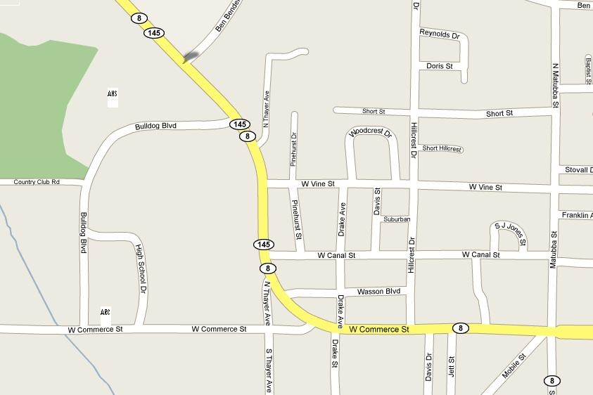

❒

❒

**Aberdeen Middle School & Aberdeen Elementary**

**Map of Location and Surrounding Streets**

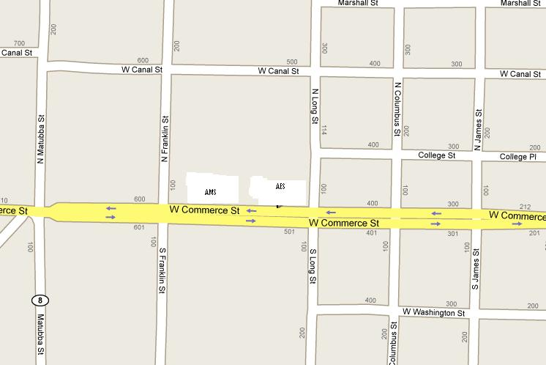

❒

❒

**Belle Elementary & Shivers Jr. High**

❒

❒

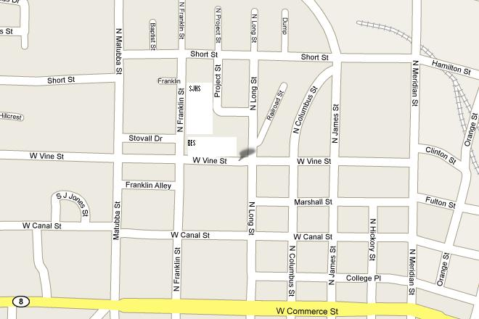

**Prairie Elementary**

❒

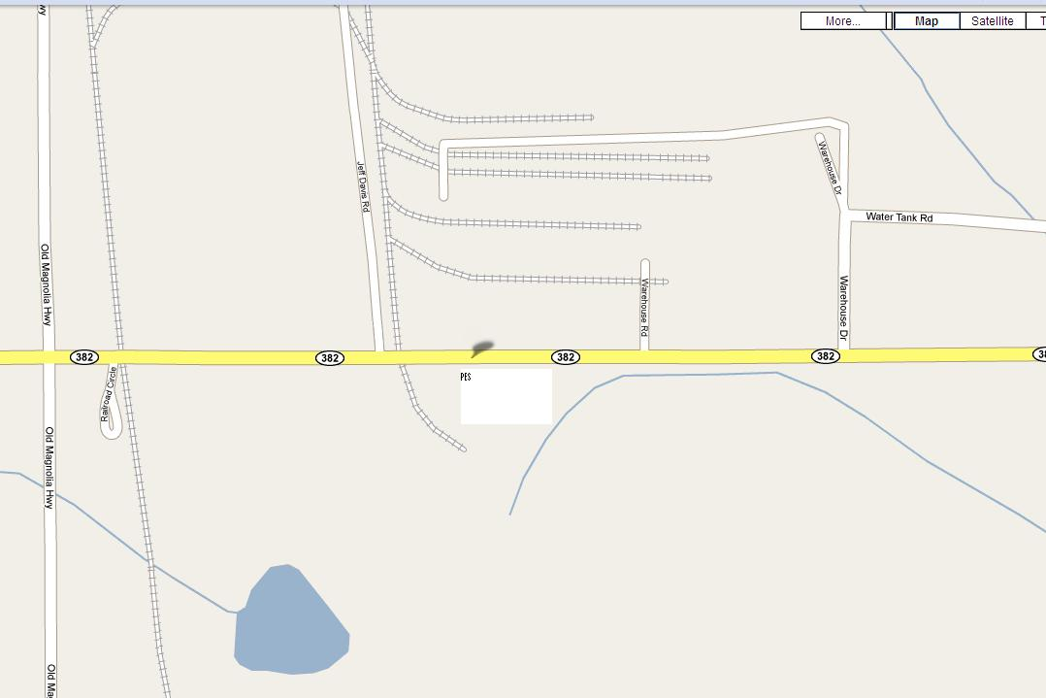

**Aberdeen Parent Center**

ALC

❒



**Aberdeen Elementary School Floor Plans**



**Belle Elementary School Floor Plans**

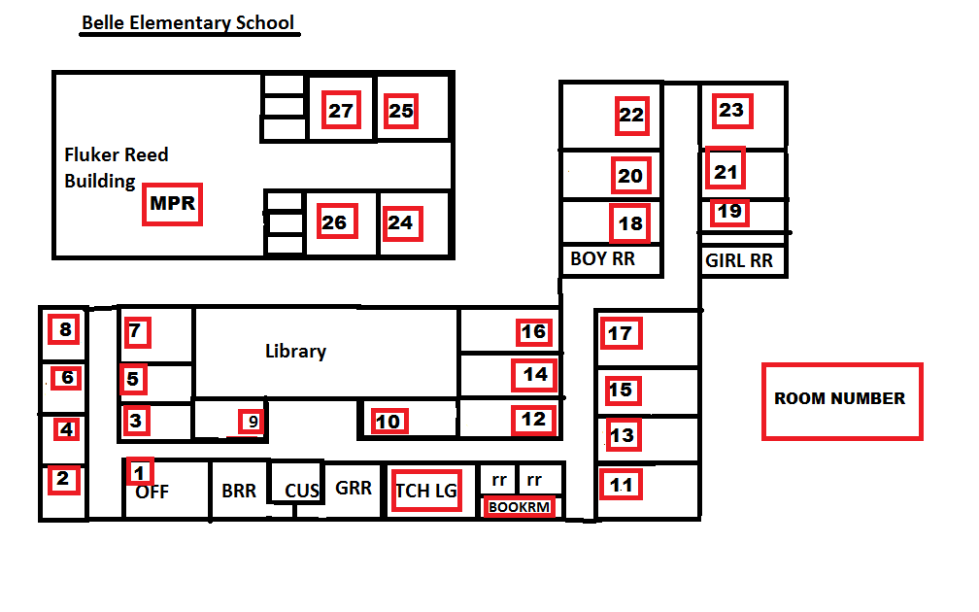

**Aberdeen Middle School Floor Plans (Vacant)**

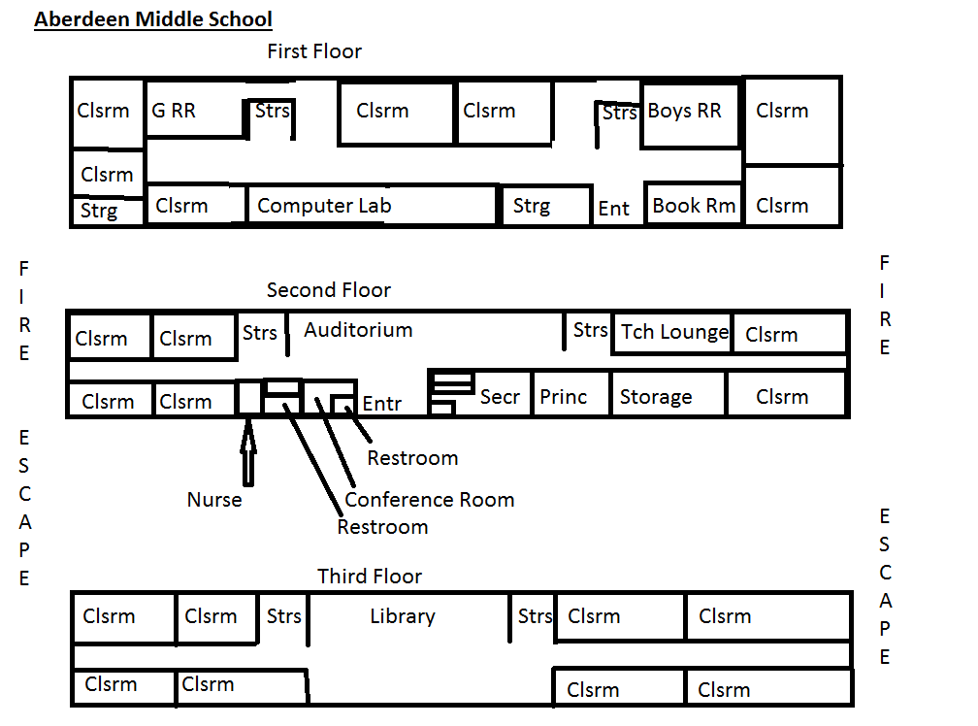

**Prairie Elementary School Floor Plans (Vacant)**

**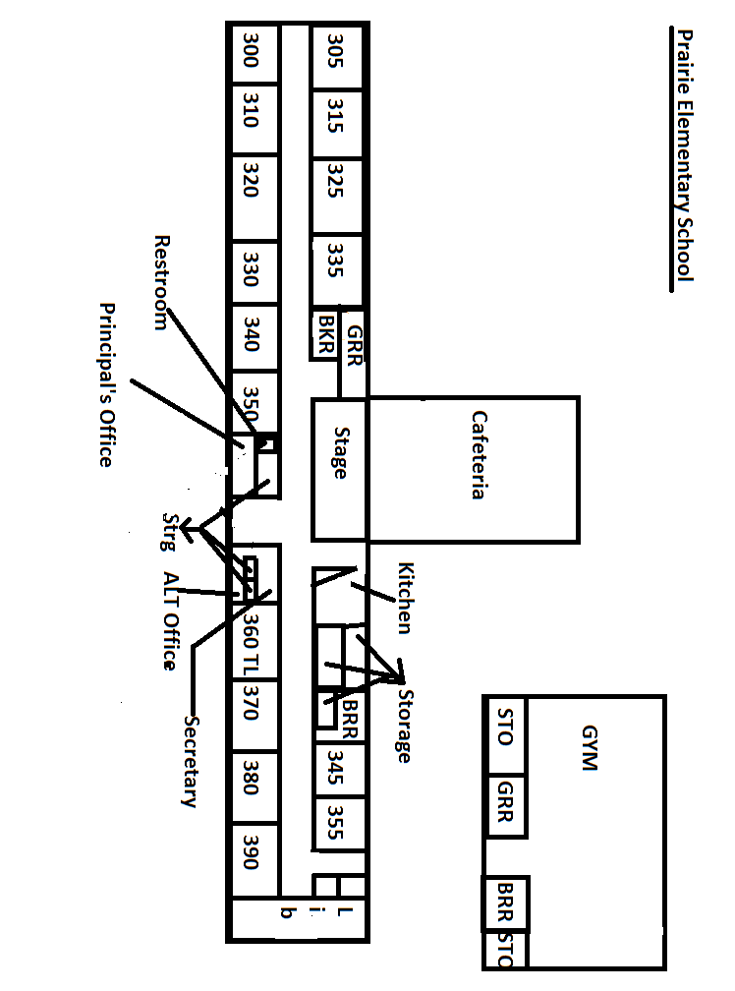****Shivers Middle School Floor Plans**

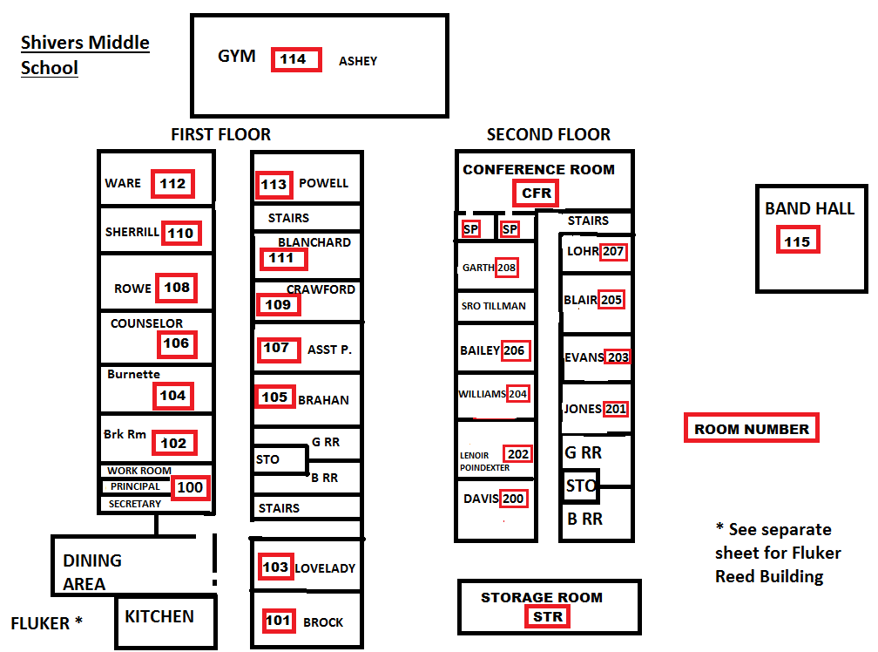**Aberdeen High School Floor Plans**

**Main, English Annex, Technology Annex**



**Aberdeen High School Gym Floor Plans**



**Aberdeen Learning Center Floor Plans**

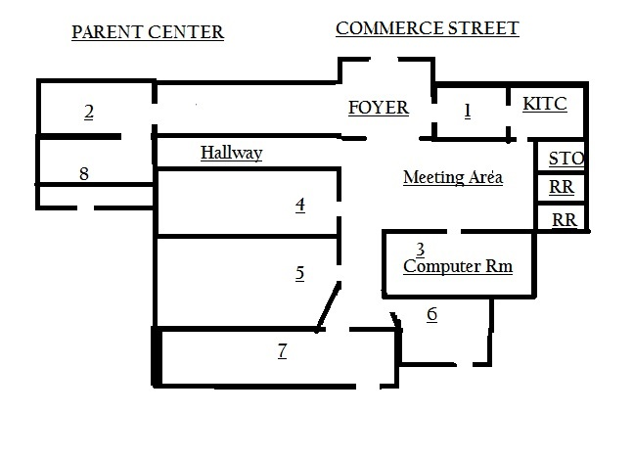

**ALTERNATE LOCATIONS**

**Below are alternate locations for schools in the event that students are relocated to another site. Buses will take student to the alternate site.**

**Plan A Alternate School Site**

|  |  |  |  |
| --- | --- | --- | --- |
| **Schools** | **Alternate School Site** | **Contact Person** | **Phone Number** |
| Aberdeen Elementary | Belle Elementary | Martha Jackson | 369-2649/436-9473 |
| Belle Elementary | Aberdeen Elementary | Lauren Fondren | 369-4782/251-2690 |
| Shivers Middle | Aberdeen Elementary Gym | Lauren Fondren | 369-6886/436-9493 |
| Aberdeen High | American Legion | Betty Kendrick | 369-4913 |

**Plan B Off Campus Site**

Relocation of students and staff will be determined by administrator and Conservator.

Announcement will be made to parents and media by Conservator.

|  |  |  |
| --- | --- | --- |
| **Alternate Location Site** | **Contact Person** | **Phone Number** |
| First Baptist Church | Judy Moore  Roger Wright | 369-9366 |
| First M.B. Church | Pastor Davis  Bernice Hodges | 369-1793/319-7905  369-6729 |
| Park & Recreation | Janet Parks  Fire Department  Jackie Benson | 369-9562  369-9552  369-8588 |
| High Street Comm. Center | Bobby Smith  James Young | 436-1040  436-0897 |
| Pilgrim Rest Church | Sanford Clay | 369-4906 |
| American Legion | Betty Kendrick | 369-4913 |
| National Guard Armory | Sgt. William Head | 369-2931 |
| Walker Union Hall | Willie Wilson | 256-7484 home  213-5442 cell  369-6604 building |

**Aberdeen School District**

Employee Review and Compliance Certification Form

Employee Name:________________ Employee Number_________

The Aberdeen School District Safety Plan consists three sections:

the School Occupational Safety Plan, the School Crisis Response Plan, and the School / Community Response Plan.

My signature below indicates that I have read and understand all three sections of the Aberdeen School District Safety Plan and that I agree to abide by this plan.

Employee Name _______________________ Employee Number _________

(Type or Print)

Employee Signature ______________________ Date of Signature __________

**INDEX**

|  |  |
| --- | --- |
| Abduction/Student Runaway | 102 |
| Accident Investigation | 22 |
| Accident Report Student | 27 |
| Accident Reports – Employees And Students | 22 |
| Accident/Serious Injury/Illness | 103 |
| After Hours Emergency Plan | 104 |
| AGENCY RESPONSIBILITY | 153 |
| Altercation: Violence Between Two or More Individuals | 105 |
| ALTERNATE LOCATIONS | 188 |
| AMBULANCE SERVICE | 158 |
| AMERICAN RED CROSS | 160 |
| APPENDIX A – Bomb Threat Call Procedure | 109 |
| Appendix I-A School Safety Assessment Instrument | 15 |
| appendix I-B Supervisors’ Accident Investigation Report | 23 |
| Appendix I-C Employee Accident Report | 26 |
| Appendix I-E MSDS Inventory | 41 |
| Appendix I-F | 45 |
| Appendix I-G | 67 |
| Appendix I-I Unsafe Work Practice Form | 71 |
| Assault of a Student | 106 |
| Assistant Principals (MS code 37-9-15) | 94 |
| Blood Borne Pathogens Exposure Control | 30 |
| Bomb Threat | 107 |
| Building Collapse | 111 |
| Building Evacuation Plan | 112 |
| Bus Accident | 114 |
| Bus Drivers | 95 |
| Cafeteria Safety Rules | 59 |
| Caring for Special Needs Students | 115 |
| Central Office Staff | 95 |
| Child Abuse/Neglect | 117 |
| Class List Generation | 95 |
| COMMAND CENTER | 98 |
| Command Post | 164 |
| Commercial Vehicle Drivers: | 63 |
| Communication | 98 |
| Communication Annex | 171 |
| Communication Chain of Command | 98 |
| CONCEPT OF OPERATIONS | 161 |
| Confrontation with Person in Possession of a Weapon | 119 |
| Conservator (Ms Code 37-9-14) | 10 |
| Construction/Renovation Safety | 62 |
| Contaminated Equipment | 32 |
| Coordinator of Public Relations | 96 |
| Counselors / Psychologist | 94 |
| Crime Scene Management | 100 |
| Crisis Site Student Release Form | 126 |
| Custodians/Maintenance | 94 |
| Death of a Student/Staff Member at School | 120 |
| Death of Student or Faculty Member Outside of School | 121 |
| Disciplinary Action | 59 |
| District Occupational Safety And Crisis Response Plan Committee | 9 |
| District Safety Director | 10 |
| Driver’s Inspection Form | 68 |
| Earthquake | 123 |
| Emergency Drill Forms | 75 |
| Emergency Drills | 73 |
| EMERGENCY MANAGEMENT | 159 |
| Emergency Management Director | 97 |
| Emergency Procedure: | 103 |
| Emergency Release List for Parents | 128 |
| Emergency Release of Students | 124 |
| EMERGENCY ROAD CLEARANCE PLAN | 163 |
| Emergency Team At Student Reunification Site | 125 |
| Employee Information, Education, And Training | 38 |
| Employee Orientation | 28 |
| Employee Review and Compliance Certification Form | 189 |
| Employees | 12 |
| Equipment Usage | 66 |
| Evacuation Location | 113 |
| Evacuation Off Site Locations | 113 |
| Explosion | 129 |
| Face And Eye Protection | 61 |
| Fallen Aircraft | 130 |
| FAMILY RELOCATION AREA (FRA) | 166 |
| Field Trips And Excursions | 77 |
| Fire | 131 |
| Fire Extinguisher List | 46 |
| Fire Extinguisher Map Aberdeen Elementary School | 47 |
| Fire Extinguisher Map Aberdeen High School | 51 |
| Fire Extinguisher Map Aberdeen High School Gym | 52 |
| Fire Extinguisher Map Aberdeen Resource Center | 53 |
| Fire Extinguisher Map Belle Elementary School | 48 |
| Fire Extinguisher Map Bus Shop / Maintenance Building | 57 |
| Fire Extinguisher Map Fluker Reed Building | 50 |
| Fire Extinguisher Map JOHN CURLEE Early Learning Center | 56 |
| Fire Extinguisher Map Parent Center | 54 |
| Fire Extinguisher Map Shivers Middle School | 49 |
| Fire Extinguisher Map THOMAS PIERCE Field House | 55 |
| Fire Response, Fire Safety, And Fire Prevention | 43 |
| First Aid | 28 |
| First Arriving Unit | 169 |
| First Responder Actions | 168 |
| Floor Plan Aberdeen Elementary School Floor Plans | 180 |
| Floor Plan Aberdeen High School Gym | 186 |
| Floor Plan Aberdeen High School Main, Eng Annex, Tech Annex | 185 |
| Floor Plan Aberdeen Learning Center Floor Plans | 187 |
| Floor Plan Aberdeen Middle School Floor Plans | 182 |
| Floor Plan Belle Elementary School Floor Plans | 181 |
| Floor Plan Prairie Elementary School Floor Plans | 183 |
| Floor Plan Shivers Junior High School Floor Plans | 184 |
| Food Equipment And Utensils | 60 |
| Food Protection | 60 |
| Food Services | 95 |
| Food Temperature Requirements | 60 |
| GENERAL CRISIS PROCEDURES | 97 |
| General Safety Rules | 58 |
| General School Building Safety Rules | 61 |
| Hazard Communication & Hazardous Materials Control | 36 |
| Hazard Communication Program | 42 |
| Hazardous Materials Incident | 132 |
| |  |  | | --- | --- | | Hazardous Materials Release Within The Facility |  | | 133 |
| Hostage | 137 |
| Hot Surfaces And Items And Energized Electrical Equipment | 62 |
| How to avoid contaminating crime scene evidence | 100 |
| INCIDENT COMMAND | 151 |
| Incident Command System | 99 |
| Incident Command System - District | 172 |
| Incident Command System - School | 173 |
| Individuals Requiring Special Assistance | 116 |
| Insect And Rodent Control | 60 |
| Inspection | 13 |
| Introduction | 5 |
| Introduction | 150 |
| Intruder | 138 |
| Intruder - Armed Intruder / Active Shooter | 133 |
| Kitchen Safety | 59 |
| Lifting And Material Movement | 62 |
| LOCAL FIRE DEPARTMENT | 156 |
| Lock Down Procedure | 136 |
| Material Safety Data Sheet (Msds) Inventory | 42 |
| Material Safety Data Sheet Inventory Form | 42 |
| MEDIA ASSEMBLY AREA (JOINT INFORMATION CENTER "JIC") | 166 |
| Media Staging Area | 140 |
| Medical Emergency | 141 |
| MENTAL HEALTH | 160 |
| Mission Statement | 7 |
| MISSISSIPPI HIGHWAY PATROL | 156 |
| Motor Vehicles And Mobile Equipment | 63 |
| MUTUAL AID POLICE DEPARTMENT | 157 |
| Natural Gas Emergency | 143 |
| Needles | 32 |
| Nuclear Warning Procedures | 143 |
| Occupational Safety And Crisis Response Plan Committee | 11 |
| Other Operations | 61 |
| Partnerships with Local Emergency Response | 84 |
| Penalties Of Unsafe Work Practices: | 70 |
| Phone Chain Emergency | 87 |
| Phone Numbers Area Agencies, Utilities, and Media | 89 |
| Phone Numbers Evacuation Off Site Locations | 113 |
| Phone Numbers First Responders | 88 |
| Phone Numbers MDE, Local Responders, Media, Federal | 142 |
| Phone Numbers Schools After Hour Contacts | 92 |
| Phone Numbers Staff | 86 |
| Phone Numbers Crisis Management Team | 82 |
| Preparing for Crises: Essential Activities | 82 |
| PRIMARY LAW ENFORCEMENT AGENCY | 155 |
| Principals (MS code 37-9-15) | 93 |
| Public Assembly Emergency Plan | 144 |
| Record Keeping | 14 |
| Regulated Waste Disposal | 34 |
| Report Any Unsafe Condition Immediately | 69 |
| Report Of Employee-Employer Interview | 72 |
| Required Training | 38 |
| Requirements For School Bus Drivers: | 64 |
| Resources: (I.E. Cpr, First Aid, Fire) | 29 |
| Responsibilities of Personnel During and After Emergency | 93 |
| Responsibilities Of School Personnel | 10 |
| ROAD BLOCKS AND TRAFFIC CONTROL | 167 |
| Safety Inspections | 14 |
| Safety Procedures | 13 |
| SALVATION ARMY | 160 |
| School Board Policy | 6 |
| School Nurse | 96 |
| School Safety Committee | 12 |
| Secretarial Staff | 95 |
| Section I Occupational Safety Plan | 8 |
| Section II School Crisis Response Plan | 79 |
| Section III School / Comminuty Response Plan | 148 |
| Security Director | 96 |
| Severe Weather | 145 |
| Severe Weather Plan | 58 |
| Site Administrator (Principal, Director, Supervisor, And/Or Manager) | 11 |
| SITE STATUS REPORT/MISSING/INJURY REPORT | 127 |
| Street Location Aberdeen High School | 175 |
| Street Location Aberdeen Middle School & Aberdeen Elementary | 176 |
| Street Location Aberdeen Parent Center | 179 |
| Street Location Belle Elementary & Shivers Jr. High | 177 |
| Street Location Prairie Elementary | 178 |
| Student Vehicles on Campus | 167 |
| Supervisor’s Accident Investigation Report (Continued) | 24 |
| Teachers | 94 |
| Toilet And Handwashing Facilities | 60 |
| Training | 28 |
| Unified Command and Media Release | 169 |
| Visitors in the Schools | 146 |
| Working with the media | 139 |
|  |  |
|  |  |
|  |  |