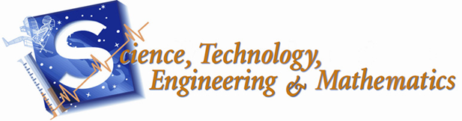

Overview

There are many challenging educational and training opportunities within the high-skilled world of Science, Technology, Engineering and Mathematics. There are two pathways - Engineering and Technology, and Science and Mathematics. Learners need a solid background in math, science and technical skills. Education and training can be obtained in high schools, technical colleges/institutes and universities.

A career in science, technology, engineering or mathematics is exciting, challenging, and ever-changing. Learners who pursue one of these fields will be involved in planning, managing, and providing scientific research and professional and technical services including laboratory and testing services, and research and development services.

Employment Outlook

Given the critical nature of much of the work in science, technology, engineering and mathematics, job possibilities abound even in times of economic downturn. More scientists, technologists and engineers will be needed to meet environmental regulations and to develop methods of cleaning up existing hazards. A shift in emphasis toward preventing problems rather than controlling those that already exist, as well as increasing public health concerns, also will spur demand for these positions. Median annual wages for these occupations range from $38,310 for social science research assistants to $132,320 for petroleum engineers.

Related Occupations, Majors and Plan of Study

For much more detailed information on occupations, majors and plan of study, log in to Naviance, click the ‘Careers’ tab, then ‘Explore Clusters and Pathways’, then choose your cluster! It is very interactive - you are able to work within a cluster and explore pathways, occupations within that pathway, as well as wages, related majors and SO MUCH MORE.

For GNHS Graduation Requirements, please click HERE.

GNHS Specific Information

Career Cluster
PATHWAY COURSES | ELECTIVE COURSES
- Graduation Requirements | - Physics (AP I, AP II, AP C)
- Biology (Honors) | - Earth Science (Dual Credit)*
- Chemistry (Honors/ AP) | - AP Statistics
- Math Analysis | - AP Computer Science
- Calculus (AP BC, AP AB) | - Career Education and Work Experiences
- Computer Programming | - Current Issues
- Introduction to Engineering and Design* | - World Languages
- Principles of Engineering*
- Civil Engineering and Architecture
- Engineering Design and Development*
*These courses have a Dual Credit option meaning it can give you High School credit for graduation and College credit at the College of Lake County.We encourage you to take at least one dual credit course in your schedule next year.

Career Related Clubs and Activities
- Science Olympiad
- Math Club
- Robotics
- Athletics or Music Related Activities
- National Technical Honor Society

