Parents/Guardians have the ability to report their student’s absences(s) on the actual day of their student’s absence or any future absences up to 30 days in advance which includes weekends and holidays in ParentVue. This does not work for past absences--You will have to call or send a note for those.

Submitting Absences using the ParentVUE Website

- Click on Report Absences under Attendance to open the Report Absences screen or from the home Screen, click on Report Absences next to the student.

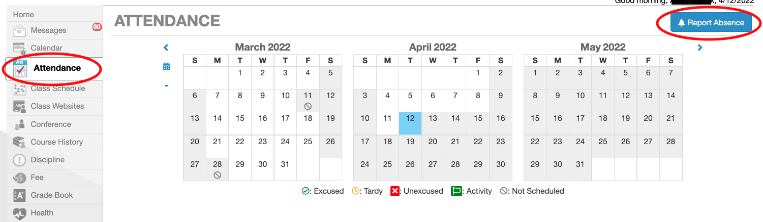

- Complete the required information: Start Date, End Date, Select a Reason, and then enter information into the Note field. For partial day absences, be very specific on drop off or pick up times.

