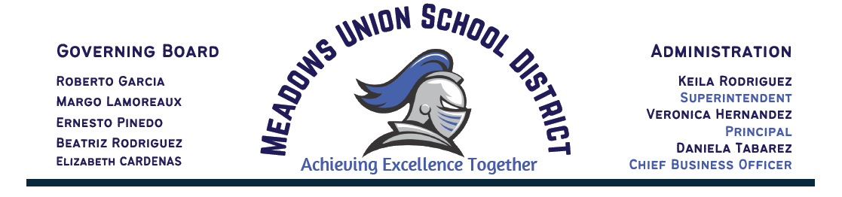

BOARD MEETING AGENDA
MEADOWS UNION SCHOOL BOARD OF TRUSTEES
April 13th, 2022
Via Zoom Teleconference
5:30pm Open Session
Pursuant to Governor Newsom’s Executive Order N-29-20, this Regular Meeting of the Meadows Union School Board shall be held by teleconference. Trustees of the Meadows Union School Board and the public shall participate in this meeting via teleconference. The Public may participate in this meeting by dialing 1 (669) 900 --6833 or accessing the following link: https://us02web.zoom.us/j/88314279925 Meeting ID: 883 1427 9925Public comments may be submitted by email as described below.
From time-to-time writings that are public records, which are related to open session items on an agenda for a regular meeting, may be distributed to school board members after the posting of the agenda. Whenever this occurs, such writings will be available for public inspection in the Office of the Superintendent located at 2059 Bowker Road, El Centro, CA, 92243.
Individuals who require special accommodation, including but not limited to accessible seating or documentation in accessible formats, should contact the Superintendent or designee at least two days before the meeting date at (760) 352-7512. (Government Code Section 54954.2).

- INTRODUCTORY PROCEDURES
Call to Order Flag Salute Roll Call
Present Absent
Margo Lamoreaux, President ______ ______
Ernesto Pinedo, Vice-President
Beatriz Rodriguez, Clerk
Robert Garcia, Member
Elizabeth Cardenas, Member

- ADOPTION OF THE AGENDA WITH MODIFICATIONS TO THE OPEN AND/OR CLOSED SESSION AGENDA, IF ANY
Roll Call Vote: Pinedo Lamoreaux_____Cardenas_____Garcia_____ Rodriguez

- PUBLIC HEARING OF DELEGATIONS AND/OR COMMENTS FROM THE AUDIENCE
This is an opportunity for members of the Public to address the Board on items appearing on this agenda or on other items under the Board's jurisdiction. For this meeting, comments may also be submitted in writing, at least three hours in advance of the meeting to: dtabarez@musdk8.net or delivered to 2059 Bowker Rd., El Centro, CA 92243. Members of the public attending virtually will have the opportunity to provide live public comment via zoom.

- BOARD COMMUNICATION

- STAFF COMMUNICATION

- CONSENT AGENDA ITEM
All items appearing will be acted upon by one motion. Should any Trustee or other person request that any item(s) be considered separately or pulled from the Consent calendar that item will be added to the end of the agenda.

Roll Call Vote: Rodriguez _____Lamoreaux _____Pinedo _____Garcia _____Cardenas_____

  - Approval of the Minutes: March 9th, 2022
Attachment: Board Minutes

  - Approval of payroll statement(s) in the amount of $488,927.10 (Reg)
Attachment: Payroll Statements

  - Approval of expenditure statement(s) in the amount of $338,794.96
Attachment: Check Register

- INFORMATIONAL ITEMS
  - MANA 8th grade Scholarship
  - MESA Program
  - Migrant Program
  - ASES Drill Team
  - Presentation TK Grant Application
  - Progress Monitoring
  - Superintendent Report

8. DISCUSSION/ACTION ITEMS

- Approval of Kinder & TK Grant Resolution - Mrs. Rodriguez
Attachment: Resolution 041322-01 & 041322-02
Roll Call Vote: Lamoreaux _____Cardenas _____Pinedo _____Rodriguez _____Garcia____

- Approval of the following one-time Coach Stipends-Mrs. Rodriguez
- Andrea Aguilar - Basketball Team B - $800 Stipend
- Johara Rodriguez - Basketball Team A - $800 Stipend
- Thomas Beeson - Football - $800 Stipend

Roll Call Vote: Lamoreaux _____Cardenas _____Pinedo _____Rodriguez _____Garcia____

- Approval of the updated MUTA MOU for split class- Mrs. Rodriguez
Attachment: Updated MUTA/MUSD MOU

Roll Call Vote: Lamoreaux _____Cardenas _____Pinedo _____Rodriguez _____Garcia____

- Approval of Declaration of Need for Fully Qualified Educators -Mrs. Rodriguez
Attachment: Declaration of Need for Fully Qualified Educators
Roll Call Vote: Rolfe____Garcia____Rodriguez____Pinedo____Lamoreaux___

- Approval of GASB Valuation Contract-Mrs. Rodriguez
Attachment: GASB Valuation Contract
Roll Call Vote: Lamoreaux _____Cardenas _____Pinedo _____Rodriguez _____Garcia____

- Approval of ICOE MOU for NGSS Time Toolkit-Mrs. Rodriguez
Attachment: ICOE MOU
Roll Call Vote: Lamoreaux _____Cardenas _____Pinedo _____Rodriguez _____Garcia____

- Approval of hiring Sandra Vasquez for Administrative Assistant to the Superintendent- Range 100/ Step 3- Pending Background Clearance- Mrs. Rodriguez

Roll Call Vote: Lamoreaux _____Cardenas _____Pinedo _____Rodriguez _____Garcia____

- Approval of hiring Stephanie Valadez for HR/Payroll Tech- 4hr- Range 100/Step2-Mrs. Rodriguez

Roll Call Vote: Lamoreaux _____Cardenas _____Pinedo _____Rodriguez _____Garcia____

- Approval of Williams Quarter 3-Mrs. Rodriguez
Attachment: Williams QT 3
Roll Call Vote: Rolfe____Garcia____Rodriguez____Pinedo____Lamoreaux___

- Approval of Auditor Selection-Mrs. Rodriguez
Attachment: Auditor Selection
Roll Call Vote: Rolfe____Garcia____Rodriguez____Pinedo____Lamoreaux___

- Approval of Resolution #041322-01 Resolution for Continuing Virtual Meetings for May 2022 Board Meetings-Mrs. Rodriguez
Attachment: Attachment: #041322-01
Roll Call Vote: Lamoreaux _____Cardenas _____Pinedo _____Rodriguez _____Garcia____

- Approval of CalSCHLS MOU for School Climate Health & Learning-Mrs. Rodriguez
Attachment: Attachment: CalSCHLS MOU
Roll Call Vote: Lamoreaux _____Cardenas _____Pinedo _____Rodriguez _____Garcia____

- ITEMS PULLED FOR DISCUSSION

- CLOSED SESSION Time: _________

- RECONVENE TO OPEN SESSION Time: _________

- ADVANCED PLANNING

Next Meeting:
- May 11th,2022 @ 5:30pm
- ADJOURNMENT

