Marion County schools  Summer Sole registation  March 3 – april 21  Marion County Schools is happy to announce our 3rd Summer SOLE Program, with opportunities for Learning & Engagement for students in grades K through 8 for school year 2022-2023.  4 Credit Recovery Locations at each High School and Barnes ALC  (Registration for Credit Recovery is conducted at each location)  Transportation and Meals will be provided.  To register your child please use the link or the QR Code below:  https://forms.office.com/r/PxfqdNHLVh  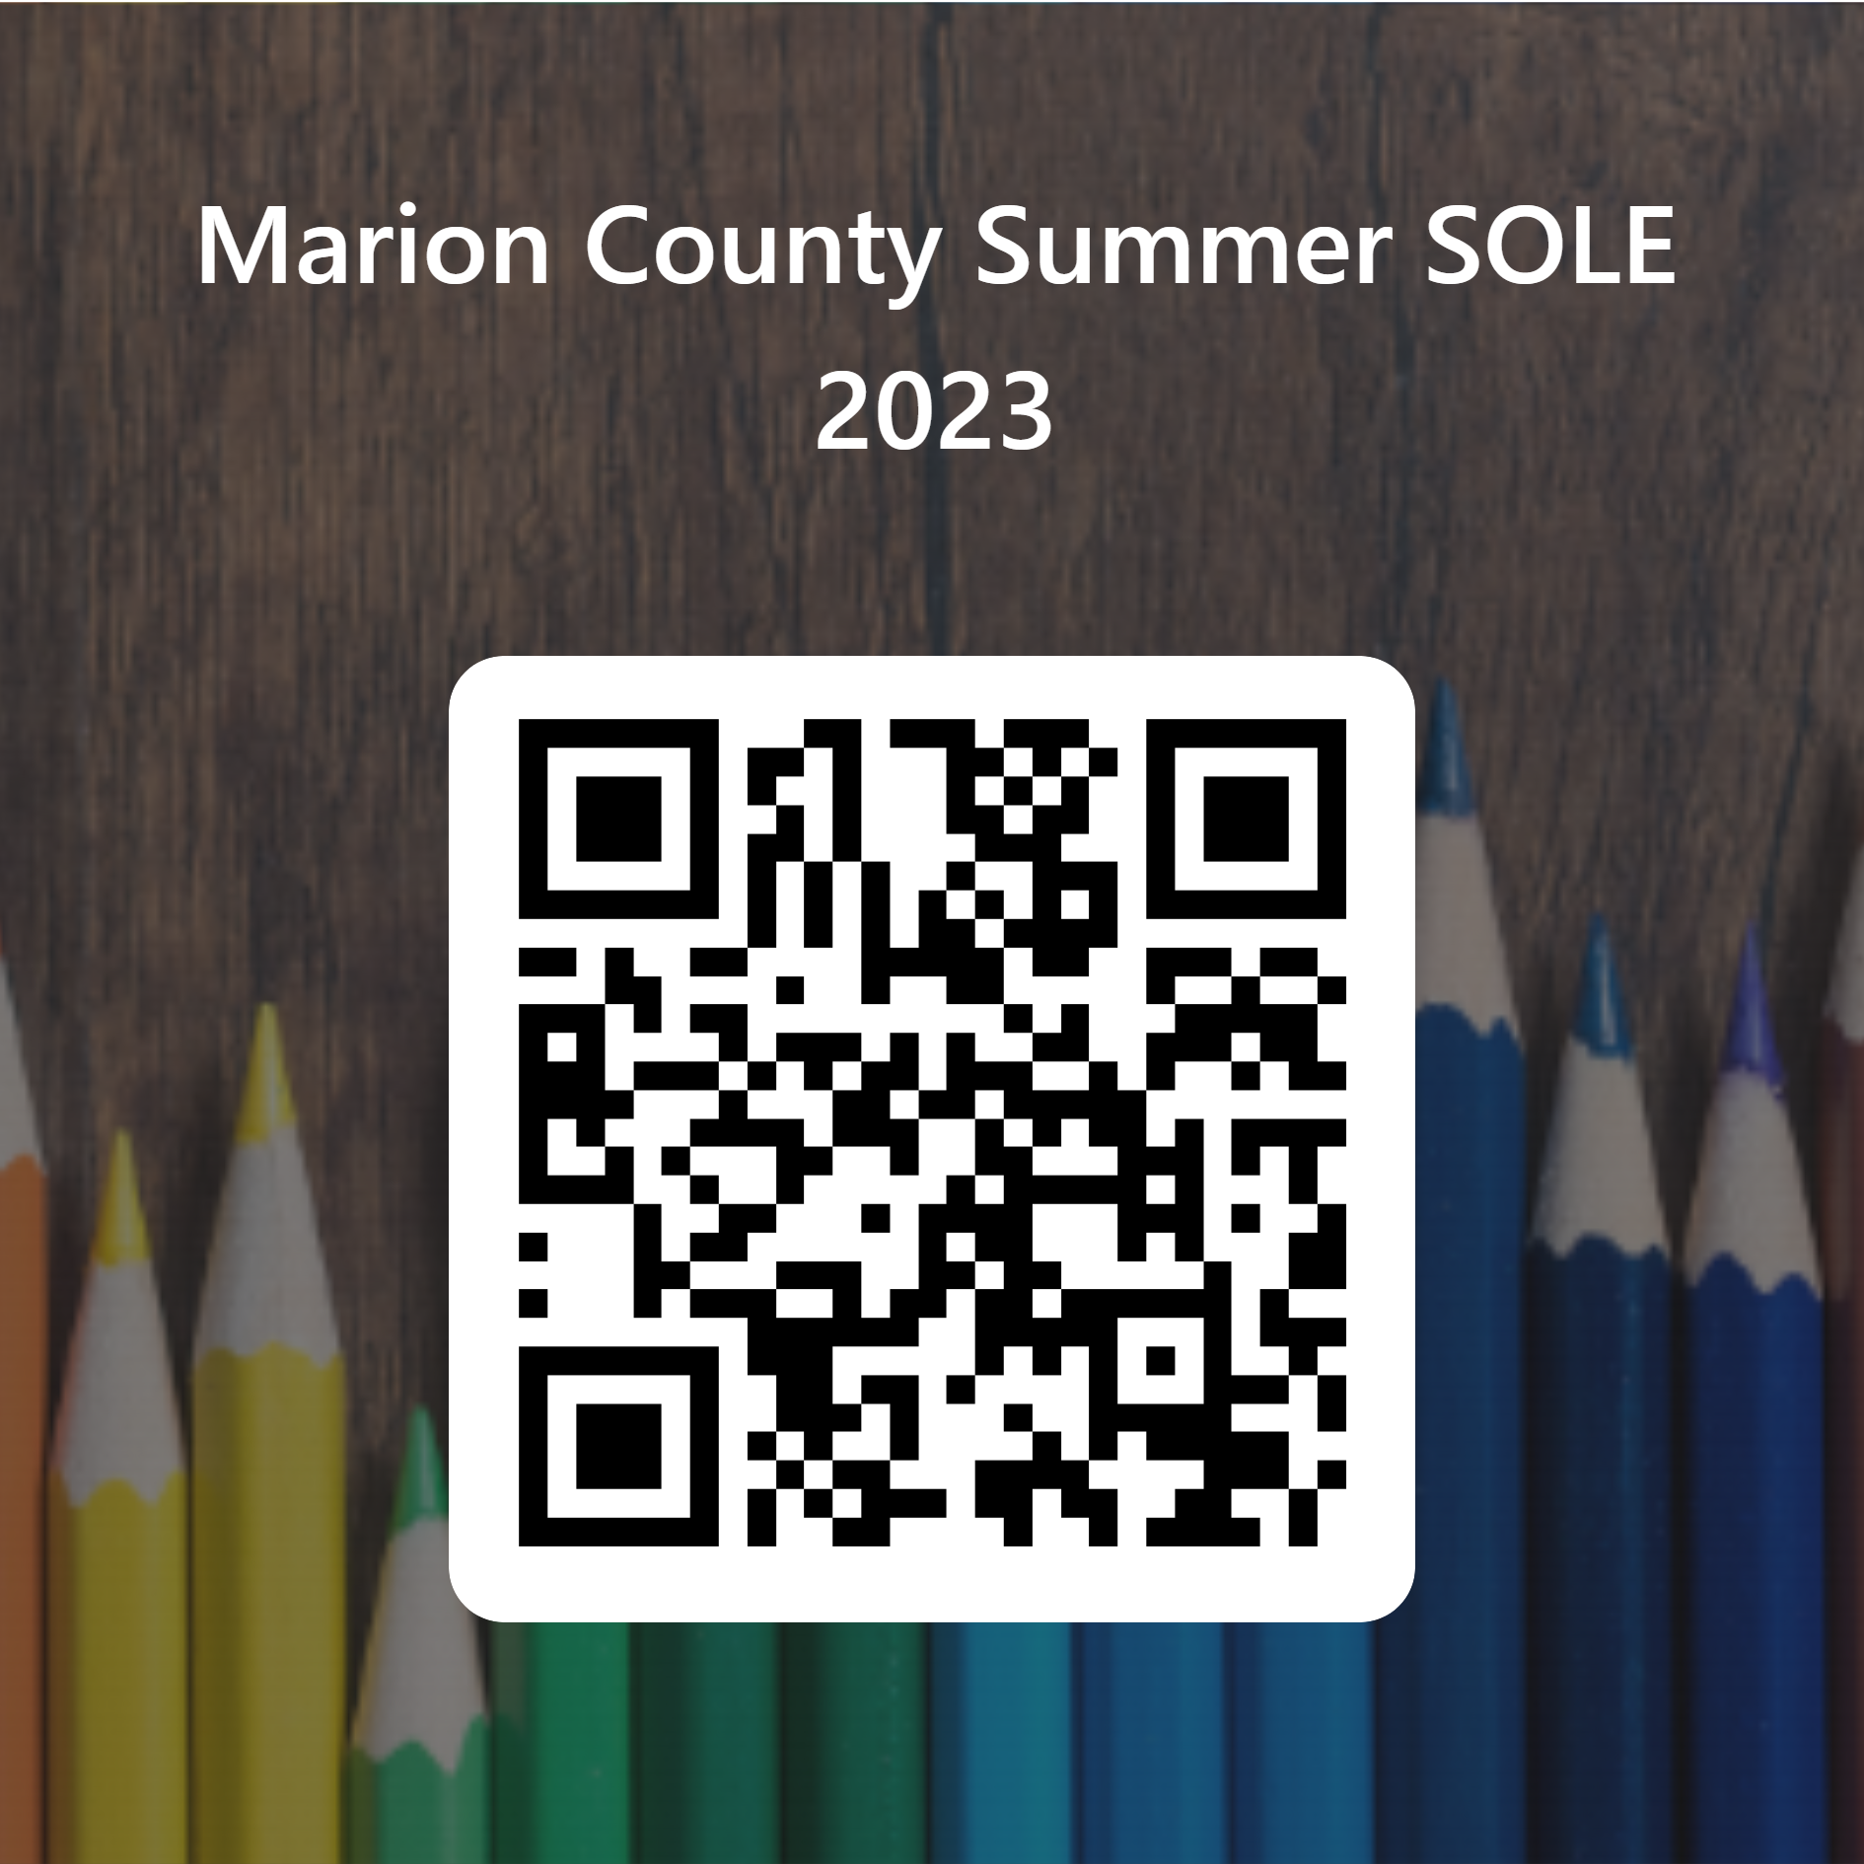  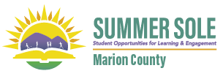 | Program Dates: June 15 – July 12  8:00 -2:30  ────  Elementary Locations:  Barrackville  Blackshere  East Park  (Students that attend East Park & East Dale)  Fairview Elementary (students that attend 4th grade at Fairview Middle)  Jayenne  Monongah Elementary  Pleasant Valley  Rivesville  Watson  White Hall  ────  Middle School Locations:  West Fairmont Middle School (for all WFMS and EFMS students)  Monongah Middle School (for all NM area MS students)  ────
For more information, please call the Marion County Board of Education at 304 -367-2100

