Minutes of the Northampton County School Board –Work Session Meeting held on Thursday, August 25, 2022 – 5:30 pm located at Central Office Administration Bldg., located at 7207 Young Street, Machipongo, Virginia 23405.
Present: Ms. Charlena Jones, Board Chairperson
Ms. Liz Jones, Board Vice-Chairperson
Ms. Jill Bieri, Board Member
Ms. Helene Doughty, Board Member
Ms. Betty Borden, Board Member
Dr. Jaime Cole, Superintendent of Schools
Ms. Karen Pitt, Board Clerk

Absent: Mr. William Oakley, Board Member
Ms. Jo Ann Molera, Board Member

The board chair, Ms. Charlena Jones called the meeting to order.

Ms. Charlena Jones then asked for a motion to convene a closed session meeting. Motion by Ms. Doughty. Seconded by Ms. Bieri. Without objection, the board convened a closed session.

Reconvene Open Session

The board chair asked for a motion to reconvene an open session meeting. Motion by Ms. Liz Jones to come out of the closed session meeting and re-enter an open session meeting. Seconded by Ms. Bieri. Without objection, the board reconvened the open session meeting.

Certification of Closed Session

The board chair read the following statement:

"Whereas, the Northampton County School Board has convened a closed meeting on this date pursuant to an affirmative recorded vote and in accordance with the provisions of the Virginia Freedom of Information Act; and

Whereas, Section 2.2-3712 of The Code of Virginia, 1950, as amended, requires certification by this School Board that such closed meeting was conducted in conformity with Virginia law;

Now, therefore, be it resolved, that the Northampton County School Board hereby certifies that, to the best of each member's knowledge, (i) only public business matters lawfully exempted from open meeting requirements by Virginia law were discussed in the closed meeting to which this certification applies, and (ii) only such public business matters as were identified in the motion convening the closed meeting were heard, discussed, or considered."

Roll call vote:

Ms. Doughty voted yes.
Ms. Liz Jones voted yes.
Ms. Borden voted yes.
Ms. Bieri voted yes.
Ms. Charlena Jones voted yes.

The motion was carried.

The board chair asked all guests who would like to speak during the public comment section of the meeting to sign up on the sign-in sheet provided.

A roll call was taken of board members present by the board clerk.

Opening Exercises and Pledge of Allegiance

The Pledge of Allegiance and Moment of Silence will be led by Dr. Cole.

Presentations

Introduction of Special Programs Director

Dr. Cole introduced Ms. Alana Walmsley, Special Programs Director, and asked Ms. Walmsley to come forth and address the board by sharing a few words about herself. Ms. Walmsley first thanked the board for the opportunity to work with the district and briefly shared information about her background.

Monthly Celebrations

Dr. Cole said too often we hear negative things from the media first and so she would like to have a monthly celebration update to share successes throughout the district with the board.

Dr. Cole then shared a slide presentation of photos taken during the Kagan training for pre-K through 6th-grade teachers and shared what the professional development training was all about. Afterward, Dr. Cole showed a live video of teachers interacting with one another to demonstrate how to get students to work together. Dr. Cole ended by saying this is what they plan to do every month and that it is also in alignment with the strategic plan.

Board chair, Charlena Jones shared that this week VSBA sent a notification out about preparing to go back to school where hatch tags were shown which Ms. Jones said would be good to share on our website as we prepare to return to school.

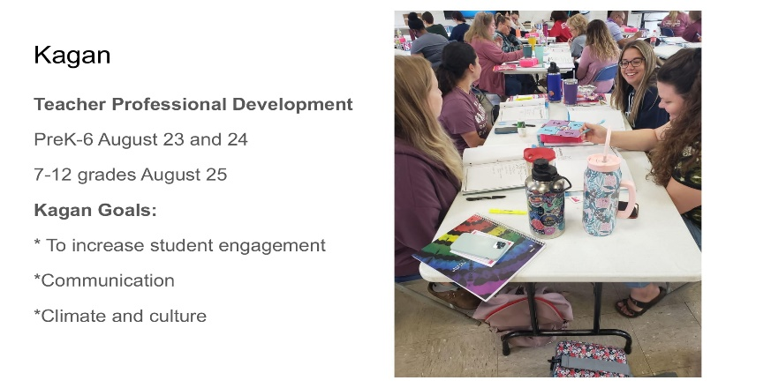
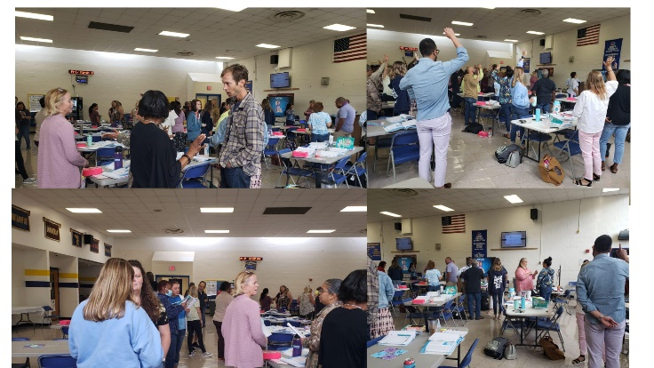

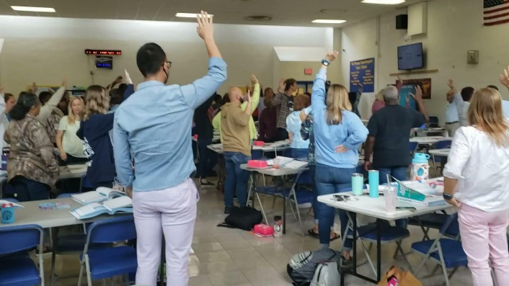

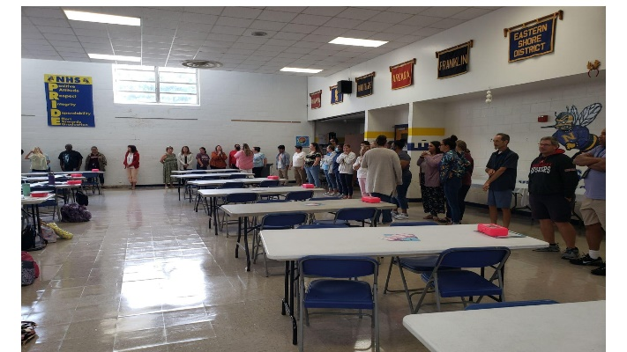

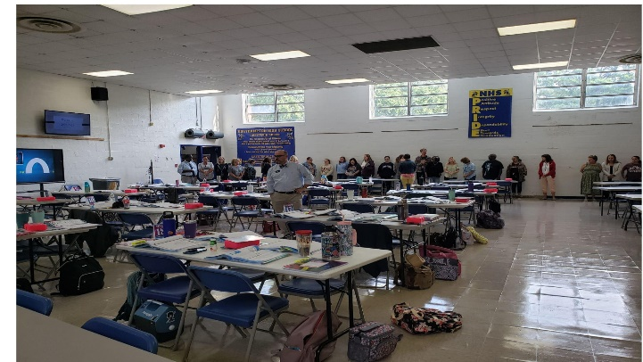

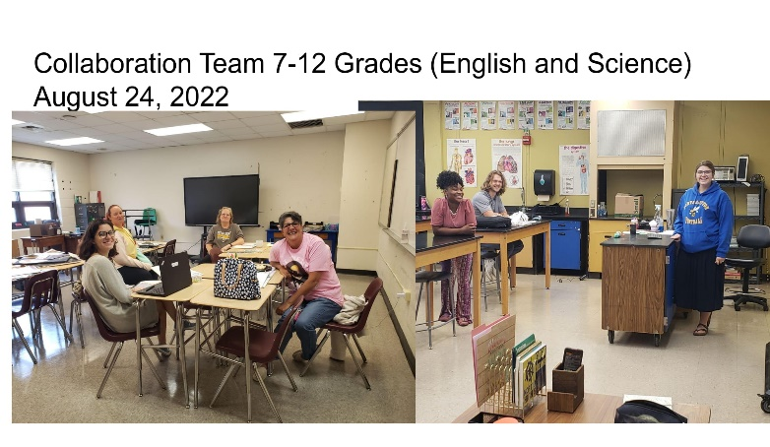
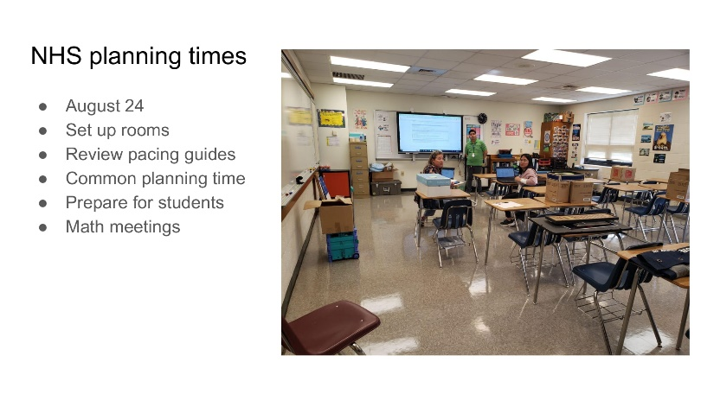

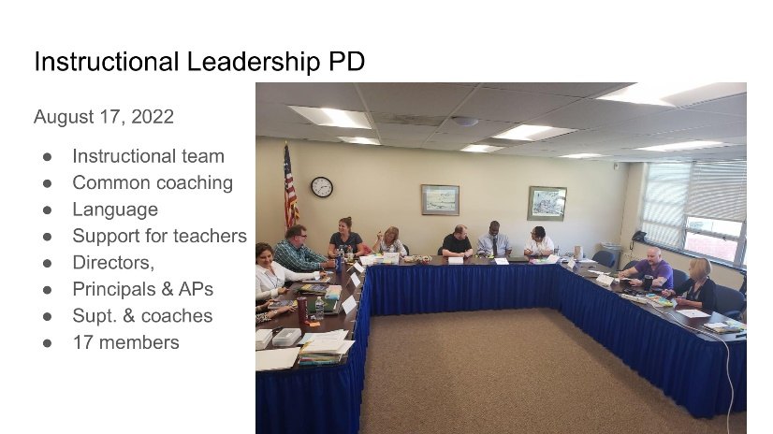

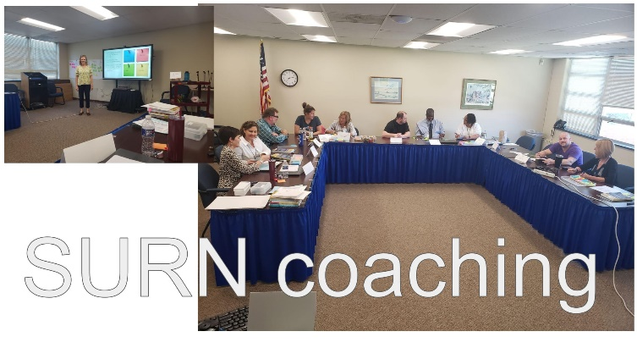
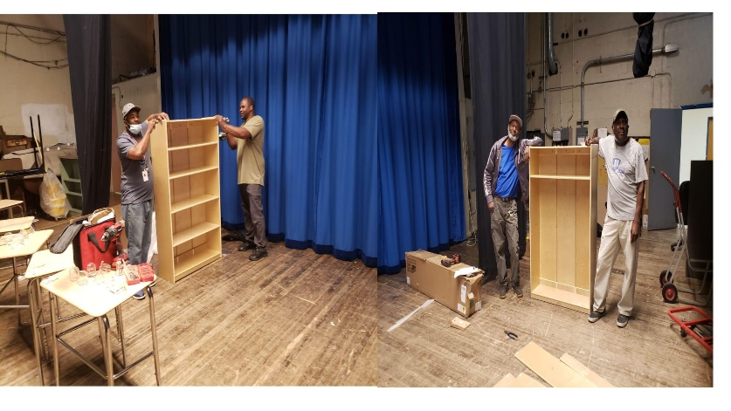
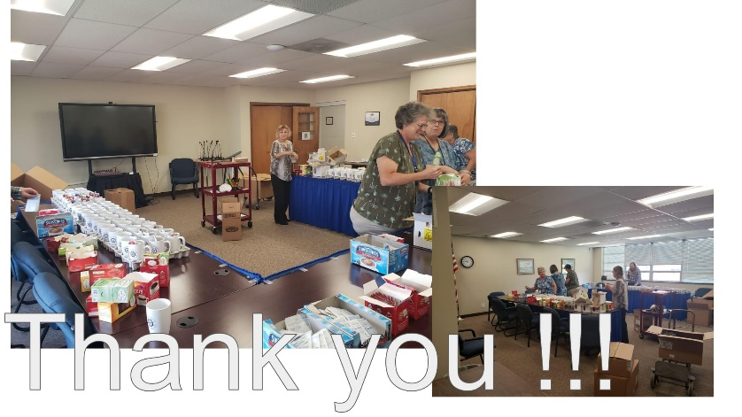

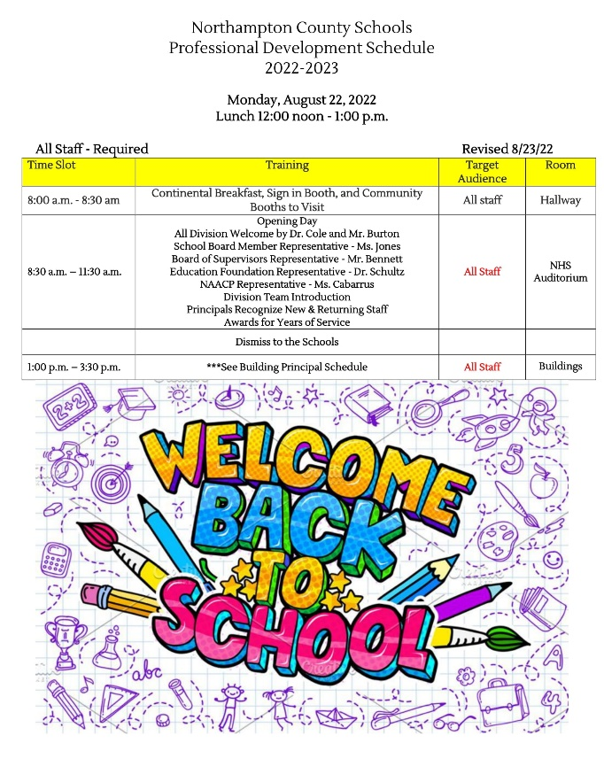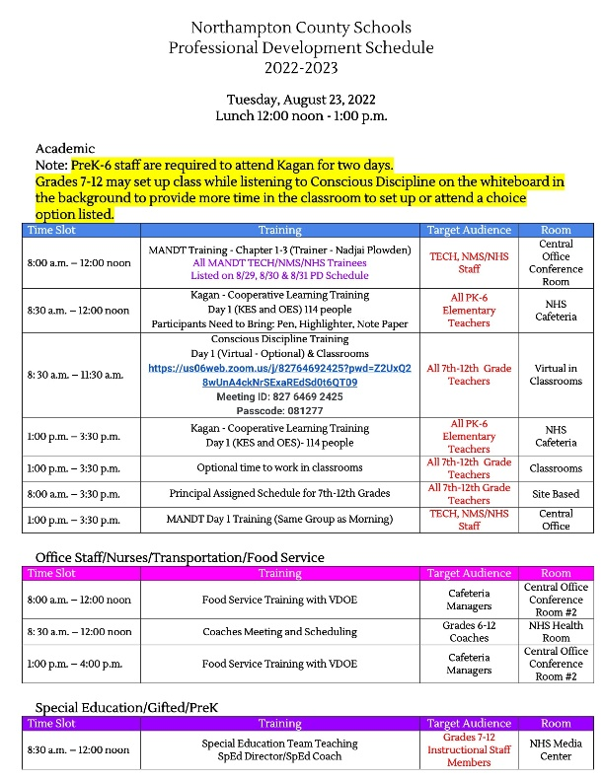

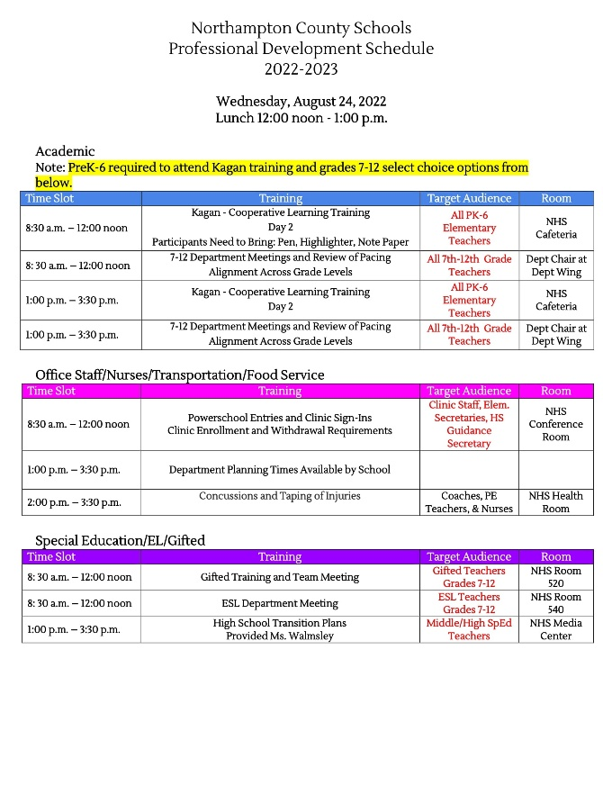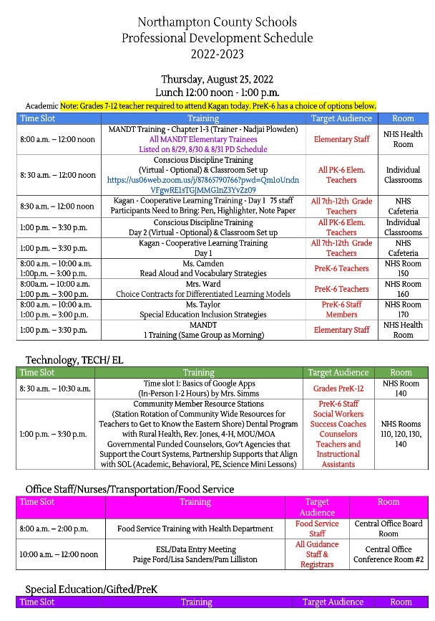

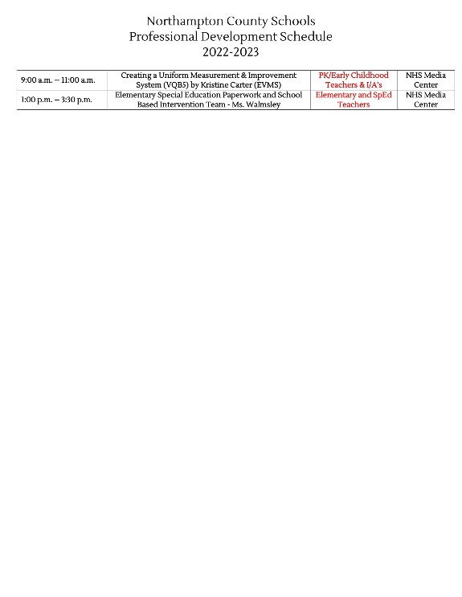
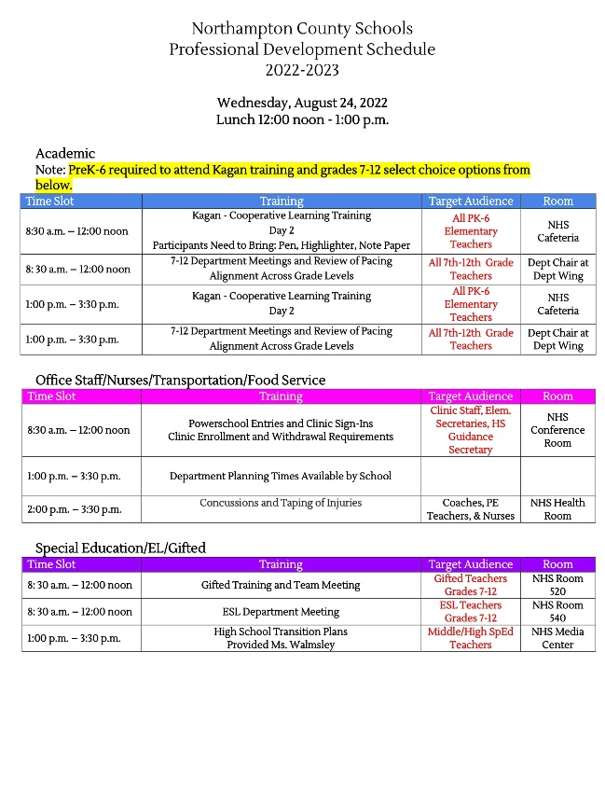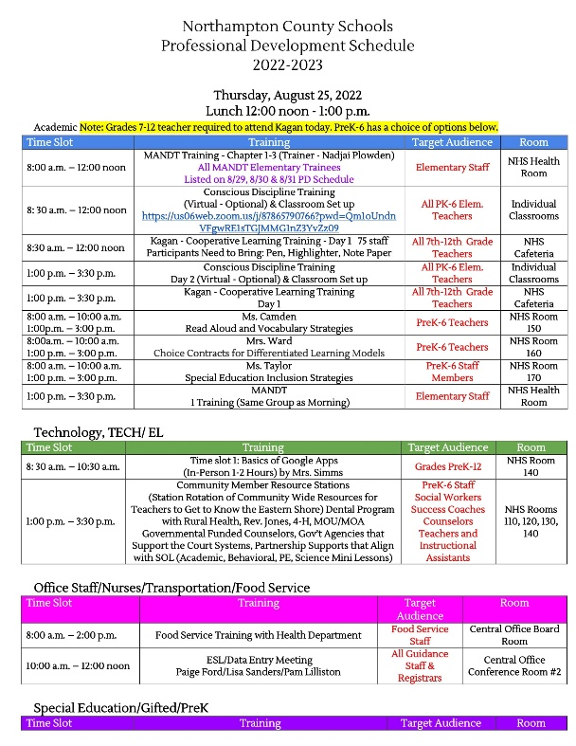

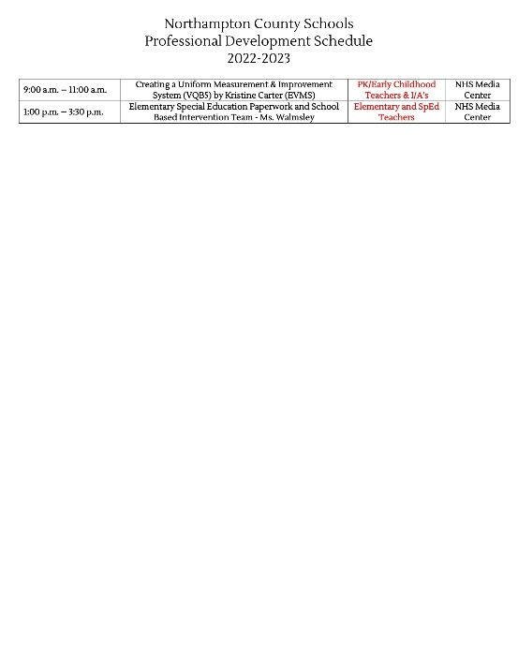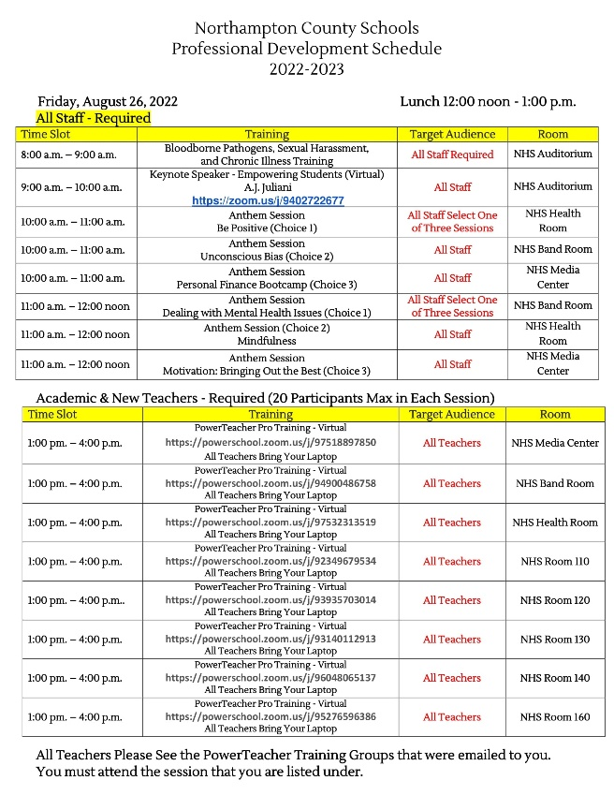

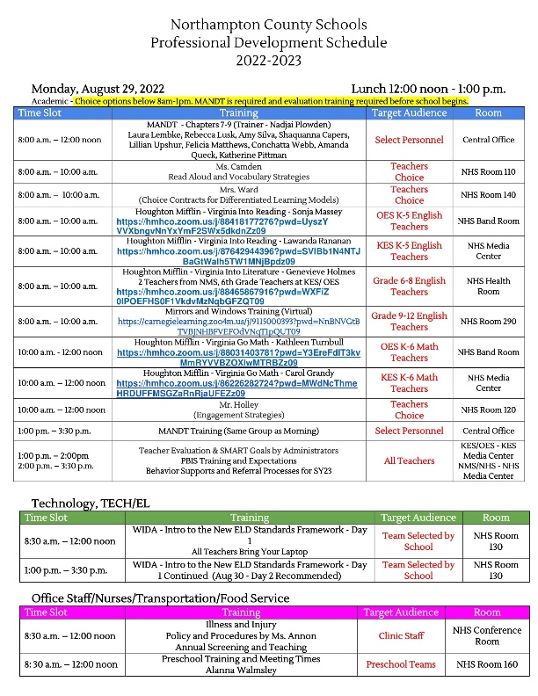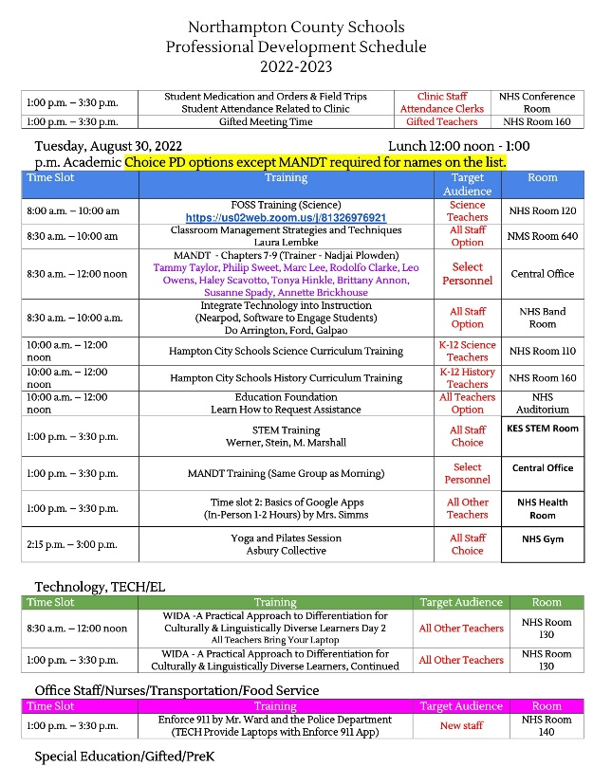

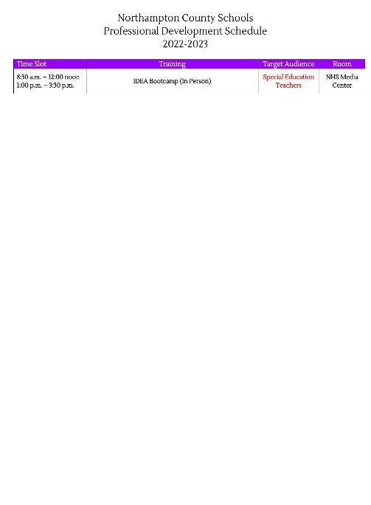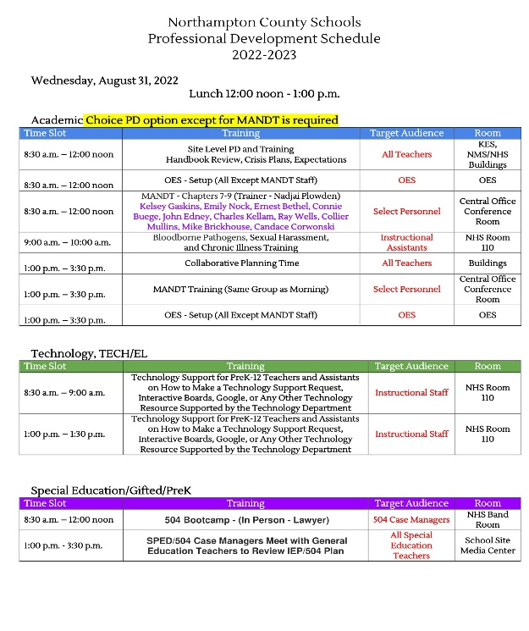

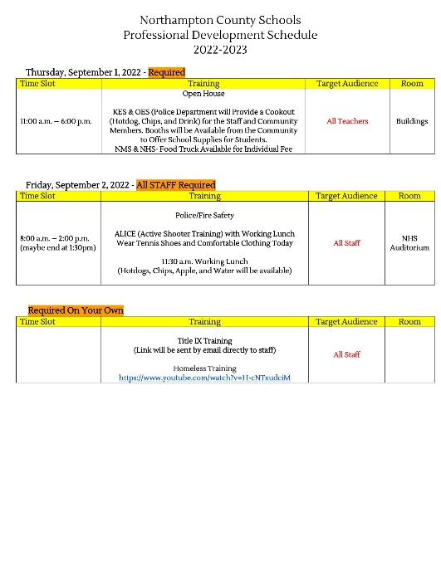

New Teachers Orientation Week Presentation

Ms. Robin Ward, New Teacher Coordinator gave a presentation on the activities of the new teachers that were held during the new teacher’s orientation week.

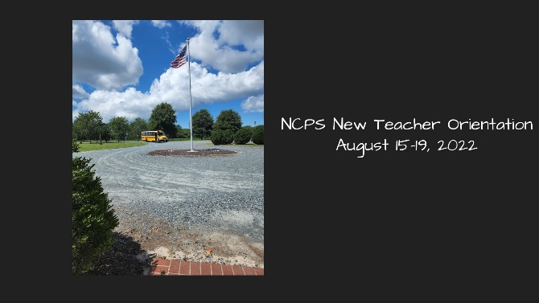

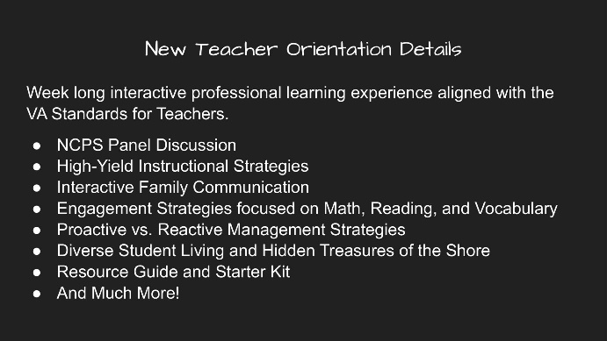

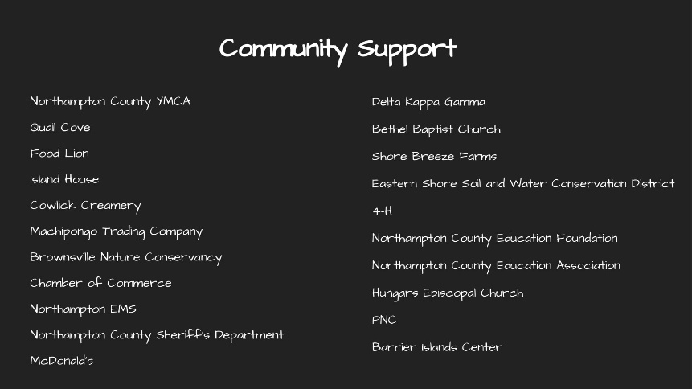

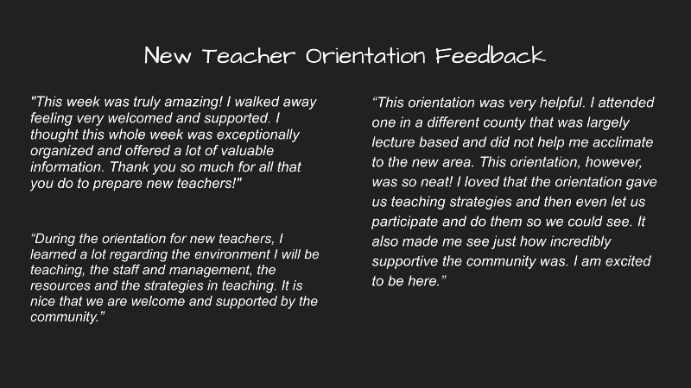

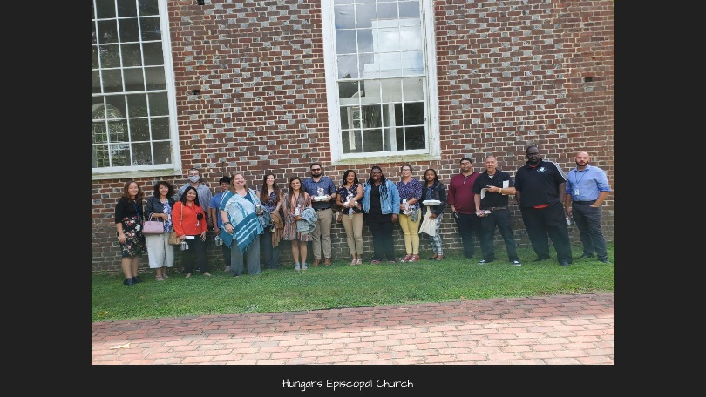

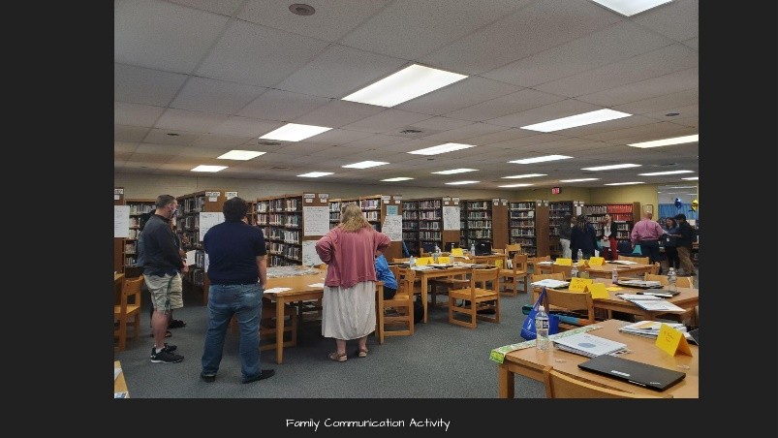

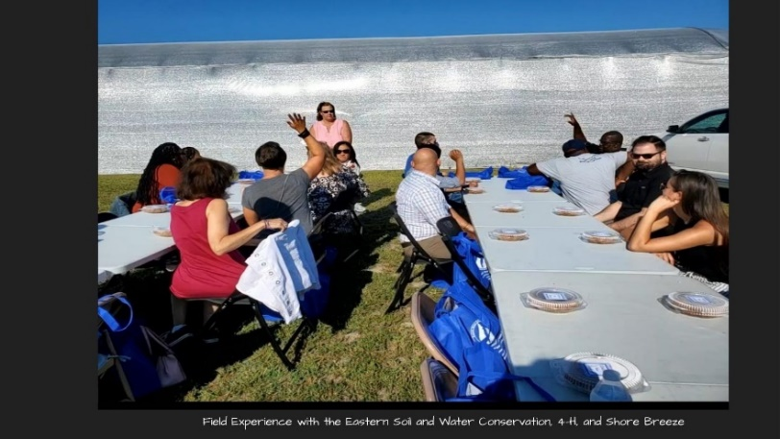

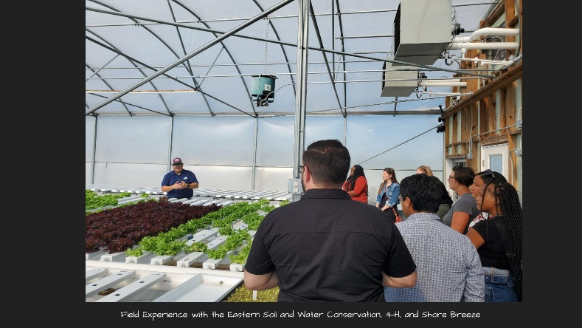

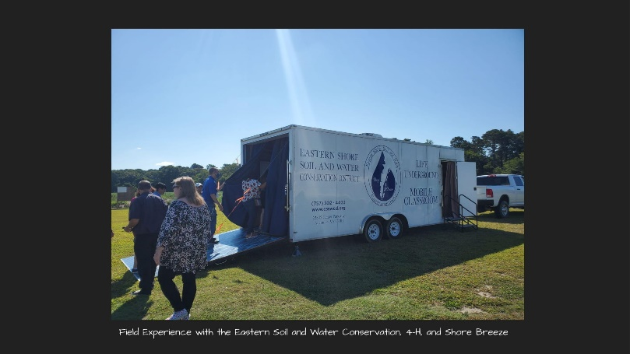

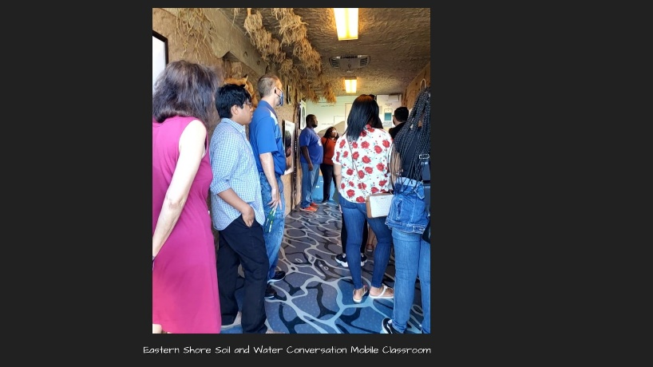

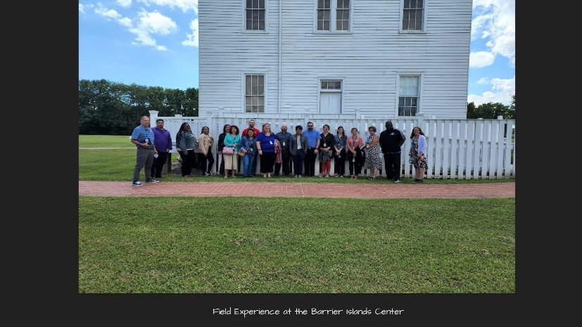

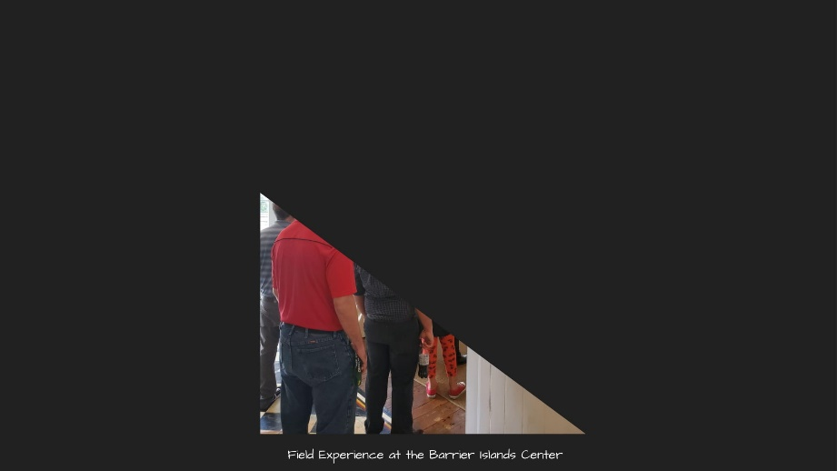

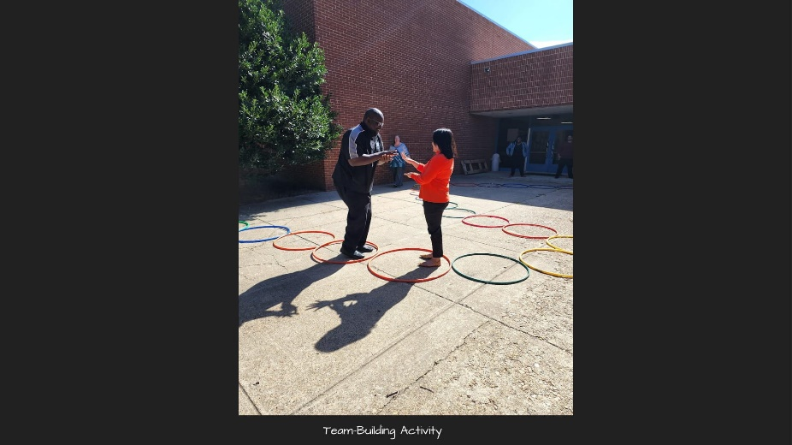

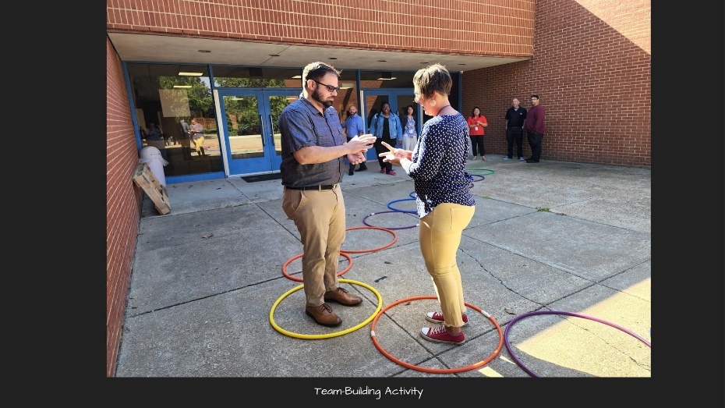

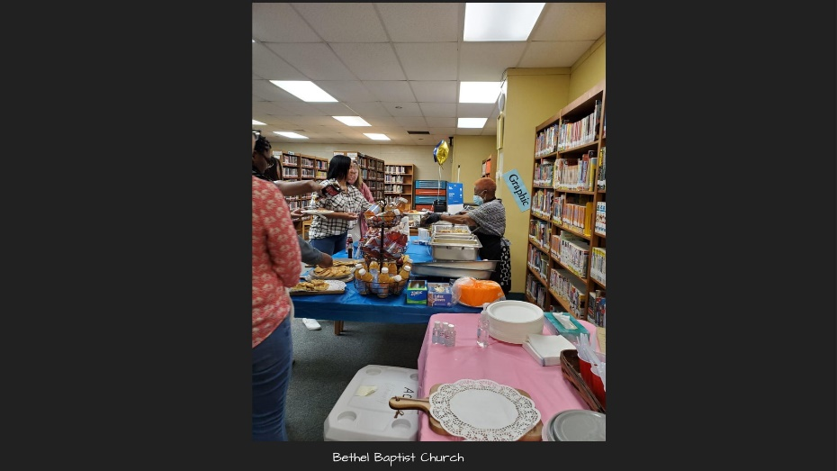

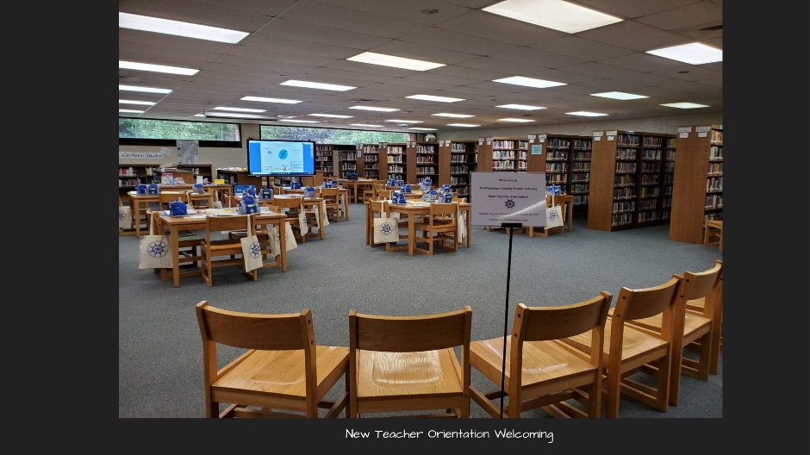

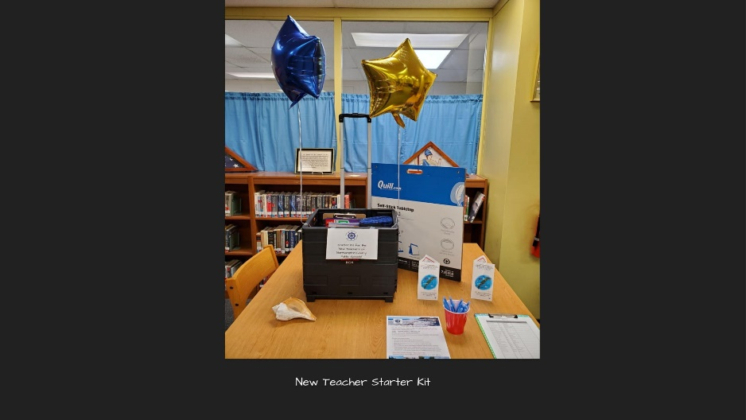

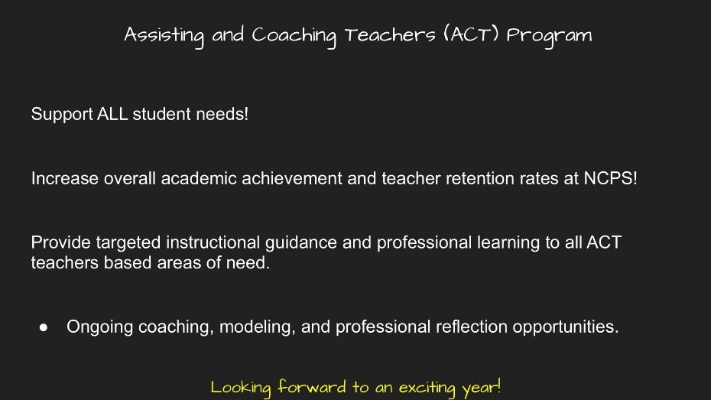

Junior Achievement Program Presentation

Mr. Frank Hughlett, President of the Junior Achievement of Greater Hampton Road gave a presentation on their resource-based program. Mr. Hughlett also said they can tailor their program to meet the needs of the district. Mr. Hughlett ended by saying they are here to help and would like the opportunity to be a resource to the district and asked if there were any questions for the board. Dr. Cole added that the principals are interested in the program.
The board chair said this program will not be voted on tonight because they expect to receive updates for the program and will act after that time. Ms. Jones asked if board members had any questions while Mr. Hughlett was available to answer questions. No additional questions from the board were received.

TECH Center Presentation

Ms. Laura Lembke, TECH Center Coordinator gave a presentation on the TECH Center. Ms. Lembke said first shared how and why they came up with the new program name; QUEST which she said stands for Quality, Unique, Educational, Student Transition. Ms. Lembke said the goal of the QUEST Program is to transition students back to their home schools. Ms. Lembke explained how the program will work along with information on the new student handbook and criteria for placement.
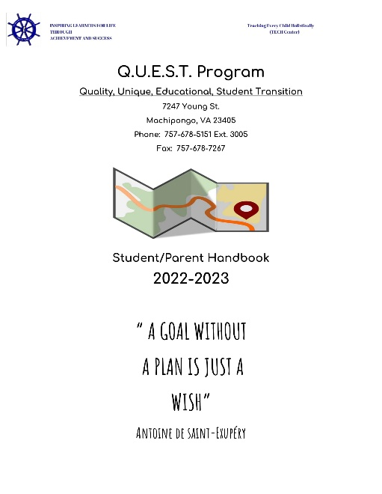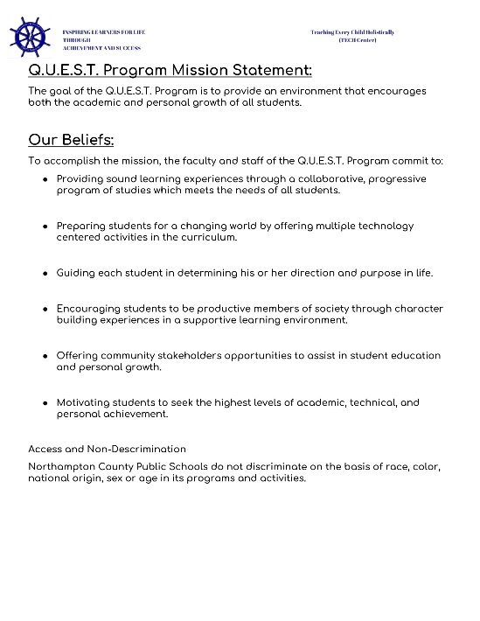

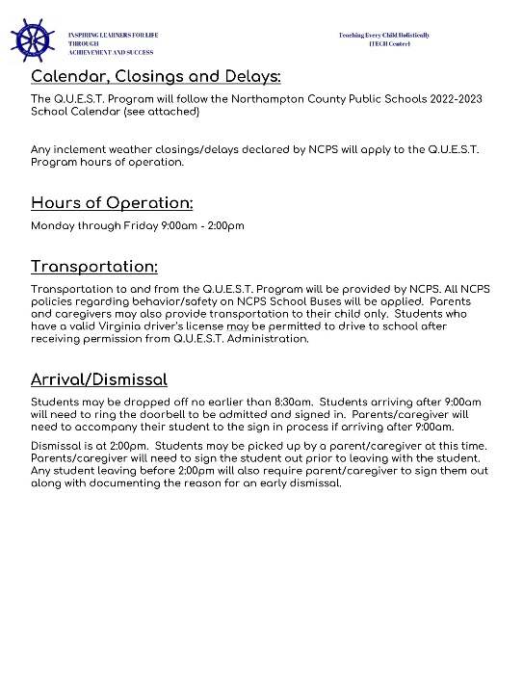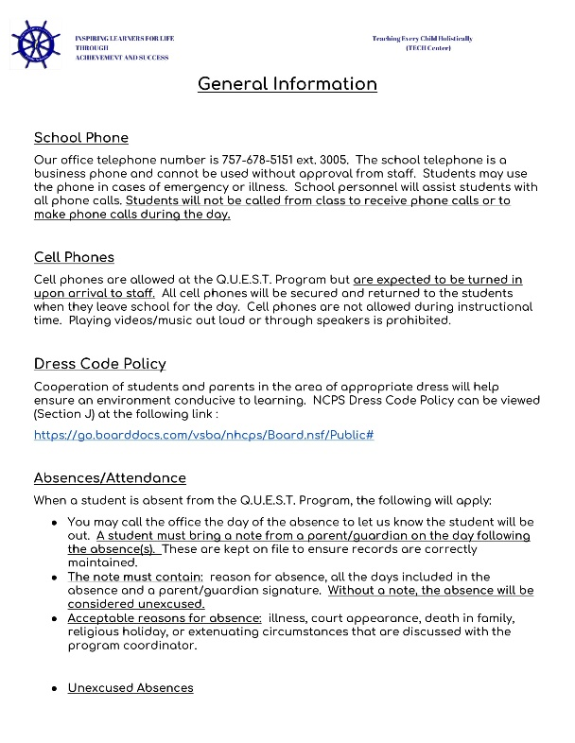

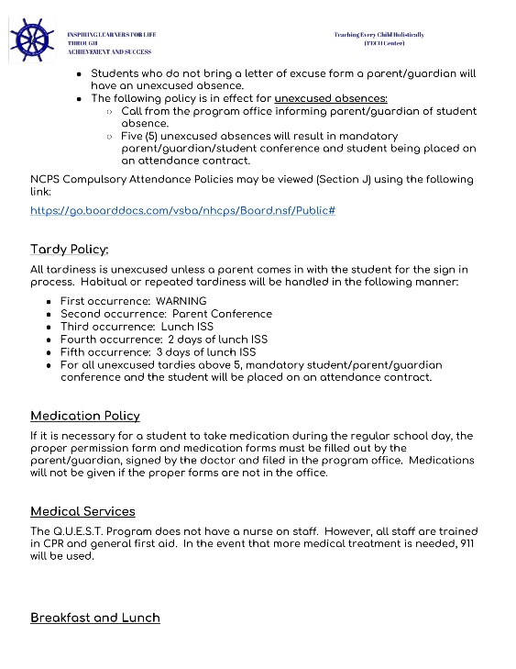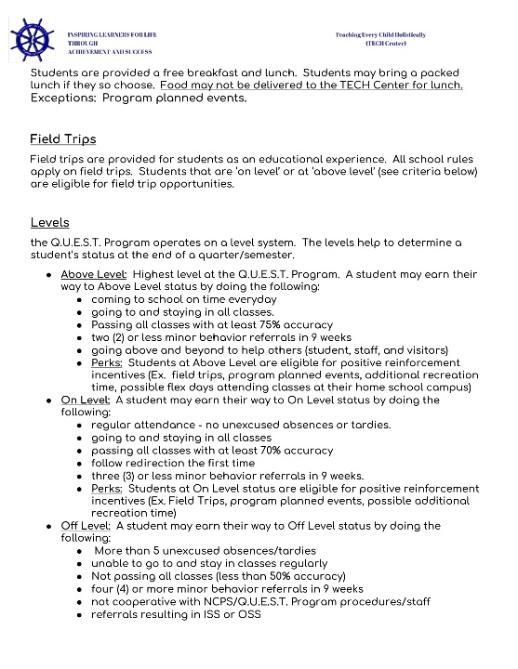

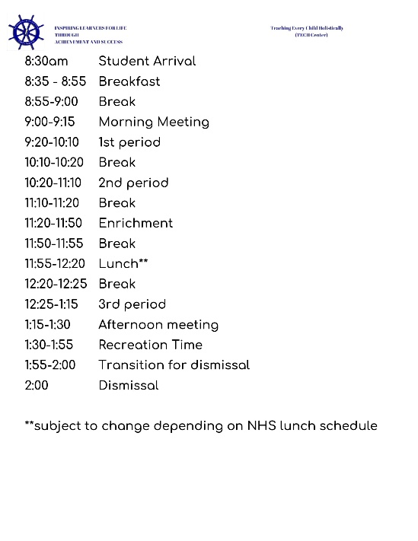
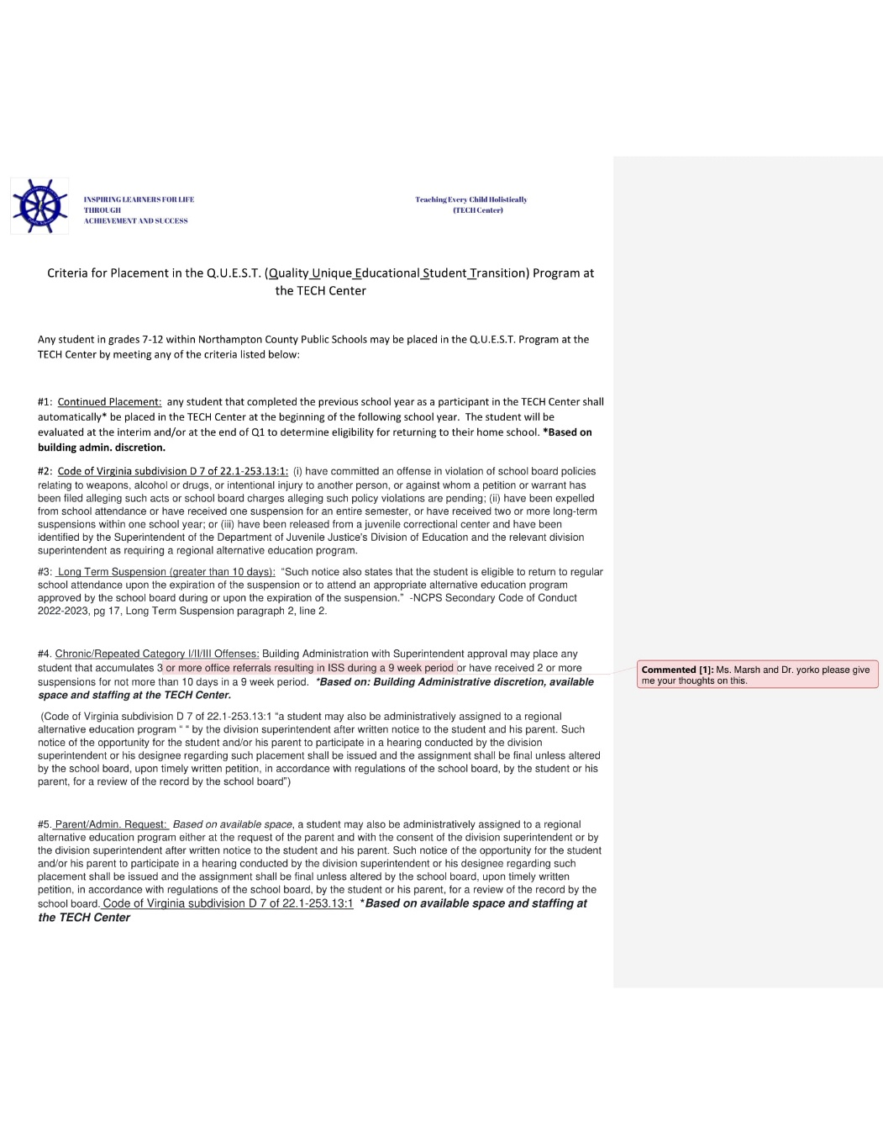

Organization Chart

Dr. Cole explained what changes have taken place in the new organization and the reasons for those changes.
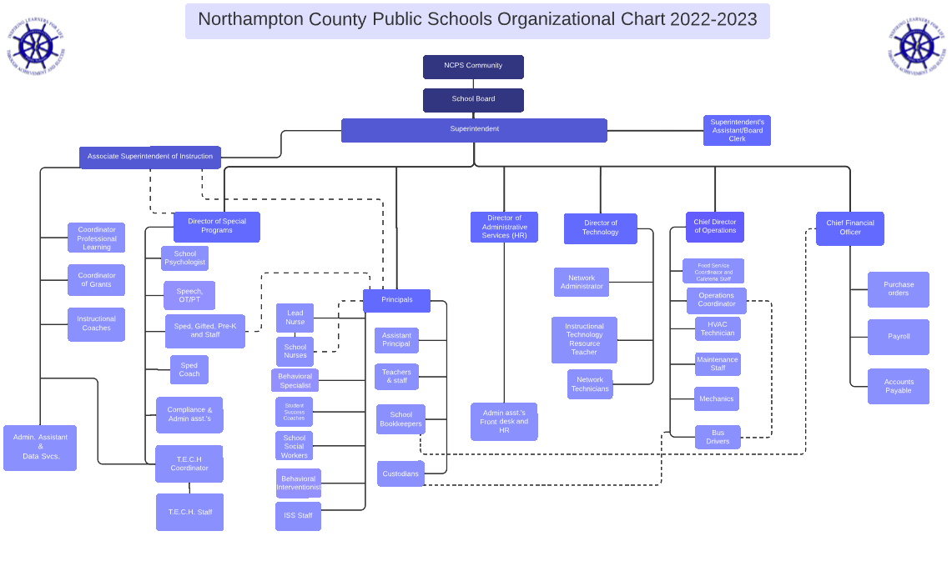

School Crisis Plan Presentations

Dr. said that together the principals and assistant principals came up with presentations on the code of conduct and school crisis plans. Dr. Cole also said due to the information included in the crisis plan it will not be visible for the public to view should there be a school threat. Dr. Cole said because the crisis plan, and code of conduct are the same for both elementary schools
Mr. Eng will present for KES and OES and Dr. Yorko will present for the middle and high school for the same reason. Dr. Cole added that the Sheriff’s Department assisted them with the process as well.

KES and OES Crisis Plan Presentation

Mr. Eng explained how the Sheriff’s Department assisted them with the language used in the crisis plan and shared what will be different and how it will benefit everyone involved. Mr. Eng also mentioned that they came up with a destination for students and staff in cases where an evacuation of the building is necessary.

NMS and NHS Crisis Plan Presentation

Dr. Yorko said one of the things they did differently this year as opposed to previous years was, that they collaboratively worked together with the Northampton County Sheriff’s Department which he said was a valuable resource. Dr. Yorko then said one of the biggest problems in the past was having two crisis plans, one for the middle school and one for the high school but only need one since they are in one building. Dr. Yorko continued and said if an emergency happened, students and staff should all be working under the same framework. Dr. Yorko then explained the changes that were made and why.

Dr. Cole thanked Dr. Yorko for taking the lead on getting the crisis plan done.

COVID Protocol and Procedures

Ms. Annon said she hopes the board will adopt the COVID procedures as a policy but if the board decides not to adopt the procedures as part of the health policy, she will follow the COVID procedures as a guideline which will be independent of the health policy procedures. Ms. Annon also said the COVID procedures they will follow are guidelines that were set forth by the Governor. Ms. Annon then shared the new division website changes regarding COVID procedures including the current mitigation strategies.

Ms. Annon explained the changes including contact tracing which can no longer be used since it is reported to be in direct violation of an employee’s HIPPA rights. Ms. Annon shared the mitigation plan and what procedures will be followed which can be found on the division website. Dr. Cole and the board members asked questions as Ms. Annon responded.

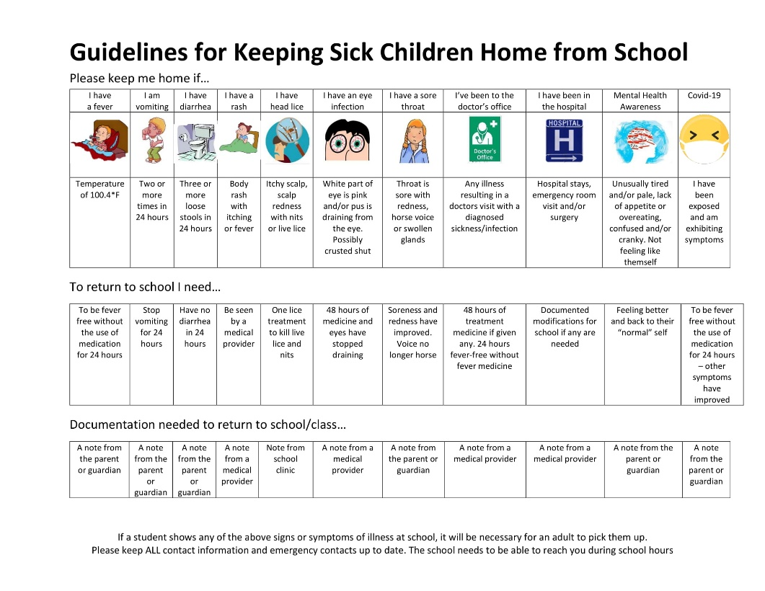

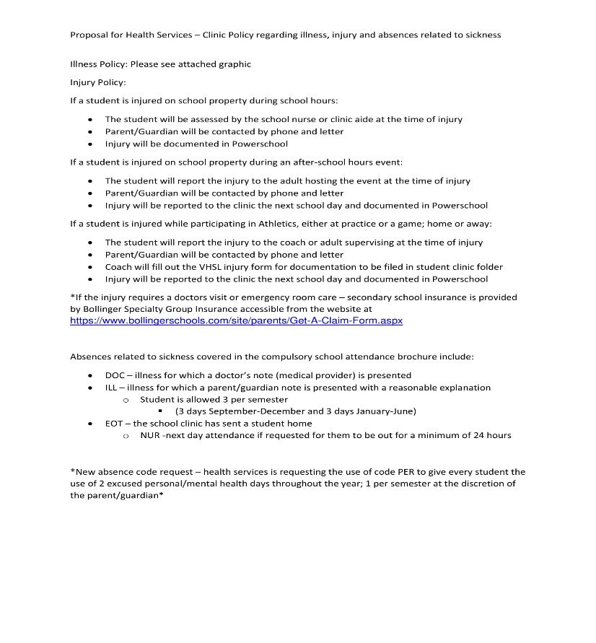
Musical Grant Presentation

Mr. Ford, NMS/NHS Band Director thanked the board for having him present. Mr. Ford said he wanted to share information about the Mr. Holland Opus Foundation Grant he applied for and was selected to receive. Mr. Ford said he wanted to share the process that it took to be selected along with what the school will receive because of the grant. Vice-chair, Liz Jones said in a world where we can be so self-consumed with what we want, and need, he is marching along and has created selflessly an amazing band and has given to and touched so many of our students by giving them an opportunity they would not otherwise have, and it is unbelievable what he has done. Dr. Cole mentioned that one of the conditions of receiving the grant is that Mr. Ford remains as band director.

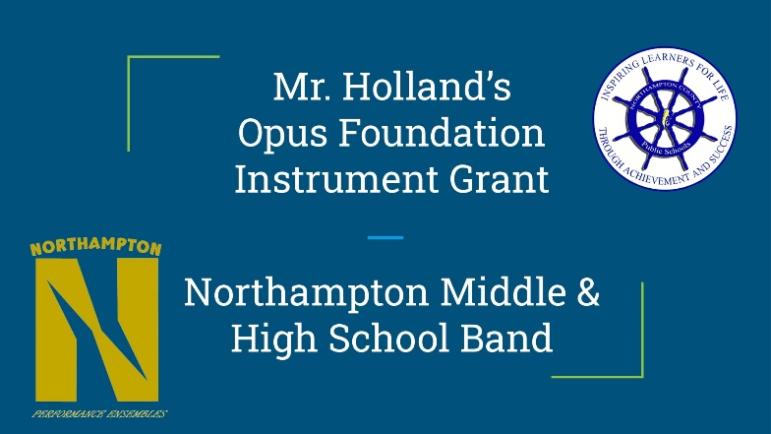

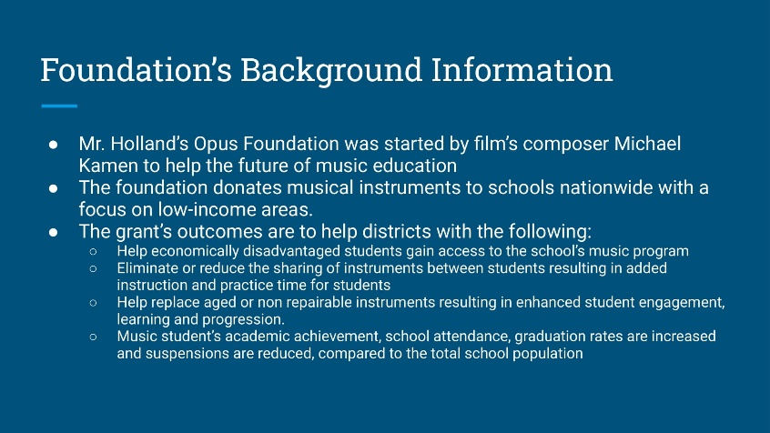

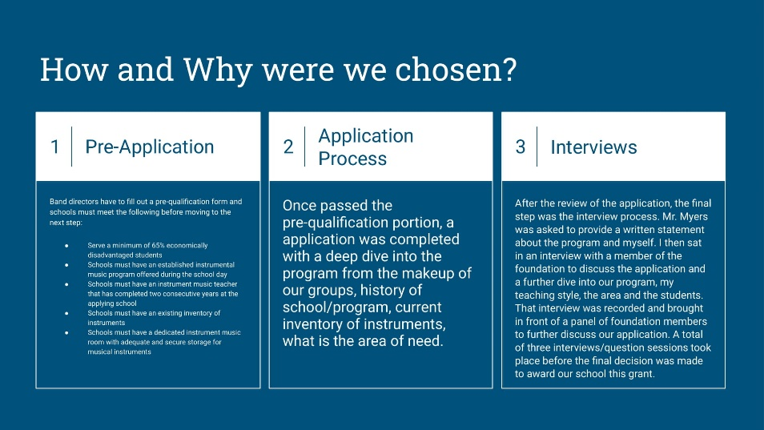

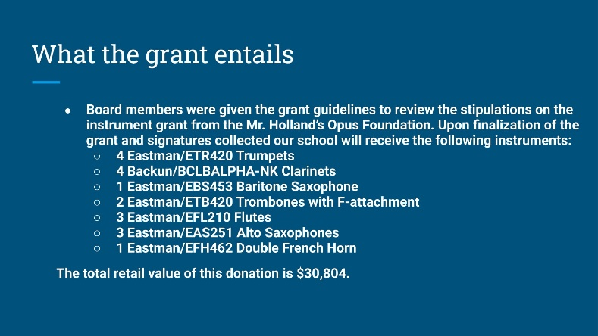

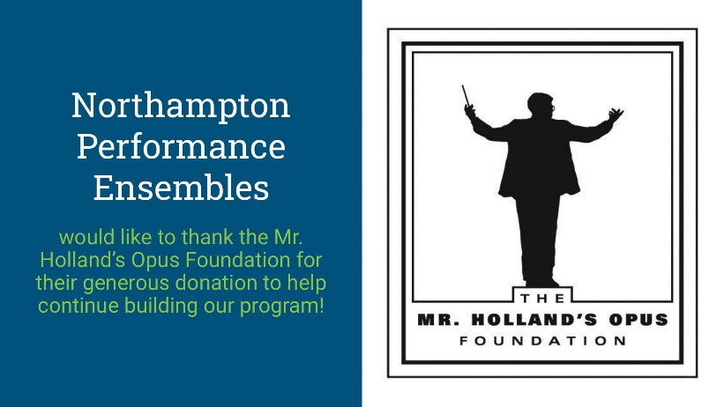

Superintendent’s Update

Dr. Cole said she was going to be brief because at the last meeting the assessment tools and gave step-by-step graphs of them and the MOU for the Sheriff’s Office provided in BoardDocs is the prior MOU for the board to see and wanted to share they are still working on getting an update for the Resource Officers which she plans to provide next month if it is ready.

Public Comment (s)

None received.

The board chair called a 5-minute recess.

The board reconvened open meeting

Consent agenda

Approval of School Board Minutes Draft for July 2022

The board chair asked if there were any changes or discussions for the school board meeting minutes for July 2022. None were given.

Approval of Financial Statements & End of Month Bills for July 2022

The board chair asked if there were any concerns or discussions about the financial statements or end-of-the-month bills for July 2022. Board member, Jill Bieri answered and said, yes, but added there was nothing to worry about. Ms. Bieri said she had received and reviewed the financials; however, the 2022-23 budget has not been uploaded and because there are multiple negative numbers she recommended that the board wait until next month, so she has a chance to review once the budget is uploaded.

Dr. Cole said she spoke with Ms. Thomas who said she is finalizing the closeout from last year, and that this is common but at the same time they are being frugal with spending and she, therefore, supported Ms. Bieri’s recommendation. The board chair asked the board clerk to make sure the minute show that the school board will hold items #10:02 and #10:03 until next month and therefore the consent agenda item will only be for the school board minutes for July.

The board chair asked for a motion to accept the school board minutes for July 2022. The motion was first and seconded. The board chair said without objection the motion was carried.

Action Items

The board chair asked for a motion to accept each of the following action items:

Policy Adoption for VSBA May 2022 Policy Updates
Dr. Cole said this is the 3rd and final reading, but the only thing needed is for the board to identify the number of days for 4-H to the policy. Dr. Cole said they do not currently participate in a 4-H program but they are required to have the number of days included in the policy should that change. Dr. Cole said she suggested 4 days but it is up to the board to decide.

The board agreed with Dr. Cole’s recommendation of using 4 days for the policy on the 4-H program.

The board chair asked for a motion to accept the Policy Adoption for the VSBA May 2022 Policy Updates to include adding the recommendation of 4 days to the 4-H policy program. A motion was made by Ms. Borden and seconded by Ms. Liz Jones.

Roll call vote:

Ms. Doughty voted yes.
Ms. Liz Jones voted yes.
Ms. Borden voted yes.
Ms. Bieri voted yes.
Ms. Charlena Jones voted yes.

The motion was carried.

Personnel Items

The board chair asked that the board wait on voting on personnel matters because they did not discuss the family engagement part and so the board will wait. Ms. Jones then asked the board clerk to add a second closed session meeting to the agenda.

Adoption of Health Policy

The board chair asked for a motion to accept the health policy, which Ms. Annon discussed earlier during the meeting. A motion was made by Ms. Liz Jones and seconded by Ms. Borden.

Roll call vote:

Ms. Doughty voted yes.
Ms. Liz Jones voted yes.
Ms. Borden voted yes.
Ms. Bieri voted yes.
Ms. Charlena Jones voted yes.

The motion was carried.

Approval of Musical Instrument Grant

The board chair asked for a motion to approve the musical grant presented earlier by Mr. Ford. A motion was made by Ms. Borden and seconded by Ms. Liz Jones.

Roll call vote:

Ms. Doughty voted yes.
Ms. Liz Jones voted yes.
Ms. Borden voted yes.
Ms. Bieri voted yes.
Ms. Charlena Jones voted yes.

The motion was carried.

Eastern Shore Community Services Board – MOA

Dr. Cole said the agreement is about initiating the six-week course free of charge with the TECH Ctr which was previously discussed. Ms. Liz Jones asked if a new MOA be required, and they decided to partner with the ESCSB for additional services. Dr. Cole's response was “no”.

Ms. Borden asked for a little more details about what will be offered. Dr. Cole responded.

The board chair asked for a motion to accept the ESCSB MOA. A motion was made by Ms. Liz Jones and seconded by Ms. Borden.

Roll call vote:

Ms. Doughty voted yes.
Ms. Liz Jones voted yes.
Ms. Borden voted yes.
Ms. Bieri voted yes.
Ms. Charlena Jones voted yes.

The motion was carried.

Acceptance of Title VI

Dr. Cole discussed all three title representatives and said Title II will be under the Special Programs Director, Title IX would be under her as done last year until Associate Superintendent when she arrives on September 6th and Title VI will be under Human Resources. Dr. Cole said the appointments need to be approved by the board before posting the information on the division website so if someone has a claim to file all the information along with procedures will be available on the website.

The board chair asked for a motion to accept the Title VI appointment of Human Resources as the representative. A motion was made by Ms. Doughty and seconded by Ms. Liz jones.

Roll call vote:

Ms. Doughty voted yes.
Ms. Liz Jones voted yes.
Ms. Borden voted yes.
Ms. Bieri voted yes.
Ms. Charlena Jones voted yes.

The motion was carried.

Approval of Organizational Chart

Dr. Cole said she is requesting board approval of the organizational chart as discussed in the previous work session meeting. Ms. Liz Jones wanted to know if Dr. Cole received any pushback from the changes and suggestions. Dr. Cole responded and said they worked on the chart collaboratively with Technology Director, Principals, and Assistant Principals who all felt comfortable with the changes and Ms. Molera had recommended that they add in the Special Education component piece before the New Associate Superintendent starts which they have done.
The board chair asked for a motion to accept the organizational chart. A motion was made by Ms. Doughty and seconded by Ms. Liz Jones.
Roll call vote:

Ms. Doughty voted yes.
Ms. Liz Jones voted yes.
Ms. Borden voted yes.
Ms. Bieri voted yes.
Ms. Charlena Jones voted yes.

The motion was carried.

Acceptance of Title II

The board chair asked for a motion to accept the appointment of Ms. Alana Walmsley, Director of Special Programs as the representative for Title II. A motion was made by Ms. Doughty and seconded by Ms. Liz Jones.

Roll call vote:

Ms. Doughty voted yes.
Ms. Liz Jones voted yes.
Ms. Borden voted yes.
Ms. Bieri voted yes.
Ms. Charlena Jones voted yes.

The motion was carried.

Acceptance of Title IX

The board chair asked for a motion to accept the appointment of Dr. Lisa Martin as the representative for Title IX. A motion was made by Ms. Liz Jones and seconded by Ms. Bieri.

Roll call vote:

Ms. Doughty voted yes.
Ms. Liz Jones voted yes.
Ms. Borden voted yes.
Ms. Bieri voted yes.
Ms. Charlena Jones voted yes.

The motion was carried.

Approval of 2022-2023 Superintendent Goals

Dr. Cole said the goals are the same as those she previously presented to the board.

The board chair asked for a motion to accept the Superintendent’s Goals as presented. Motion by Ms. Borden and seconded by Ms. Bieri. The board chair asked for any discussion.

Vice-chair Liz Jones said she needed more time and recommended they use the September 8th work session to look at them closer. The board discussed and the consensus was to table approval of the superintendent’s goals later. The board chair then stated she was not in favor of tabling the decision to approve the superintendent’s goals because she felt board members had enough time to review it but will go with the majority decision. The board chair reminded board members to please look over the goals so they can be ready to vote on them. The board chair asked the board clerk to let the minutes show that the board voted 3 to 2 that the superintendent goals be tabled until the September work session where it will be reviewed and then voted on at the regular session meeting.

Approval of the 2022-2023 Strategic Plan

Dr. Cole said the team has been meeting on Tuesdays and what she presented is just a snapshot or overview. Dr. Cole explained what pieces will be forthcoming and shared that in September the schools will be presenting their goals and sharing what will take place as they move forward.

The board chair asked for a motion to accept the 2022-2023 Strategic Plan. A motion was made by Ms. Doughty and seconded by Ms. Borden.

Roll call vote:

Ms. Doughty voted yes.
Ms. Liz Jones voted yes.
Ms. Borden voted yes.
Ms. Bieri voted yes.
Ms. Charlena Jones voted yes.

The motion was carried.

Approval of KES Crisis Plan

The board chair asked for a motion to accept the crisis plan for KES. A motion was made by Ms. Bieri and seconded by Ms. Liz Jones.

Roll call vote:

Ms. Doughty voted yes.
Ms. Liz Jones voted yes.
Ms. Borden voted yes.
Ms. Bieri voted yes.
Ms. Charlena Jones voted yes.

The motion was carried.

Approval of OES Crisis Plan

The board chair asked for a motion to accept the crisis plan for OES. A motion was made by Ms. Borden and seconded by Ms. Liz Jones.

Roll call vote:

Ms. Doughty voted yes.
Ms. Liz Jones voted yes.
Ms. Borden voted yes.
Ms. Bieri voted yes.
Ms. Charlena Jones voted yes.

The motion was carried.

Approval of NMS Crisis Plan

The board chair asked for a motion to accept the crisis plan for NMS. A motion was made by Ms. Bieri and seconded by Ms. Doughty.

Roll call vote:

Ms. Doughty voted yes.
Ms. Liz Jones voted yes.
Ms. Borden voted yes.
Ms. Bieri voted yes.
Ms. Charlena Jones voted yes.

The motion was carried.

Approval of NHS Crisis Plan

The board chair asked for a motion to accept the crisis plan for NHS. Motion was made by Ms. Borden and seconded by Ms. Doughty.

Roll call vote:

Ms. Doughty voted yes.
Ms. Liz Jones voted yes.
Ms. Borden voted yes.
Ms. Bieri voted yes.
Ms. Charlena Jones voted yes.

The motion was carried.

Approval of the Junior Achievement Program

The board chair asked for a motion to accept the Junior Achievement Program. Motion was made by Ms. Doughty and seconded by Ms. Bieri.

Roll call vote:

Ms. Doughty voted yes.
Ms. Liz Jones voted yes.
Ms. Borden voted yes.
Ms. Bieri voted yes.
Ms. Charlena Jones voted yes.

The motion was carried.

Approval of Non-Resident Student Applications

Dr. Cole said OES had three requests to transfer and KES three requests to transfer which are pre-school and kindergarten and staff work for NCPS.

The board chair asked for a motion to accept the non-resident student applications. Motion was made by Ms. Borden and seconded by Ms. Doughty.

Roll call vote:

Ms. Doughty voted yes.
Ms. Liz Jones voted yes.
Ms. Borden voted yes.
Ms. Bieri voted yes.
Ms. Charlena Jones voted yes.

The motion was carried.

Appropriation Req FY 22-23 #4 – USDA SNP Supply Chain Assistance

Dr. Cole shared the amount and reason for the request for approval.

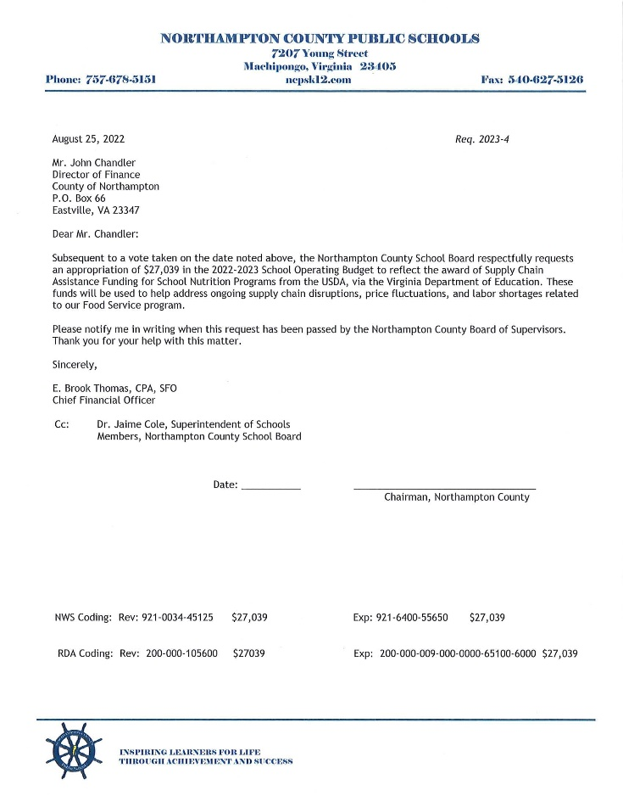

The board chair asked for a motion to accept the appropriation request for USDA SNP Supply Chain Assistance. A motion was made by Ms. Liz Jones and seconded by Ms. Bieri.

Roll call vote:

Ms. Doughty voted yes.
Ms. Liz Jones voted yes.
Ms. Borden voted yes.
Ms. Bieri voted yes.
Ms. Charlena Jones voted yes.

The motion was carried.

Appropriation Req FY 22-23 #5 – Final State CTE Allocation

Dr. Cole shared the amount and reason for the request for approval.

The board chair asked for a motion to accept the appropriation request for Final State CTE Allocation. A motion was made by Ms. Borden and seconded by Ms. Liz Jones.

Roll call vote:

Ms. Doughty voted yes.
Ms. Liz Jones voted yes.
Ms. Borden voted yes.
Ms. Bieri voted yes.
Ms. Charlena Jones voted yes.

The motion was carried.

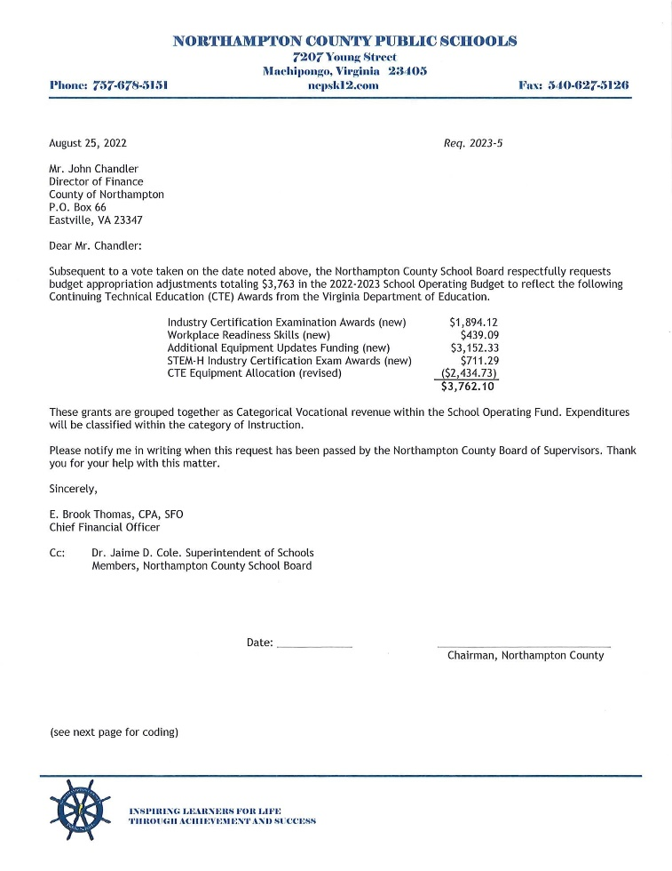

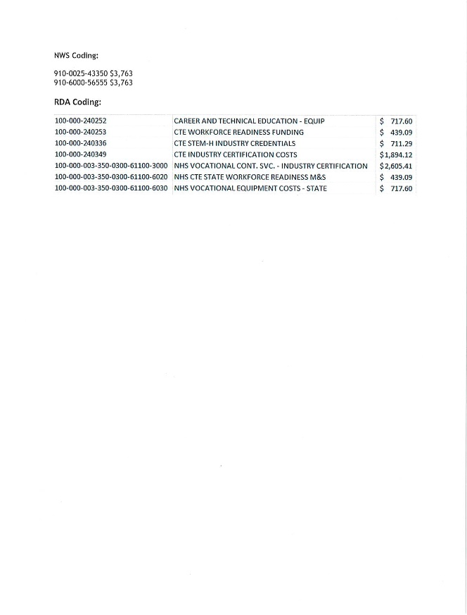
The board chair said they will skip the personnel items and go back to it after the second closed session.

Old/New Business Discussions

Wrap-Up Discussion (School Governance)
Ms. Jones said the VSBA asked if the board would still like to host the training virtually or have an in-person training in Charlottesville. Ms. Jones is recommending the board go to Charlottesville for the in-person training and asked the board to share their thoughts.

The chair asked board members who are undecided to let her know as soon as possible so she can contact VSBA.

Dates of Notice

Dr. Cole said she wanted to remind board members that the first football game will take place tomorrow and asked for their support by attending if possible. Dr. Cole also said Ms. Marsh was unable to attend tonight's meeting because she had to attend a volleyball game and also Ms. Joyner was unable to attend due to a family matter. Dr. Cole the board chair discussed upcoming events and meetings.

Date | Event
8/25/2022 | School Board Mtg held at the Central Office  5:30 pm - Closed Session  6:00 pm - Regular Session
9/1/2022 | Open House for All Schools - 11 am to 6 pm
9/2/2022 | Police/Fire Safety Training 8 am to 2 pm
9/8/2022 | School Board Mtg held at the Central Office  5:30 pm - Closed Session  6:00 pm - Work Session
9/13/2022 | VSBA School Board Governance Training - (Virtual) located at Central Admn Bldg.
9/22/2022 | School Board Mtg held at the Central Office  5:30 pm - Closed Session  6:00 pm - Regular Session
10/4/2022 | VSBA Superintendent's Evaluation Workshop in Charlottesville, VA
10/13/2022 | School Board Mtg held at the Central Office  5:30 pm - Closed Session  6:00 pm - Work Session
10/27/2022 | School Board Mtg held at the Central Office  5:30 pm - Closed Session  6:00 pm - Regular Session
11/10/2022 | School Board Mtg held at the Central Office  5:30 pm - Closed Session  6:00 pm - Regular Session
11/16/2022 -  11/18/2022 | 2022 ANNUAL VSBA CONFERENCE IN WILLIAMSBURG, VA
12/8/2022 | School Board Mtg held at the Central Office  5:30 pm - Closed Session  6:00 pm - Regular Session

Public Comment(s)

None received.

Ms. Annon shared additional information regarding health policy and the board chair asked that the minutes reflect that Ms. Annon’s earlier discussion was not her presentation. Dr. Cole then said they have done a first and second reading of the health policy and so this would be the final adoption.

Second Closed Session Meeting

The board chair said the board will now convene a second closed session to discuss one personnel item.

Reconvene Open Session & Reading of Closed Session Certification

The board chair asked for a motion to come out of the closed session. Motion by Ms. Liz Jones
and seconded by Ms. Bieri. The board chair said without objection the motion was carried.

The board chair read the following statement:

"Whereas, the Northampton County School Board has convened a closed meeting on this date pursuant to an affirmative recorded vote and in accordance with the provisions of the Virginia Freedom of Information Act; and

Whereas, Section 2.2-3712 of The Code of Virginia, 1950, as amended, requires certification by this School Board that such closed meeting was conducted in conformity with Virginia law;

Now, therefore, be it resolved, that the Northampton County School Board hereby certifies that, to the best of each member's knowledge, (i) only public business matters lawfully exempted from open meeting requirements by Virginia law were discussed in the closed meeting to which this certification applies, and (ii) only such public business matters as were identified in the motion convening the closed meeting were heard, discussed, or considered."

Roll call vote:

Ms. Doughty voted yes.
Ms. Liz Jones voted yes.
Ms. Borden voted yes.
Ms. Bieri voted yes.
Ms. Charlena Jones voted yes.

The motion was carried.

Approval of Personnel Item

The board chair went back to action items to vote on the personnel items.

The board chair asked for a motion to accept all personnel items as discussed in the closed session to include a Family Engagement Coordinator job description which was changed from a required bachelor’s degree and preferred master’s degree to a required associate’s degree preferred bachelor’s degree. A motion was made by Ms. Doughty and seconded by Ms. Borden.

Roll call vote:

Ms. Doughty voted yes.
Ms. Liz Jones voted yes.
Ms. Borden voted yes.
Ms. Bieri voted yes.
Ms. Charlena Jones voted yes.

The motion was carried.

Adjournment

The board chair said without objection meeting adjourned.

Approved by the board at the September 22, 2022, regular session board mtg. Karen Pitt, Board Clerk

