Name(s):

Jamala R. Pelfrey

School:

Whitesburg Middle School

Title of Strategy

Random Name and Group Generator (SmartBoard)

Type of Strategy (i.e. self-reflection, hands-on activities, technology, group work, or teach the class):

Technology

Website/Author/Source (Where did you get this strategy? Where can we find out more?):

exchange.smarttech.com

Resources Needed (What is necessary to implement this strategy in the classroom):

Smartboard Software and/or ActivInspire Software
Directions (Describe how this strategy is used in the classroom [assume the reader has never used this strategy before]):

1.Visit exchange.smarttech.com
2. Search random name generator*
*Notice there are SEVERAL options, the one with name and group is the one that is
depicted in this strategy*
3. Click Download
4. Once downloaded open up the document using the Smartboard Software (and/or the ActivInspire Software converter)
5. If you have multiple classes, BEFORE you start typing names, copy the two pages in the document (one is a name generator and the other is a group generator) and paste them for how many classes you have (i.e. I have six classes, so my document has 12 pages)
6. Click on the first page, select, from the drop down menu the number of students in your class and begin typing in student names
7. Click on the second page (group generator) and begin typing student names
8. Repeat this process for ALL classes
9. Save the document with a name you will remember in a location on your computer you will be able to find (i.e. Classes 2016 – 2017 on the desktop)
10. To use the name generator, select the class you have and click “select” this will randomly select a student
11. If you want the students to only be called on ONCE, place a check in the box that says repeat off
12. To use the group generator, select the class you have, then from the drop down menu select how many groups you need and click generate
13. If you don’t like the way the students are grouped you can keep clicking regroup until new groups are formed

Attachments (Please submit any handouts, etc. that are necessary for this strategy and explain what you have included):

Screen shots of student names and group generator (word document)

Sample of Student names and selecting how many students are in the class(es)
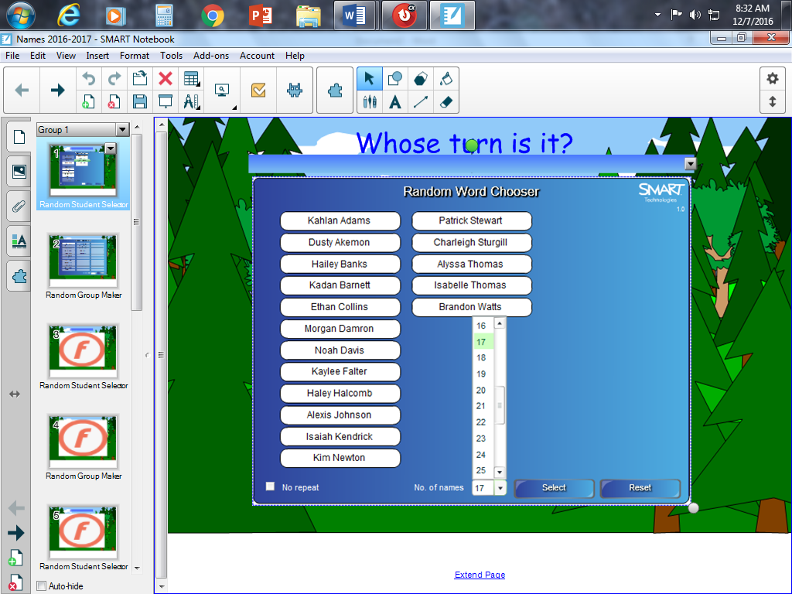
Sample of clicking select one time, student in green has been randomly chosen
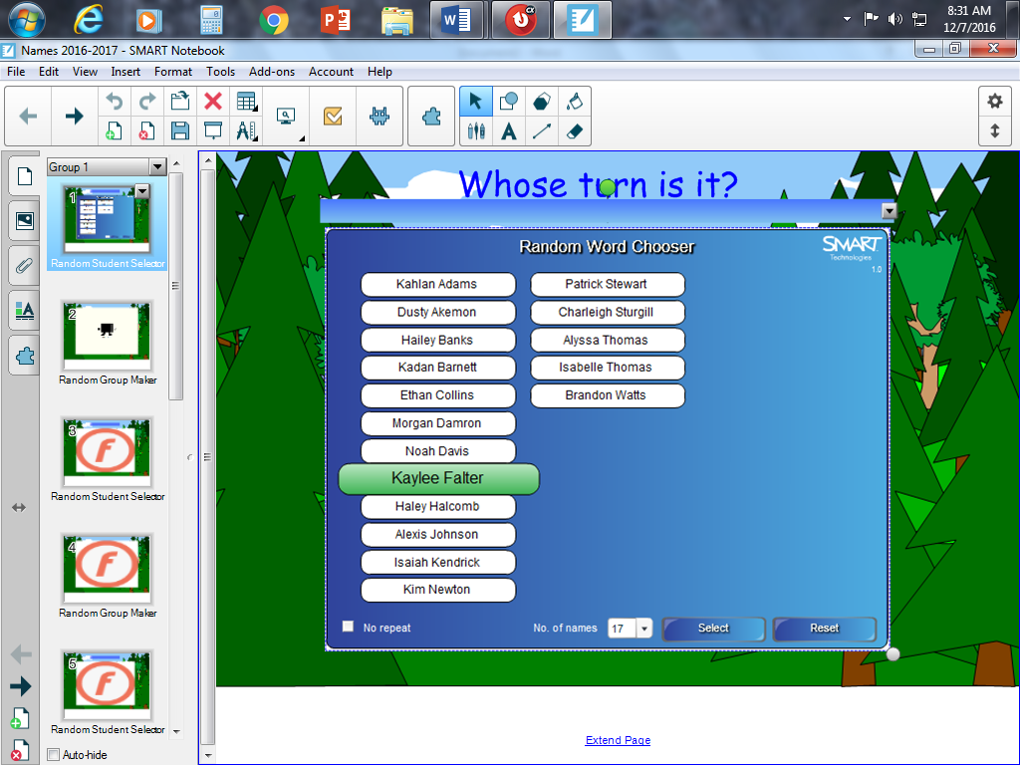

Sample of selecting ‘No repeat’: students in blue have been called on once, student in green is the new chosen student
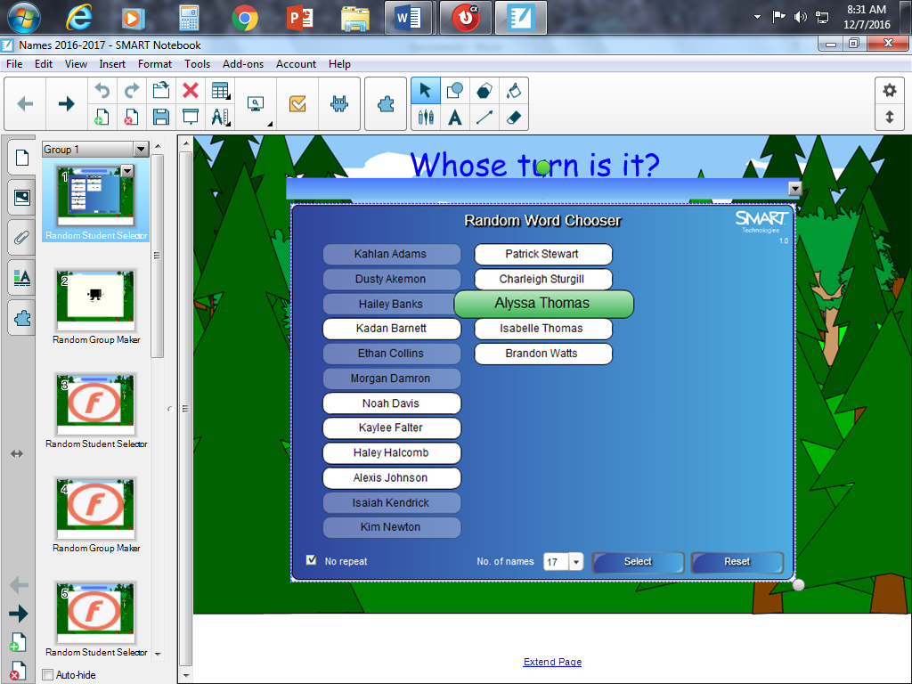

Sample of random group generator and selecting the number of groups (6 in the example)
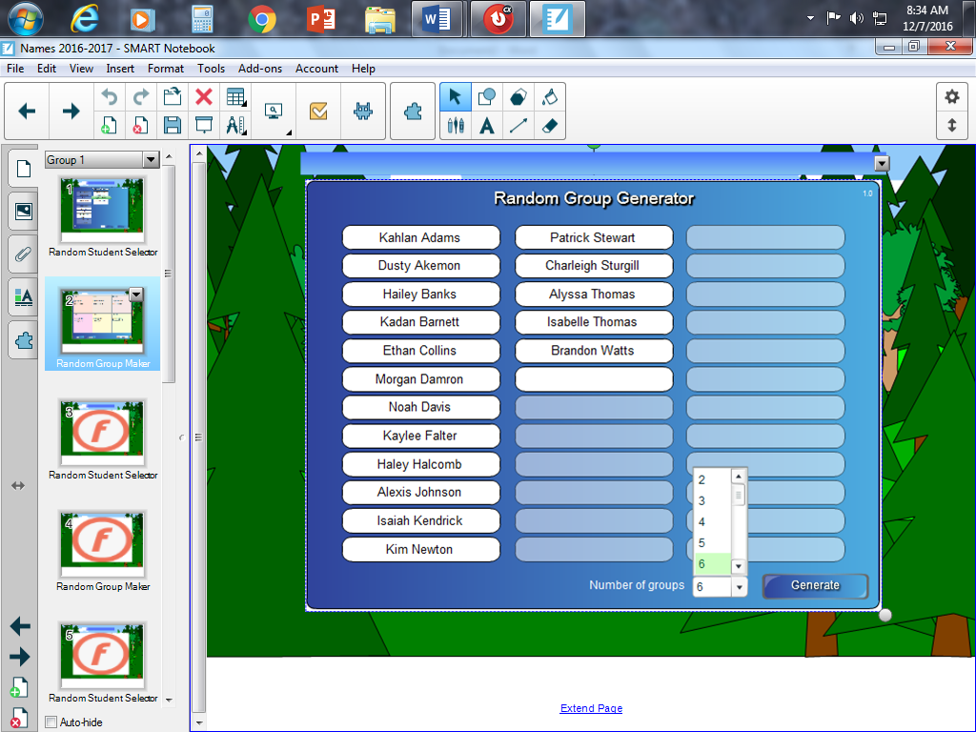

Sample of random groups
To get a different combination click ‘Regroup’
To move students individually leave the ‘Inject all groups’ selected and type names in the groups manually
