Name(s): Suzette Sturgill-Sexton
School: Arlie Boggs Elem.
Title of Strategy
Strength and Weaknesses Communication Guides
Type of Strategy (i.e. self-reflection, hands-on activities, technology, group work, or teach the class):
Self-Reflection
Website/Author/Source (Where did you get this strategy? Where can we find out more?):
http://teachinginroom6.com

Resources Needed (What is necessary to implement this strategy in the classroom):
Anchor Paper
Notebook/Journal
template

Directions (Describe how this strategy is used in the classroom [assume the reader has never used this strategy before]):
- Make sure every student has a Language Arts journal/notebook
- Locate and create the anchor paper shown on the website Teaching in room 6 http://www.teachinginroom6.com

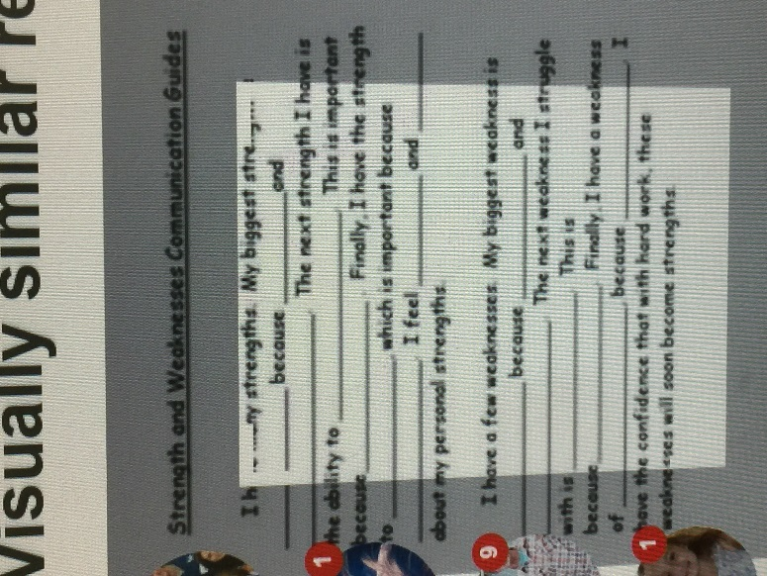
- After a lesson, have the students write their responses to the questions on the anchor chart in their journal/notebook. Once completed, they can share what they learned with a classmate.
- Randomly choose several students to share their responses to the anchor questions.

Attachments (Please submit any handouts, etc. that are necessary for this strategy and explain what you have included):

