Name(s):
Jessica Antonio and Arely Muñoz- Spanish Sub PLC
School:
Letcher County Central High School
Title of Strategy
Plus/Delta Chart
Type of Strategy (i.e. self-reflection, hands-on activities, technology, group work, or teach the class):
Student Self-Reflection
Website/Author/Source (Where did you get this strategy? Where can we find out more?):

This strategy can be applied to any discipline and updated as needed. It is simple to search for examples to get started and it is a process that can be used after lessons, exams or a checkpoint. It can also serve as a time for students to provide feedback and for teachers to better morph lessons to address different needs. This is a useful strategy if you are trying to have students reflect on various aspects and begin to determine areas they can begin to work on and improve.

This link gives a quick intro to the plus/delta chart and reflection strategy. I have personally used it after exams and tend to do follow up questions. You can find an example of mine under “Handouts”. (Muñoz)
http://www.innovationgames.com/plusdelta/

This link gives more examples of how a plus/delta chart can be modified to reflect on different aspects of the learning environment and for students to reflect on their different outputs. For example they can reflect, using the chart, on their study habits, behavior, team work, etc.
https://www.edutopia.org/blog/reflection-assessment-empowerment-self-awareness-james-kobialka

Resources Needed (What is necessary to implement this strategy in the classroom):
All you need is to understand how it works and explain it to the class with either:
-handout
-PowerPoint
-example

You can also create follow-up questions depending on what you are using.

Time to prepare: 5 min
Time to execute: 5 min

Directions (Describe how this strategy is used in the classroom [assume the reader has never used this strategy before]):

This is a modification of a T-Chart for reflection and a way of turning any negative feedback or comments into areas of improvement. The Plus (+) represents areas the student feels comfortable with, understand, strategies that have worked for them, and even aspects they recognize as important. The Delta (Δ) is the areas the students have determined, based on reflection, are still difficult, do not understand, need more explanation or fail to identify the relevance and importance.

The follow-up questions can be designed based on what you need for the students to reflect on such as their studying prep, behavior, effort and overall achievement. These questions should also provide a space for students to not only reflect but determine or set realistic action plans to personally work on.

So the instructions are:
1.Select what you want the students to individually reflect on

2. Explain what the plus/delta chart is to the students.

3. Have them fill it out with about 3 per section. (3 plus, 3 delta)

4. Create 2-5 questions to guide their reflection

5. Set steps or guide them with determining what their next action plan is.

6. Allocate time for them to self-reflect using this tool (should take about 5 min)

*What is need about this self-reflection tool is that is also promotes the use of language of achievement where students can focus on areas of improvement. This is also a very powerful tool that teachers can use to modify lectures/exams to accommodate different needs and even as a quick formative assessment.

Attachments (Please submit any handouts, etc. that are necessary for this strategy and explain what you have included):

This is an example that is used in a Spanish class after an Unit Exam. It explains once again what the Plus/Delta chart does and includes questions. It is not a handout for the students can use their own piece of paper. Usually I used this in class right before moving on to the next unit and focus on their Deltas and how to practice or improve on them. I also reference bach to these as we move on to the unit to make sure they are working on their own plan. I change these as I find it necessary and even sometimes create one together as a class.
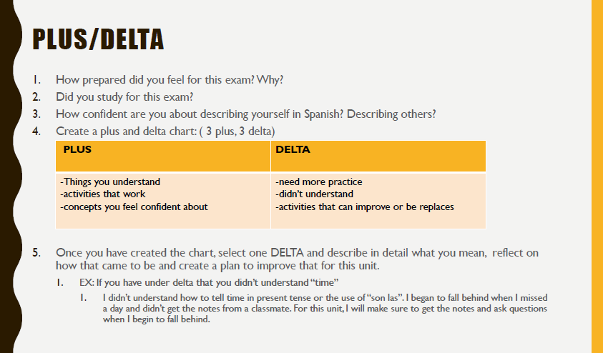

This is an example of one chart that is used. Notice how the reflection questions are guided and encourage the student(s) to not only reflect but map out their next step.
http://pedagogy21.pbworks.com/f/Plus_Delta.pdf

Another example, not necessarily tied to rigor but how it can be a tool of reflection for just about anything!
