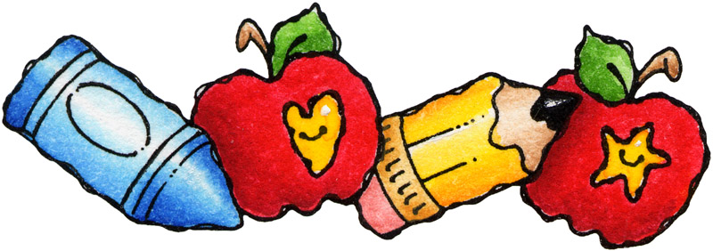

Wisner- Pilger Elementary School

3rd Grade Supply List

2 Boxes of Tissues
2 Large Glue Sticks
1 Large Eraser
3 Boxes of Plain Pencils (sharpened)
3 Red Pens
1 Box of Crayons (24 pack)
1 Pair of Scissors
2 Pocket Folders
1 Notebook (70 page, wide-ruled)
Zipper Bag OR Pencil Box
1 Box of Colored Pencils
8 Black Dry Erase Markers
1 Set of Inexpensive Earbuds

Please label all supplies with first name and last initial.
Supplies will need to be replenished throughout the school year as needed.

