Internal Use Only: 1 2 3
What to Bring to Appointment:
- Completed COVID-19 Vaccine Screening Form
- Vaccine Card (if this is a 2nd dose or booster dose)

COVID-19 Vaccine Screening Form
Last Name: ___________________ First Name: ________________ M.I: ____ DOB: ____/____/____
Age: ______ Phone Number: (_____)_____-______ Gender Assigned at Birth: Male Female
Race: _____________ Emergency Contact Name and Phone#:_______________________________________
Address: __________________________ City: ___________________State: ________Zip Code: ___________
Please answer the following questions: If you answer “yes” to any question, it does not necessarily mean you should not be vaccinated. It just means additional questions may be asked. If a question is not clear, please ask your healthcare provider to explain it.
Are you feeling sick today? | YES | NO
Have you ever received a dose of Pfizer COVID-19 vaccine? How many doses? 1 2 3 | YES | NO
Have you ever had a severe allergic reaction (e.g., anaphylaxis) to something? For example, a reaction for which you were treated with epinephrine or EpiPen®, or for which you had to go to the hospital? | YES | NO
Was the severe allergic reaction after receiving a COVID-19 vaccine or any other vaccine or injectable medication? | YES | NO
Have you had a positive test for COVID-19 or has a doctor ever told you that you had COVID-19? | YES | NO
Have you been diagnosed with Multisystem Inflammatory Syndrome (MIS-C or MIS-A) after a Covid-19 infection? | YES | NO
Have you received passive antibody therapy (monoclonal antibodies or convalescent serum) as treatment for COVID-19? | YES | NO
Are you a male between the ages of 12 and 29 years old and have a history of myocarditis or pericarditis? | YES | NO
Do you have a weakened immune system caused by something such as HIV infection or cancer or do you take immunosuppressive drugs or therapies? | YES | NO
Do you have a bleeding disorder or are you taking a blood thinner? | YES | NO
Do you have a history of Guillain-Barre Syndrome? | YES | NO
Are you pregnant or breastfeeding? | YES | NO
I acknowledge that I have read or had explained to me the Emergency Use Authorization Fact Sheet for the following COVID-19 vaccine. I have also had the chance to ask questions which were answered to my satisfaction, and I understand the benefits and risks of the COVID-19 vaccine as described. I request that the COVID-19 vaccine be given to me or to the person named above for whom I am authorized to make this request.
__________________________________________ ____/_______/_____
Signature (if under 18, must be signed by parent/guardian) Date

__________________________________________________
Printed name of parent/guardian if under 18

For Internal Use Only: Injection Site: LA RA
Pfizer 12+ Lot: _______________ Pfizer Ages 5-11 Lot: ______________
Provider Name, Signature and Date
_______________________________________________________________________________________________________________

Information for Vaccine Recipients

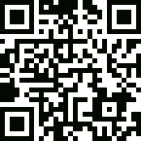
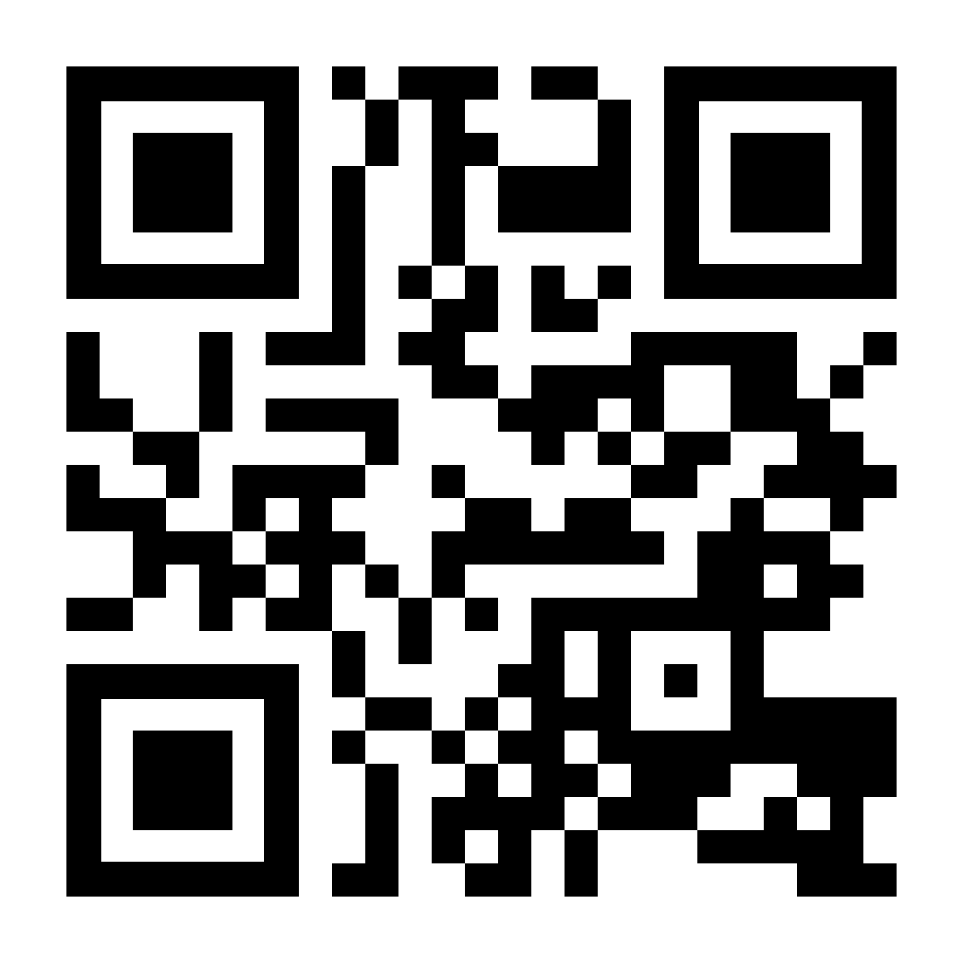
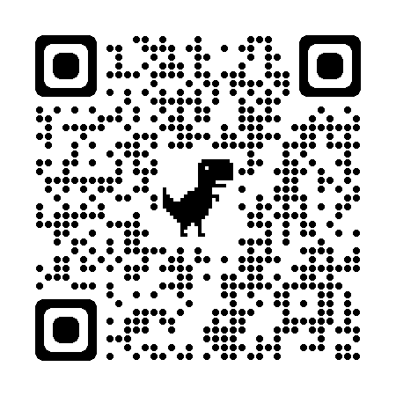
For more information on the Pfizer Covid-19 Vaccine for ages 5-11:
Scan the QR code or to get to the Fact Sheet for Recipients and Caregivers: www.cvdvaccine.com
For more information on the Pfizer 12+ COVID-19 Vaccine:
Scan the QR code or to get the Fact Sheet for Recipients and Caregivers: www.cvdvaccine.com

To Enroll on V-safe:
V-safe is a web-based tool that uses text messaging and web surveys to provide personalized health check-ins after you receive a COVID-19 vaccination. Through v-safe, you can quickly tell CDC if you have any side effects after getting the COVID-19 vaccine. Depending on your answers, someone from CDC may call to check on you and get more information. And v-safe will remind you to get your second COVID-19 vaccine dose if you need one.

Your participation in CDC’s v–safe makes a difference — it helps keep COVID-19 vaccines safe scan the QR code or go to vsafe.cdc.gov

