Mr. Monte Thompson
Superintendent
Mrs. Amy Williams
HS Principal

Mrs. Brenda Shockley
Elementary Principal

Hallea Votaw
Special Education Director
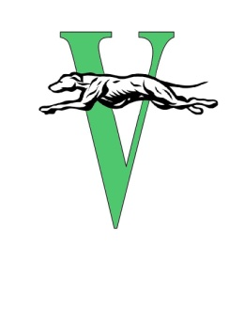
Ms. Heather White
Counseling Services

Varnum Public Schools
11929 NS 3550
Seminole. OK 74868
(405)382-1448

VARNUM SCHOOL BOARD MEETING DATES FOR THE 2022-2023 SCHOOL YEAR

School Board meetings will be held at 6:00 p.m. in the Varnum Middle School Library at
11929 NS 3550 Seminole, OK 74868.

Dates are as follows:
July 11, 2022
Special meeting on July 26, 2022
August 8, 2022
September 12, 2022
October 10, 2022
November 14, 2022
December 12, 2022
January 9, 2023
February 13, 2023
March 6, 2023
April 10, 2023
May 8, 2023
June 12, 2022

