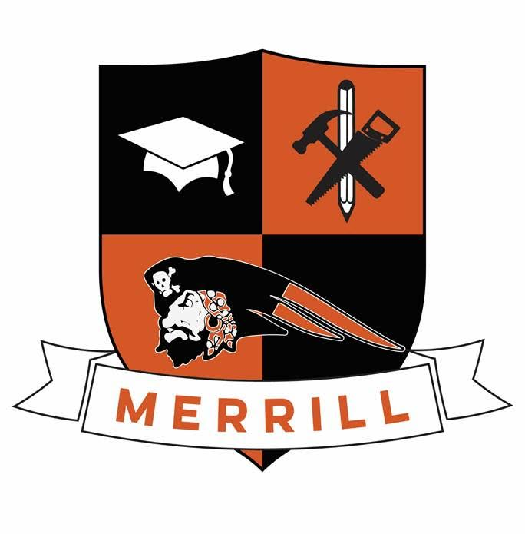
Merrill Community Early College
Frequently Asked Questions

What is an Early College?

Early Colleges are high schools designed to provide students with a diploma and up to an Associate’s degree from an accredited college or vocational program. Early College high schools have the potential to improve college completion rates and better prepare all students for high-skill careers by engaging them in a rigorous, college preparatory or vocational curriculum and compressing the number of years after high school to a college degree or vocational certification.

A benefit of becoming an Early College in Michigan is that the Department of Education provides funding which allows Early Colleges to provide tuition support for students to attend college full time during the fifth year. By doing this, students can realistically earn an Associate’s degree, vocational certification or 60 transfer credits while still in high school.

Why is Merrill High School offering an Early College program?

Merrill Community Schools is committed to preparing all learners for career and college readiness after high school. We know that post-secondary education is essential for financial and personal freedom in today’s economy. A degree or vocational certification translates into earnings significantly higher than those earned by an individual with a high school diploma alone.

The State of Michigan shares our mission and is allowing more flexibility for districts to have students graduate from high school with post-secondary credit.

By becoming an Early College, Merrill High School can increase the likelihood of students’ post-secondary success by offering college courses and vocational training opportunities while in high school.

As an Early College, would all Merrill High School students’ graduates be required to earn college credit while in high school?

Students electing to participate in MCS Early College program must earn a minimum of 15 college credits or complete vocational certification, in addition to their high school diploma, before graduating from high school. These credits can be earned in a variety of ways: online courses, vocational courses at MHS, Delta College coursework, articulated high school courses, etc. Our goals as an Early College is to work with each individual student to develop their educational development plan to highlight a path for obtaining these credits.

Why would a student want to participate in a five year program?

Research clearly demonstrates the value of completing post-secondary training. Students earning an associate’s degree (or higher) or a vocational certification have a lifetime earning potential of nearly 1 million dollars more than a student who completes a high school diploma with no additional training. An Early College provides a fifth year of support and college/vocational funding to students who choose to take advantage of this opportunity. Students electing to participate in the college path benefit from entering their new college with college credit, while maintaining freshman scholarship opportunities.

When will students be able to start taking college courses?

Learners are eligible to enroll in college courses once they are “credentialed”. Students are credentialed once they complete the following:
- Have an Educational Development Plan on file in Career Cruising that has been updated within the past semester.
- Complete a minimum of 1 semester of Career/College Readiness Seminar with a 2.0 or higher
- Achieved a passing score on Accuplacer or SAT
- Earned a GPA of 2.5 or higher
- Have a guardian/parent signature of maturity

We will explore alternatives to these milestones on a case-by-case, year-by-year basis.

What are my options if I fail to earn qualifying scores on the Accuplacer or SAT assessments?

Students who fail to earn the necessary benchmarks in writing, reading and math will be required to take a course below 100 level. These courses do not meet the dual enrollment requirements for the State of Michigan and thus the student will be required to pay for these classes. Students can retake the Accuplacer assessment 3 times per subject per year.

Are there any issues with colleges not accepting credit earned during high school?

Through our partnership with Delta College, students will be advised on transferability of courses. A vast majority of Delta College courses transfer to other colleges and universities. Students are strongly encouraged to meet with an academic advisor to determine the best path. Information about transfer credits can be found through the Michigan Transfer Network at http://www.michigantransfernetwork.org/

Would High School students take courses with other Delta College students?

Yes. Our goal is to provide an authentic post-secondary experience to our students. This includes being free to enroll in eligible courses at Delta College and taking these classes with college-age students. Students completing their 13th year will be taking courses full time through Delta College will not be participating in any courses on Merrill High School main campus unless they choose to take Delta classes here.

What about high school graduation?

Early College students have full graduation privileges. They will walk with their graduating class and are eligible to participate in the same activities afforded to students with senior class status. However, learner’s high school diplomas are awarded following the completion of their fifth academic year.

Will I be able to participate in athletics?

Students are eligible to participate in athletics through their senior year. Learners are not eligible to participate in athletics at Delta College or Merrill High School during their fifth year.

Will the college academic calendar differ from the high school academic calendar?

Our school calendar is different than Delta College’s calendar. All college and vocational courses will follow Delta College’s academic calendar. Students will be required to attend during those times.

How many credits do I need to take and what are the required courses I need in the fifth year?

To be considered a full time college student, learners must register and complete a minimum of 12 college credits per semester. Students enrolled in MCEC should meet or exceed 12 college credits per semester. The State of Michigan also requires students take a math course during the fifth year. MCEC students will also be required to complete an Employability Skills course to fulfill graduation requirements.

Can I receive financial aid through the Free Application for Federal Student Aid (FAFSA) to help pay for college expenses?

MCEC will provide full tuition support to students taking eligible Delta College courses. MCEC is currently developing a textbook purchasing policy. One of FAFSA’s eligibility requirements is that you must have a high school diploma. Students considering using FAFSA funds will need to meet with MCEC counselor to discuss this further, as it is NOT part of our program.

How do we purchase books for our courses and are we responsible for any costs?

MCEC is currently developing a textbook purchasing policy. Learner’s tuition and fees will be paid by MCEC as long as the class is level 100 or above and is not a wellness, recreation or religion course.

