October 19, 2017

Dear Parents and Guardians,

Because of the uncertainty of the rural conditions during the winter months, 2 hour delay, snow closure, and emergency bus route procedures have been established. When poor conditions exist, the buses will run on paved and plowed roads only, because these roads are the first plowed and maintained during snowy conditions. When implemented, emergency bus route status will be in effect for all bus routes in the Oakesdale-Farmington School District for both morning and after school routes. All bus routes are driven in early morning hours before 5:30 am and again before the end of school to determine the safest procedures.

ANYTIME WEATHER IS BAD-Understand that it takes buses longer to travel when weather and/or road conditions are poor. Bus drivers have a large responsibility to safely transport our students and are required to use extreme caution. Bus drivers will determine if some roads are passable, and if not the school or bus garage will be in contact with you. Also, understand that when weather and/or road conditions are poor, it is likely the bus will be running late. Be patient with this as it is in the interest of the safety of the students.

TWO HOURS LATE –PAVED & PLOWED ROADS ONLY: Buses will not operate on gravel roads, or on any roads that are not safely passable by school busses. Two hour delays CAN turn into cancellation if conditions do not improve. The school website (www.gonighthawsk.net), Alert Now phone calls, and media will notify you of this.

AFTER SCHOOL –PAVED AND PLOWED ROADS ONLY: Buses will not operate on gravel roads, or on any roads that are not safely passable by school buses.

SNOW DAY-SCHOOL CANCELLATION: Every effort is made to get students to school and not cancel school. On occasion, weather is too poor for buses to travel. School cancellation will be communicated on the website at www.gonighthawks.net, through the Alert Now phone calls, and through radio and television news. Decisions to close school are often difficult to get right; roads are driven in the early hours of the morning so decisions can be made for the morning bus routes. Please be patient and understand it is the intention of the school district to get the children to school, safely. Snow day school cancellation is a last option.

AFTER PRACTICE ACTIVITY ROUTE will run as normal on 2 hour late days. However, practice and other after school events will be cancelled if we close school during the day or if it is decided by 3:00P.M. that the roads will not be safe that afternoon and/or evening. If there are any events scheduled on a snow day, those events are also cancelled.

EMERGENCY CLOSURES DURING THE SCHOOL DAY-EVERY EFFORT WILL BE MADE TO NOT CANCEL SCHOOL DURING THE DAY
- The Alert Now phone system will call and notify parents of the emergency closing of school.
- Children will be released and transported to their home as usual. High school students who drove themselves to school will be allowed to drive home unless a parent contacts the school and specifically requests that they not drive and ride the bus.
- If your child needs to be taken to a location other than their regular drop-off, please contact the school immediately. If no one is present to release the child to at their stop, the student will be held and returned to the school.
Public notification will be made on the school website, through the Alert Now phone system, and through area radio and television stations as early as possible. Please post the enclosed station listing. IF YOU HEAR NO ANNOUNCEMENT, THAT MEANS SCHOOL AS USUAL. Please do not assume that since other area schools are delaying or cancelling school that we are. Please listen or watch for the Oakesdale School District when waiting for delay or cancellation announcements.
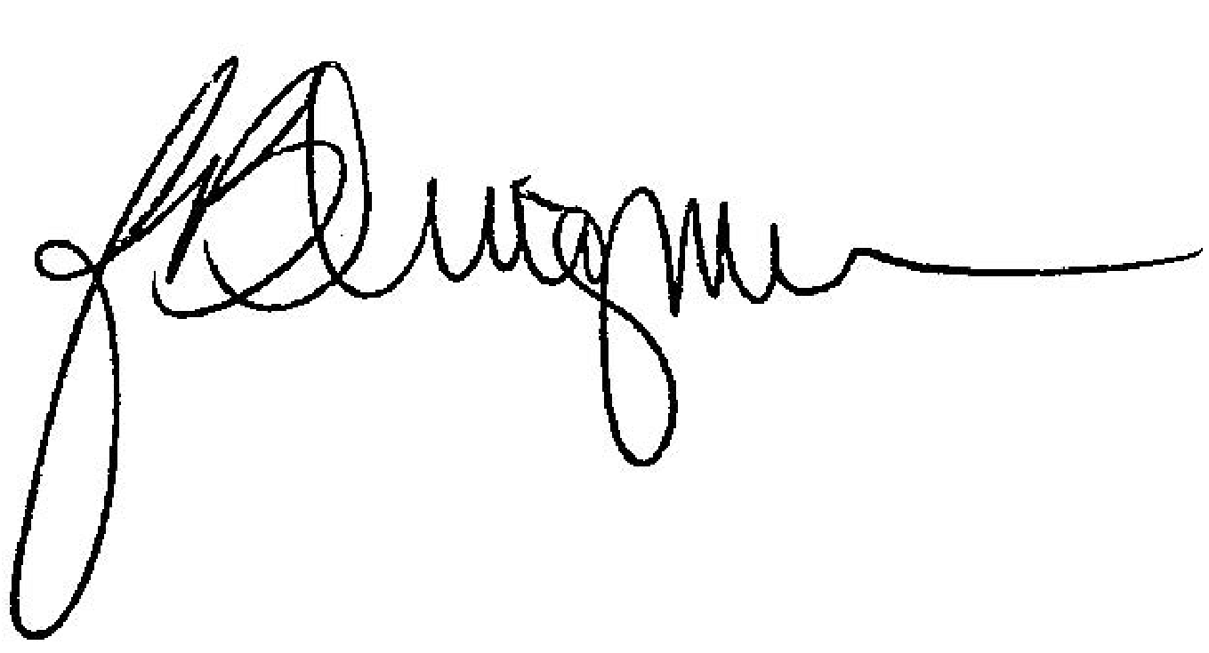
Sincerely,

