Who is homeless?  (McKinney-Vento Homeless Assistance  Act of 2001 – Title X, Part C, of the No  Child Left Behind Act – Sec 725)  The term “homeless children and youth” means:  A. individuals who lack a fixed, regular, and adequate nighttime residence  B. children and youths who are sharing the housing of other persons due to loss of housing, economic hardship, or similar reason;  i. children and youth living in motels, hotels, trailer parks, or camping grounds due to the lack of alternative accommodations, are living in emergency or transitional shelters, are abandoned in hospitals;  ii. children and youths who have a primary nighttime residence that is a public or private place not designed for or ordinarily used as a regular sleeping accommodation for human beings…  iii. children and youths who are living in cars, parks, public spaces, abandoned buildings, substandard housing, bus or train stations, or similar settings; and  iv. migratory children, qualifying as homeless. | Educational Rights under the McKinney-Vento Act  Students who are homeless have the right to attend school, no matter where or how long they lived there  - Attend either the local school or the school of origin, if this is in their best interest; The school of origin is the school the child attended when he/she was permanently housed or the school in which the child was last enrolled  - Transportation to and from the school of origin  - Enroll in school immediately, even if missing records and documents normally required  for enrollment such as a birth certificate,  proof of residence, previous school records, or immunization/medical records  - Enroll, attend classes, and participate fully  in all school activities while the school  arranges for the transfer of records  - Access to the same programs and  services that are available to all other  students including transportation and  supplemental educational services  - Attend school with children not experiencing homelessness; segregation based on a student’s status as homeless is prohibited  - Referrals to health services, housing, and other appropriate services  - Access to early interventions such as Head Start, public preschool, and early interventions  - Assist students with credit recovery from previous coursework completed  - Go to school where all staff have received professional development in identifying, enrolling, and providing assistance with post-secondary education, stability and success for student experiencing homelessness | 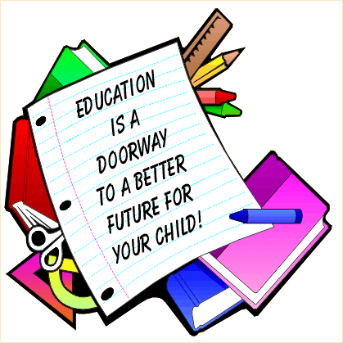Supporting the Education of Children Experiencing Homelessness to Ensure Every Student Succeeds  Braxton  County  Schools
What is NCHE?  The National Center for Homeless Education (NCHE) supports educators, service providers, parents, community members, and others interested in the education of children and youth experiencing homelessness  nche helpline 1 800-308-2145  WEBSITE https://nche.ed.gov  Students experiencing Homelessness  One-half million children attended more than three schools between first and third grade.  15 to 18 percent of school-age children changed residences from the previous year. Frequent school changes have been correlated with lower academic achievement, many elementary students change schools frequently, harming their education. It may take 4 to 6 months to recover academically  Mobile students are twice as likely to repeat a grade  Mobile students are half as likely to graduate from high school  Students who move frequently have lower attendance rates. A 20% absentee rate results in achievement scores 20 points lower than those of stable peers  Mobile students have not had the opportunity to build the relationships needed to be successful in school or life  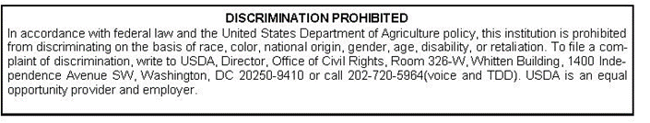 | YOU can STILL Enroll in School!  Do you live in one of these situations?  Is your residence or housing uncertain?  Do you live at a temporary address?  Do you lack a permanent physical address?  The McKinney-Vento Act and West Virginia state law and policy guarantee that you can enroll in school if you live:  In a shelter (family shelter, domestic violence shelter, youth shelter or transitional living program)  In a motel, hotel or weekly rate housing  In a house or apartment with more than one family because of economic hardship or loss  In an abandoned building, a car, at a campground or on the street  In substandard housing (no electricity, no water, and/or no heat)  With friends or family because you are a runaway or unaccompanied youth  You May Be Eligible to….  Continue to attend the school in which you were last enrolled, even if you have moved away from that school’s attendance zone or district, if feasible and in the best interest of the child  Receive transportation from the current residence back to the school of origin  Participate fully in all school activities and programs for which you are eligible | Enrolling in School  Contact the new school for immediate enrollment  Contact the district’s liaison for help in enrolling in a new school or for transportation consideration to the previous school.  Contact the district liaison to resolve any disputes that arise during the enrollment process.  Provide any information necessary to assist teachers in helping your child adjust to new circumstances  Ask the local liaison, shelter staff, or a social worker for assistance with records, clothing and supplies, if needed  Questions to ask the school  What transportation is available to stay in the same school? • If I have to change schools, can someone help transfer records quickly? •  Are any tutoring services available? •  If special education services are needed, how long is the wait for testing? •  Are there special classes to benefit a talent I have? •  Are there sports, music or other activities available to me? • Are school supplies available? • Will I be able to go on class field trips if unable to pay?  Contact Us:  Braxton County Schools, Tim Via, Homeless Liaison  98 Carter Braxton Drive, Sutton, WV 26601  304.765.7101 tvia@k12.wv.us  http://boe.brax.k12.wv.us/  Rebecca Derenge WV State Coordinator for Homeless Ed Bldg 6 Rm 728 1900 Kanawha Blvd., E. Charleston, WV 25305  304.558.8833 rderenge@k12.wv.us  http://wvde.state.wv.us

