Romero Elementary (209) 854-6177

2022 Love Romero Scholarship Application
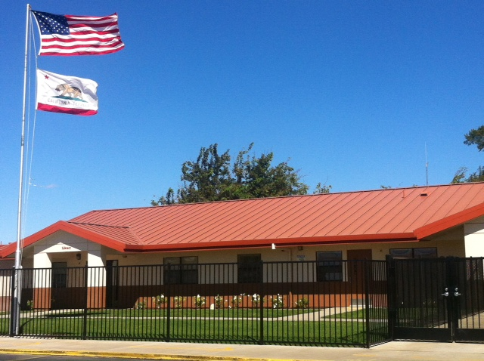
Romero Elementary
*If you are a scholarship recipient, once you have enrolled in a post-secondary program and have your classes, please submit a copy in order to receive your award by November 1, 2022. After this date, scholarship will be forfeited.
Please complete the attached
scholarship application and submit it by
Midnight of April 1, 2022
Late applications will not be accepted.
Requirements:
- Must have attended
Romero Elementary
for at least 3 full years
- Must have a GPA of 2.5
or higher.
- If you are a recipient of our
scholarship, you must show
proof of enrollment (classes)
in a post-secondary program
for the fall 2022 semester in
order to receive your money.*
Please email completed application
to Gail Tallman, gtallman@gustineusd.org ,
mail or bring hard copy by Romero Office.
13500 Luis Rd. Santa Nella, CA 95322
(209)854-6177
Due: April 1, 2022- midnight
Application assistance will be available for
any applicant. Email or call for more information.

We look forward to receiving your
application.
Sincerely,
Romero Elementary

2022 Love Romero Scholarship Application
- Personal Information
First Name:Click here to enter text. | Last Name: Click here to enter text.
Address:Click here to enter text. | Primary Phone:Click here tenter text.
City:Click here to enter text. | E-mail:Click here to enter text.
Years/Grades attended Romero Elem. | Click here to enter text.
GPA (please attach current transcript)  Do you give us permission to use your photo for advertisement? Yes___ No_____  *We would like to invite you to come out and help at Love Romero, April 2, 2022 | Click here to enter text.

- Personal Statement, please type on new page and send with application. No more than one page, double spaced include any or all of the following:

- What is important for us to know about you?
- How have you contributed or given back to your community?
- Future educational plans?
- Anything else that makes you stand out from your peers?

- Record your activities below or type resume on new page

School Organizations, Awards, Offices Held: Click here to enter text.
Community Activities: Click here to enter text.
Why do you feel continuing your education is important?
Click here to enter text.

Please outline your long-term goals:
Click here to enter text.

Click here to enter text.

