Public Information Session
Our first public information session regarding the April 5th referendum will take place on Wednesday, February 23rd at 6:00 in the High School’s lecture hall.

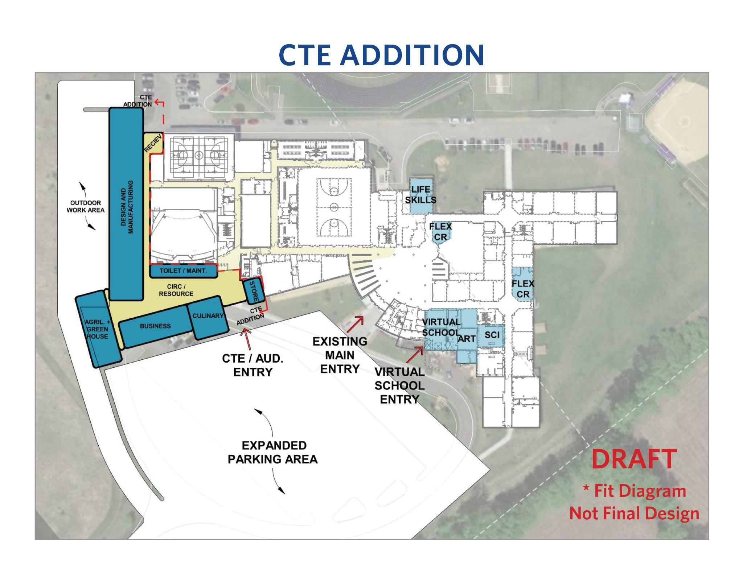
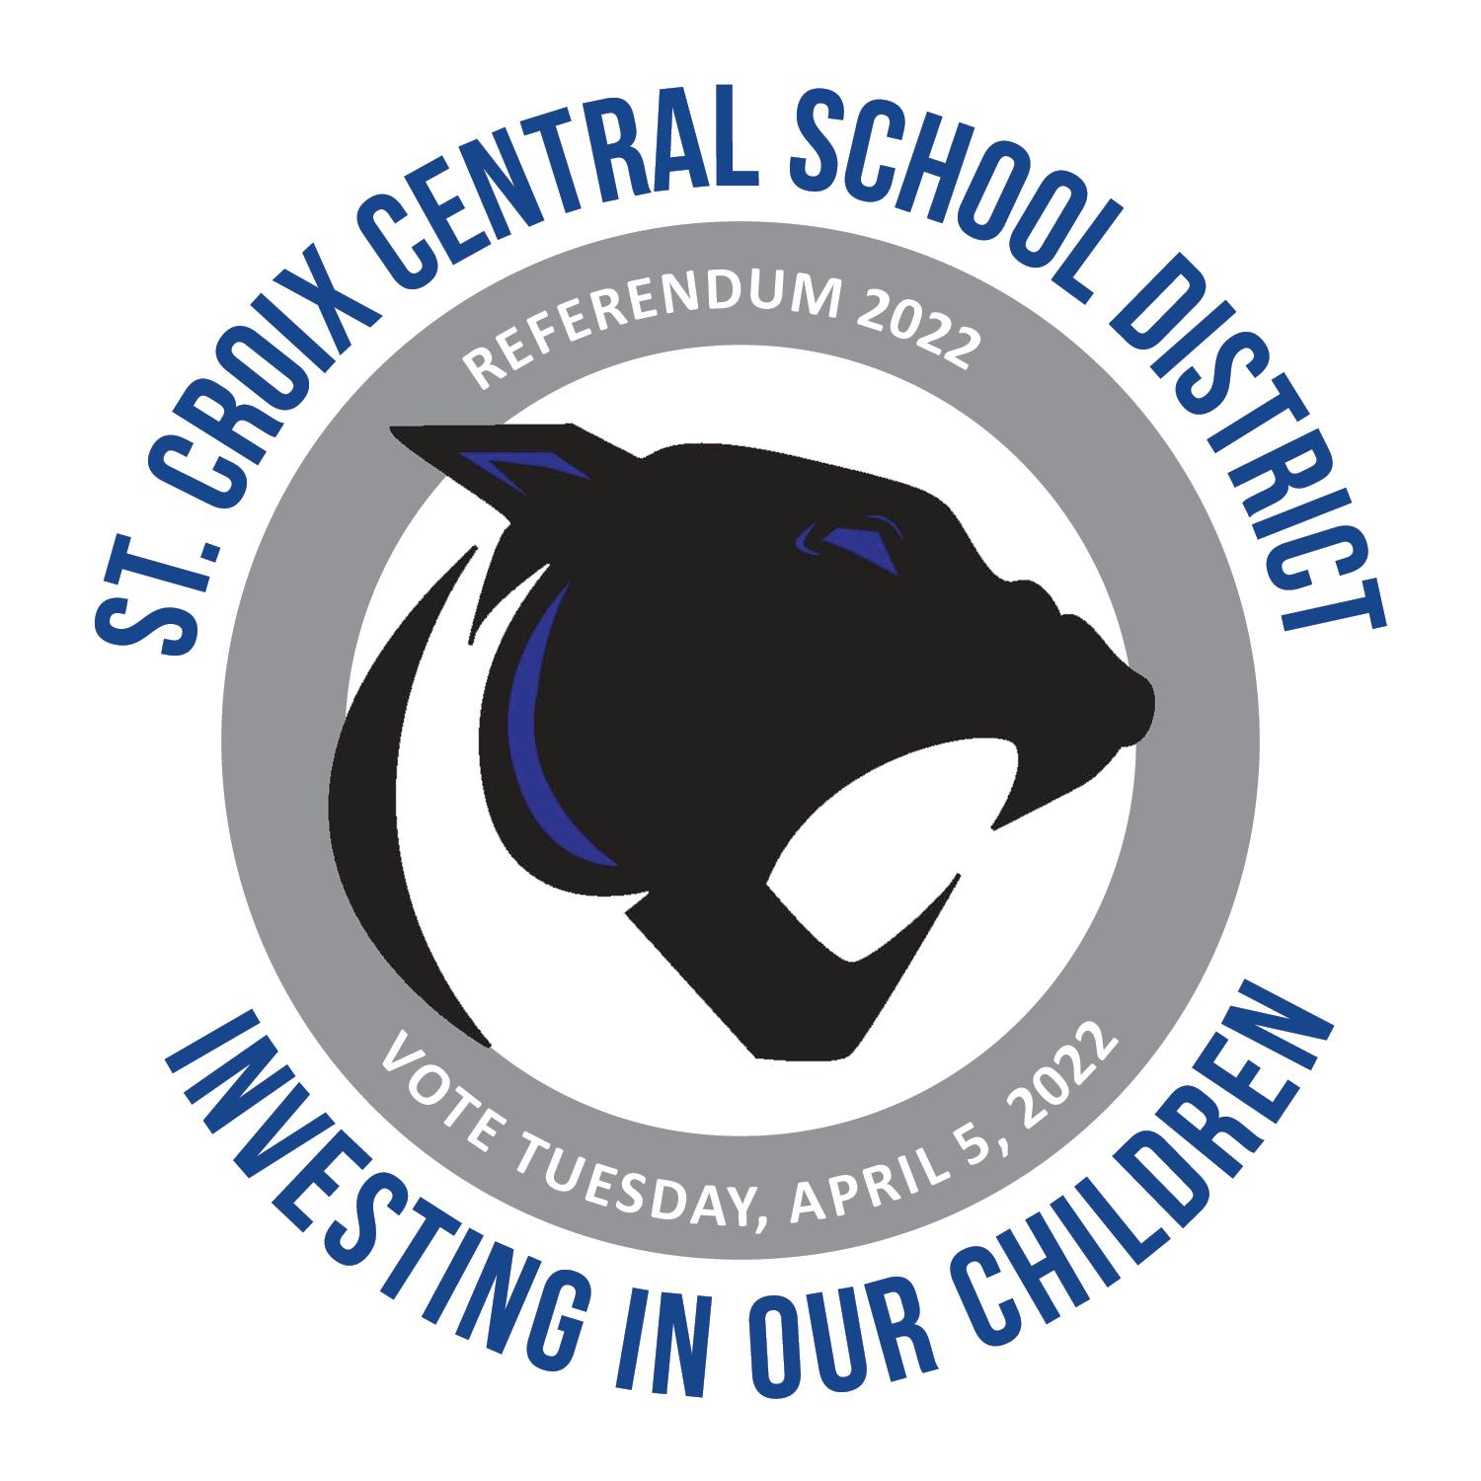
Please join us for a brief presentation about this year’s referendum, a tour of the areas that would benefit from the referendum and to have any questions that you may have answered.

