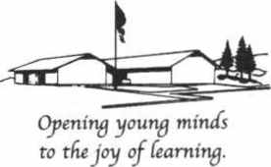
Tres Pinos Union School
5635 Airline Highway - P.O. Box 188
Tres Pinos, California 95075-0188
(831) 637-0503
Fax: (831) 637-9423

February 7, 2022
Dear Parent or Guardian,
Your child is being asked to take a survey at school. The survey includes questions about alcohol, tobacco, and other drug issues, as well as questions about school safety and the learning environment. Student participation in the survey is voluntary. We hope that you will give permission for your child to participate in the survey so that his or her opinion and knowledge can be used to improve the school.
The survey is anonymous. No names or any other identifying information is connected to the answers except for the name of the school.
If you have questions, please contact Mrs. LoBue at 831 637-0503.
If you wish to view the survey, you may do so at the school office or go to our website at trespinosschool.org.
Sincerely
Mrs. Mendes-LoBue
Superintendent/Principal

---------------------------------------------------------------------------------------------------------------------
Parent Consent Form for the California Healthy Kids Survey

Please check below whether you grant permission, sign and return this form within three days to your child’s teacher.

_____ I give permission for my child to be in the California Healthy Kids Survey.

_____ I do not give permission for my child to be in the California Healthy Kids Survey.

Signature: ____________________________ Date:___________________

My child’s name is:________________________________
(Please Print)

