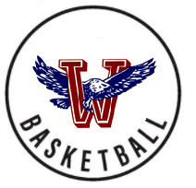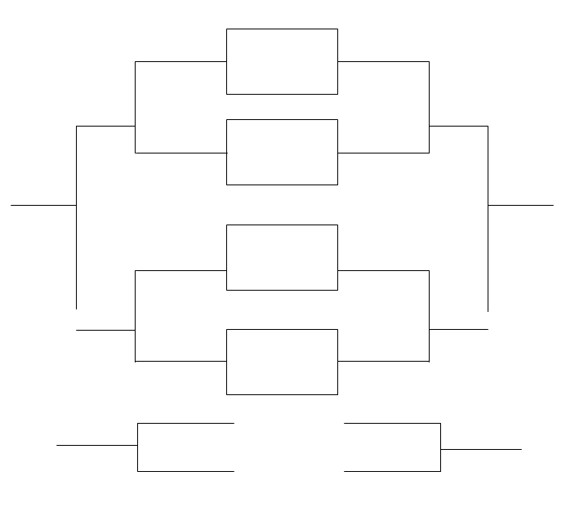

Nemaha Cent 30

**2022**

*\*\* THE TOP TEAM IS CONSIDERED THE HOME TEAM &*

*WILL WEAR THEIR WHITE UNIFORMS \*\**

Wellsville, KS | January 25th, 27th, 29th

**SATURDAY**

**THURSDAY**

**TUESDAY**

**THURSDAY**

**SATURDAY**

(3) NEMAHA CENT 54

**BLUE GYM**

**6:30**

(6) LOUISBURG 47

(2) HAYDEN 58

**BLUE GYM**

**5:00**

(7) BALDWIN 38

(4) JEFF WEST 26

**K.D. GYM**

**6:45**

(5) SPRING HILL 43

(1) LANSING 68

**K.D. GYM**

**5:15**

(8) WELLSVILLE 8

**BLUE GYM**

**6:30**

**BLUE GYM**

**5:00**

**KD GYM**

**5TH 1:15**

Baldwin 41

Louisburg 44

Louisburg

Jeff West

Jeff West 53

Wellsville 13

**K.D GYM**

**3RD 3:15**

**BLUE GYM**

**7TH 1:00**

Baldwin

Wellsville

Hayden 32

Nemaha Central

Lansing

**K.D GYM**

**6:45**

**K.D GYM**

**1ST 5:00**

**K.D GYM**

**5:15**

Hayden

Spring Hill

Spring Hill 59

Lansing 54

TOP GUN TOURNAMENT

WELLSVILLE 32nd ANNUAL