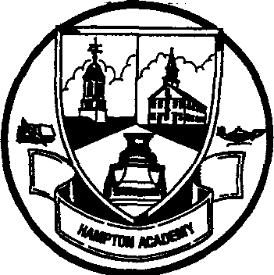 | 29 Academy Avenue  Hampton, New Hampshire  03842  Phone: 603-926-2000  Fax: 603-926-1855  http://www.sau90.org/ha
Hampton Academy

Dear Family,

We are notifying you because a case of COVID-19 has been identified in your child’s classroom (8 Academy). Your child may have been exposed, Thursday, 1/27.

COVID-19 is most commonly spread through respiratory droplets when an infected person talks, coughs, sneezes or sings. The symptoms for COVID-19 are:

· Fever/chills (measured 100.4F)
· Headache
· Cough
· New loss of taste or smell
· Shortness of breath or difficulty breathing
· Nausea or vomiting
· Sore throat
· Diarrhea
· Runny nose or nasal congestion
· Fatigue
· Muscle or body aches

The current recommendation from NH Department of Health and Human Services for people who may have been exposed to COVID-19 in the school setting is:

For 14 days from the last exposure,
· Monitor for COVID-19 symptoms listed above and
· Wear a mask in indoor public settings and
· Consider testing 3-5 days following the last day of exposure

If your child develops symptoms please isolate them at home and seek testing for Covid-19. https://www.covid19.nh.gov/resources/testing-guidance Symptomatic students or staff can be allowed to return to school when one of the following two conditions is met:

1. Person receives an FDA-approved COVID-19 test that is negative, AND the person’s symptoms are improving and they are fever-free for at least 24 hours off any fever-reducing medications.
Approved tests include:
a. A PCR-based molecular test
b. Antigen testing conducted within an appropriate number of days since symptom onset
2. Person has met CDC criteria for ending home isolation https://www.cdc.gov/coronavirus/2019-ncov/hcp/duration-isolation.html (i.e., if a person is not tested, they are managed assuming they have COVID-19).

Our school is working closely with the New Hampshire (NH) Department of Health and Human Services (DHHS) to follow the guidance they have provided for this situation and will provide updates should their recommendations change.

Should you have any questions or concerns, please contact the school nurse: Karen Brand R.N.

Sincerely,

David O’Connor Karen Brand, R.N
Principal School Nurse

