Paris School District Plan for Safe Return to In-Person Instruction and
Continuity of Services
2021-2022
Updated January 21, 2022

January 18, 2022

COVID Reporting Form
In the event your student tests positive for COVID, please complete the Google Form at the attached link. COVID Reporting Form
Thank you for your help!
Paris School District

January 11, 2022
Mask Mandate - Update
During a special called board meeting on January 11, 2022, the the Paris School Board reinstated the mask mandate effective tomorrow, January 12.

January 6, 2002

Letter to Parents
Parents
Covid cases, especially the Omicron variant, are on the rise statewide prompting once again the possibility of students being sent home to quarantine. Please remember that if a student is fully vaccinated and has no symptoms after exposure they are exempt from quarantine and will not be sent home. If your child is vaccinated please remember to share that information with our Wellness Center Director, Shawna Clayton, RN.
Also, our district has chosen to “opt-in” to the Test-to-Stay program in Arkansas. If your child is exposed while at school you will be given the choice to have your child tested at school. If your child tests negative during the testing period, they will be allowed to stay at school. This is voluntary but, another avenue that allows students to remain in the school setting.
As always, if you have questions please feel free to contact Shawna Clayton, Wellness Director at sclayton@parisschools.org or call toll free 844-963-3243. We will continue to clean and disinfect, practice distancing and employ whatever mitigation strategies necessary to contain the potential spread of the virus.
R. Wayne Fawcett, EdD
Superintendent
Paris School District

October 20, 2021

COVID - 19 "Test to Stay" Modified Quarantine Guidance Plan
The Paris School District wants to help our students stay in school. One way to do this is to provide probable close contacts with another option to remain on-site for educational purposes. To do this, the District will follow the “Test to Stay" Modified Quarantine Plan. In utilizing this plan, we can minimize disruptions for both students AND staff and keep students attending in-person instruction.
For more information, please read the Supplemental Guidance for a "Test to Stay" Modified Quarantine Plan below. If you have any questions, please contact Shawna Clayton, RN, Wellness Center Director, and Point of Contact for the Paris School District at sclayton@parisschools.org
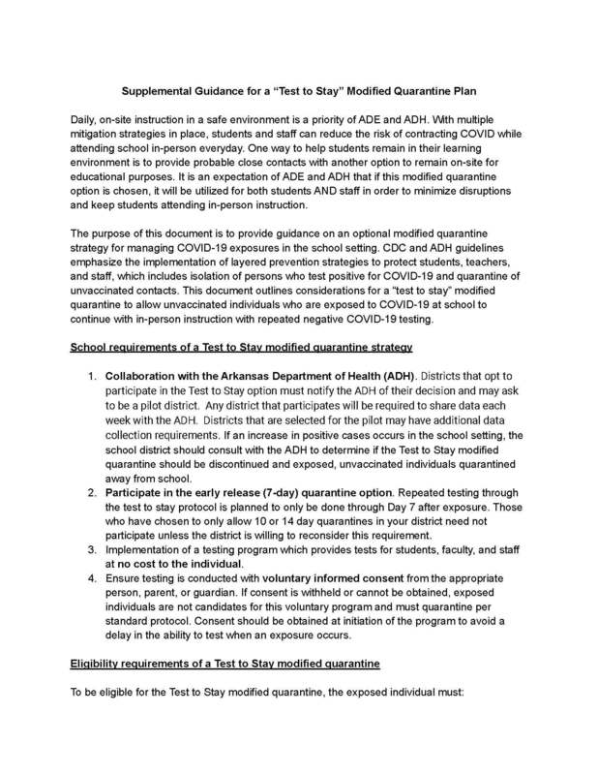

October 19, 2021
Protocol changes for K-12 Schools:

The definition of a close contact in a school setting has changed from within 6 feet for 15 minutes to within 3 feet for 15 minutes.

Test-to-stay protocols now apply to extracurricular activities instead of only apply to the school day.

Remember:

Vaccination eliminates the need for quarantine.

If both the case and the contact are masked, there is no need to quarantine.

October 12, 2021 Board Meeting
The Board voted in favor of keeping the mask policy

CONTACT TRACING

The Paris School District Point of Contact (POC): Shawna Clayton, RN, Wellness Center Director 844.963.3243 EXT. 3099 or 479.518.7720

The Paris School District will continue to wear masks to help mitigate the spread of COVID – 19 in our schools. CDC guidance states, “When teachers, staff, and students consistently and correctly wear a mask, they protect others as well as themselves. Consistent and correct mask use is especially important indoors and in crowded settings, when physical distancing cannot be maintained.” The CDC currently recommends the following regarding the wearing of masks in school settings:

● Indoors. CDC recommends indoor masking for all individuals age 2 years and older, including students, teachers, staff, and visitors, regardless of vaccination status.
● Outdoors. In general, people do not need to wear masks when outdoors. CDC recommends that people who are not fully vaccinated wear a mask in crowded outdoor settings or during activities that involve sustained close contact with other people. Fully vaccinated people might choose to wear a mask in crowded outdoor settings if they or someone in their household is immunocompromised.
- PHYSICAL DISTANCING
CSD will continue to promote physical distancing and follow CDC recommendations which include schools maintain:
● at least 3 feet of physical distance between students within classrooms, and
● at least 6 feet between students and adults, and between adults who are not fully vaccinated.
- HANDWASHING
Sanitation and cleanliness will be a high priority for our district as we return in the fall. We will be cleaning high-touch surfaces (doorknobs, light switches, etc.) and restrooms continuously throughout the day. In addition, we will provide time for handwashing, and hand sanitizer is available throughout all campuses. Students are asked to sanitize their hands each time they leave and enter a space.
- RESPIRATORY ETIQUETTE
Teachers and staff will continue to train and promote sneezing/coughing into one’s elbow, using tissues and throwing them away, and washing/sanitizing hands after touching your nose or mouth. Social distancing will be encouraged as well.
- MAINTAINING HEALTHY FACILITIES
Staff is provided additional cleaning supplies to continue with current sanitation procedures even though CDC now states:
“The virus that causes COVID-19 can land on surfaces. It’s possible for people to become infected if they touch those surfaces and then touch their nose, mouth, or eyes. In most situations, the risk of infection from touching a surface is low. The most reliable way to prevent infection from surfaces is to regularly wash hands or use hand sanitizer.” Link to CDC website on Cleaning Your Facility

LINK to the COVID – 19 Information on the Arkansas Department of Education (DESE) webpage

LINK to the AR Ready for Learning page that contains current guidance to schools

Paris School District reviewed its plan (see below) for safe return to in-person instruction and continuity of services on August 9, 2021, during a Ready for Learning Committee email meeting. During the meeting, participants reviewed the mask policy and it was a consensus to keep the mask and this will be discussed at the board meeting on August 12, 2021.

August 9, 2021

Wayne Fawcett <wfawcett@parisschools.org>

Members of the Paris School District Reopen/Relearn Committee

You only thought your time on this committee was over! Honestly, so did I but Covid doesn't seem ready to relent.

One month ago, I was optimistic that we would have a much more "normal" school year. Yes, we would have to continue to take some precautions but we expected things to be back to pre-March 2020 routines. But as we all know the Delta variant is affecting younger people and is much more transmissible. Consequently, we will implement many of the strategies that we had last year: distancing, shields, split lunches, sanitizing, cleaning, etc. The one option that is undecided and currently a political football is masks.

As you are aware Act 1002 of 2021 prohibits the implementation of a mask mandate in public schools (private schools can mandate them). It went into effect July 28, 2021. However, last Thursday, August 5, 2021 Judge Tim Fox in Pulaski County issued a temporary injunction prohibiting the implementation of the law in response to a lawsuit filed on behalf of some parents. The effect is Act 1002 CURRENTLY cannot be enforced which means a mask mandate CAN be implemented, at this time. There is no doubt that the Arkansas Attorney General will appeal the ruling whether to circuit court or to the Arkansas Supreme Court. This leaves school districts in limbo as to whether to ask their local boards to approve masks or not since at any moment a court may rule that the law can be implemented OR the AG loses and appeals again to another court that then may rule either way.

Which brings me to my email. Please let me know your thoughts about a mask mandate in the Paris School District. Last year it was a statewide mandate issued by the Governor. That will not happen this time, it will be a local decision by each local school board. There are many opinions and some options. No mandate at all, mandate only those that cannot be vaccinated (ages Pre-K-11 years old), total mandate for all students and staff, etc.

I am writing this on Monday, August 9, 2021, one week before school starts. There is a board meeting Thursday, August 12, 2021 at 5:30 pm. While I am not advocating for any decision at this time and, given the fluid situation with the courts, it is not certain when any decision can or will be made. My purpose is to simply gather information and opinions for our board. Either way it is a difficult decision when and if one can be made.

Thank you in advance for your time and thoughts on a difficult topic. As always feel free to call, write or come by if I can help in any way.

August 2, 2021

Paris School District Employees

As we get closer to the beginning of the school year I have purposely waited as late as possible to give you the most recent and updated information. A month ago I was excited that we appeared ready to have a relatively "normal" school year. But, at this point it is obvious that we are once again faced with serious issues to start the school year. In some ways we are better off than we were last year. We have a vaccination that has proven to be effective in combating the virus, IF someone is vaccinated and becomes a close contact with someone infected they DO NOT have to quarantine. Even if not vaccinated and two people both have masks on and one is positive the other does not have to quarantine and, students at age 12 and above are eligible for vaccination. However, we also know that the current variant is much more transmissible than a year ago and it is affecting younger people. Last year we had an emergency declaration from Governor Hutchinson that allowed us to require masks for everyone in our school buildings but, now that is not legally possible and only rises to recommended status. Last school year we had 88 positive cases among staff and students and through contact tracing we were able to determine that not a single case was transmitted at school. This was no doubt because of everyone's effort to wear masks, sanitize, distance, etc.

I was adamant that we would not have a virtual option available for the coming school year given the success we had last year and the relatively low number of cases statewide, countywide and within the boundary of our district. But, things have changed quickly in the last 30 days. After informal consultation with the board I feel that we must offer a virtual option to a very limited number of students. Parents are apprehensive about sending their children to school even though we know we can and will be successful in offering a clean and safe environment. Multiple conditions must be met for a student to avail themselves of a virtual option. Included are the following conditions:
1. There will not be blanket approval to any and all requests. Students will have to apply to their respective buildings using an application process unique to each building. Principals will establish a committee that will review the application and determine whether the student qualifies.
Appeals will be to the superintendent only.
2. Lack of success in the virtual option last year will almost certainly eliminate the possibility for 2021-22.
3. There must be extenuating circumstances in order to qualify. Each situation is different and will be judged on its merits. Simply being concerned is not sufficient.
4. If permission is granted the district will reserve the right to revise or rescind the permission at any time.
5. If permission is granted and a student fails to contact the school as set forth they may be subject to being referred to the juvenile prosecuting attorney.
This is not an exhaustive list and there may be conditions specific to each building. Students in the virtual option will be the exception rather than the rule.
We submitted our tentative DLP (District Learning Plan) to DESE Friday and will continue to refine it ahead of when it will be presented to the State Board of Education. Specifics will be discussed later.

The Paris School District will be offering a vaccination clinic for staff only on Monday, August 9. If you are interested in getting either your first or second dose contact Shawna Clayton. As always receiving a vaccination is a personal choice and is not required by the Paris School District.

We will continue to screen staff to begin each day. Nurses or their designees will be screening for symptoms related to Covid until further notice. I will be contacting the 2020-21 PPC later this week to discuss revisions to the Covid leave policy from last year for presentation to the board at the August 12 meeting.

Given the rate of positivity and hospitalizations, and at the risk of being a pessimist, it is likely that we will begin the school year with immediate positive cases and quarantine. The Marion School District operates on a hybrid schedule starting last week. Within a week they sent 168 students and 3 staff members to quarantine. Unfortunately we must be prepared again this year for disruptions caused by the virus. All of the building administrators have been working on plans to begin the school year to be as prepared as possible and have and will continue to share those plans with everyone.

Tomorrow I will release information to the public about issues such as those discussed here. Information will be posted on the district web site, Facebook page and I will provide a short video. Each building will also provide building level specificity on their respective web sites.

As always I appreciate the job that each of you do daily for the students in the Paris School District. The coming year comes again with uncertainty but, the strength and commitment of the Paris School District staff insures the best will be available for our students.

Thank you

RWF

