Mount Vernon School District
Return to Learning Plan/Safe Return to In-Person Instruction and Continuity of Services Plan
2021-22

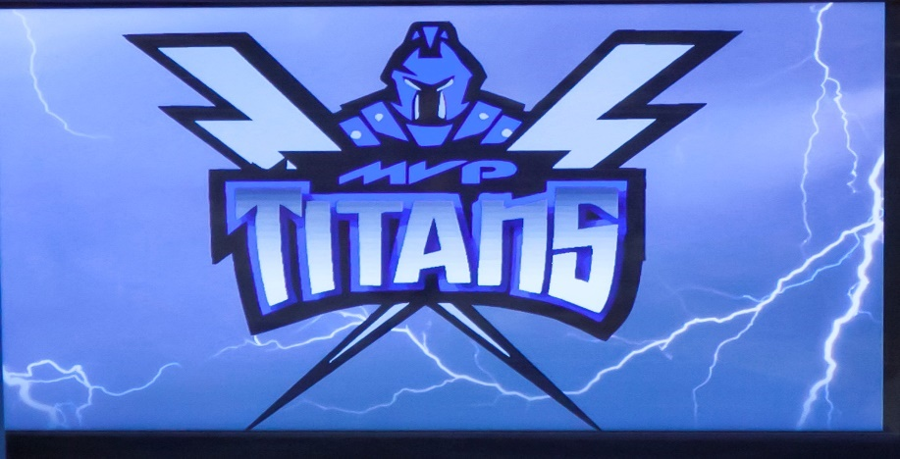

2021-22 Return to Learn Plan/Safe Return to In-Person Instruction and Continuity of Service Plan Dates
Last Revised: January 17, 2022
Board Reading January 19, 2022
Board Adoption: January 19, 2022

Message from the Superintendent
The Mount Vernon School District is committed to a safe and secure learning environment for all its students and staff. Due to the COVID-19 pandemic, our district has developed a learning plan with protocols for the 21-22 school year written with flexibility for our district to help ensure a quality learning experience for all students.
At this time, the Mount Vernon school board has adopted a position on masks. At this time masks will be a matter of personal preference. The school board retains the right to adjust provisions of the plan as needed. Our District’s plan is to begin the 21-22 school year on Thursday, August 19, 2021, with a normal learning environment. The Mount Vernon School District’s 2021-2022 Return to Learning Plan/Safe Return to In-Person Instruction and Continuity of Services Plan contains information regarding Delivery of Instruction, Online Learning, Modified Alternative School, and Extracurricular Activities. To meet the requirements of the American Rescue Plan Act Elementary and Secondary School Emergency Fund (ARP ESSER), the Mount Vernon School district needs to re-evaluate our “Safe Return to In-Person Instruction and Continuity of Services Plan” every six months. As per the United States Department of Education’s ARP ESSER requirements, our plan must include the following:
- Date of school board approval (pg. 1)
- Date of Last review (pg. 1)
- Contact person for questions (pg. 8)
- Accessible to parents who speak a language other than English and individuals with disabilities. (pg.8, website URL: Spanish Version
- Accessible (easily) on our website (pg. 8, English Version
- Plan components to address how the district will maintain the health and safety of students, educators, and other staff; and the extent to which the district has adopted policies, and a description of such policies, on each of the Center of Disease Control and Prevention’s (CDC) safety recommendation including, at a minimum:
  - Universal and correct wearing of masks (pg. 4)
  - Modifying facilities to allow for physical distancing (may include cohorts) (pg. 5-6)
  - Handwashing etiquette (pg. 6)
  - Respiratory etiquette (pg. 6)
  - Cleaning of facilities (pg. 6)
  - Maintaining healthy facilities (may include improvements to ventilation) (pg. 6)
  - Appropriate accommodations for children with disabilities with respect to Health and safety policies (pg. 6)
  - Contact tracing in collaboration with state, local, and (as applicable) tribal health officials (pg. 6)
  - Quarantine policy for close contacts, whether identified in the school setting or outside of the school setting, in collaboration with state, local, and (as applicable) triable health officials (pg. 5-7)
  - Isolation policy for positive COVID-19 cases, in collaboration with state, local, and (as applicable) tribal health officials (pg. 5-7)
  - Diagnostic and screening testing for COVID-19 (pg. 7)
  - Efforts to provide vaccinations for eligible members of the school community. (pg. 7)
  - Coordination with state and local health officials (pg. 7)

- Plan to include how the district will ensure the continuity of services for in-person, remote, and/or hybrid students as applicable, including at minimum:
  - Services to address students’ academic needs, including learning loss (pg. 8)
  - Students’ social, emotional, and mental health needs (pg.
  - Staff members’ social, emotional, and mental health needs
  - Foodservices, and Student health, if not addressed in the above
Within this document, you will find the factors associated with the Learning plans from Normal Learning to Virtual Learning. The information within this document depicts how the Mount Vernon School District meets the requirements of the American Rescue Plan Act Elementary & Secondary School Emergency Relief Fund (ARP ESSER). The health and safety of our students, staff, and families will continue to drive the decision making that will go into the 2021-22 school year.

Sincerely,

Clint Nelson, Superintendent/Elementary Principal
Mount Vernon School District

The following district plan outlines the processes the Mount Vernon School District will use to facilitate the COVID-19 pre-cautions and implementations of student learning and safety for the 2012-22 school year.
Before school at home:
Checklist for Students/Parents (will be provided) – keep kids at home if sick or exhibiting symptoms, we recommend you become aware of your children’s normal temperature range and discuss their overall health with them. Follow the checklist on website.
Busing/Transportation
Due to the inability to social distance and limited quality air environment masks will be encouraged but remains a matter of personal preference.
We will communicate expectations for the bus and the risks of riding the bus for students. No guarantee for social distancing but will do what is practical.

Students arrive at school -7:45 arrival time: no earlier for all students.
- If a student shows any symptoms, which includes, fever, chills, cough, nausea, etc. Students will be monitored, and parents will be notified of the symptoms or possible illness to return home for the day.
-The student can return to school when they are 24 hours symptom/fever-free without fever-reducing medication. This is the procedure for all illnesses. It is suggested that parents contact their healthcare provider for guidance during an illness/absence and prior to returning to school and closely monitor student’s symptoms at home.
We will encourage students and parents to communicate daily with teachers on their current health and well-being.
Parents are encouraged to limit entry to bare minimum. We recognize the apprehension and difficulty some students may have, however the sooner we can limit parent presence the better. Parents will wait in the main entrance lobby upon dismissal.
If face masks become necessary, they will be available upon request if needed or students can wear their own. Students will be educated on the use of masks. Students will be educated on the fact that different people have different health circumstances that either prevent or necessitate the need for a mask. We will emphasize the school boards or other legal entity’s decision regarding masks and those decisions will have to be accepted regardless of personal feelings one way or the other. Bullying is recognized as a concern and will be addressed with all students and staff when incident occurs.
Delivery of Instruction - Normal in person instruction day to day
The school will be in session as normal as possible as in prior school years.
For extended absence due to Covid-19, students will be accommodated by district staff utilizing distance learning platforms. It will be a different experience and will be supported by learning packets in Elementary for those that need it.
If a student is deemed a close contact, the following measures will be followed: the mask mandate will be implemented, and an alternative lunch setting will be provided.
If a student or faculty member tests positive for Covid-19, they will isolate at home for 5 days and return to school symptom free and with a mask on. The remaining allotted 5 days with a mask on, can be removed by taking a Covid test on return. One negative test is needed to remain out of a mask. All Covid tests for students MUST have PARENTS permission prior to testing. We are not using vaccination status as a guideline.

If a student or faculty member is deemed a close contact, they will be in a mask for 5 total days or have the option to take a Covid test. Any school day in a mask that falls within that 5-day window, student will need a negative test to remain out of a mask. All Covid tests for students MUST have PARENTS permission prior to testing. We are not using vaccination status as a guideline.

A close contact is anyone deemed in the vicinity of 6 feet of a positive test for 15 minutes.

If a student chooses to stay home for the window of 5 days rather than wear a mask in school, there will be no expectation of alternative instruction if the choice is to stay home. Notification must be made to the school if students choose to stay home.
Close contacts choosing not to come to school, will not be allowed to participate in school activities on those designated days.
Parents/Guardians will be contacted by the school if their student is deemed a close contact and placed in a mask or given the option to test out of a mask.
Short-Term Schedule – Reverting to Online Learning (could be a class, school level, or the whole district)
School reserves the right to E- Learning when factors relating to illness, require the school to close for a short period of time.
Special Education
The Mount Vernon School District Special Education Department is committed to providing necessary and appropriate educational opportunities for students with disabilities to the greatest extent in accordance with the guidance from the US Department of Education, SD Department of Education, SD Department of Health, CDC guidelines and the state of South Dakota.
Collaboration with families will continue to be an integral part of the special education process. The district will address the individual needs of each student with disabilities, special education staff will continue to work with families to provide the necessary services in the normal learning setting or when remote learning must become an option. Individual Education Plans (IEP’s) may be adjusted, as needed, for circumstances of the learning environment based on students’ needs and services. Staff will work diligently to provide special education services.
Lunch
If a student is deemed a close contact, the student will eat in a designated area where social distancing/isolation is exhibited. The student will return to the normal lunch routine after the completion of the quarantine.

Extracurricular Activities
Come at your own risk. Participate at your own risk. We encourage fans to follow hosting schools’ policies regarding masking and social distancing. Masking for active extracurricular participant will be held at the coach’s discretion.
Teacher considerations
Self-check prior to coming to school. Checklist provided.
If I am identified as positive and I can teach, I will teach from home. I will provide a professional learning opportunity. This will be case by case and we will consider the situation. We want teachers to teach via distance if capable when we have to.
Choosing to stay at home and work is not an option unless you have a proven medical condition with medical documentation that prevents or restricts you from teaching your assigned duties. Contractual Issues will need to be discussed with the school’s attorney. Contact administration about personal medical conditions that are a concern. Consideration for release of your contract will be given to all if you feel you cannot perform the expected duties as assigned.
The ability for the teacher to teach while being placed in isolation or quarantine by the state DOH will be case-specific.
Consideration for all staff as a Critical Infrastructure Need.
Mitigation Practices and Procedures School and Classroom Environment:
Encourage students to avoid touching their eyes, nose, and mouth.
Increased cleaning efforts from all students/staff (rooms during day) custodial after school to ensure surfaces are disinfected.
Signage will be posted for proper hygiene practices strategically around the building.
Continue cleaning protocol for hallways, student lockers 4-12, bathrooms, and door handles during the day custodial staff.
Continued usage of HVAC air filtration systems that help kill the virus. The ionizer creates electric charge in the air-kills the majority of all viruses.
Seating charts will be used in the classroom when applicable, to limit exposure and assist with contact tracing information.
Contact tracing will be followed.

Safe Return to In-Person Instruction and Continuity of Services Plan
Diagnostic and Screening Testing for COVID-19
During the 2021-22 school year, the Mount Vernon School district will use both the Diagnostic Abbott BinaxNOW Rapid Antigen testing materials (symptomatic testing) and the Quidel QuickVue COVID-19 over the counter (OTC) testing materials (symptomatic/asymptomatic testing).
Vaccination Efforts to Eligible Members of the School Community

During the 2020-21 school year, Lewis Drug offered COVID-19 vaccines to Mount Vernon School District staff members.

State and Local Health Official – Coordination Efforts

The Mount Vernon School District will in good faith, work with local and state health officials when managing COVID-19 cases.
Continuity of Services
Learning Loss
The Mount Vernon School District will track learning progression via state, local, classroom, and NWEA assessments. Learners who need additional support and services may be eligible for summer school learning opportunities, classroom interventions, and after school remediation. Provided services would take place during the school year and/or during supervised summer sessions.
Student Needs -Social, Emotional, and Mental Health
The Mount Vernon School District will continue to meet student social, emotional, and mental health needs through the following avenues: (a) district-provided school counseling, (b) character development programming appropriate to each grade-level during Titan Time, (c) relationship building between students and staff.
Staff Needs -Social, Emotional, and Mental Health
The Mount Vernon School District will address staff social, emotional, and mental health needs through the following avenues: (a) professional development activities/sessions focused on mindfulness, well-being, and gratefulness, and (b) by maintaining a work environment conducive to communication and collaboration amongst all individuals.

Accessibility
The Mount Vernon School District will post English and Spanish versions of this document online. Individuals with issues accessing information due to language or disability should contact Clint Nelson via email (clint.nelson@k12.sd.us) or phone (1-605-236-5237). Plan Location: https:// Documents | Mount Vernon School District (k12.sd.us)
Board Action: The School Board has been kept abreast of the plan and reserves the right to change elements of the plan at any time. The fluidity of the situation will demand changes be made. These are recommendations being made for the School Board’s consideration. The School Board will make the final decision on the plan’s implementation and restructuring. The School Board has legal right to adopt and implement all policies and procedures.

Stakeholders and Communications
The Mount Vernon School District will keep all stakeholders informed through email, district messaging systems, our website, and our social media platform – live, feed, and Facebook. The district must communicate in a timely manner about the model(s) of education delivery, procedures, and protocols that are specific to each building. A successful Return to Learning Plan will require the support and full investment of all stakeholders.

Mr. Clint Nelson Mr. Eric Denning
Superintendent/Elementary Principal 6-12 Principal/Athletic Director
605-236-5237 605-236-5237
Clint.nelson@k12.sd.us Eric.denning@k12.sd.us

Mrs. Allison Sandland
Business Manager
605-236-5237
Allison.sandland@k12.sd.us

