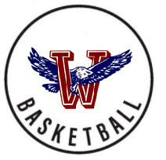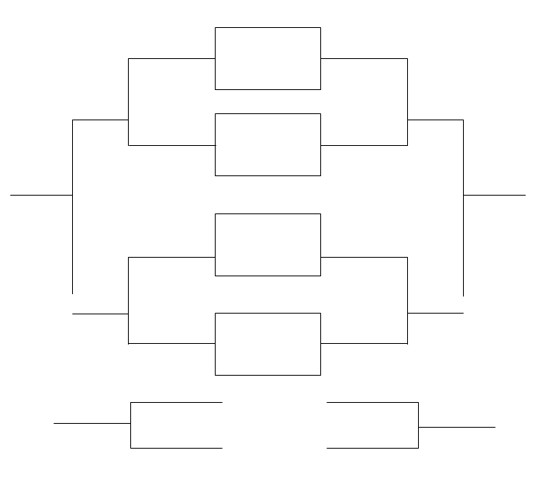

**2022**

*\*\* THE TOP TEAM IS CONSIDERED THE HOME TEAM &*

*WILL WEAR THEIR WHITE UNIFORMS \*\**

Wellsville, KS | January 25th, 27th, 29th

**SATURDAY**

**THURSDAY**

**TUESDAY**

**THURSDAY**

**SATURDAY**

(3) NEMAHA CENT

**BLUE GYM**

**6:30**

(6) LOUISBURG

(2) HAYDEN

**BLUE GYM**

**5:00**

(7) BALDWIN

(4) JEFF WEST

**K.D. GYM**

**6:45**

(5) SPRING HILL

(1) LANSING

**K.D. GYM**

**5:15**

(8) WELLSVILLE

**BLUE GYM**

**6:30**

**BLUE GYM**

**5:00**

**KD GYM**

**5TH 1:15**

**K.D GYM**

**3RD 3:15**

**BLUE GYM**

**7TH 1:00**

**K.D GYM**

**6:45**

**K.D GYM**

**1ST 5:00**

**K.D GYM**

**5:15**

TOP GUN TOURNAMENT

WELLSVILLE 32nd ANNUAL