Visit Marysville - A Marysville Minute

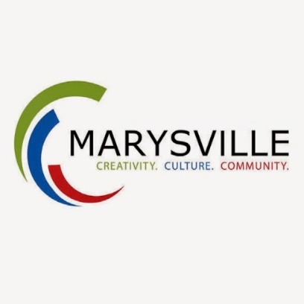

Moving to our community or just visiting? Visit our YouTube Channel to learn all you can about our wonderful community.
https://www.youtube.com/channel/UCnIUCxRWjZCNSuvgWuxIitQ/feed

