Cougar Booster Club
Campbellsport High School Athletic Booster Club

June 2018 Newsletter

Booster Club News
NEW MEMBERS NEEDED—Many of our current active members have children who have graduated or will be graduating. In order to keep the Cougar Booster Club running, we need parents to become involved. The Booster Club has provided funding for numerous items for our school programs. For example: concession stand at softball & soccer fields, storage sheds, scoreboards, video equipment, weightroom equipment, ShotKam units for trap, team bags, team posters, etc. The list is large and many updated items will be needed in the future. PLEASE CONSIDER BECOMING INVOLVED—MORE HANDS, LESS WORK!!!

Upcoming Events
*Cougar Dash – July 4th
Who: All Ages
What: 7th Annual Cougar Dash – 5k Run/Walk and ½ mile Kids Fun Run
When: Wednesday, July 4th – starting at 8:00 a.m.
Where: Campbellsport Fireman’s Park
Why: Have fun and help raise money for all student athletes

We are excited to announce that you can now register for the race online and get all of the race details at https://runsignup.com/Race/WI/Campbellsport/CougarDash

*Annual Golf Outing Fundraiser -- Friday, August 10th at Auburn Bluffs
-- 11 a.m. and 3 p.m. Golf
-- 4 p.m. to 7 p.m. Dinner
-- Games, live auction, silent auction and bucket raffles
-- Please register by July 13th
-- Complete details and registration form can be found attached to this newsletter,
on the Campbellsport School District website and in The Campbellsport News.

This year’s Hall of Fame Inductees will be recognized at a different event. Time and date to be determined.

*Watch for our $2,500 Travel Certificate raffle tickets to be sold again this Fall.

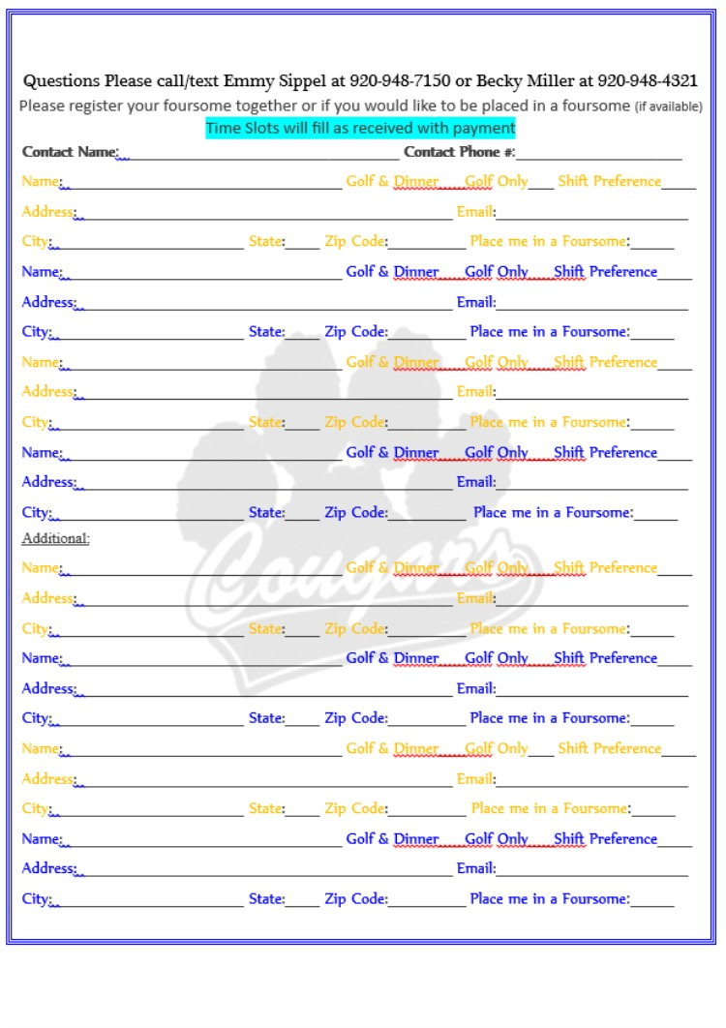

Concessions
Watch for information on how to sign up for Fall Sports Concessions at the
HS Fall Athletic Code Meeting on Mon. July 30st at 7:00 p.m. in the gym.

Concession stand will be opened and closed by Booster Club member; however, volunteers are needed to work concession stand. Remember NO VOLUNTEERS, NO CONCESSIONS.

About the Booster Club
The Booster Club is a tax deductible 501(c)(3) nonprofit organization. Our goal is to provide funds and support for Campbellsport High School Student Athletes. We do this through the Annual Cougar Club Golf Outing, 5K Cougar Dash, concession stand revenue, spirit wear sales, other various fundraisers, and donations. A list of the 2017-18 officers and board members can be found on the Campbellsport School District website: www.csd.k12.wi.us and search Cougar Booster Club.
The Booster Club meets the second Wednesday of every month with few exceptions such as playoff games or events. Meetings include updates from Athletic Director Tom Griesemer, current fundraising efforts, and other booster club news. Agendas, financial reports and previous month's Minutes are available at these meetings.
All are welcome to join and attend the meetings that start at 7PM sharp and usually conclude by 8PM. BE INVOLVED - STAY INFORMED - COME to Booster Club!
GO COUGARS!!

Next Booster Club Meeting
Wednesday, July 11th at Auburn Bluffs Golf Course 7:00 p.m.

Other

Search "Campbellsport Cougar Booster Club" on Facebook. "Like" the page and get daily updates on what is happening with CHS Booster Club through Facebook.

To remove your name from our mailing list, or if you have any questions or comments, please notify us at: cougarclub@csd.k12.wi.us

Campbellsport High School Booster Club
PO Box 104
Campbellsport WI 53010
2017-2018: President – Emmy Sippel/ Vice President – Tammie Lindsley
Treasurer – Becky Miller / Secretary – Lisa Ferguson

