Safe Return to In-Person Instruction and Continuity of Services {SRCSP)

**BOE Approved.December 20, 2021

Montgomery County R-II
2021-22

Table of Contents

Masks for Staff and Students 1
Health Services/Facilities 1
Physical Distancing 2
Hand-Washing 2
Cleaning of District Facilities/Improved Ventilation 2
Contact Tracing 3
Diagnostic Screening and Testing 3
Vaccinations 3
Appropriate Accommodations for Students with Disabilities 3
COVID-19 Home Screening Tool 4
In-Home Exclusions 5

**.December 20, 2021

1

Plan Development Guidance Documents

District Mission

Lifelong Learners, Productive Citizens!

Team Purpose

The Safe Return to In-Person Instruction provides an opportunity to review practices and policies. This document offers guidance on ways to continue the health and safety for our students, staff, and community. This document is intended to show the continued safety protocols and provide a plan for managing risk, and will be adjusted as conditions change, in order to do our best for this learning community. This Safe Return to In-Person Instruction may be amended at any time by the MCR-11 School District may be amended at any time. Any changes will be shared with
the MCHD for approval,

Ongoing and Future Essential Procedures and Guidelines for Consideration

Mask Wearing for Staff and Students
- PPE (gloves, masks, gowns, goggles, face shields) will be an option for all staff and students. For those that choose to wear masks, they need to be worn correctly, with mask covering both the mouth and nose.
- Sanitizers, cleansers, hand soap, tissues will still be at staff and student disposal.
- Additional touchless water bottle filling stations have been added in our buildings, and water bottles will be recommended for use by staff and students.
- Additional touchless features have been added on district urinals, toilets, and sinks.

Health Services/Facility Review
- Provide a separate room for students/staff who might have COVID-19 or other communicable disease and are waiting for pickup as recommended. The room needs to be disinfected frequently and restricted to authorized staff and students. Each of our district buildings will have a designated area for those students to be placed.
- Determine if an area separate from the nurse's office is necessary to care for students that need suctioning, tube feeding and nebulizers to minimize contact with potentially ill children.

**.December 20, 2021

2

Physical Distancing
  - The Montgomery County R-II School District will continue to physical distance (at least 3 feet), where applicable (and up to 6 wear applicable). Seating charts will still be kept by all classroom teachers for contact tracing purposes.

Hand Washing

- MCR-II Elementary students will continue to learn proper handwashing techniques. All students and staff will be encouraged to wash their hands several times a day, especially prior to eating. Hand sanitizer will continue to be available for all classrooms, and in high traffic areas.

Cleaning of District Facilities/Improved Ventilation

  - The MCR-II School will continue to sanitize hallway door knobs, lockers, water fountains, and other traffic areas (multiple times per day). The district will also install more touchless items, such as water bottle fillers, sinks, urinals, etc. District staff members will also be encouraged to spray their rooms, desks, equipment, etc. on a daily basis. The MCR-II will also continue to upgrade district HVAC systems with systems that utilize fresh air return (for better breathing opportunities). Hand sanitizer will still be readily available for all staff and students, especially in high traffic areas.

**

3

Contact Tracing and Exclusions:

- Each classroom will continue to have seating charts, which will be kept in each district office.
- The District will maintain a room in each building for students who be excluded from school due to exposure to an acute or chronic contagious or infectious disease and is liable to transmit the contagious or infectious disease (per BOE Policy EBB).
- The District collaborates with and takes recommendations from the MCHD to perform contact tracing (if needed) and exclusion of students from district classes or activities of a student is found to have been exposed to an acute or chronic contagious or infectious disease and is liable to transmit the contagious or infectious disease (per BOE Policy EBB).
- In home close contacts will be determined by the MCHD. The district will follow recommendations from the CDS and MCHD for exclusion of in-home contacts from school or school sponsored events/activities.
- The District will issue a letter to families when a student tests positive for COVID in the classroom. This letter will only serve as notification to monitor their child for symptoms.
- Students and Staff that may have been classified as a in-school contact will be notified by letter (letter will indicate that the student or staff may have been in contact with either someone who tested positive, or someone who is designated as an in-home contact.

Diagnostic and Screening Testing

- Antigen testing will be continued for all district staff member, and will follow all protocol set by the MDHSS and the MCHD.

Educator Vaccinations

- The MCR-II School District will continue to promote vaccinations for all students and staff, where appropriate. If the district can aide by hosting a vaccination event, they will.

Appropriate Accommodations for Children with Disabilities

- The MCR-II School District will meet all IDEA requirements set forth by the US Department of Education, DESE and MCR-II Board Policies, and MCR-II School District.

COVID Home Screening Tool

In an effort to keep the students and staff of MCR2 healthy, the Montgomery County Health Department is asking each parent/guardian to screen their children daily.
Please check your child's temperature and ask them if they have any of the following symptoms each day before sending them to school.

If your child has a fever of
100.4 or greater ...

Do not send your child to school!

If your child has any of the following symptoms:

  - Chills
  - Muscle aches
  - Loss of smell and/ or taste
OR
  - Severe fatigue
  - Cough
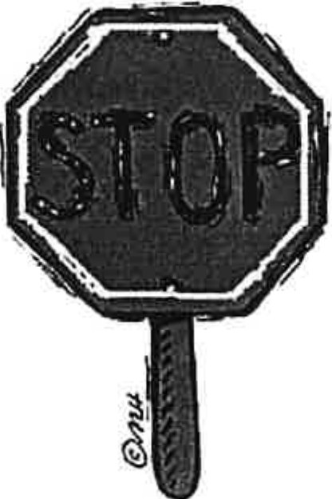
  - Difficulty breathing

New onset or worsening of the follow­ ing symptoms:
  - Runny nose
  - Sore throat
  - Headache
  - Diarrhea/ abdominal pain

Do not send your child to school!

If you answered YES to any of the above

IN-HOME CONTACT GUIDANCE

Your child has been identified as being an in-home contact of a person who tested positive for COVID-19.
We value the importance of in-seat learning and want to provide options for your child to get back in-set quickly. There are currently 3 options to complete exclusion guidelines set by the Department of Health & Senior Services and the Department of Elementary & Secondary Education. Remember Option 1 is FULL Quarantine of 14 days and the other two options are modifications to return/remain in school, but your child is still considered quarantined for 14 days.
Please review these options to decide which best fits your child.

Option 1: 14-day Exclusion-No testing or masking while at school
This is the safest option, and the only option for students in Preschool, Kindergarten & 1st Grade due to
most younger children not being able to wear a mask the whole day at school.
This option requires 14 days of quarantine from the students last day of exposure
The student can return to school on day 15, provided the student has remained symptom free
If this is the option you choose, your student can return to school on ____________________.

Option 2: 7-day Exclusion- Students may take a Rapid Test or PCR Test (given by a Health Care
Professional) on day 5, 6, or 7 of first day of exposure (these tests are given free by the MCHD).
If the student has a negative test on day 5, 6, or 7, they may return on day 8 with a mask (as
Long as the student is still symptom free). If the student does not want to wear a mask, they
should return on day 15.
If this is the option you choose, your student can return to school on _____________________.

