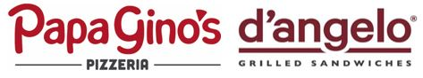
Raise Some Dough to Benefit

Windham High School Junior Class

We will earn 20% of the Sales from our
Families & Friends during this time!

When: Wednesday, December 15, 2021
Time: 3:00 PM – 7:30 PM
Where: 95 Storrs Road, Mansfield
Phone: 860-456-1884

Valid for Dine-in, Carry Out, Online & Delivery orders!

- When you place your order, tell us you support this fundraiser! Hand us this flyer or show it on a mobile device, in order for your organization to get credit for your order.
- Online orders enter code 19 at the payment screen and then click apply.
- Papa Gino’s will donate 20% of the total pre-tax sales from all the guests that present your flyer during the fundraiser.
- Fundraiser orders are only valid with regular priced menu items and cannot be paired with coupons or deals.
- Flyers cannot be handed out in or around the Papa Gino’s restaurant on the day of your event.
- Flyers made by the organization will not be accepted for the fundraiser event.
- RESTAURANT ONLY - Ring this sale using the POS button 19: Fundraiser.

