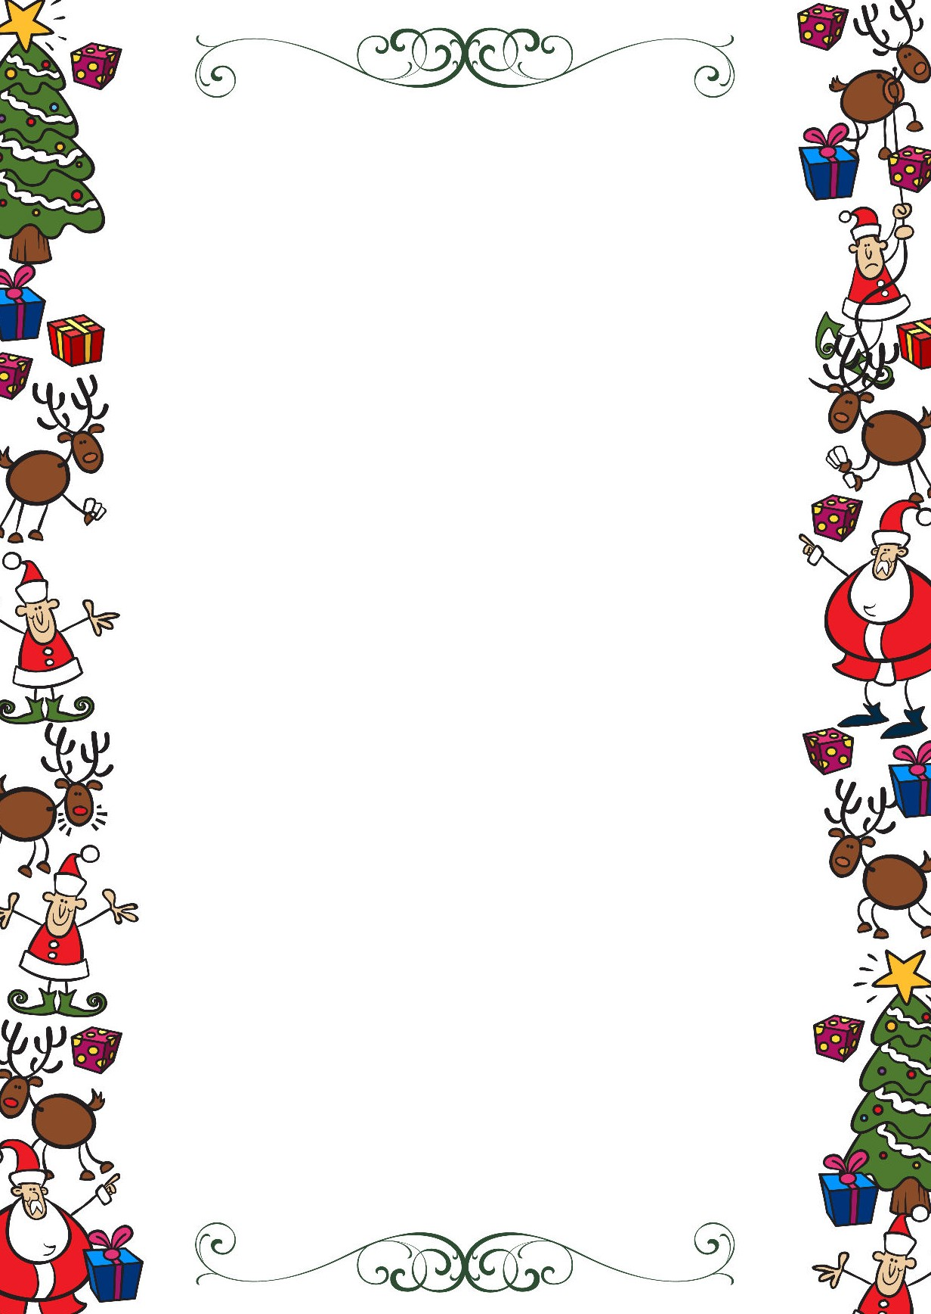
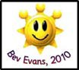
Public Schools of Robeson County
Holiday Online Enrichment Activities
(Christmas)

First Grade ELA/Reading

https://www.redbookmag.com/life/mom-kids/how-to/g3780/christmas-activities-kids/

https://growingbookbybook.com/christmas-books-and-activities/

https://abcsofliteracy.com/25-days-of-christmas-activities/

First Grade Math

Get a little fine motor practice while using a hole punch to do this simple Christmas Tree counting activity from Sugar Aunts.
Practice counting with this Gingerbread Cookies Counting Tray from Teach Me Mommy.
Explore patterns with this simple Candy Cane Pattern activity from This Reading Mama (comes with a free printable).
Have some sweet counting fun with this simple M&M Christmas tree counting activity from Umbrella Tree Cafe.

First Grade Arts

Cut Out Snowflakes

Christmas Crafts

Music Skill Activities

Public Schools of Robeson County
Holiday Online Enrichment Activities
(Christmas)

First Grade Science

Christmas Science: Grow the Grinch’s Heart

Christmas Science Experiments for Kids

Hot Chocolate Science

Snow Science Prediction and Observation:

Christmas Science Experiments

First Grade Social Studies

6 Fun Virtual Christmas Activities for Online Students

Printable Family Activities Advent Calendar
Paper Plate Christmas Tree Kids Craft
The Best Salt Dough Ornaments for Kids

