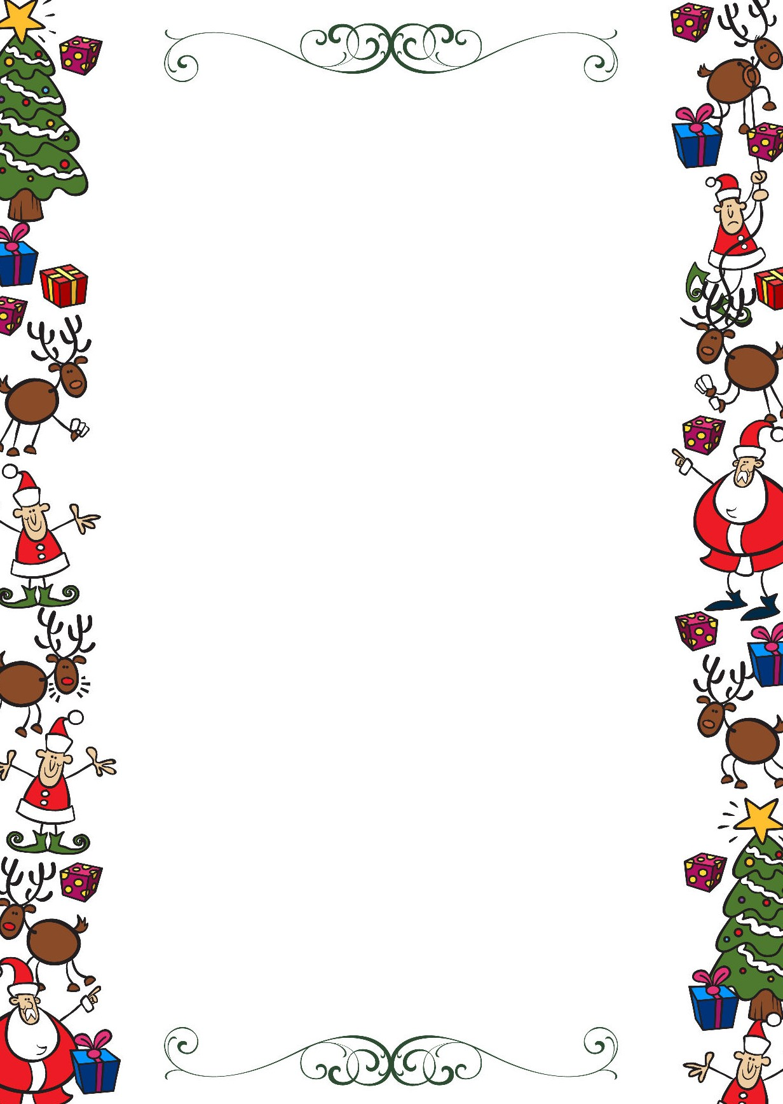
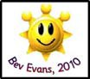
Public Schools of Robeson County
Holiday Online Enrichment Activities
(Christmas)

Third Grade ELA/Reading

https://www.redbookmag.com/life/mom-kids/how-to/g3780/christmas-activities-kids/

https://growingbookbybook.com/christmas-books-and-activities/

https://abcsofliteracy.com/25-days-of-christmas-activities/

Third Grade Math

LEGO math activity from Little Bins for Little Hands.
Explore tangrams with this fun (and yummy) Christmas Cookie Tangram activity from Left Brain Craft Brain.
Learn about fractions with this Snowman Fractions game from Teach Beside Me.

Third Grade Science

Christmas Science: Grow the Grinch’s Heart

Christmas Science Experiments for Kids

Hot Chocolate Science
Snow Science Prediction and Observation:

Public Schools of Robeson County
Holiday Online Enrichment Activities
(Christmas)

Kindergarten Social Studies

6 Fun Virtual Christmas Activities for Online Students

Printable Family Activities Advent Calendar
Paper Plate Christmas Tree Kids Craft
The Best Salt Dough Ornaments for Kids

Kindergarten Arts

Cut Out Snowflakes

Christmas Crafts

Music Skill Activities

