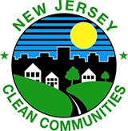
MODEL CLEAN COMMUNITIES
WEBSITE GUIDE

New Jersey Clean Communities Coordinators,

Within this document is a copy & paste* guide to creating your very own Clean Communities website or webpage to show your residents what New Jersey Clean Communities is all about and the many great programs that the state and your county and/or town have to offer!

This guide was put together by taking different examples from different counties and municipalities Clean Communities webpages.

You are not required to have all the content listed within the document on your webpages but are encouraged to add the most content possible that is relatable to your Clean Communities program.

CSS and HTML coding is available at the end of the document for those that are familiar with the coding process. For those that are not, it’s easy! If you remember the Recycle Coach plug-in code that you were given to copy and paste into your website, it’s just like that! If you would like to learn more about the codes, please don’t hesitate to contact Rachel Barton or have your website developer the place it into your website.

*Please note that images may not directly copy and paste and may need to be “uploaded” to your website. Please contact your IT Department/Website Designer to find out the best way to insert graphics. All graphics in the document can be saved directly to your computer by right-clicking on the image and selecting “Save as Picture...” *

Questions? Please contact Rachel Barton at rbarton@co.burlington.nj.us, Rebecca Turygan at rturygan@acua.com, and Joann Gemenden at njccc@njclean.org

Main Webpage
ABOUT CLEAN COMMUNITIES
NJ Clean Communities Overview
New Jersey Clean Communities is a statewide, comprehensive, litter-abatement program created by the passage of the Clean Communities Act in 1986. The mission is to reduce litter in public places, promote the volunteer cleanup of public lands and sustain a reduction in litter through education. The Act provides a funding source for the program by placing a tax on fifteen categories of businesses that may produce litter-generating products. The program focuses on three areas: cleanup, education and enforcement. For more information on the state program visit njclean.org.
Tackling the Litter Problem
What is litter? Litter is solid waste that is out of place. It's the kind of trash found on highways, lakefronts, parks and school grounds. Litter takes many forms: paper, plastics, metal cans, cigarette butts, glass, food packaging, tires and graffiti.
Where does litter come from? There are at least seven sources of litter: pedestrians, motorists, overflowing household garbage, overflowing commercial containers, loading docks, construction sites and uncovered trucks. Litter is often blown by the wind until it is trapped somewhere or goes down a storm drain.
Why do people litter? People tend to litter when they think someone else will clean up, when an area is already littered, and when they do not feel a sense of ownership or community pride.
Why is litter a problem? Even small amounts of litter are unsightly, unhealthy and dangerous. Litter causes blighted landscapes resulting in an increase in taxes and a decrease in tourism and industry; loss of civic pride and morale; and a negative public image. Litter can also cause accidents, especially on roadways, fires and disease in people and animals.
How are we solving the problem? In addition to the efforts of local governments, residents, schools, civic associations and non-profit organizations are enlisted as volunteers to help with cleanup events. At these cleanup events we offer education to volunteers while they pick up litter so they become environmental stewards. With education, acts of littering can be changed!
[INSERT NAME] CLEAN COMMUNITIES PROGRAM
[insert name] Clean Communities program is part of a statewide strategy to clean and prevent litter on streets, beaches, waterways, parks, recreation sites and vacant lots. Clean Communities Grant funding is used for educational programs, supporting clean up events and implementing adopt-a-road and mini-grant programs.
Should also be placed on main webpage
IMPORTANT LINKS
State NJCC Website: www.njclean.org
State Bag Up NJ Website: www.bagupnj.com
NJDEP Single Use Plastics Website: https://www.nj.gov/dep/plastic-ban-law/
Sign Up for NJCC Newsletter: https://njclean.org/register-for-web-news
NJCC Certification Training: http://www.cpe.rutgers.edu/courses/current/er0400ca.html

Separate Menu Options
CLEANUPS
Help us keep [insert name] clean! A variety of volunteer opportunities are available whether you’re a resident, business, civic association, school or non-profit organization.

Sample Guidelines for COVID-19 Litter Cleanup Protocol :
Please Note: Volunteers must adhere to the following cleanup guidelines :
- Volunteers must maintain social distance of at least 6 ft. and wear face masks when necessary;
- The number of volunteers must be limited to 10 in any one location;
- The addition of face masks, gloves, trash and recycling bags, trash pickers, safety vests and hand sanitizer must be available to volunteers.
One Day Cleanup Event – Civic groups, volunteer organizations, churches and scout troops, as well as residents and businesses, are encouraged to participate in a joint effort to clean up our streets and public properties.

[Hint: post flyer for upcoming event(s), post cleanup results and pictures of event]

(Apply now buttons must be embedded into your website and link to your own program specific application. For application samples, view the Clean Communities Best Practices Link: https://njclean.org/our-programs/best-practices )
Mini Grants are available to any school group or non-profit association in return for cleaning up designated public areas. Groups are eligible to receive a stipend which is dependent on the number of volunteers. Equipment and supplies are available to volunteers. Please download the 2021 application here:
Adopt a Road groups are required to clean sections of the adopted area, and all necessary equipment such as grabbers, safety shirts, bags and gloves are provided. All groups are acknowledged with a road sign displaying their name.
Hint: insert pictures of signs, cleanup groups, maps of available roadways, annual statistics see http://acua.com/adoptaroad/

Cleanup Results [Enter # of Volunteers] volunteers spent a total of [Enter # of hours spent – (# of volunteers x total hours of all events = total man hours)] man hours cleaning litter along our roads, parks and waterways. Thank you for all your hard work that truly makes a positive impact on our community!

Info Graphics are a fun and attractive way to present statistics and can be created by your in-house graphic artist! Excel Tables are also always an option.

Safety - the safety of our volunteers is important. Please review safety protocols before conducting any cleanup programs and encourage volunteers to watch the NJCCC safety video:
https://njclean.org/aag-individual-safety-video

EDUCATION
Education is communication in a more complex form. It aims to change the attitudes that cause littering. The basic premise of the New Jersey Clean Communities program is to change habits so residents do not litter, bring their own reusable bags when shopping, skip the straw, and other sustainable practices. A long-term education program will teach both residents and visitors the ramifications of littering and ways to work together to prevent litter from affecting our state.

School Programs/Virtual Events/Community
[School programs/virtual events/community – List all that opportunities that you have to offer, whether that be presentations by a coordinator, performer, Clean Communities special events, etc.]

ENFORCEMENT
[Provide a link to your county/municipal litter related ordinances (balloon, straw etc.) and who to call to report littering on county/town property.]

New Jersey Single Use Plastic Ban Law:
https://www.nj.gov/dep/plastic-ban-law/docs/plastic-bag-law-c117.pdf

Bag Up NJ

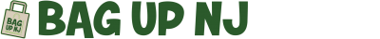
On Nov. 4, 2020, Governor Phil Murphy and the New Jersey Legislature enacted the most progressive bag ban law in the country. The law reduces litter and encourages the use of reusable bags by phasing out single-use carryout bags.
The law bans single-use plastic bags, regardless of thickness, at grocery stores and retail establishments, as well as paper bags at grocery stores equal to or larger than 2,500 square feet. It also bans polystyrene foam takeout food containers and other products such as plates, cups, food trays and utensils. As of November 4, 2021, plastic straws will only be available upon request.
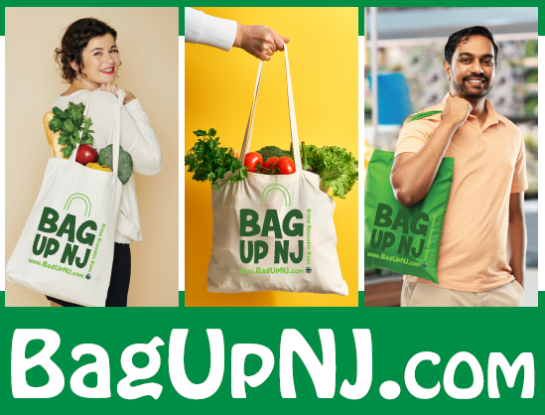
The "Bag Up NJ" campaign is the New Jersey Clean Communities Council’s new single use plastic and paper bag ban outreach campaign, which has a simple message: Bring your own reusable bag(s) when you shop.

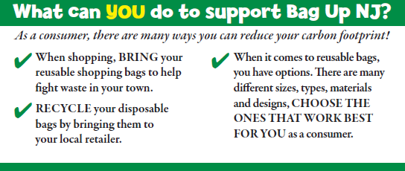
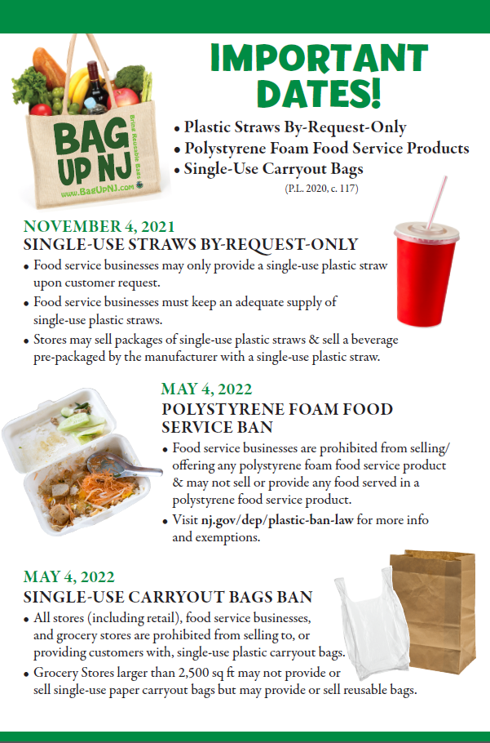

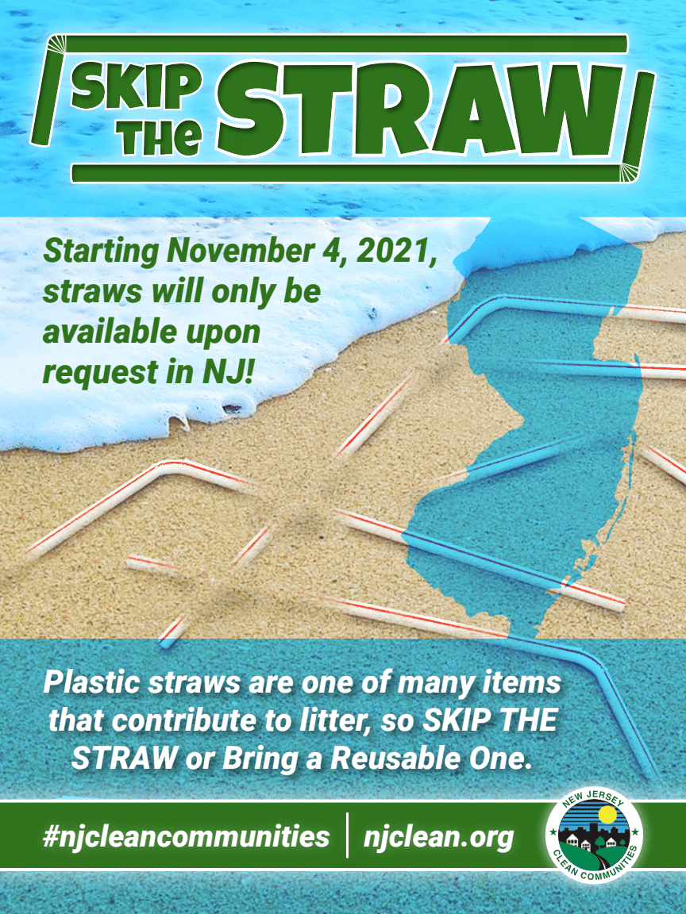

For more information on the NJ Bag Ban Law, please visit: https://www.nj.gov/dep/plastic-ban-law/

For information on Business Compliance please contact
the New Jersey Business Action Center
https://business.nj.gov/recent/disposable-bag-ban
REPORT ILLEGAL DUMPING
The Problem:
"Public lands all over New Jersey are being used as dumping grounds. Litter, garbage bags, tires, televisions, electronic waste, appliances, yard waste, and construction debris are being dumped and threatening our local environment, animals and public. This dumping detracts from the natural beauty of our public lands; it decreases property value, and costs the citizens of New Jersey tax dollars to cleanup."
-NJDEP
"There's an app for that!"
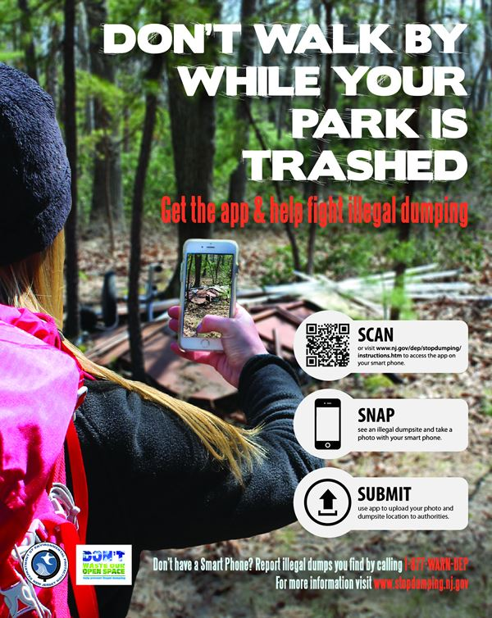
The NJDEP offers a free and easy to use app that can be downloaded onto your smartphone device. Click on the link below and start reporting illegal dumping sites in New Jersey.
https://www.stopdumping.nj.gov/instructions.htm

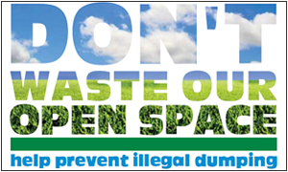
NJDEP's “Don’t Waste our Open Space” campaign

CSS/HTML Coding
About Clean Communities Section (copy + paste below)
<p id="isPasted" style='margin-top:0in;margin-right:0in;margin-bottom:8.0pt;margin-left:0in;line-height:107%;font-size:15px;font-family:"Calibri",sans-serif;'><span style='font-size:27px;line-height:107%;font-family:"Candara",sans-serif;color:#0070C0;'><strong><em>NJ Clean Communities Overview</em></strong></span></p>
<p> New Jersey Clean Communities is a statewide, comprehensive, litter-abatement program created by the passage of the Clean Communities Act in 1986. The mission is to reduce litter in public places, promote the volunteer cleanup of public lands and sustain a reduction in litter through education. The Act provides a funding source for the program by placing a tax on fifteen categories of businesses that may produce litter-generating products. The program focuses on three areas: cleanup, education and enforcement. For more information on the state program visit <a href="http://www.njclean.org" rel="noopener" target="_blank">njclean.org</a></strong></p>
<br>

Tackling the Litter Problem Section (copy + paste below)
<p id="isPasted" style='margin-top:0in;margin-right:0in;margin-bottom:8.0pt;margin-left:0in;line-height:107%;font-size:15px;font-family:"Calibri",sans-serif;'><span style='font-size:27px;line-height:107%;font-family:"Candara",sans-serif;color:#0070C0;'><strong><em>Tackling the Litter Problem</em></strong></span></p>
<br>
<p><strong>What is litter?&nbsp;</strong>Litter is solid waste that&apos;s out of place. It&apos;s the kind of trash found on highways, lakefronts, parks and school grounds. Litter takes many forms: paper, plastics, metal cans, cigarette butts, glass, food packaging, tires and graffiti.</p>
<br>
<p><strong>Where does it come from?&nbsp;</strong>There are seven sources of litter: pedestrians, motorists, overflowing household garbage, construction sites and uncovered trucks. Litter is often blown by the wind until it is trapped somewhere, as along a fence.</p>
<br>
<p><strong>Why do people litter?&nbsp;</strong>People tend to litter when they think someone else will clean up, when an area is already littered, and when they do not feel a sense of ownership or community pride.</p>
<br>
<p><strong>Why is litter a problem?&nbsp;</strong>Even small amounts of litter are unsightly, unhealthy and dangerous. Litter causes blighted landscapes resulting in an increase in taxes and a decrease in tourism and industry; loss of civic pride and morale; and a negative public image. Litter can also cause disease in people and animals, fires, and accidents, especially on roadways.</p>
<br>
<p><strong>How are we solving the problem?&nbsp;</strong>County residents and different organizations are enlisted as volunteers to help with cleanup events. At these cleanup events we offer education to volunteers while they pick up litter so they can fulfill being environmental stewards. With education, habits and acts of littering can be changed! The Burlington County Clean Communities program also offers litter education in schools, county road clean up projects, and more! This office does offer assistance to municipal clean communities coordinators and their projects.</p>

Clean Communities Program Section (copy + paste below)
<p id="isPasted" style='margin-top:0in;margin-right:0in;margin-bottom:8.0pt;margin-left:0in;line-height:107%;font-size:15px;font-family:"Calibri",sans-serif;'><span style='font-size:27px;line-height:107%;font-family:"Candara",sans-serif;color:#0070C0;'>[INSERT NAME] CLEAN COMMUNITIES PROGRAM</span></p>
<br>
<p style='margin-top:0in;margin-right:0in;margin-bottom:8.0pt;margin-left:0in;line-height:107%;font-size:15px;font-family:"Calibri",sans-serif;'><span style='font-size:16px;line-height:107%;font-family:"Candara",sans-serif;color:#1F4E79;'> [insert name] </span><span style='font-size:16px;line-height:107%;font-family:"Candara",sans-serif;color:#1F4E79;'>&nbsp;</span>
<span style='font-size:16px;line-height:107%;font-family:"Candara",sans-serif;color:#323E4F;'>Clean Communities program is part of a statewide strategy to clean and prevent litter on streets, beaches, waterways, parks, recreation sites and vacant lots.&nbsp;</span><span style='font-size:16px;line-height:107%;font-family:"Candara",sans-serif;color:#44546A;'>&nbsp;Clean Communities Grant funding is used for educational programs, supporting clean up events and implementing adopt-a-road and mini-grant programs.</span></p>

Important Links Section (copy + paste below)
<p id="isPasted" style='margin-top:0in;margin-right:0in;margin-bottom:0in;margin-left:0in;line-height:107%;font-size:15px;font-family:"Calibri",sans-serif;'><span style='font-size:40px;line-height:107%;font-family:"Candara",sans-serif;color:#2F5496;'>IMPORTANT LINKS</span></p>
<br>
<p style='margin-top:0in;margin-right:0in;margin-bottom:6.0pt;margin-left:0in;line-height:107%;font-size:15px;font-family:"Calibri",sans-serif;'><span style='font-size:19px;line-height:107%;font-family:"Candara",sans-serif;color:#8EAADB;'>State NJCC Website:&nbsp;</span><a href="http://www.njclean.org"><span style='font-size:19px;line-height:107%;font-family:"Candara",sans-serif;'>www.njclean.org</span></a></p>
<br>
<p style='margin-top:0in;margin-right:0in;margin-bottom:6.0pt;margin-left:0in;line-height:107%;font-size:15px;font-family:"Calibri",sans-serif;'><span style='font-size:19px;line-height:107%;font-family:"Candara",sans-serif;color:#8EAADB;'>State Bag Up NJ Website:&nbsp;</span><a href="http://www.bagupnj.com"><span style='font-size:19px;line-height:107%;font-family:"Candara",sans-serif;'>www.bagupnj.com</span></a></p>

<p style='margin-top:0in;margin-right:0in;margin-bottom:6.0pt;margin-left:0in;line-height:107%;font-size:15px;font-family:"Calibri",sans-serif;'><span style='font-size:19px;line-height:107%;font-family:"Candara",sans-serif;color:#8EAADB;'>NJDEP Single Use Plastics Website:&nbsp;</span><a href="https://www.nj.gov/dep/plastic-ban-law/"><span style='font-size:19px;line-height:107%;font-family:"Candara",sans-serif;'>https://www.nj.gov/dep/plastic-ban-law/</span></a></p>
<br>
<p style='margin-top:0in;margin-right:0in;margin-bottom:6.0pt;margin-left:0in;line-height:107%;font-size:15px;font-family:"Calibri",sans-serif;'><span style='font-size:19px;line-height:107%;font-family:"Candara",sans-serif;color:#8EAADB;'>Sign Up for NJCC Newsletter:&nbsp;</span><a href="https://njclean.org/register-for-web-news"><span style='font-size:19px;line-height:107%;font-family:"Candara",sans-serif;'>https://njclean.org/register-for-web-news</span></a></p>
<br>
<p style='margin-top:0in;margin-right:0in;margin-bottom:6.0pt;margin-left:0in;line-height:107%;font-size:15px;font-family:"Calibri",sans-serif;'><span style='font-size:19px;line-height:107%;font-family:"Candara",sans-serif;color:#8EAADB;'>NJCC Certification Training:&nbsp;</span><a href="http://www.cpe.rutgers.edu/courses/current/er0400ca.html"><span style='font-size:16px;line-height:107%;font-family:"Candara",sans-serif;'>http://www.cpe.rutgers.edu/courses/current/er0400ca.html</span></a></p>

Cleanups Section (copy + paste below)
<p id="isPasted" style='margin-top:0in;margin-right:0in;margin-bottom:8.0pt;margin-left:0in;line-height:107%;font-size:15px;font-family:"Calibri",sans-serif;'><span style='font-size:40px;line-height:107%;font-family:"Candara",sans-serif;color:#2F5496;'><strong>CLEANUPS </strong></span></p>
<br>
<p style='margin-top:0in;margin-right:0in;margin-bottom:0in;margin-left:0in;line-height:normal;font-size:15px;font-family:"Calibri",sans-serif;'><span style='font-size:16px;font-family:"Candara",sans-serif;color:#44546A;'>Help us keep&nbsp;</span><span style='font-size:16px;font-family:"Candara",sans-serif;color:#1F4E79;'>[insert name] &nbsp;</span><span style='font-size:16px;font-family:"Candara",sans-serif;color:#44546A;'>clean! &nbsp;A variety of volunteer opportunities are available whether you&rsquo;re a resident, business, civic association, school or non-profit organization.&nbsp;</span></p>
<br>
<p style='margin-top:0in;margin-right:0in;margin-bottom:0in;margin-left:0in;line-height:normal;font-size:15px;font-family:"Calibri",sans-serif;'><span style='font-size:16px;font-family:"Candara",sans-serif;color:#44546A;'>&nbsp;</span></p>
<br>

Cleanup Results (copy + paste below)
<p><strong><span id="isPasted" style='font-size:21px;line-height:107%;font-family:"Candara",sans-serif;color:#44546A;'>Cleanup Results&nbsp;</span><span style='font-size:16px;line-height:107%;font-family:"Candara",sans-serif;color:#44546A;'>&nbsp;[Enter # of Volunteers]&nbsp;</span><span style='font-size:16px;line-height:107%;font-family:"Candara",sans-serif;color:#44546A;'>volunteers spent a total of &nbsp;[Enter # of hours spent &ndash; (# of volunteers x total hours of all events = total man hours)] man hours cleaning litter along our roads, parks and waterways. &nbsp; Thank you for all your hard work that truly makes a positive impact on our community!</span><br></strong></p>

COVID-19 Guidelines for Cleanups (copy + paste below)

<p style='margin-top:0in;margin-right:0in;margin-bottom:0in;margin-left:0in;line-height:normal;font-size:15px;font-family:"Calibri",sans-serif;'><span style='font-size:16px;font-family:"Candara",sans-serif;color:#1F4E79;'>Please Note: Volunteers must adhere to the following cleanup guidelines :</span></p>

<ul style="margin-bottom:0in;margin-top:0in;" type="disc">
<li style='margin-top:0in;margin-right:0in;margin-bottom:0in;margin-left:0in;line-height:normal;font-size:15px;font-family:"Calibri",sans-serif;color:#1F4E79;'><span style='font-size:16px;font-family:"Candara",sans-serif;'>Volunteers must maintain social distance of at least 6 ft. and wear face masks when necessary;</span></li>
<li style='margin-top:0in;margin-right:0in;margin-bottom:8.0pt;margin-left:0in;line-height:normal;font-size:15px;font-family:"Calibri",sans-serif;color:#1F4E79;'><span style='font-size:16px;font-family:"Candara",sans-serif;'>The number of volunteers must be limited to 10 in any one location;&nbsp;</span></li>
<li style='margin-top:0in;margin-right:0in;margin-bottom:8.0pt;margin-left:0in;line-height:normal;font-size:15px;font-family:"Calibri",sans-serif;color:#1F4E79;'><span style='font-size:16px;font-family:"Candara",sans-serif;'>The addition of face masks, gloves, trash and recycling bags, trash pickers, safety vests and hand sanitizer must be available to volunteers.&nbsp;</span></li>
</ul>
<br>

One Day Cleanup Event (copy + paste below)
<p style='margin-top:0in;margin-right:0in;margin-bottom:0in;margin-left:0in;line-height:normal;font-size:15px;font-family:"Calibri",sans-serif;'><span style='font-size:21px;font-family:"Candara",sans-serif;color:#44546A;'>One Day Cleanup Event</span><span style='font-size:16px;font-family:"Candara",sans-serif;color:#44546A;'>&nbsp;&ndash;</span><span style='font-family:"Arial",sans-serif;'>&nbsp;</span><span style='font-size:16px;font-family:"Candara",sans-serif;color:#44546A;'>Civic groups, volunteer organizations, churches and scout troops, as well as residents and businesses, are encouraged to participate in a joint effort to clean up our streets and public properties.&nbsp;</span></p>

Apply Now Button (copy + paste below)
<a href="[INSERT LINK TO APPLICATION HERE]">
<img src="[INSERT CODETO APPLY NOW PICTURE HERE]" alt="" style="width:100px;height:100px;border:0;">
</a>

Mini Grants (copy + paste below)
<p id="isPasted" style='margin-top:0in;margin-right:0in;margin-bottom:7.5pt;margin-left:0in;line-height:normal;font-size:15px;font-family:"Calibri",sans-serif;'><span style='font-size:21px;font-family:"Candara",sans-serif;color:#44546A;'>Mini Grants</span><span style='font-size:19px;font-family:"Candara",sans-serif;color:#44546A;'>&nbsp;</span><span style='font-size:16px;font-family:"Candara",sans-serif;color:#44546A;'>are available to any school group or non-profit association in return for cleaning up designated public areas. &nbsp;Groups are eligible to receive a stipend which is dependent on the number of volunteers. &nbsp; Equipment and supplies are available to volunteers. &nbsp;Please download the 2021 application here:</span></p>

Apply Now Button (copy + paste below)
<a href="[INSERT LINK TO APPLICATION HERE]">
<img src="[INSERT CODE TO APPLY NOW PICTURE HERE]" alt="" style="width:100px;height:100px;border:0;">
</a>
Adopt-A-Road, Highway, etc. (copy + paste below)
<p id="isPasted" style='margin-top:0in;margin-right:0in;margin-bottom:7.5pt;margin-left:0in;line-height:normal;font-size:15px;font-family:"Calibri",sans-serif;'><span style='font-size:21px;font-family:"Candara",sans-serif;color:#44546A;'>Adopt a Road</span><span style='font-size:16px;font-family:"Candara",sans-serif;color:#44546A;'>&nbsp;groups are required to clean sections of the adopted area, and all necessary equipment such as grabbers, safety shirts, bags and gloves are provided. &nbsp;All groups are acknowledged with a road sign displaying their name.</span></p>

Apply Now Button (copy + paste below)
<a href="[INSERT LINK TO APPLICATION HERE]">
<img src="[INSERT CODE TO APPLY NOW PICTURE HERE]" alt="" style="width:100px;height:100px;border:0;">
</a>

Safety Section (copy + paste below)
<p id="isPasted" style='margin-top:0in;margin-right:0in;margin-bottom:7.5pt;margin-left:0in;line-height:normal;font-size:15px;font-family:"Calibri",sans-serif;'><span style='font-size:21px;font-family:"Candara",sans-serif;color:#44546A;'>Safety -&nbsp;</span><span style='font-size:16px;font-family:"Candara",sans-serif;color:#44546A;'>the safety of our volunteers is important. &nbsp;Please review safety protocols before conducting any cleanup programs and encourage volunteers to watch the NJCCC safety video:&nbsp;</span></p>
<br>
<p style='margin-top:0in;margin-right:0in;margin-bottom:7.5pt;margin-left:0in;line-height:normal;font-size:15px;font-family:"Calibri",sans-serif;'><a href="https://njclean.org/aag-individual-safety-video"><span style='font-size:16px;font-family:"Candara",sans-serif;'>https://njclean.org/aag-individual-safety-video</span></a></p>

Education Section (copy + paste below)
<p>Education is communication in a more complex form. &nbsp;It aims to change the attitudes that cause littering. The basic premise of the New Jersey Clean Communities program is to change habits so residents do not litter, bring their own reusable bags when shopping, skip the straw, and other sustainable practices. &nbsp;A long-term education program will teach both residents and visitors the ramifications of littering and ways to work together to prevent litter from affecting our state.</p>
<BR>
<p style='margin-top:0in;margin-right:0in;margin-bottom:0in;margin-left:0in;line-height:107%;font-size:15px;font-family:"Calibri",sans-serif;'><a href="[ENTER LINK TO EDUCATION PROGRAMS HERE]"><span style='font-size:19px;line-height:107%;font-family:"Candara",sans-serif;'>[ENTER LINK TO EDUCATION PROGRAMS HERE]</span></a></p>

Bag Up NJ Section (copy + paste below)
<p><img src="[INSERT BAG UP NJ IMAGE CODEHERE]" class="fr-dib" alt="Bag Up NJ County Webpage Graphic" style="width: 361px;"></p>
<BR>
<p>On Nov. 4, 2020, Governor Phil Murphy and the New Jersey Legislature enacted the most progressive bag ban law in the country. The law reduces litter and encourages the use of reusable bags by phasing out <strong>single-use carryout bags</strong>.&nbsp;</p>
<br>
<p>The law bans single-use plastic bags, regardless of thickness, at grocery stores and retail establishments, as well as paper bags at grocery stores <strong><u>equal to or</u></strong> <strong>larger than 2,500 sq. ft.&nbsp;</strong></p>
<br>
<p>It also bans polystyrene<strong>&nbsp;foam&nbsp;</strong>takeout food containers and other products such as plates, cups, food trays and utensils; and makes plastic straws at restaurants available only upon request. As of November 4, 2021, plastic straws will only be available upon request.</p>
<br>
<p>The &quot;Bag Up NJ&quot; campaign is the New Jersey Clean Communities Council&apos;s new single use plastic and paper bag ban outreach campaign, which has a simple message: <strong>Bring your own reusable bag(s) when you shop.</strong></p>
<br>
<p style="text-align: center;"><img src="[INSERT BAG UP NJ GRAPHIC IMAGE LINK HERE] " class="fr-dib" alt="Bag Up NJ Heading2" style="width: 762px;"></p>
<br>
<p><img src="[INSERT WHAT CAN YOU DO GRAPHIC IMAGE LINK HERE] " class="fr-dib" alt="What can you do" style="width: 763px;"></p>
<br>
<p><img src=" [INSERT TIMELINE GRAPHIC IMAGE LINK HERE] " class="fr-dib" alt="Bag Ban Timeline" style="width: 751px;"></p>
<br>
<p><img src=" [INSERT SKIP THE STRAW GRAPHIC IMAGE LINK HERE] " class="fr-dib" alt="Skip the Straw" style="width: 751px;"></p>
<br>
<p style='margin-top:0in;margin-right:0in;margin-bottom:0in;margin-left:0in;line-height:normal;font-size:15px;font-family:"Calibri",sans-serif;text-align:center;'><strong><span style='font-size:20px;font-family:"Montserrat",serif;color:#2B303A;'>For more information on the NJ Bag Ban Law, please visit:&nbsp;</span></strong><a href="https://www.nj.gov/dep/plastic-ban-law/"><strong><span style='font-size:20px;font-family:"Montserrat",serif;border:none windowtext 1.0pt;padding:0in;'>https://www.nj.gov/dep/plastic-ban-law/</span></strong></a></p>

<p style='margin-top:0in;margin-right:0in;margin-bottom:0in;margin-left:0in;line-height:normal;font-size:15px;font-family:"Calibri",sans-serif;text-align:center;'><span style="color:#0563C1;text-decoration:underline;"><strong><span style='font-size:20px;font-family:"Montserrat",serif;border:none windowtext 1.0pt;padding:0in;'><span style="text-decoration: none;">&nbsp;</span></span></strong></span></p>

<p style='margin-top:0in;margin-right:0in;margin-bottom:0in;margin-left:0in;line-height:normal;font-size:15px;font-family:"Calibri",sans-serif;text-align:center;background:white;'><strong><span style='font-size:20px;font-family:"Montserrat",serif;color:black;'>For information on Business Compliance please contact</span></strong></p>

<p style='margin-top:0in;margin-right:0in;margin-bottom:0in;margin-left:0in;line-height:normal;font-size:15px;font-family:"Calibri",sans-serif;text-align:center;background:white;'><strong><span style='font-size:20px;font-family:"Montserrat",serif;color:black;'>&nbsp;the New Jersey Business Action Center</span></strong></p>

<p style='margin-top:0in;margin-right:0in;margin-bottom:0in;margin-left:0in;line-height:normal;font-size:15px;font-family:"Calibri",sans-serif;text-align:center;background:white;'><span style="color:black;"><a href="https://business.nj.gov/recent/disposable-bag-ban"><strong><span style='font-size:20px;font-family:"Montserrat",serif;'>https://business.nj.gov/recent/disposable-bag-ban</span></strong></a></span></p>

Enforcement Section (copy + paste below)
<p style='margin-top:0in;margin-right:0in;margin-bottom:0in;margin-left:0in;line-height:107%;font-size:15px;font-family:"Calibri",sans-serif;'><a href="[ENTER LINK TO ORDINANCE HERE]"><span style='font-size:19px;line-height:107%;font-family:"Candara",sans-serif;'>[ENTER LINK TO ORDINANCE HERE]</span></a></p>

<p id="isPasted" style='margin-top:0in;margin-right:0in;margin-bottom:0in;margin-left:0in;line-height:107%;font-size:15px;font-family:"Calibri",sans-serif;'><span style='font-size:19px;line-height:107%;font-family:"Candara",sans-serif;color:#2F5496;'>New Jersey Single Use Plastic Ban Law:&nbsp;</span></p>

<p style='margin-top:0in;margin-right:0in;margin-bottom:0in;margin-left:0in;line-height:107%;font-size:15px;font-family:"Calibri",sans-serif;'><a href="https://www.nj.gov/dep/plastic-ban-law/docs/plastic-bag-law-c117.pdf"><span style='font-size:19px;line-height:107%;font-family:"Candara",sans-serif;'>https://www.nj.gov/dep/plastic-ban-law/docs/plastic-bag-law-c117.pdf</span></a></p>

Report Illegal Dumping (copy + paste below)
<h2 class="subhead1 ">The Problem:</h2>
<br>
<p><strong>&quot;Public lands all over New Jersey are being used as dumping grounds. Litter, garbage bags, tires, televisions, electronic waste, appliances, yard waste, and construction debris are being dumped and threatening our local environment, animals and public. This dumping detracts from the natural beauty of our public lands; it decreases property value, and costs the citizens of New Jersey tax dollars to cleanup.&quot;<br>&nbsp;-NJDEP<br></strong></p>
<br>
<h2 class="subhead1 ">&quot;There&apos;s an app for that!&quot;&nbsp;</h2>
<br>
<p>The NJDEP offers a free and easy to use app that can be downloaded onto your smartphone device. Click the poster to the right to start reporting illegal dumping sites in New Jersey.</p>
<a href="http://www.stopdumping.nj.gov/instructions.htm">
<img src="[INSERT IMAGE CODE TO NJDEP ILLEGAL DUMPING FLYER HERE] " alt="" style="width:350px;height:450px;border:0;">
</a>

