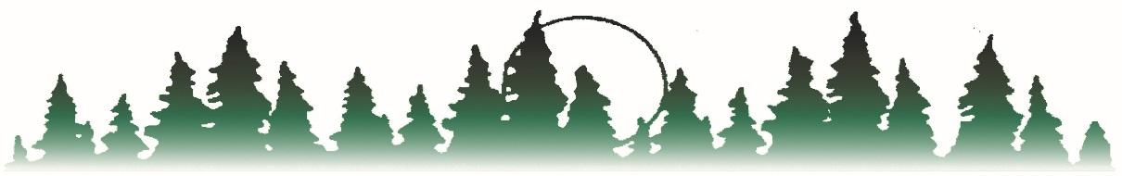

BEMIDJI REGIONAL INTERDISTRICT COUNCIL
Bagley PO Box 974 Kelliher
Blackduck Bemidji, MN 56619 Lake of the Woods
Cass Lake-Bena Phone 218-751-6622 Laporte
Clearbrook-Gonvick Brenda R. Story, Executive Director Littlefork - Big Falls
Mahnomen FAX Number 218-751-6625 Waubun-Ogema
Northome-Indus www.bric-k12.com Admin Office-Bemidji
Special Education Transportation
Determination Form

Date: ___________________________________ Case Manager: __________________________________

Student Name:____________________________ District/Building: _________________________________

Reason for Authorization Request

- Accessibility: The regular bus is not accessible for the child.

Describe need related to accessibility (i.e., student is in a wheelchair):

- Social Behavior: The Student’s bus conduct requires a different mode of transportation. This will only be offered after the case manager and/or building principal design, implement and document two interventions, over two weeks, for the regular bus.

Number of bus referrals: _________ Primary reason(s) __________________________________

Interventions designed and implemented to address bus concerns (at least 2 required):

1.

2.

Interventions waived due to safety concerns. Yes____ No _____ Principal Initials ______

- Health/Medical Condition: A health/medical condition exists which involves the safety of the child or others. Please note: emergency health card should be completed prior to special education transportation.

List health/medical condition(s) warranting special education transportation:

- Bus Route Modification due to Adjusted Student Schedule

List reason for adjusted schedule:

Special Transportation

- Yes

- No

