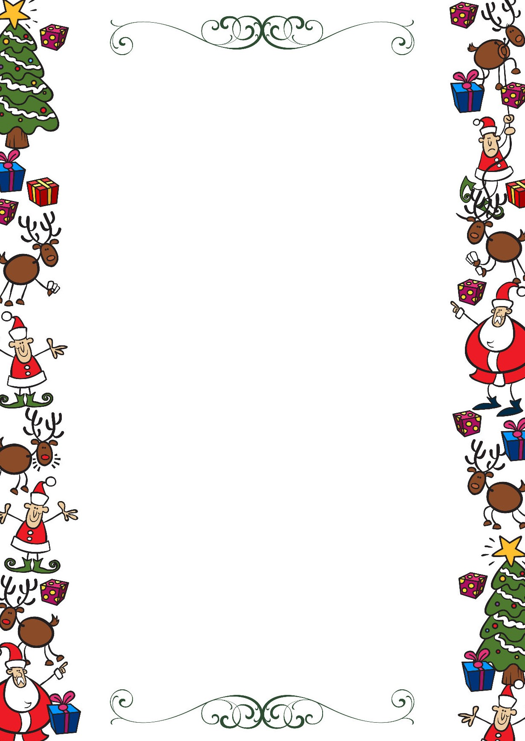
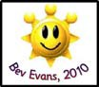
Public Schools of Robeson County
Holiday Online Enrichment Activities
(Christmas)

9-12 ELA/Reading

10 Christmas Activities for Secondary English Classes

Classic Christmas Literature List

9-12 Math

Classworks

Christmas Ugly Sweater Plotting Points- Mystery Picture from Amazing Mathematics ($)

Christmas Crafts

Holiday Card Star

Swedish Advent Star

Paper Roll Snowflake

Number and Logic IQ Puzzles

Mathsphere Math Puzzles

Math Puzzles

Math Puzzles for Teenagers

Logic Puzzles

9-12 Science
Paper STEM Challenges
High School STEM activities
BBC Games
Yellow Jackie Science Mystery
Smog City Simulation
PBS Learning Media
Paper Roll Snowflake
Go to Worldbook online in your canvas course and find a topic to read about.

Public Schools of Robeson County
Holiday Online Enrichment Activities
(Christmas)

9-12 Social Studies

Christmas traditions around the world (Santas.net)

Christmas around the world (TheHolidaySpot.com)

Christmas around the world (The-North-Pole.com)

Christmas around the world (Christmas.com, an archived site)

- Winter Holidays
- Holiday Poems
- Potato Print Wrapping Paper
9-12 Arts

Crafts for Kids

Crafts for Tweens

Beat Box Mix It

Nutcracker Christmas Art Activity & Lesson, How to draw lessons
PopArt 3D Ornament
How To Draw Christmas Characters
Christmas crafts and activities

