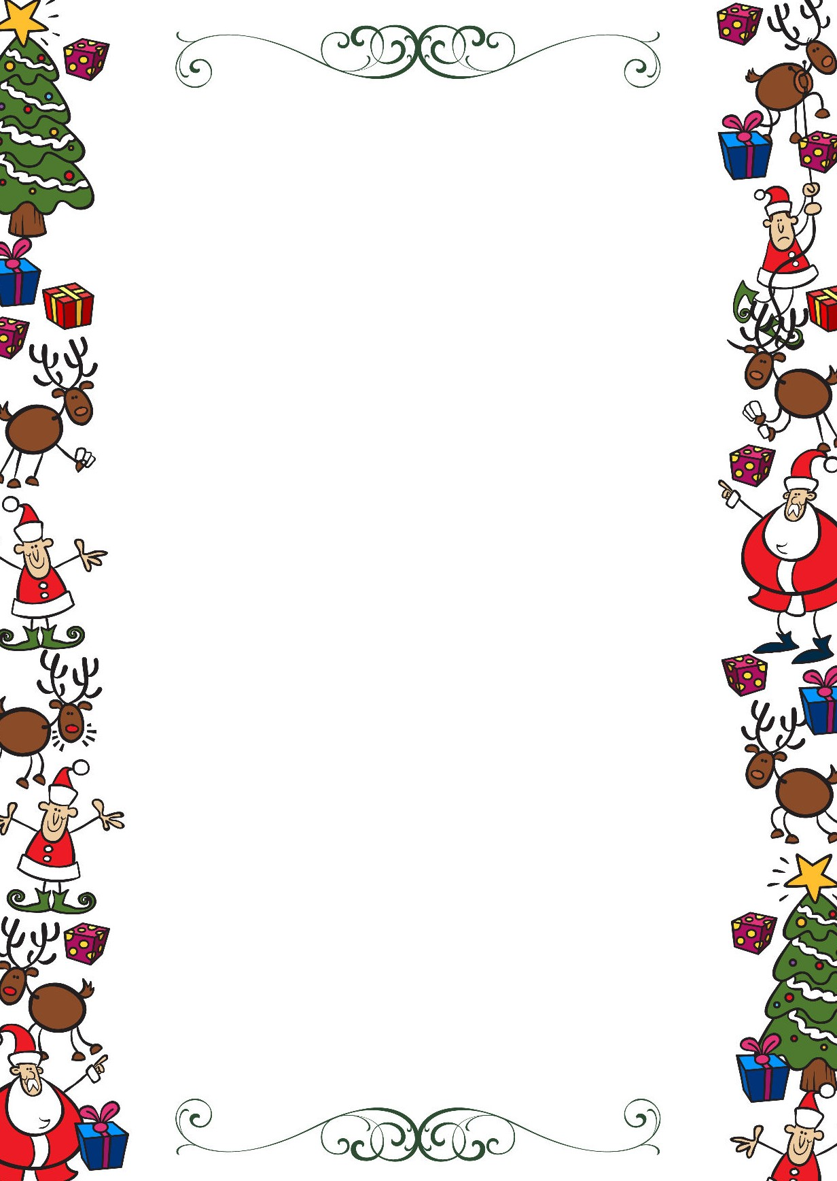
Public Schools of Robeson County
Holiday Online Enrichment Activities
(Christmas)

Seventh Grade ELA/Reading

https://masandpas.com/14-fun-christmas-activities-that-your-teen-will-love/

Seventh Grade Math

The 12 days of Christmas math activities:
Christmas Math Mazes
Math Ornament Coloring Activity
Wits and Wagers Trivia Game
Distributive Property Christmas Bingo
Order of Operations Puzzle
Santa and Christmas Tree themed prizes
Christmas Tree Exit TicketsMath Challenges
Constructing a Giant Snowflake
Analyzing the 12 days of Christmas
Christmas Themed Word Problems
Real World Math Activities

Seventh Grade Science

Christmas Science: Grow the Grinch’s Heart

Christmas Science Experiments for Kids

Hot Chocolate Science
Snow Science Prediction and Observation:

Public Schools of Robeson County
Holiday Online Enrichment Activities
(Christmas)

Seventh Grade Social Studies

6 Fun Virtual Christmas Activities for Online Students

Printable Family Activities Advent Calendar
Paper Plate Christmas Tree Kids Craft
The Best Salt Dough Ornaments for Kids

Seventh Grade Arts

Crafts for Kids

Crafts for Tweens

Beat Box Mix It

