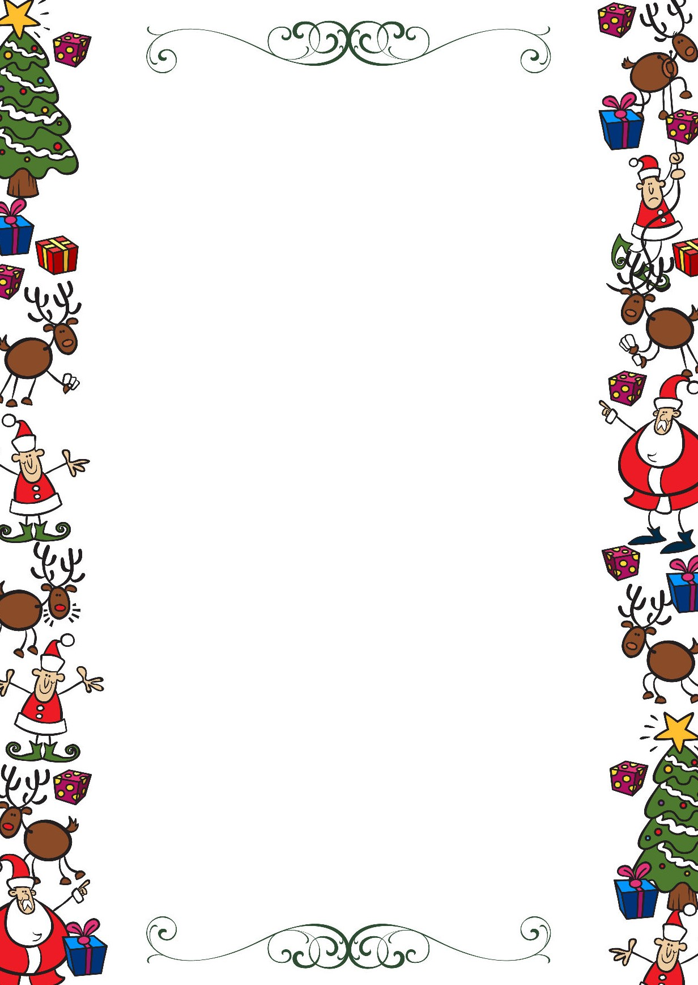
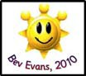
Public Schools of Robeson County
Holiday Online Enrichment Activities
(Thanksgiving/Christmas)

Kindergarten ELA/Reading

https://www.redbookmag.com/life/mom-kids/how-to/g3780/christmas-activities-kids/

https://growingbookbybook.com/christmas-books-and-activities/

https://abcsofliteracy.com/25-days-of-christmas-activities/

Kindergarten Math

Get a little fine motor practice while using a hole punch to do this simple Christmas Tree counting activity from Sugar Aunts.

Explore patterns with this simple Candy Cane
Pattern activity from This Reading Mama (comes with a free printable).
Have some sweet counting fun with this simple M&M Christmas tree counting activity from Umbrella Tree Cafe.
Kindergarten Science

Christmas Science: Grow the Grinch’s Heart

Christmas Science Experiments for Kids

Hot Chocolate Science

Snow Science Prediction and Observation:

Christmas Science Experiments

Go to Worldbook online in your canvas course and find a topic to read about.

Public Schools of Robeson County
Holiday Online Enrichment Activities
(Christmas)

Kindergarten Social Studies

6 Fun Virtual Christmas Activities for Online Students

Printable Family Activities Advent Calendar
Paper Plate Christmas Tree Kids Craft
The Best Salt Dough Ornaments for Kids

Kindergarten Arts

Cut Out Snowflakes

Christmas Crafts

Music Skill Activities

