Louisiana School Boards Association
SCHOOL BOARD MEMBER
RECOGNITION MONTH
JANUARY 2022
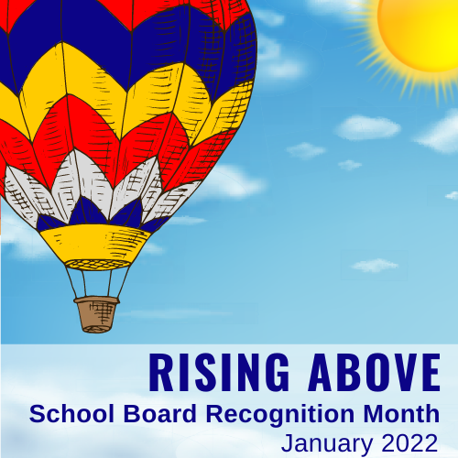
PLANNING KIT

TABLE OF CONTENTS

- LSBA Code of Conduct for Louisiana School Board Members

- Sample Resolution for Local School Boards

- Sample Video – Role of the School Board for Elementary Students

- Sample News Release

- Sample Public Service Announcements

- Ideas to Get You Started
  - Tell Us How You Celebrated

*LSBA extends a special thanks to the Texas Association of School Boards for sharing their ideas, sample documents, and the above referenced video.

LSBA CODE of CONDUCT for
LOUSIANA SCHOOL BOARD MEMBERS
(9-9-16)

As a member of the School Board, I will endeavor to meet and adhere to the following LSBA Code of Conduct:

- Represent the constituents, parents and students of the district which I serve, while remembering that my overarching concern must be the educational welfare of all of the students of the District.
- Respect and uphold the laws and Constitution of the United States, the State of Louisiana, and the policies adopted by the School Board.
- Respect and treat with professionalism and courtesy my fellow School Board members, the Superintendent, staff, educators, parents and students of the District.
- Maintain decorum and professionalism in my communications with and about my fellow School Board members, the Superintendent, staff, educators, parents and students of the District, no matter the forum.
- Recognize that my authority is that of a member of the School Board, acting through the process of the School Board, and that I do not have, nor will I attempt to exert, any authority, as an individual, over the Superintendent, staff, educators, parents or students of the District.
- Respect and adhere to the decisions of the School Board, while retaining the right to respectfully seek reconsideration of decisions with which I, individually, disagree.
- Guide and direct the concerns, complaints and questions of constituents, parents and students to the Superintendent for consideration and action, in accordance with School Board policy.
- Conduct my personal and professional life in a manner befitting an elected representative of the people and in accordance with the laws of the United States and State of Louisiana.
- Refrain from using the position as an elected School Board member to pursue personal financial gain or aggrandizement.
- Make a concerted effort to attend the meetings of the School Board to which I am called and be prepared to discuss and deliberate on the matters that are scheduled to be before me.
- Respect and maintain the confidentiality of information to which I may become privy, in accordance with State and Federal laws and the fiduciary obligation that I owe to the District.
- Affiliate with the Louisiana School Boards Association and avail myself of the continuing education opportunities offered thereby toward meeting my obligations for annual continuing education as provided by law.

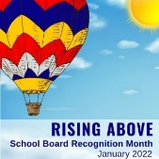
SAMPLE PROCLAMATION

Ask your mayor, city council, or parish official to proclaim January 2022 as School Board Recognition Month in your community. Publicize this action with a news release, on your website, and in your district’s newsletter.

WHEREAS, the mission of public schools is to meet the diverse educational needs of all children and to empower them to become competent, productive contributors to a democratic society and an ever-changing world; and

WHEREAS, local school board members are committed to children and believe that all children can be successful learners and that the best education is tailored to the individual needs of the child; and

WHEREAS, local school board members work closely with parents, educational professionals, and other community members to create the educational vision we want for our students; and

WHEREAS, local school board members are responsible for ensuring the structure that provides a solid foundation for our school system; and

WHEREAS, local school board members are strong advocates for public education and are responsible for communicating the needs of the school district to the public and the public’s expectations to the district;

NOW, THEREFORE, I, ______________________________, do hereby declare my appreciation to the members of the _____________________ School Board and proclaim January 2022 as

School Board Recognition Month in _________________________. I urge all citizens to join me in recognizing the dedication and hard work of local school board members and in working with them to mold an education system that meets the needs of both today’s and tomorrow’s children.

In official recognition whereof, I hereby affix my signature this _______________ day of _______________________, 2022.

_______________________________________________

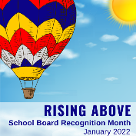
SAMPLE ONLINE VIDEO TO EXPLAIN THE ROLE OF SCHOOL BOARDS

*Note: The online video (2 minutes and 36 seconds) below was produced by the Texas Association of School Boards. The Louisiana School Boards Association has been provided with express permission from the Texas Association of School Boards to allow its member districts to utilize the video for the purposes of helping our students to understand the role of elected school board members in Louisiana.

Help your students learn about the “Role of the School Board!”

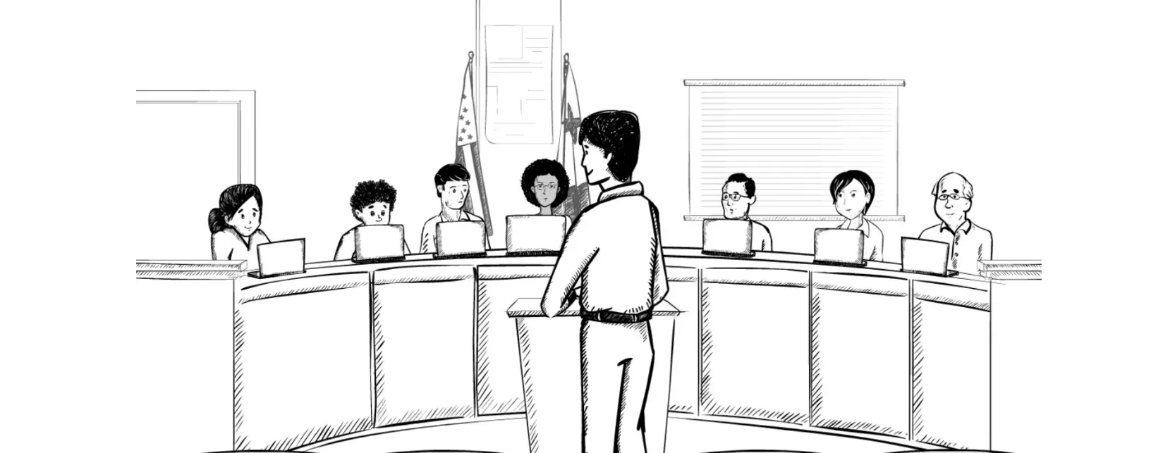

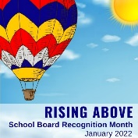
SAMPLE NEWS RELEASE

Prepare this release on district letterhead and submit it to local media. You also can post this and LSBA artwork on your website with photos of the board.

District contact: (name, title, phone number, email address)

For release: January 2022

_________________ celebrates School Board Recognition Month this January

(City, Louisiana)– January is School Board Recognition Month and (district’s name) is honored to celebrate its school board members for their dedication and commitment to the district’s schools and students.

“Our school board members are selfless volunteers who spend long hours working to ensure all of our students have the opportunity to learn and grow,” (Superintendent first/last name) said. “Celebrating School Board Recognition Month is one way to say thanks for all they do.”

Serving as a link between the community and classroom, school board members are elected to establish the policies that provide the framework for public schools. The (school district’s name) board is responsible for an annual budget of $_____million, ______students, _______, and _________campuses.

“School boards are essential to a strong public education system,” Louisiana School Boards Association (LSBA) Executive Director Janet Pope said. “They provide the local governance and oversight that makes it possible for school districts to serve students, including establishing a strategic plan, adopting policies, approving a budget, and selecting and evaluating a superintendent. It’s fitting that we celebrate them in January as their leadership is key to the success of every school district in Louisiana.”

LSBA Board President Patricia Russo echoed those same thoughts. “It’s the perfect opportunity to honor our school board members and let the communities they serve know about their many contributions.”

(Summarize major district achievements and honors accomplished recently under the board’s leadership. Add details about specific activities planned in January.)

Board members serving (district name) are: (List name, years on board, occupation, and personal quote from each board member on why he or she serves.)

Learn more about school board service at lsba.com.

# # #

SAMPLE PUBLIC SERVICE ANNOUNCEMENTS

[DATE]
Contact
[NAME]
[SCHOOL DISTRICT]
[PHONE]

“School Boards Speak Out For Public Schools”

THANK YOU ANNOUNCEMENT (15 seconds)
The month of January marks the annual observance of School Board Recognition Month – a good time to salute the work of school board members especially in these unprecedented times. Tell your locally [ELECTED/APPOINTED] board members you appreciate what they do for students in [SCHOOL DISTRICT] and for speaking out for public schools. A message from [RADIO STATION] and [SCHOOL DISTRICT].

THANK YOU ANNOUNCEMENT (30 seconds)
The month of January marks the annual observance of School Board Recognition Month – a good time to salute the work of school board members especially in these unprecedented times. Your locally [ELECTED/APPOINTED] board in [SCHOOL DISTRICT] speaks out for public schools by ensuring our students have the opportunity to benefit from a safe high-quality education. Their decisions and actions affect the present and future lives of our community’s children. Join us in celebrating School Board Recognition Month in [SCHOOL DISTRICT]. A message from [RADIO STATION] and [SCHOOL DISTRICT].

IDEAS TO GET YOU STARTED

Let your board members know how much their work for our students is appreciated during School Board Recognition Month (SBRM) in January. This printed kit is just the starting point. Artwork, sample news release, downloadable logos for your website, social media platforms, and printed materials, and other resources are available for use.

The theme for 2022 is Rising Above, and we hope these ideas will lift you into successful board appreciation campaigns at your district!

Plan a board member recognition event
- Plan a special reception at your January board meeting.
- Present a SBRM certificate, poster (11x17, 18x24), flyer, student thank-you cards/notes, artwork, and any other tokens of appreciation to board members during the event.
- Feature student entertainment at the event.
- Ask staff to say a few words on behalf of their teams, including teachers, school secretaries, bus drivers, cafeteria workers, etc.
- Give special recognition to board members with extensive service records. (May be a good time to mention school board member training hours for 2021).
- Ask local businesses to support the event.

Promote school board appreciation in the community
- Encourage your city council, chamber of commerce, or PTA to pass a local SBRM proclamation.
- Publish information on board members, including their background, years of service, accomplishments, etc. This information can be distributed in a variety of formats, like a brochure, web page, blog, and even communicated at civic meetings.
- Place appreciation messages on school marquees.
- Download the SBRM logo and print it on shirts, use it on school or district websites, and more.

Promote SBRM using your district’s digital assets
- Place a SBRM logo in staff email signatures during the month of January. Link it to your dedicated SBRM district web page.
- Use your district’s blog, newsletter, or website to post information about SBRM, post board member profiles, and more.
- Watch LSBA’s Facebook and Twitter accounts for updates. Feel free to like, retweet, and share posts.
- Invite your community members to share their appreciation for school board members through social media and email.
- Share the SBRM graphics (Facebook cover, Facebook, Twitter, Instagram, LinkedIn) on your social media accounts. Be sure to use #LSBALeads on Twitter and Instagram.

Get media coverage
- Send a press release about SBRM.
- Provide your local media information about what the school board does, major decisions and actions your board is facing, and the amount of time board members spend supporting your district. Offer to coordinate interviews with board members.
- Ask your local radio station to run a public service announcement.

Educate students, the community on what a school board does
- Hold mock school board meetings and elections in high school and invite your board members to attend either virtually or in-person.
- Include information about what a board does on your district/school cable TV channel or in school newspapers. Encourage students to interview board members.
- Link to and share LSBA’s video (https://player.vimeo.com/video/145640536) about the role of a school board in classrooms, your website, and on social media.

Student projects
- Have students create thank-you notes or artwork using bright colors for hot air balloons and positive messages.
- Use blue butcher paper to decorate a door like the sky with the words “You lift us up!” Have students write their name on a cloud and/or balloon to arrange in the sky. Consider having students place their picture next to their name.
- Have culinary students bake cupcakes featuring hot air balloon designs.

Other creative ideas
Below are some fun suggestions for districts.
- Give school board members a free school lunch. Have members of the schools’ student council or other student group sit with the board member(s).
- Visit your board members’ place of employment and thank them for their service.
- Invite board members to athletic events to throw the first ball or blow the whistle to kick off the game.

Don’t forget to complete and return the Tell Us How You Celebrated! form to share your great ideas and help us continue to improve this campaign.

