WASHINGTON ELEMENTARY



Things are changing daily. We thought we would give you some ideas of what you could do at home with your children. All activities are optional. Check out the learning mats. They are great ideas for those that want another choice other than internet options. You can download all mats at the very bottom of the pages. Your health and safety are of the utmost importance. Stay safe and healthy!

**Math * Reading * Science * Social Studies**

**PLEASE VISIT THE NEW WASHINGTON WEBSITE FOR ALL RESOURCES**

[**Washington Elementary Website**](https://sites.google.com/fairfieldsfuture.org/washington-elementary-home-act/home)

**Top 5 Math Websites**

[**https://www.ixl.com/**](https://www.ixl.com/)

[**https://www.prodigygame.com/**](https://www.prodigygame.com/)

[**https://www.tynker.com/**](https://www.tynker.com/) **Free coding during school closure**

[**https://pages.sumdog.com/home-learning-during-school-closures/**](https://pages.sumdog.com/home-learning-during-school-closures/)

[**https://classroommagazines.scholastic.com/support/learnathome.html**](https://classroommagazines.scholastic.com/support/learnathome.html)

**more online resources:**

**Pebble Go-** Informational stories read online <https://site.pebblego.com/login>

user:: gpaea59 password: reads

Your child can write a couple sentences about what they learned.

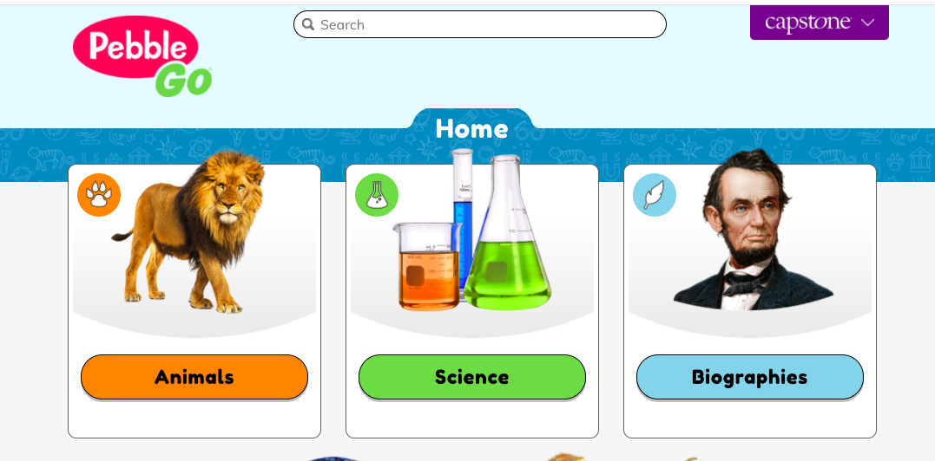

**Bookflix** is another good source of online books and students can practice retelling beginning, middle, and end of story

[**http://auth.grolier.com/login/bookflix//login.php?bffs=N**](http://auth.grolier.com/login/bookflix//login.php?bffs=N)

**User: 31fairfield, password: gpaea**

**Raz-Kids-** books that students can listen to, read to self, and take a comprehension quiz on. [**https://www.kidsa-z.com/main/Login**](https://www.kidsa-z.com/main/Login)**-** contact Mrs. Clark for login info or parents you can create your own account.

**GoNoodle**

<https://app.gonoodle.com/> has many brain breaks, yoga, and movement songs to break up your day and get moving!

*Students can use their Clever badge to do ST Math, Splash Math, Brainpop Jr. and many other resources. Ask Mrs. Clark for a copy of your child’s clever badge if you need one.

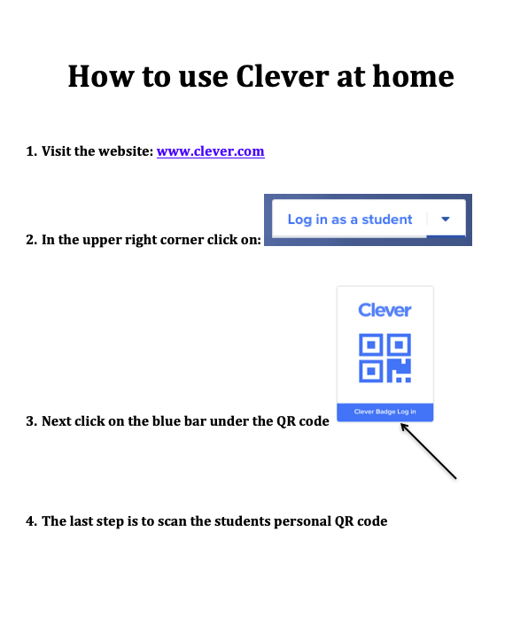

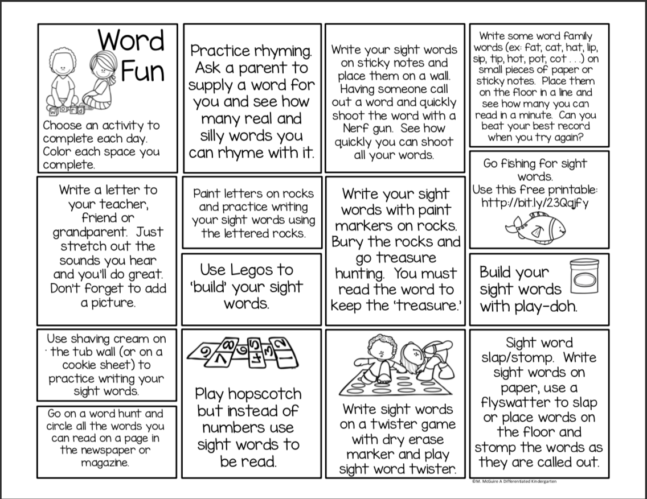

Online Phonics Opportunities (Parents will need to assist)

Washington Elementary uses really great reading for teaching phonics.

This sight will be a great sight to keep boosting reading skills.

[Really Great Reading Home School Connection](http://www.reallygreatreading.com/homeconnection/)



Do your Visual Phonics with Mrs. C. just like we do at school every morning! Just click on the following link!

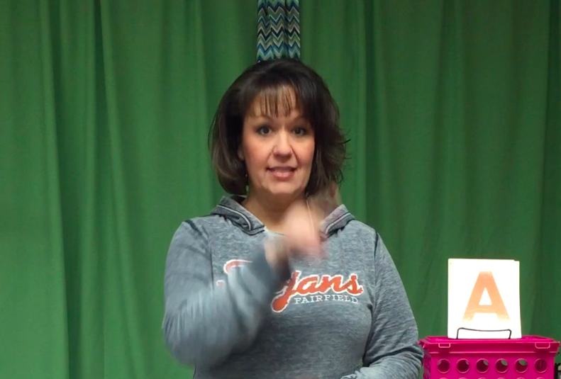 [Visual Phonics](https://youtu.be/2FwlwK__Poc)

**More Fun Online Reading Opportunities:**

[TeachYourMonsterToRead.com](http://teachyourmonstertoread.com)

[Storyline Online](https://www.storylineonline.net/?fbclid=IwAR33tn4gRgYSI1cdUuW2PUKENCV8tBYyLGBhFYrh8jo60l74Tog9q6sqTow)

[Read to Me](https://www.readtomeintl.org/?fbclid=IwAR2zkhmLL2q5FpqYj8A_QiXtTwbzzsnaumD--eeRNAlxwp79m6XqfMOtV_Y)

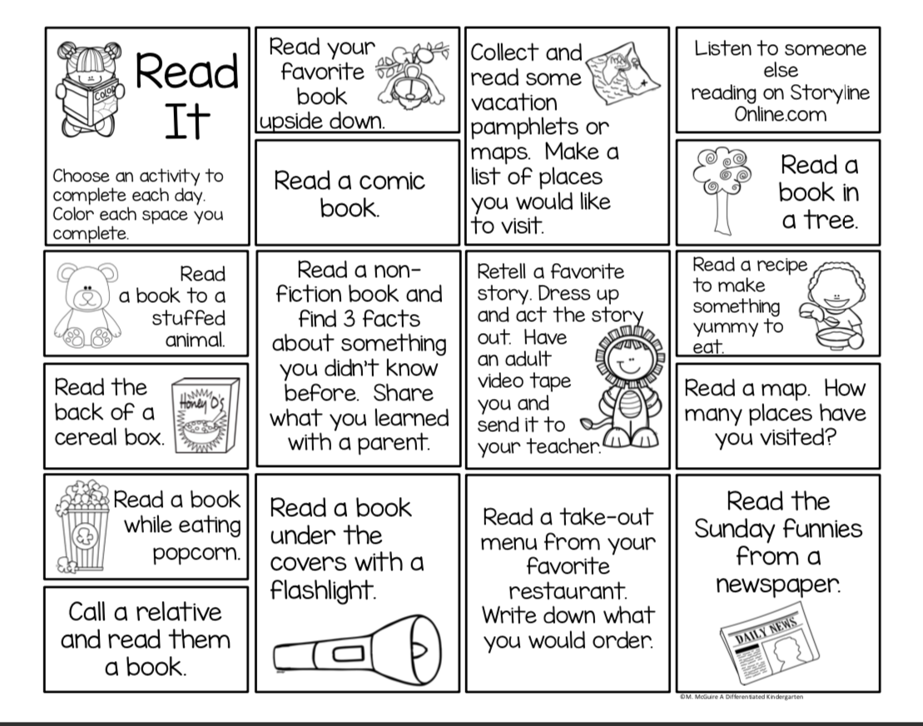

Kindergarten families-

Here are the 50 sight words. Students need to be able to read 13 in a minute by May.

| not | on | up | my | be |
| --- | --- | --- | --- | --- |
| in | too | will | a | make |
| just | to | like | what | it |
| but | or | he | day | I |
| your | two | was | for | she |
| you | is | some | have | look |
| out | big | did | him | at |
| food | so | me | one | by |
| little | had | we | can | all |
| the | are | if | school | and |

First Grade families-

Here are the 150 sight words. Students need to be able to read 65 in a minute by May.

| what | and | sea | want | or |
| --- | --- | --- | --- | --- |
| much | all | it’s | after | school |
| because | here | than | well | went |
| him | a | you | and | to |
| door | off | when | has | this |
| only | today | light | night | many |
| was | out | too | some | like |
| by | she | he | had | have |
| tell | family | help | down | as |
| show | right | soon | sea | way |

| but | food | not | air | the |
| --- | --- | --- | --- | --- |
| my | house | now | about | need |
| said | try | run | under | does |
| also | look | is | be | at |
| I | two | then | of | them |
| first | that | last | any | let |
| took | on | me | one | little |
| it | old | how | could | more |
| into | very | never | mother | who |
| who | eat | red | family | tell |

**Bucket filler coloring page Here is link to hear a story about being a bucket filler:**

[**https://www.teachertube.com/videos/have-you-filled-a-bucket-a-narrated-picture-story-314654**](https://www.teachertube.com/videos/have-you-filled-a-bucket-a-narrated-picture-story-314654)

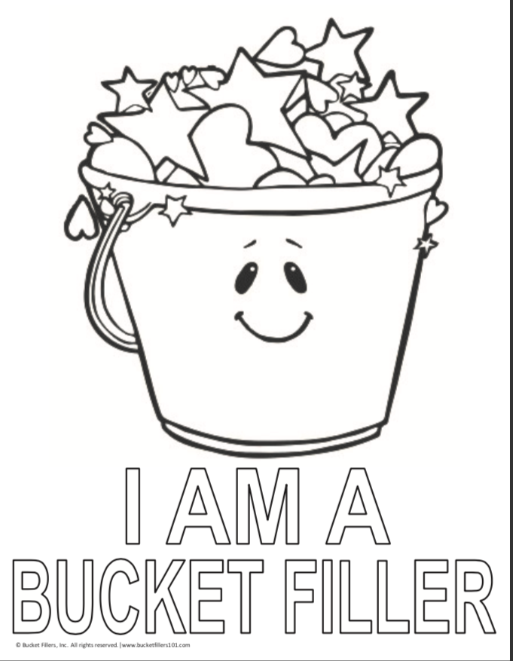

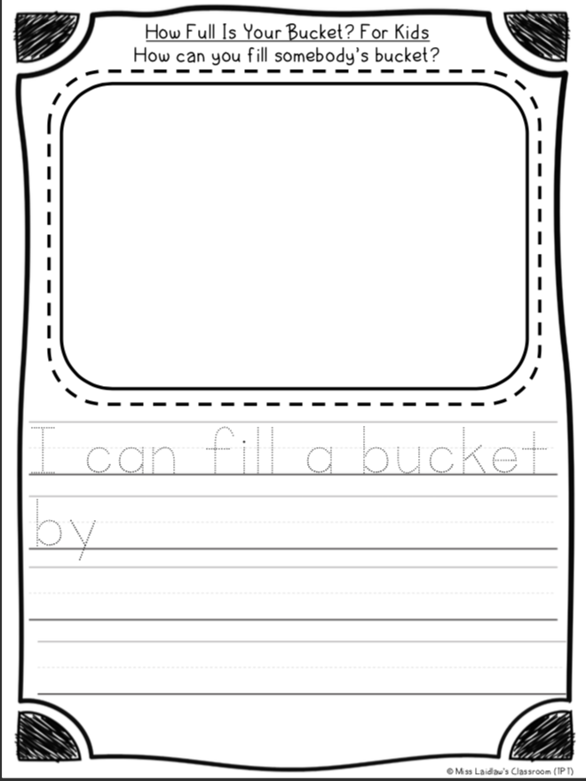

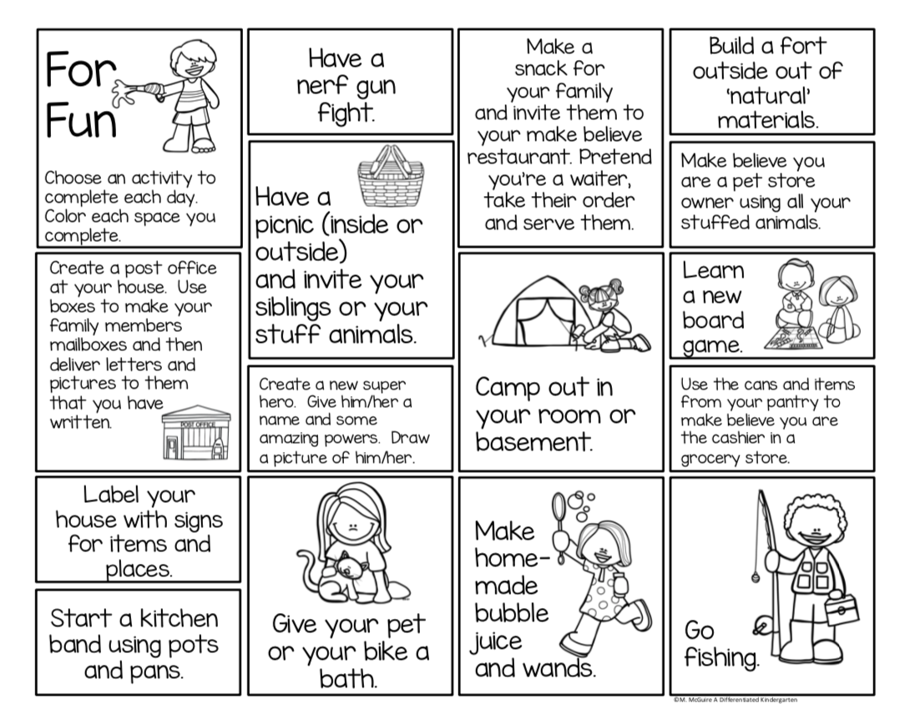

**Download the Learning Mats here if you would like them in printable form.**

[**https://differentiatedkindergarten.com/free-worksheet-free-at-home-activities-games-and-ideas/**](https://differentiatedkindergarten.com/free-worksheet-free-at-home-activities-games-and-ideas/)

Virtual Field Trips with Links

**(Click on colored text for links. Safe Travels!)**

| San Diego Zoo |  | **The** [**San Diego Zoo**](https://kids.sandiegozoo.org/) **has a website just for kids with amazing videos, activities, and games. Enjoy the tour!** | |
| --- | --- | --- | --- |
| Yellowstone National Park Virtual Field Trip |  | [**Mud Volcano**](https://www.nps.gov/thingstodo/yell-mud-volcano-trails.htm)**,** [**Mammoth Hot Springs**](https://www.nps.gov/thingstodo/yell-mammoth-hot-springs-trails.htm)**, and so much more.**  **Tour** [**Yellowstone National Park**](https://www.nps.gov/yell/learn/photosmultimedia/virtualtours.htm)**!** | |
| MARS!!! |  | [**Explore the surface of Mars**](https://accessmars.withgoogle.com/) **on the Curiosity Rover.**  **They are updating from WEBVR to WEBXR now, but** [**360 Mode**](https://accessmars.withgoogle.com/) **offers a digital view!** | |
| Animal Cameras |  | [**Live Cams at the San Diego Zoo**](https://zoo.sandiegozoo.org/live-cams)  [**Monterey Bay Aquarium live cams**](https://www.montereybayaquarium.org/animals/live-cams)  [**Panda Cam at Zoo Atlanta**](https://zooatlanta.org/panda-cam/)  [**6 Animal Cams at Houston Zoo**](https://www.houstonzoo.org/explore/webcams/)  [**Georgia Aquarium**](https://www.georgiaaquarium.org/webcam/beluga-whale-webcam/) **has** [**Jellyfish**](https://www.georgiaaquarium.org/webcam/jelly-webcam/)**,** [**Beluga Whales**](https://www.georgiaaquarium.org/webcam/beluga-whale-webcam/)**, and** [**more**](https://www.georgiaaquarium.org/webcam/indo-pacific-barrier-reef/) | |
| Virtual Farm  Tour |  | **This Canadian site** [**FarmFood 360**](http://www.farmfood360.ca) **offers**  [**11 Virtual Tours**](https://www.farmfood360.ca/?utm_source=domain&utm_campaign=www.virtualfarmtours.ca&utm_medium=redirect) **of farms from minks, pigs, and cows, to apples and eggs.** | |

Check out the Eagles in their nest in Decorah, IA.

Learn about Eagles, Falcons, and other birds in Iowa.

[www.raptorresource.org/birdcams/decorah-eagles/](http://www.raptorresource.org/birdcams/decorah-eagles/)

[Elementary On-Line Resources](http://docs.google.com/document/d/1rCgHAQAnCJOFmMYdL1IjfVa-C6F589H4oGkqFXAtruc/edit)

These are all On-Line Resources for students to use on their devices at home.

[Resources and Activities for Early Childhood (PK) Students](http://docs.google.com/document/d/1-CKMOM503nuMlYFveDEJIJjrn_hqHDGRo9Hdxs9xmno/edit)

Activities and resources from your Preschool Team, Ms. Brittany and Ms. Brandi.

This link is to activities that you can do with your student at home. This is a work in progress. As we create or link the paper and pencil activities we will link them through this document. Thank you for your patience. Please check back often. :)

[**Family Activities**](https://docs.google.com/document/d/1fnzJt6vZseUw6ZglX7OYMM4l5GjQ1P1vwWibSPJyCqY/edit)

**Math Packets - This a packet of daily math routines. It starts at zero and goes to 100. Please do not print the entire packet. Only print to page 103 as that is where the packet repeats, beginning at zero again.**

[**Math Packet to Print**](https://drive.google.com/file/d/1ZH4JtLP3tFsdre8FUfzFCIP9FxzEd5RX/view?usp=sharing)

Here is the link to Age-Appropriate Chores for all children to be able to help around the house. Children who help are happier, feel productive and less stressed.

[Age Appropriate Chores](https://www.webmd.com/parenting/features/chores-for-children#1)

Iowa PBS Resources and Strategies



| ***COVID-19 Support***  **Virtual learning**  Join families from across Iowa as we keep our skills sharp through a guided online learning camp with weekly challenges and educational apps from PBS KIDS and Iowa PBS Education! This guided camp is ideal for little ones 5-8 to spend a little time each week practicing their [literacy and math skills](http://r20.rs6.net/tn.jsp?f=001lVx5E0OdV8NBzorCNb2XIgV1TlQ0z_6tOEdSg-eORIbuKNK9Hzmar70Uv4U2nXA_IKr2P45DXbnFMVukm7k7cZPDNPj_f_KJ9qgflkZsQD_RMBhIrrPpQhdgaaMrqEDX1BJpu-UXkGa2P9FHX3iunKWU2lgWD_GwHbtHzjSMM9vgORtNtK15fAJykWHwELGNd9x_cf6mY999t8j2LQ-tzg==&c=Gv5Qh6hyJjJINKbbAJkqcIKBCPZgfgkDoSI5wTbbaW-VqLhc_txuOA==&ch=VlXxHFNNWDzuQEQjFqaoa04zlQdjvr29Xv27-luzAE1-5R4WFqmN5w==). |
| --- |



| ***Kids & Family***  **Virus information and prevention**  What are viruses and how do they spread? Find resources that explore [the nature of viruses](http://r20.rs6.net/tn.jsp?f=001lVx5E0OdV8NBzorCNb2XIgV1TlQ0z_6tOEdSg-eORIbuKNK9Hzmarza1UrKFuYnPP8Cgfr2xkFn8Z7Ho2B1vkvOeTfB8I6ufrrY7k_BFNFsUOKFZ-IrsDuKE1sAuntl-noXS-olTjq5AQHk_OSy3wf9IQwxNEl96gYT3whQ3EOvtEk52SPOtbBP4oBu05SqoB2UAuvT6K7B7ew3J95TbrsI6WdfEa8VHOHLbYmly9qXgW3b14ZZV3w==&c=Gv5Qh6hyJjJINKbbAJkqcIKBCPZgfgkDoSI5wTbbaW-VqLhc_txuOA==&ch=VlXxHFNNWDzuQEQjFqaoa04zlQdjvr29Xv27-luzAE1-5R4WFqmN5w==), how they are transmitted and the healthy habits we can all engage in to prevent their spread. From the common cold to coronavirus, these videos, interactive lessons and discussion questions will offer families a variety of ways to introduce the topic to children. |
| --- |



| Early Childhood  Iowa PBS resources for home learning    Iowa PBS is here to support you in providing [learning opportunities](http://r20.rs6.net/tn.jsp?f=001lVx5E0OdV8NBzorCNb2XIgV1TlQ0z_6tOEdSg-eORIbuKNK9Hzmar70Uv4U2nXA_nRBbFmMTtJoeL5bhAYY7EG9gkXZMJdsEWmjv5Oi_dhalqzXHXOd-652Lg0LrItD7WA-vE99WT7SMTRW32qbyyumv6r72eqImF5LqTHr7fwm-9NScjlsq8Alw7Ynu_Zuxvsu6c4EpX_4l4al8QMgPGnUMSlJalkhSDfpXWzD2qU2hLce-i477aA8cKmehcxpZ&c=Gv5Qh6hyJjJINKbbAJkqcIKBCPZgfgkDoSI5wTbbaW-VqLhc_txuOA==&ch=VlXxHFNNWDzuQEQjFqaoa04zlQdjvr29Xv27-luzAE1-5R4WFqmN5w==) that you can feel confident using with your children during school closures. We will continue to add more resources as they become available. We're dedicated to helping Iowa's parents find necessary resources so please reach out to us via Facebook or email if you have specific questions or resource needs.  Iowa Healthy State Initiatives Sites  [Iowa Healthy State](http://www.iowahealthieststate.com/blog/individuals/coronavirus-covid-19-home-physical-activity-health/?utm_medium=email&utm_campaign=Momentum%20newsletter%20March%202020&utm_content=Momentum%20newsletter%20March%202020+CID_c63f45ecdce4c3810c16a6ecc1fd426b&utm_source=U%20Mail&utm_term=Try%20these%20ideas) |
| --- |

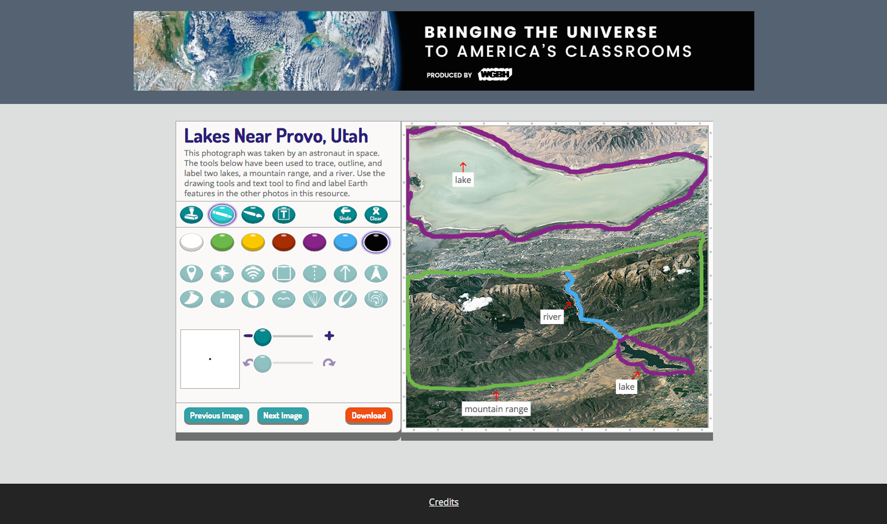

Here are the flower coloring pages for kids to download and color. Once they are colored, please hang them in your windows for EVERYONE to see! Let’s make our neighborhoods BLOOM! Thank you

<http://www.supercoloring.com/coloring-pages/orchid-0>

<http://www.supercoloring.com/coloring-pages/orchid>

<http://www.supercoloring.com/coloring-pages/sophronitis-cernua-orchid>

| |  |  | | --- | --- |   ***Elementary***  **PreK-12 resources for emergency closings**  As teachers, students and families deal with school closures, PBS LearningMedia producers and educators have come together to curate a special collection of [resources organized by grade and subject area](http://r20.rs6.net/tn.jsp?f=001lVx5E0OdV8NBzorCNb2XIgV1TlQ0z_6tOEdSg-eORIbuKNK9Hzmarza1UrKFuYnPdQwrGGi8bCSJlkhMBzD71-ZhevsJrbGXvPZNOKutzAe3Nri8h2-MxbsGm9ckqTNvpoUDv8xKpw1sh49VGcwboxQYMTFFGJeuxpd8TczvE5xnspsHAm4-jIoQEOnka-Iie9F_t1N5WVWLjIml--7zeaRAl7-obEPTpUXfgubXdyFyzsIRN9Ct0A==&c=Gv5Qh6hyJjJINKbbAJkqcIKBCPZgfgkDoSI5wTbbaW-VqLhc_txuOA==&ch=VlXxHFNNWDzuQEQjFqaoa04zlQdjvr29Xv27-luzAE1-5R4WFqmN5w==). Find videos, lesson plans and activities that support learning at home. |
| --- | --- | --- |

| |  |  | | --- | --- |   ***Secondary***  **Making sense of coronavirus through media and storytelling**  With many schools closing and teaching moving online, ***PBS NewsHour*** Student Reporting Labs has created a special unit that covers the [basics of local community journalism](http://r20.rs6.net/tn.jsp?f=001lVx5E0OdV8NBzorCNb2XIgV1TlQ0z_6tOEdSg-eORIbuKNK9Hzmarza1UrKFuYnP_hW8O8i3iATQTEz5a8Lnj0CUy-XX-m_6dRXOEOE1e9d9TBSU9cQTQlN46OOwuSdcZGYV1X1B5cUHYhBachPctuz6C1x0BEi-LUc75fU3ahlX3Ney9rWDH0O5rilEKKDOKuFFtydXlERkzH-5MeWU3qXgkxASjip2jqBDaVsGFpSzVkw6hQs3MZxcYa74iT2vBFrITgjBUJ2Z5drgD-QuopKtPuTAoUy7r-9AAe_9lZlyRfdakYubdriO_1Qn1ik_AQx4gItYXxK529TR7ao75LTsfSUvCdzexwjZjsNN0mr_JVjqYUQPUmkmbB28hJltD-tnVxpdu7raHAIc44kGUFnUl0JhkeYx&c=Gv5Qh6hyJjJINKbbAJkqcIKBCPZgfgkDoSI5wTbbaW-VqLhc_txuOA==&ch=VlXxHFNNWDzuQEQjFqaoa04zlQdjvr29Xv27-luzAE1-5R4WFqmN5w==), storytelling, scripting and video editing. These are difficult times for everyone, and your stories will add a uniquely critical perspective to coronavirus coverage. |
| --- | --- | --- |

| **Coming Up**  Look for Iowa PBS Education at the following events:   * March 23 - April 18 [Iowa PBS Virtual Learning Camp](http://r20.rs6.net/tn.jsp?f=001lVx5E0OdV8NBzorCNb2XIgV1TlQ0z_6tOEdSg-eORIbuKNK9Hzmar70Uv4U2nXA_IKr2P45DXbnFMVukm7k7cZPDNPj_f_KJ9qgflkZsQD_RMBhIrrPpQhdgaaMrqEDX1BJpu-UXkGa2P9FHX3iunKWU2lgWD_GwHbtHzjSMM9vgORtNtK15fAJykWHwELGNd9x_cf6mY999t8j2LQ-tzg==&c=Gv5Qh6hyJjJINKbbAJkqcIKBCPZgfgkDoSI5wTbbaW-VqLhc_txuOA==&ch=VlXxHFNNWDzuQEQjFqaoa04zlQdjvr29Xv27-luzAE1-5R4WFqmN5w==)   Email Iowa PBS Education for resource assistance during COVID-19 closures. |
| --- |

|  |
| --- |