Local Evaluation for Grantee Name
Iowa 21st CCLC for 2018-2019
Overview
To assist grantees with meeting the local evaluation requirements, the Iowa DOE provides a standardized form for local evaluations of the 21st CCLC Programs. Each grantee is required to complete the local evaluation form with data from the previous school year. Each grantee must submit one evaluation that encompasses all centers funded by the grantee. Cohorts 9-13 are to be included for reporting data for the 2018-2019 school year. Reported data will be from the Fall of 2018 and the Spring of 2019. Data will also be reported for the Summer of 2018. The table below lists the eight required sections of the local evaluation. Each section includes a checklist of required items to include. The completed form should be saved with the filename <Grantee Name 21st CCLC Local Evaluation Form 2018-2019>. The form must be completed and submitted in Word format. (Note: Instructions and clarifications are shown in RED.)
Required Section | Complete?
- General Information | x
- Introduction/Executive Summary | x
- Demographic Data | x
- GPRA Measures | x
- Local Objectives | x
- Anecdotal Data | x
- Sustainability Plans | x
- Summary and Recommendations | x

- General Information
General Information Required Elements | Complete?
Basic Information Table | x
Center Information Table | x

Basic Information Table
Item | Information
Date Form Submitted
Grantee Name | Fairfield Community School District
Program Director Name | Katie Boatright
Program Director E-mail | Katie.boatright@fairfieldsfuture.org
Program Director Phone | 641-919-0009
Evaluator Name | Margaret Kelly
Evaluator E-mail | melizabethkelly@gmail.com
Evaluator Phone | 641-472-2912
Additional Information from Grantee (optional)

Center Information Table
Cohort | Centers
(If not in a cohort, leave that cohort info blank) | (Enter Names of Centers, separated by commas)
Cohort 9
Cohort 10
Cohort 11
Cohort 12
Cohort 13 | Pence Elementary School
Additional Information from Grantee (optional)

- Introduction/Executive Summary
Introduction/Executive Summary Required Elements | Complete?
Program Implementation
- Needs Assessment Process | x
- Key People Involved | x
- Development of Objectives | x
Program Description
- Program days and hours | x
- List of activities | x
- Location of centers | x
- Attendance requirements | x
- Governance (board, director, etc.) | x
Program Highlights | x

Type or copy and paste Introduction/Executive Summary here. In late summer 2018, Fairfield Community School District received grant funding/approval through the Iowa Department of Education for a 21st Century Community Learning Center. A program was opened in October 2018 at Pence School, an elementary building housing all district 2nd – 4th graders. It provides activities for any Pence student through a before-school program, 7:30 AM – 8:20 AM, M-F and an after-school program, 3:30PM – 5:30 PM, M-F during weeks (or days) when school is in session. In addition, further enrichment/field-trip programming is offered from 9:00 AM – Noon, one Saturday each month or 10 Saturdays during the school year. Parents completed an initial student registration before the program opened; children may be added to the program at any point during the year. There are no attendance requirements. Average daily attendance from October, 2018 – January, 2019 was 42 with a high of 54 and low of 28.
The needs assessment process as outlined in the CCLC grant application included the following program stakeholder representatives: District Administrators; Pence Elementary TLC Leadership and Teachers; FCSD Board of Education; the CCP Program Director; existing partners who had supported after-school programming efforts and a more cohesive, consistent future startup program (HyVee, Cambridge Investments, Agri-Plastics); and parents from Trojans Unite PTO. The stakeholders examined summative academic building data, broken down by grade level and demographics; a connection to school survey completed by grade 2-4 students; the 2016 Laborshed Report; a family needs assessment completed by parents/guardians of grade 2-4students; and student attendance, grades, medical records, and behavior referrals contained in PBIS and Infinite Campus.
Data collected on family needs was combined with annual academic analysis to establish prioritized program needs which subsequently served as program needs/objectives: (1) increase student reading and math achievement through supplemental, research-based reading and math activities; (2) eliminate familial stress regarding after school student supervision in a safe, accessible environment; (3) provide an environment that enhances students’ social/emotional development; and (4) enrich student learning with STEM experiences that enhance critical thinking and applied math skills.
The daily schedule/activities align with the prioritized needs/objectives: Children check in from 3:20 – 3:30 PM. Children are then offered the daily snack (provided by FCSD Food Service, consistent with USDA guidelines. Students have 15 – 30 minutes of supervised physical activity during each after-school session. Weather permitting, student play outside before homework completion time, and academic and enrichment activities begin. About 5:10 PM, additional physical activities are provided in the school gym. (e.g. During one activity period, an instructor taught the children basic yoga poses.) Participation varies for individual students, dependent on the time parents arrive for pick-up. A program staff member checks students out as they leave; signature of the parent/guardian picking the student up is required (safety).
Activities included the following: partner reading, ST Math, McGraw-Hill Everyday Math games, Project Lead the Way Launch and additional STEM activities, silent reading practice, craft activities, Really Great Reading Activities, guest speakers (partners and/or district teachers), activities planned and staffed by middle school and high school teams and clubs.
The CCP Advisory membership includes the program director, a FCSD Board member, Pence School Principal, FCSD Director of Curriculum/Grant Facilitator, parents/Trojan Unite PTO members, community partners, and field trip site providers. The advisory reviews attendance and achievement data, makes recommendations for program adjustments, discusses sustainability planning, and reviews staff eligibility criteria. The Grant Facilitator is responsible for budget management and program oversight.
Program Highlights: Students formed closer relationships with other students and with Program staff. On a survey of Program staff members, respondents agreed they had gained personally through positive relationships with students. They enjoyed observing new learning and improved social skills among regular attendees. For example, two children, both with challenging behaviors, chose to work together on a project in what the staff predicted would be an “epic fail”. It wasn’t! Definitely a highlight.
After-school program students enjoyed carving large pumpkins and painting small pumpkins. (As shown in the pictures at the end of this report.)
Among other program highlights: using the Pence climbing wall, constructing a miniature golf course game for a service project at a Trojans Unite PTO carnival/fundraiser, and a game of dodgeball in the Pence gym with the middle school cross country team.
The Program Director related a recent incident she certainly counts as a Program highlight! A fifth grader, a student with challenging behaviors who attended the after-school program in 2018-2019 as a fourth grader, came up to her, gave her a hug and said “I miss you! I miss the after-school program!”

- Demographic Data
Demographic Data Required Elements | Complete?
2018-2019 School Year Attendance Tables
- 2018-2019 School Year Attendance Summary Table | x
- 2018-2019 School Year Attendance Ethnicity Table | x
- 2018-2019 School Year Attendance Special Needs Table | x
Summer of 2018 Attendance Tables
- Summer of 2018 Attendance Summary Table
- Summer of 2018 Attendance Ethnicity Table
- Summer of 2018 Attendance Special Needs Table
Attendance Discussion | x
Partnerships
- Partnerships Table | x
- Partnerships Discussion | x
Parent Involvement Information and Discussion | x

2018-2019 School Year Attendance. Enter data in the appropriate fields in the tables below. Data will be from the Fall of 2018 and the Spring of 2019. There are separate tables for the Summer of 2018. Leave blank any cohorts that do not apply.
21st CCLC Program 2018-2019 School Year Attendance Summary Table
Cohort | Attendees | Total Attendance | Male | Female
Leave Blank if NA |  | Enter # | Enter # | Enter #
Cohort 9 | All
 | Regular*
Cohort 10 | All
 | Regular*
Cohort 11 | All
 | Regular*
Cohort 12 | All
 | Regular*
Cohort 13 | All | 101 | 46 | 55
 | Regular* | 59 | 31 | 28
*Regular Attendees have attended the program for 30 or more days.
21st CCLC Program 2018-2019 School Year Attendance Ethnicity Table
Cohort | Attendees | White | Hispanic/  Latino | American  Indian/  Alaska  Native | Black/  African  American | Asian/  Pacific  Islander | Unknown  Race
Leave Blank if NA |  | Enter # | Enter # | Enter # | Enter # | Enter # | Enter #
Cohort 9 | All
 | Regular*
Cohort 10 | All
 | Regular*
Cohort 11 | All
 | Regular*
Cohort 12 | All
 | Regular*
Cohort 13 | All | 73 | 10 | 1 | 6 | 11
 | Regular* | 40 | 6 | 0 | 6 | 7
*Regular Attendees have attended the program for 30 or more days.
21st CCLC Program 2018-2019 School Year Attendance Special Needs Table
Cohort | Attendees | LEP | Free and Reduced Price Lunch (FRPL) | Special Needs
Leave Blank if NA |  | Enter # | Enter # | Enter #
Cohort 9 | All
 | Regular*
Cohort 10 | All
 | Regular*
Cohort 11 | All
 | Regular*
Cohort 12 | All
 | Regular*
Cohort 13 | All | 4 | 50 | 21
 | Regular* | 3 | 30 | 16
*Regular Attendees have attended the program for 30 or more days.
Summer of 2018 Attendance. Enter data in the appropriate fields in the tables below. Data will be from the Summer of 2018 ONLY. Leave blank any cohorts that do not apply.
21st CCLC Program Summer 2018 Attendance Summary Table
Cohort | Attendees | Total Attendance | Male | Female
Leave Blank if NA |  | Enter # | Enter # | Enter #
Cohort 9 | All
 | Regular*
Cohort 10 | All
 | Regular*
Cohort 11 | All
 | Regular*
Cohort 12 | All
 | Regular*
Cohort 13 | All
 | Regular*
*Regular Attendees have attended the program for 30 or more days.

21st CCL Program Summer 2018 Attendance Ethnicity Table
Cohort | Attendees | White | Hispanic/  Latino | American  Indian/  Alaska  Native | Black/  African  American | Asian/  Pacific  Islander | Unknown  Race
Leave Blank if NA
Cohort 9 |  | Enter # | Enter # | Enter # | Enter # | Enter # | Enter #
 | All
Cohort 10 | Regular*
 | All
Cohort 11 | Regular*
 | All
Cohort 12 | Regular*
 | All
Cohort 13 | Regular*
Cohort | All
 | Regular*
*Regular Attendees have attended the program for 30 or more days.

21st CCLC Program Summer 2018 Attendance Special Needs Table
Cohort | Attendees | LEP | Free and Reduced Price Lunch (FRPL) | Special Needs
Leave Blank if NA |  | Enter # | Enter # | Enter #
Cohort 9 | All
 | Regular*
Cohort 10 | All
 | Regular*
Cohort 11 | All
 | Regular*
Cohort 12 | All
 | Regular*
Cohort 13 | All
 | Regular*
*Regular Attendees have attended the program for 30 or more days.

Attendance Discussion.
Attendance Discussion Required Elements | Complete?
General discussion on attendance including | x
- Percentage of 21st CCLC attendance compared to total population. | x
- Percentage of attendees who are FRPL. | x
- Efforts to increase and keep attendance high. | x
- Recruitment efforts. | x
- Discussion on how contact hours requirement is being met. 60 hours per month (3 hours per day x 5 days a week) during weeks when school is in session (not counting Christmas or Spring Break) | x

Type or copy and paste Attendance Discussion here.
Pence Elementary building enrollment was 351 students as of May, 2019. Initial registration for the CCLC program was 101 students. Number of students attending regularly (30 or more days) was 59, or 58% of those registered and 17% of the building’s total enrollment. (Additionally, 27 students attended less than 20 days and 13 students attended from 20 – 29 days. Thus 99 different students attended the program at some point during the year.)
In January 2019, 31 parents who completed a survey were asked how many days of after-school programming per week would be ideal for their child. Responses were as follows: 5 days – 16 parents or 52%; 4 days – 6 parents or 19%; 3 days – 8 parents or 26%; 2 days – 2 parents or 6%.
The program director, advisory board, program partners, at risk coordinators and school counselors have used various strategies to recruit students, and to increase and keep attendance high. Program newsletters detailing activities are sent quarterly to all parents of all Pence students. In February 2019, the local daily newspaper (The Fairfield Ledger) carried an article, with pictures, about the program and its activities. In February the school counselor submitted names of several children who wished to attend but lacked transportation. From that point forward, the district provided a van to fulfill the request: depending on the day, from 1 – 6 children utilized this service.
Community service endeavors bring attention to the program, familiarize the community with its benefits and serve recruitment efforts. Attendees made sack lunches to provide to identified food-insecure individuals. In February, 2019, children constructed a miniature golf course used at a PTO carnival/fund-raising event. This activity involved numerous problem-solving activities!
As reflected in the demographic table above, 30 (51%) of regular attendees and 50 (51%) of all program attendees were eligible for free or reduced meal prices. The percentage of the total enrollment of Pence Elementary eligible for free or reduced meal prices was 53% as of May, 2019.
The percentage of program attendees by ethnicity: White – 72%; Asian – 11%; Hispanic – 10%; Black – 6%. The percentage of total building enrollment by ethnicity: White – 79%; Asian – 4%; Hispanic – 11%; Black – 2%; Two or More Races – 3%.
The percentage of program attendees by special needs: LEP – 4%; IEP – 21%. The percentage of total building enrollment by special needs: LEP – 5%; IEP – 21%.
Demographic distributions among CCLC attendees are similar to those of the building as a whole.
Required monthly contact hours are met through a before-school program, 7:30 AM – 8:20 AM, M-F; and an after-school program, 3:30PM – 5:30 PM, M-F during weeks (or days) when school was in session. In addition, further enrichment/field-trip programming was offered from 9:00 AM – Noon, one Saturday each month or 10 Saturdays during the school year.

Partnerships Table. Enter data in the appropriate fields in the table below. Add rows as needed. In-kind value must be reported as a monetary value (i.e. $1,200). Contribution type must be one of the following eight items. The number of each item may be used in the table (i.e. 4 in place of Provide Food). If a partner has more than one contribution type, enter all of them in the Contribution Type cell.
- Provide Evaluation Services
- Raise Funds
- Provide Programming / Activity-Related Services
- Provide Food
- Provide Goods
- Provide Volunteer Staffing
- Provide Paid Staffing
- Other
21st CCLC Program 2018-2019 Partnerships Table
Name of Partner  (Enter name of Partner) | Type*: Full/  Partial/  Vendor (descriptions  below) | Contribution Type  (From list above) | Staff Provided  (Describe if applicable) | In-kind Value  (Monetary Value if unpaid partner) | Number of Centers Served  (Input the number of centers this partner served)
Iowa State University Extension Office | Full | Programming, Volunteer Staffing, Goods | *weekly staff provided STEM activities | $400 (salaried by ISU Extension) | 1
Jefferson County Farm Bureau | Full | Programming, Volunteer Staffing, Goods | Director/Outreach coordinator provided two programs designed to educate children about careers in ag and conservation | $50 (salaried by Farm Bureau) | 1
Fairfield High School FFA | Full | Programming, Volunteer Staffing |  | $50 in-kind | 1
Jefferson County Health Center | Full | Programming, Volunteer Staffing, Provide Food |  | $175 in-kind | 1
Trojans Unite: Parent Teacher Organization | Full | Volunteer Staffing |  | Other | 1
Fairfield Park and Recreation Department | Full | Programming, Volunteer Staffing, Provide Food |  | $150 in-kind | 1
Fairfield Arts and Convention Center | Full | Programming, Volunteer Staffing, Provide Goods |  | $125 in-kind | 1
Jefferson County Conservation | Full | Programming, Volunteer Staffing |  | $80 in-kind | 1
Tokyo Pen Shoppe |  | Raise Funds |  | $100 | 1
Edward Jones |  | Raise Funds |  | $100 | 1
Miller Realty |  | Raise Funds |  | $100 | 1
Cambridge Research Investments |  | Other-Advisory Board Member |  | Other | 1
Hy-Vee | Partial | Provided discounted food/gift card |  | $25 gift card | 1
Agri-Plastics |  | Other-Advisory Board Member |  | Other | 1
FCSD Food Service | Full | Provide Food for Daily Snacks |  | Average of $35 - $45 per session/ day in-kind* | 1
Fairfield Public Library | Full | Programming |  | $25 in-kind | 1
First United Methodist Church Women’s Group | Full | Programming, Volunteer Staffing, Provide Goods | Provided food preparation activities | $100 in-kind

*Full – partner works with local program at no cost to the program
Partial – partner works with local program by providing discounted costs/rates
Vendor – services only provided with a cost to the program

Partnerships Discussion.
Partnerships Discussion Required Elements | Complete?
General discussion on Partnerships including | x
- Summary of partnerships table. | x
- Total unpaid and paid partners. (all partner types) | x
- Efforts to recruit partners. | x
- Highlights of partnerships. | x
- How partnerships help program serve students. | x

Type or copy and paste Partnerships Discussion here. The district’s most integral partner, providing vision over recent years for the school’s role in the economic development of the community and STEM programming, has been Agri-Plastics, a local blow mold plastic industry that has championed engineering education. Their commitment launched PLTW programs at middle and high schools and was a natural fit for this after-school program. Agri-Plastic membership on the advisory board has provided programming expertise and continuing support.
The program director has utilized the volunteer services and monetary donations of 16 additional CCP partners. Several, including Fairfield Arts and Convention Center and Fairfield Public Library, are new partners, recruited by the program director since after-school programming was initiated. Each partner has contributed to the vision of CCP as well as to the development of future community leaders and employees. Partners the impact the program by bringing new perspectives, connections and experiences to program attendees, their parents, and to district program employees.
Specific highlights of partnerships are best illustrated by examples from CCP Saturday morning programming. Among those experiences: (1) children toured the Jefferson County Health Center, discussed health services and employee roles, and prepared their own lunch in the facility’s kitchen; (2) attendees toured the Fairfield Recreation Center, used the indoor pool, and enjoyed pizza provided by the center; (3) tour of the Fairfield Arts and Convention Center, introduction to the Center’s variety of programs and venue services, and an art activity for each attendee.
Four advisory board members (two are also community partners), completed an open-ended survey at the February 13, 2019 meeting. Responses to selected questions follow:
How, if at all, do you see this partnership supporting student academic achievement?
- Balancing time for homework plus a learning curriculum supports a rich learning environment.
- Allows for social skills development and engagement in our community. Teaches during a hands-on experience, another way to learn outside the classroom.
How, if at all, do you see this partnership supporting student social development?
- Teaches the student manners and how to act in public and outside the school setting.
- There are opportunities to develop social skills through interactions with teachers, students and community members.
How do you see this partnership benefitting the mission of the after-school program?
- It provides learning outside the school setting. Some students may have these opportunities if the program didn’t exist.
- After-school support is needed so employees have peace of mind that their children are safe and in an educational environment. When children are secure, employees can focus on their job.
- If the district would expand the program to additional grade levels, the successes of this program can inform future planning.
*Using the district governmental reimbursement for 2018-2019 of $.91 per snack served, the cost, if borne by the program and using average attendance of approximately 40-50 children per day, would be $35-$45 per day the program was in session; $175 - $225 per week; $700 - $900 per month; and as high as $4,900 - $6,300 per year for approximately 7 months during 2018-2019.

Parent Involvement Information and Discussion.
Parent Involvement Information and Discussion Required Elements | Complete?
Number and description of parent meetings and/or events. | x
Number of parents at each meeting and/or event. | X
Description of communication with parents (flyers, letters, phone calls, personal contact, etc.) | x
Efforts to increase parental involvement. | x

Type or copy and paste Parent Involvement Information and Discussion here. The program director and staff planned and implemented two Literacy Night events for all district elementary parents/families. The meetings were held on November 15,2018 and February 21, 2019 and were attended by approximately 300 parents and children. An evening meal and childcare were provided. During the evening, parents and children rotated among stations where district staff demonstrated activities designed to promote accurate decoding/word recognition and reading comprehension.
In January, 2019, an online survey designed to elicit parent input was completed by parents of 31 regular program students. Given the average daily attendance of 42 in the CCP at the time of the survey, these 31 respondents could represent approximately 75% of those children.
All respondents rated the overall CCP as either good or excellent. One parent rated child safety at the program as fair; 30 rated safety as either good or excellent. Twenty-four rated snacks as either good or excellent; 3 rated snacks as fair and 4 chose the “don’t know” option.
All respondents agreed or strongly agreed the kinds of activities, and amount of physical activity offered at the program were satisfactory. Responses to the questions about time for homework completion were mixed: Four respondents didn’t know if there was adequate quiet time for their children to complete homework; two parents chose disagree or strongly disagree; the remaining 18 respondents agreed or strongly agreed there was adequate time for homework completion. Responses to whether the CCP was helpful for children to complete homework were similar.
All respondents agreed or strongly agree that their child was comfortable with the after-school staff. Similarly, 29 parents agreed that their child enjoyed attending; 2 did not. Although 31 agreed or strongly agreed with the statement “I am comfortable talking with the staff”, the opinions whether staff provides adequate communication about their child and the program were less consistent: 29 thought communication was adequate, 1 disagreed and 1 didn’t know.
Pence Elementary has a link on the district’s website homepage that provides an additional link to the after-school program:
http://www.fairfieldsfuture.org/
http://www.fairfieldsfuture.org/vnews/display.v/SEC/Pence%20Elementary
http://www.fairfieldsfuture.org/vnews/display.v/SEC/Pence%20Elementary%7CPence%20After%20School%20Program
Information about the after-school program is provided at this site. In addition, quarterly newsletters are e-mailed to parents; print copies are also available. Printed information about the program is available to families new to the district when they register and to all parents at twice-yearly parent teacher conferences.
In the above parent survey, 24 respondents agreed or strongly agreed that the staff welcomes parents to observe or volunteer; 7 didn’t know. However, most parents are at work during program hours and not available to visit. The program staff and members of the advisory also have personal contact with parents of prospective attendees as well.

- GPRA Measures
For 2018-2019, the US DOE has indicated that 21st CCLC Programs should measure 14 performance indicators that follow the Government Performance and Results Act (GPRA). Please note the GPRA data intends to measure student improvement based on how many regular attendees needed improvement. If you do not have this number, then enter the total number of Regular Attendees for each grade level instead. Also note that reading scores can be used for GPRA Measures 4-6 – Improvement in English. This is the same data reported online to the APR Data System.

GPRA Measures Required Elements | Complete?
GPRA Measures Data Table
- Name of Assessment Tools Used for Each Measure.
- Data Entered for all Applicable Measures.
GPRA Measures Discussion

GPRA Measures Data Table.
GPRA Measures | Number of Regular Student Attendees Needing Improvement | Number of Students Who Improved | Percentage of Students Who Improved
GPRA Measures 1-3 – Improvement in Mathematics
Assessment Tool Used: Iowa Core Mathematics Standards

1. The number of elementary 21st Century regular program participants who improved in mathematics from fall to spring. | 12 | 3 | 25%
2. The number of middle/high school 21st Century regular program participants who improved in mathematics from fall to spring. | NA
3. The number of all 21st Century regular program participants who improved in mathematics from fall to spring. | 12 | 3 | 25%
GPRA Measures 4-6 – Improvement in English
Assessment Tool Used: Iowa Core English Standards

4. The number of elementary 21st Century regular program participants who improved in English from fall to spring. | 9 | 3 | 33%
5. The number of middle/high school 21st Century regular program participants who improved in English from fall to spring.
6. The number of all 21st Century regular program participants who improved in English from fall to spring. | 9 | 3 | 33%
GPRA Measures 7-8 – Improvement in Proficiency
Assessment Tool Used: Formative Assessment System for Teachers (FAST)

7. The number of elementary 21st Century regular program participants who improve from not proficient to proficient or above in reading. | 20 | 5 | 25%
8. The number of middle/high school 21st Century regular program participants who improve from not proficient to proficient or above in mathematics.
GPRA Measures 9-11 – Homework and Class Participation
Assessment Tool Used: Teacher Survey

9. The number of elementary 21st Century regular program participants with teacher-reported improvement in homework completion and class participation. | 23 | 20 | 87%
10. The number of middle/high school 21st Century regular program participants with teacher-reported improvement in homework completion and class participation.
11. The number of all 21st Century regular program participants with teacher-reported improvement in homework completion and class participation. | 23 | 20 | 87%
GPRA Measures 12-14 – Student Behavior
Assessment Tool Used: Teacher Survey

12. The number of elementary 21st Century regular program participants with teacher-reported improvements in student behavior. | 23 | 17 | 74%
13. The number of middle/high school 21st Century regular program participants with teacher-reported improvements in student behavior.
14. The number of all 21st Century regular program participants with teacher-reported improvements in student behavior. | 23 | 17 | 74%

GPRA Measures Discussion.
GPRA Measures Discussion Required Elements | Complete?
Total or Regular Attendance Used? | x
Discussion of high performing and low performing areas.
Description of data collecting instrument. | x
Discussion of difficulties on any GPRA Measure.
Assessment of 21st CCLC Program based solely on GPRA Measures.

Type or copy and paste GPRA Measures Discussion here. Scores of regular attendees were used to calculate (1) number of students needing improvement in fall 2018 in math, English, reading, behavior, and homework completion/classroom participation; (2) numbers and percentages of those who improved by spring, 2019.
Results from the Formative Assessment System for Teachers (or FAST, an IDOE sanctioned assessment) was used to measure levels of proficiency in reading. Twenty regular CCP program students scored at the High-Risk level and were categorized as not proficient in reading at their grade levels in fall, 2018. In spring 2019 testing, 5 of these students scored at the Some-Risk or Low-Risk levels and were categorized as proficient in reading at their grade levels. Fifteen students remained at the High-Risk or not proficient level. Two of these students are receiving ELL services and 9 are being served in Level I or Level II SEPs. Although the expectation is that these students will reach proficiency in reading, yearly progress on this assessment occurs in smaller increments.
As a comparison, among all Pence Elementary students, 65 scored at the High-Risk level and were categorized as not proficient in reading at their grade levels in fall 2018 on the FAST assessment. On spring testing, 19 students, or 29% improved to the Some-Risk or Low-Risk levels. Forty-four students enrolled in special education programming at Pence scored at the High-Risk in fall FAST testing; 11 students or 25% had improved to the Some-Risk or Low-Risk levels on spring, 2019 testing.
The FCSD uses standards-based grading for elementary students. If as students are categorized as needing improvement in a subject area, they have not achieved 80% cumulative proficiency on the standards for their grade level. This was the data collecting instrument for mathematics and English for the 2018-2019 school year for the purposes of this evaluation.
The number of all regular attendees needing improvement in mathematics for the fall, 2018 grading period was 12; the number who improved for the spring, 2019 grading period was 3, or 25%. The number of all regular attendees needing improvement in fall in English fall, 2018, was 9; the number who improved was 3, or 33%.
The number of regular attendees needing improvement in (1) classroom behavior and (2) homework completion and class participation was determined through a classroom teacher survey. The number of students needing improvement in classroom behavior was 23; teachers reported that 17, or 74% improved from fall to spring. The number needing improvement in homework completion and class participation was also 20; teachers reported that 20, or 87% improved from fall to spring.
The teacher survey used separate questions for these items, i.e. behavior and classroom behavior; the results were combined for purposes of the GPRA measure. A clearer picture of CCP impact might result from separating the items.
Assessing the 21st Century CCLC program based solely on GPRA measures indicates low impact on academic improvement measures and higher success on the social-emotional learning measures. Part of the lower rating could be attributed to 2018-2019 being the first year of operation. Several items in the recommendations/summary section of this report address programming changes that could be made to increase academic achievement.
Note: The revised Iowa Test of Basic Skills, ITED, now the Iowa Statewide Assessment of Student Progress (ISASP) was administered to district students in spring, 2019. The scores, with disaggregation, were not available until late summer, 2019. This assessment will be used as a baseline to measure student achievement progress for CCLC 2019-2020 evaluation reporting.

- Local Objectives
ON JULY 1, 2017, GPRA MEASURES BECAME THE OFFICIAL OBJECTIVES. Additional local objectives should be added to help your local organizations better serve your community. However, these local objectives will be considered as additional information since the GPRA Measures will always serve as the official objectives. Data will be from the Summer and Fall of 2018 and the Spring of 2019.

Local Objectives Required Elements | Complete?
Local Objectives Data Tables
- Rating of each Objective as listed below. | x
- Full Methodology used for measurement. | x
- Justification for Rating | x
Local Objectives Discussion | x

Local Objectives Data Tables.
For each cohort table, enter the appropriate data. If a Grantee did not participate in a cohort, that cohort table will be left blank. Rows may be added as needed. If desired, all cohorts may be combined into one table (especially helpful if all objectives are the same). If this is done, in the objectives discussion section, note that the table combines more than one cohort. Objectives will be rated as one of four ways:

- Met the stated objective. Must provide methodology on how the objective was measured and justification for meeting the objective.
- Did not meet but made progress toward the stated objective. Must provide methodology on how the objective was measured and what criteria was used to determine that progress was made.
- Did not meet and no progress was made toward the stated objective. Must provide methodology on how the objective was measured and what criteria was used to determine that no progress was made.
- Unable to measure the stated objective. All objectives should be measured unless extraordinary circumstances prevent doing so. If an objective cannot be measured, complete details on these circumstances must be provided in the Methodology/Justification column.

Cohort 9 Table
Cohort 9 Objectives | Objective Rating | Methodology/Justification for Rating

Cohort 10 Table
Cohort 10 Objectives | Objective Rating | Methodology/Justification for Rating

Cohort 11 Table
Cohort 11 Objectives | Objective Rating | Methodology/Justification for Rating

Cohort 12 Table
Cohort 12 Objectives | Objective Rating | Methodology/Justification for Rating

Cohort 13 Table
Cohort 13 Objectives | Objective Rating | Methodology/Justification for Rating
#1 80% of all CCP students will achieve GL reading proficiency or surpass 1 year’s growth on IA assessments and FAST. | Did not meet but made progress toward the stated objective. | Formative Assessment System for Teachers, reading a: measurement was for students who attended at least 30 CCP sessions, rather than all CCP students. See discussion.
#2 80% of all CCP students will achieve GL math proficiency or surpass 1 year’s growth on IA assessments and ST Math. | Did not meet but made progress toward the stated objective. | FCSD Standards-Based Report Cards: measurement was for students who attended at least 30 CCP sessions, rather than all CCP students. See discussion
#3 & 5 100 % of all CCP students will attain average daily CCP and school attendance of 98% or higher. | Did not meet but made progress toward the stated objective. | Infinite Campus: measurement was for students who attended at least 30 CCP sessions, rather than all CCP students. See discussion
#4 100% of all CCP students will increase nutrition intake/activity levels from baseline to end of the year. | Unable to measure stated objective | Student nutrition logs and surveys: Nutrition logs were not kept by students; student survey did not address nutrition.
# 6A Decrease Pence gr. 2-4 disciplinary referrals by 35%. | Unable to measure stated objective. | Infinite Campus: A baseline was established in January 2019. No further data.
#6B 100% of CCP students will rate positive outlook on school and relationships above neutral on Spring Survey | Did not meet but made progress toward stated objective. | Student Survey: 73% of students surveyed indicated they “enjoyed coming to school all or most of the time”; 11% said “some of the time”; only 5% said “never.”
#6C All involved families will improve overall family well-being rating to at or above neutral, or at least 1 SD from baseline. | Did not meet but made progress toward stated objective. | Parent/Student Surveys: “All involved families” language in the stated objective does not specify which families are to be included in the measure; See discussion: survey items used to gain some insight are discussed.
#6D 80% of all non-English speaking CCP parents will participate in 1 or more adult education course offerings. | Unable to measure stated objective. | IHCC Adult Education: Relevant coursework was available outside the FCSD community only. Arrangements were not made with IHCC to provide easier access and affordable options. See discussion
#7 80% CCP students will achieve at or above grade level in quarterly classroom evaluations of engineering | Did not meet but made progress toward stated objective. | FCSD Standards-Based Report Cards: Using the district scoring scale on the standards of 1-5, 1 being the lowest and 5 the highest, average scores for regular CCP attendees in grade 2 was 2.9 (all Pence – 2.94); grade 3, 2.91 (all Pence 2.86); grade 4 was 3.0 (all Pence 2.98) See discussion

Local Objectives Discussion Required Elements | Complete?
- Statistical Analysis as Applicable. | X
- Improvement over more than one year as observed. | X
- Applicable graphs, tables, and/or charts. | X
- Details on methodology and ratings as needed. | X
- Clarification for objectives not met. | X
- Clarification for objectives not measured. | X

Local Objectives Discussion.
Note: This was the first year for the CCP program; improvement over more than one year was not measured/disaggregated for students’ scores over previous year.
Objective #1: Results from the Formative Assessment System for Teachers (or FAST, an IDOE sanctioned assessment) was used to measure levels of proficiency in reading. Twenty students scored at the High-Risk level and were categorized as not proficient in reading at their grade levels in fall, 2018. In spring 2019 testing, 5 of these students scored at the Some-Risk or Low-Risk levels and were categorized as proficient in reading at their grade levels. Fifteen students remained at the High-Risk or not proficient level. Two of these students are receiving ELL services and 9 are being served in Level I or Level II SEPs. Although the expectation is that these students will reach proficiency in reading, yearly progress on this assessment occurs in smaller increments.
Objective #2: The FCSD uses standards-based grading for elementary students. If as students are categorized as needing improvement in a subject area, they have not achieved 80% cumulative proficiency on the standards for their grade level. This was the data collecting instrument for mathematics and English for the 2018-2019 school year for the purposes of this evaluation.
The number of all regular attendees needing improvement in mathematics for the fall, 2018 grading period was 12; the number who improved for the spring, 2019 grading period was 3, or 25%. The number of all regular attendees needing improvement in fall in English fall, 2018, was 9; the number who improved was 3, or 33%.
Objective #3 & #5: The Average Daily Attendance for all Pence students was 95%. Nine regular attending CCP students met or exceeded the goal of 98% ADA school day attendance.
Excluding early-dismissal, vacations, and teacher PD days, the CCP after-school program was in session 116 days. Attendance rate of 98% would require attendance at 113 sessions; 3 students (or 5% of students who attended 30 or more sessions) met the stated objective. Distribution of attendance by all registered students is shown below.
Sixteen of 31 (57%) respondents on the parent survey indicated that 5 days a week of after school programming would be ideal for their child; 6 (19%) indicated 4 days per week would be ideal; 8 26%, 3 days per week and 2 6%, 2 days per week. These responses would seem to indicate that not all parents expected that their child would attend the program for 98% of the sessions.
Distribution of attendance by 101 registered students is shown below.
Less than 20 sessions | 27 students (27%)
20-29 sessions | 15 students (13%)
30 – 50 sessions | 12 students (10%)
51 – 70 sessions | 17 students (14%)
71 – 90 sessions | 16 students (14%
91 – 116 sessions | 14 students (13%)
Objective #4: As nutrition and nutrition logs were not maintained, the available data points are from the Food Service Director’s records and the daily after-school program schedule for physical activity. Additionally, the student survey did not include an item regarding physical activity levels so a baseline was not established.
The Food Service Director’s records, combined with monthly attendance rates as follows for selected months: October: 76% of CCP students in attendance took snacks; 98% in November; December and January, 96%. Thus, the average number of CCP students who took snacks did increase from 76% in October to 96 – 98% during November and December. The Program Director indicated that during October the students had fewer snack options and believed they must eat everything taken. Starting in November the students were offered 2 food items, and were not required to take mild, since most had milk after the afternoon recess.
Students have 15 – 30 minutes of physical activity during most after-school session. It varies depending on the activity for the day and the times children are picked up by parents: some leave by 4:45 and others at 5:30.
Objective #6A: Information from Infinite Campus compiled by the Pence Elementary Principal show 95 total discipline referrals among 46 students during the first semester, 2018-2019. Among CCP students the total number of discipline referrals was 15, among just 6 students, or stated in different form, 6 CCP students received discipline referrals
If total referrals were reduced by 35% from the above baseline as indicated in the objective, given that enrollment remains about the same, total referrals from the general population would drop from 95 to 62 by the end of the second semester. This information is not available.
The objective was written to reflect behavior total Pence students rather than those regularly attending CCP programming. Teacher’s survey respondents indicated that of 23 CCP students needing improvement in classroom behavior, 17, or 74% improved.
Objective #6B: 73% of students surveyed indicated they “enjoyed coming to school all or most of the time”; 11% said “some of the time”; only 5% said “never.”
Objective #6C: Among the items on the parent survey, the only item that addresses this objective asked respondents to agree or disagree with this statement: “My child seems happier or less stressed since participating in the after-school program”. One respondent disagreed; 29 either agreed or strongly agreed; 3 respondents chose the “don’t know” option.
Students were asked: Do your parents talk to you about school or homework?” 16 children (46%) answered “all the time”; 7 (19%) said “most of the time”; 11 (29%) said “some of the time”; 3 students (8%) responded “never”.
This is the only data available that could be used to determine progress, or to establish a baseline for the goal of “All involved families will improve overall family well-being rating to at or above neutral, or at least 1 SD from baseline.”
Objective #6D: Although no accurate data exists, it is believed, given the number of Pence students receiving ELL services, that some adults would welcome such coursework. The ELL teacher most familiar with these families suffered a broken leg from a fall at school, needed surgery, and has been on sick leave most of the second semester. Although the substitute has provided services to children, there has been little outreach to family. It is hoped that with the return of this teacher, accurate data can be obtained and arrangements for accessible services, either free of charge to the district or at least at a cost within CCP/district resources, can be arranged with IHCC for the 2019 – 2020 school year.
Objective #7: Although use of selected grade-level district/Iowa standards in math, science and social studies is an adequate measure of problem-solving, data interpretation, and other STEM skills, it is not ideal or easily combined to provide progress monitoring of this goal.
Using the district scoring scale of 1-5, 1 being the lowest and 5 the highest, average scores on selected standards related to this goal (engineering) for regular CCP attendees in grade 2 was 2.9 (all Pence – 2.94); grade 3, 2.91 (all Pence 2.86); grade 4 was 3.0 (all Pence 2.98). This data provides a baseline that could be used for future monitoring; specific items from ISASP may give a more reliable measure of achievement in the future.
(The revised Iowa Test of Basic Skills, ITED, now the Iowa Statewide Assessment of Student Progress (ISASP) was administered to district students in spring, 2019. The scores, with disaggregation, were not available until late summer, 2019. This assessment will be used as a baseline to measure student achievement progress for CCLC 2019-2020 evaluation reporting.)

- Anecdotal Data
Anecdotal Data Required Elements | Complete?
Success Stories | x
Best Practices | x
Pictures | x
Student, teacher, parent, and stakeholder input. | x

Success Stories
Success Stories Required Elements | Complete?
Specific Examples. | x
Key People Involved | x
Quotes from participants, teachers, parents, etc. | x
Include objectives showing large increases. | x

“The Character & Community Program provided local field trips and service projects on Saturday mornings twice a month during the 2018-1019 school year. The Program Director partnered with local business and community agencies to provide fun, educational opportunities for students. Field trips included Jefferson County Park, Fairfield Arts and Convention Center, Fairfield Park and Recreation Center, Jefferson County Health Center, as well as a service project with First United Methodist Women to make and donate pies for the FHS music program’s fundraiser.
The Jefferson County Health Center provided students with a tour of the hospital, including the ER, some simple CPR and first aid training, and the opportunity to learn new exercise skills. They also let the students make their own healthy pizzas for lunch!
The Fairfield Park and Recreation Center allowed students to use the facilities, including the pool, for free, and provided the with lunch. The FHS swim team members were at this event to swim with the students. All enjoyed the activities very much!
The First United Methodist Church Women’s group supplied materials and helped students bake chocolate pies to donate to the Chocolate Sunday event the FHS choir puts on each year as a fundraiser. The women and children had lots of fun learning new baking skills!”
-submitted by Katie Boatright, CCP Program Director
These Saturday events are success stories for the program. One of the objectives was to increase participation in the Saturday programming. Six children attended the first Saturday event; attendance increased to 17 at mid-year, and 10 for the last event.

Best Practices
Best Practices Required Elements | Complete?
Description of the practice/activity. | x
Methodology of measuring success of best practice. | x
Information on why practice/activity was implemented. | x
Impact of practice/activity on attendance. | x
Impact of practice/activity on student achievement. | x

Type or copy and paste Best Practices here.
The Saturday morning field trips are of best practice element of the CCP programming. Long term benefits of field trips for children from high poverty and rural areas are documented in an article The Importance of Field Trips for At-Risk Children, found among the resources provided for CCP programs.
“Not only to field trips provide alternative educational opportunities for children, they can also benefit the community if they include some type of community service. Field trips can result in greater achievement in all subjects.”
“Field Trips help kids define real life goals, see careers outside the classroom, develop interpersonal relationship skills and gain experience-based learning.”
The CCP program provided many hands-on activities, including the maker-space cart, LEGO challenges, craft activities, STEM activities, art activities. Benefits include more retention of content material, a stimulating and motivational learning environment, development of critical thinking skills, real world experience and knowledge, and use of materials and knowledge in authentic environments.
The Saturday program has shown an increase in attendance as detailed above. After-school programming correlates with a modest increase in reading and math achievement, and a more significant improvement in positive attitudes towards school and classroom behavior.

Pictures
Insert pictures here. Pictures should showcase students engaged in activities and learning.

Celebrating after a dodge-ball game with middle school cross country team.
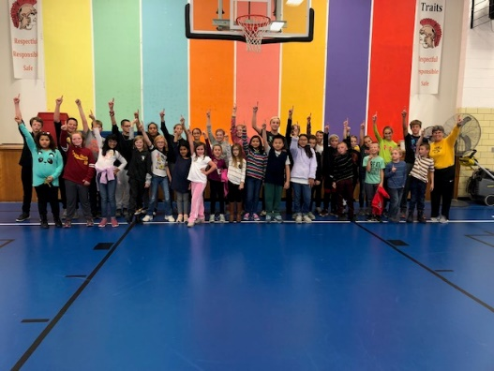
Dodgeball with Fairfield Middle School Cross Country team

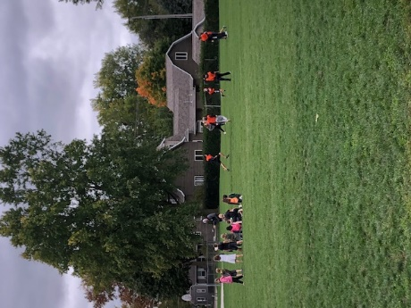
Football with Fairfield Middle School team
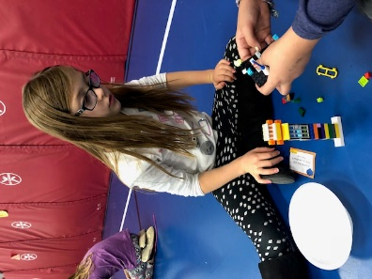
Lego challenge with ISU Extension
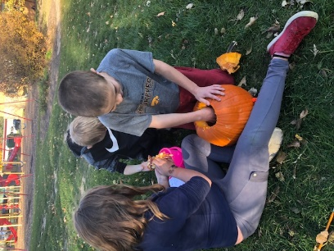
Carving pumpkins
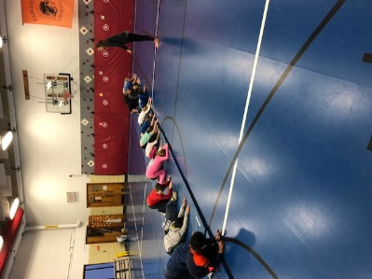
Learning basic yoga poses
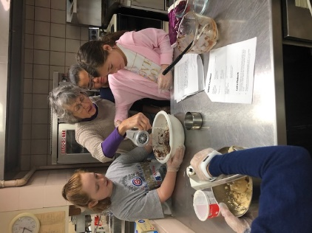
Baking pies with FUMW
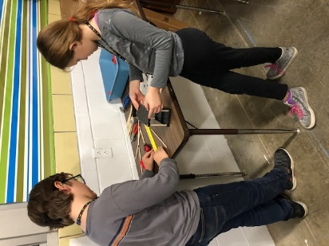
Building rubber band cars with Makerspace Cart
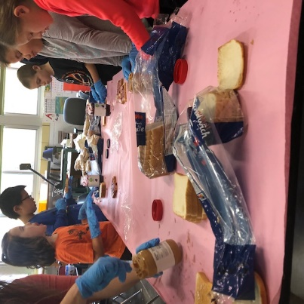
Sack lunch service project
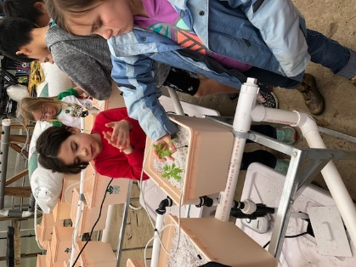
Exploring hydroponics at FHS greenhouse
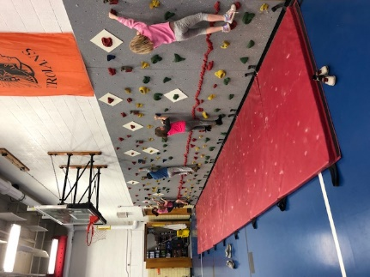
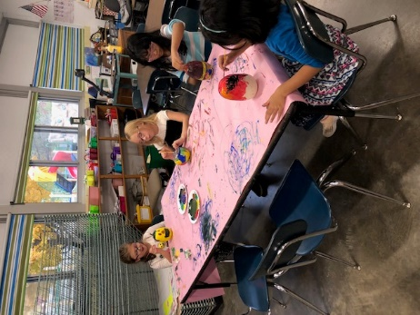
Climbing wall
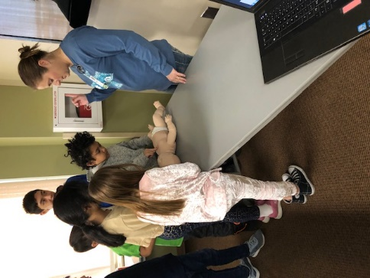
Learning infant CPR at JCHC
Painting pumpkins

Student, teacher, parent, and stakeholder input
Student, teacher, parent, and stakeholder input Required Elements | Complete?
Quotes from student, teacher, parent, and stakeholders. | x
Quotes from partners. | x
Quotes should be attributed (titles can be used but names only with permission). | x
Showcase success of the program, especially for student attendance, behavior and academic success. | x

Type or copy and paste student, teacher, parent and stakeholder input here.
“As a school board member at FCSD, I see the Community and Character Program as one our most valuable avenues to reach our district goal of student success. The engaging curriculum and activities designed by our program director have already shown progress in reading success among our participants, and the ability to connect a particular student’s classroom challenges to their work after school is an amazing benefit. Our program is growing and adapting based on performance of the students and I expect many more improvements as the program matures.”
Frank Broz
“As a local small business owner with children of my own and employees with kids in the school system as well, it is great to know that the youth of Fairfield have a safe, fun and educational place to go after school. This program has provided great activities that appeal to a variety of interest among the children, as well as healthy snacks and physical activity each day. The CCP is a great addition to the services that our school district has to offer the parents of young children in Jefferson County.”
Alissa Doyle Ward
“Our after-school program at Pence has truly taken off in the year that we have had it in the building. We are serving about a 1/3 of our student population within the program. This year we have branched out and created smaller groups with focused programs, such as NASA Club and Cooking Club. These sorts of smaller clubs have truly boosted our enrollment, as we ask students participate in other whole program days. Also, this year we have branched out and are serving students on no school days and have used these days for field trips. Overall, we have reflected on where we've started and changed to fit the needs of our community. The feedback from students and parents are positive, as we've integrated a balance of fun and educational support. I am excited to see where this program will lead in the years to come. “
Angela Jones
Principal
Pence Elementary School
641-472-2957

“The program encourages students to go on more outings in the community and provides new experiences that can only benefit the community as a whole.” –Advisory Board Member

- Sustainability Plans
Sustainability Plans Required Elements | Complete?
Original plan from grant application summary. | x
Discuss formal sustainability plan if applicable. | N/A
How program will continue without 21st CCLC grant funding. | x
How partnership contributions will help the program continue (refer to partnership table from section 3). | x

Type or copy and paste Sustainability Discussion here.
CCP Sustainability Actions from the grant application include:
- Build knowledge of after-school programming
- Include budgeting meetings with Title I, At Risk, TAG, Special Education, 504 coordinators to generate effective, integrative budgeting.
- Continue pursuit of stand-alone grants for programming materials, i.e. Jefferson County Juvenile Court System, D-cat Board, STEM Scale Up awards.
- Focus acquisition on in-kind district contributions to comprehensive program development that aligns with strategic improvement. District in-kind: copier, electricity, accounting, payroll, general materials, building care, occasional transportation and grant director time.
- Maintain a strong, educated CCP staff who builds and follows the program’s vision
The actions detailed above continue as sustainability actions/priorities.
The Board of Education has established the CCP program as a district priority in the past, and members are well aware of funding parameters. The amount of available funding remains a question, particularly in light of the election of three new Board members in November, 2019. Monetary and in-kind contributions from community partners during the 2018-2019 school year totaled $6500. (Refer to partnership table in section 3).
The Advisory Board discusses sustainability actions/possibilities at meeting, including the need to sustain strong partnerships. Current partners are convinced of the Program’s value to the community and assist with sustainability actions. The Program Coordinator communicates with Trojans Unite PTO and seeks support from parents through that organization and seeks new Partnerships.
“As a business we need to continue to support this program through donations of time, money, and advisory board membership”. --- Community Partner

- Summary and Recommendations
Summary and Recommendations Required Elements | Complete?
Summary of program.
Dissemination of local evaluation.
Recommendations for local objectives.
Recommendations on future plans for change.

Summary of Program
Summary of Program Required Elements | Complete?
Reference introduction section. | x
Showcase successes of program. | x
Highlight items contributing to program success. | x
Include exemplary contributions from staff, teachers, volunteers and/or partners. | x

Type or copy and paste Summary of Program here.
The initial year of Character and Community programming, beginning in October, 2018 and continuing through April 2019, was successful in terms of attendance, activities, inclusion, accessibility, and community outreach. A safe, fun and educational environment is a program priority. It provides activities for any Pence student through a before-school program, 7:30 AM – 8:20 AM, M-F and an after-school program, 3:30PM – 5:30 PM, M-F during weeks (or days) when school is in session. In addition, further enrichment/field-trip programming is offered from 9:00 AM – Noon, 10 Saturdays during the school year. Children may be added to the program at any point during the year. Parents registered 101 children in Fall, 2018; 61 of those students attended 30 or more days. Fifteen students attended from 91 – 116 days!
Activities included partner reading, ST Math, McGraw-Hill Everyday Math games, Project Lead the Way Launch and additional STEM activities, silent reading practice, craft activities, Really Great Reading Activities, guest speakers (partners and/or district teachers), activities planned and staffed by middle school and high school teams and clubs. A nutritious snack is offered daily and 15 – 30 minutes of physical activity is planned for each day as well.
The Character & Community Program provided local field trips and service projects on Saturday mornings twice a month/10 times a year during the 2018-1019 school year. The Program Director partnered with local business and community agencies to provide fun, educational opportunities for students. Field trips included Jefferson County Park, Fairfield Arts and Convention Center, Fairfield Park and Recreation Center, Jefferson County Health Center, as well as a service project with First United Methodist Women to make and donate pies for the FHS music program’s fundraiser.
The Program had a moderate impact on achievement in reading and math. Twenty regular CCP program students scored at the High-Risk level on the Formative Assessment System for Teachers and were categorized as not proficient in reading at their grade levels in fall, 2018. In spring 2019 testing, 5 of these students improved the Some-Risk or Low-Risk levels and were categorized as proficient in reading at their grade levels. Fifteen students remained at the High-Risk or not proficient level.

The program also had a moderate impact on achievement in math. The FCSD uses standards-based grading for elementary students. If students are categorized as needing improvement in a subject area, they have not achieved 80% cumulative proficiency on the standards for their grade level. This was the data collecting instrument for mathematics and English for the 2018-2019 school year for the purposes of this evaluation.
The number of all regular CCP attendees needing improvement in mathematics for the fall, 2018 grading period, was 12; the number who improved for the spring, 2019 grading period was 3, or 25%. The number of all regular attendees needing improvement in fall in English fall, 2018, was 9; the number who improved was 3, or 33%.
The CCP program had a more significant impact on student behavior. The number of regular attendees needing improvement in (1) classroom behavior and (2) homework completion and class participation was determined through a classroom teacher survey. The number of students needing improvement in classroom behavior was 23; teachers reported that 17, or 74% improved from fall to spring. The number needing improvement in homework completion and class participation was also 20; teachers reported that 20, or 87% improved from fall to spring.

Dissemination of Local Evaluation.
Dissemination of Local Evaluation Required Elements | Complete?
Exact url where local evaluation is posted (required by US DOE). | x
Discussion of other methods of Dissemination (Board reports, community meetings, person to person, e-mail, etc.) | x

Type or copy and paste Dissemination of Local Evaluation here: The local evaluation will be disseminated to FCSD Board of Directors, Elementary Principals, Advisory Board members and Community Partners. It is available on the district website links shown below:
http://www.fairfieldsfuture.org/
http://www.fairfieldsfuture.org/vnews/display.v/SEC/Pence%20Elementary
http://www.fairfieldsfuture.org/vnews/display.v/SEC/Pence%20Elementary%7CPence%20After%20School%20Program
The Evaluator has presented updates to the Advisory Board and Community Partners at two meetings and will also be present at a future meeting to answer questions. The Program Director will present highlights of the report to the FCSD Board of Directors.
A summary of this report is posted on the site above and will be included in a future e-mail to Pence parents. The printed form of the quarterly newsletter

Recommendations for Local Objectives.
Recommendations for Local Objectives Required Elements | Complete?
Objectives to be changed and reasons why. | x
Objectives to be added. | x
Include objectives not met. | x
Include objectives not measured. | x

Type or copy and paste Recommendations for Local Objectives here.
Inclusion of scores on the ISASP for measuring student achievement progress, particularly for achievement in mathematics and science/engineering. The principal, program director and advisory board should discuss and determine whether this year’s measures of the FAST and district content standards should be included as well. Depending on the group’s decision, the objectives regarding progress in reading, mathematics and science/engineering may need to be rewritten.
The objectives regarding CCP and school attendance should be rewritten as SMART goals.
The objectives regarding nutrition intake physical should be rewritten as SMART goals.
The objective regarding behavior/disciplinary referrals should be rewritten as a SMART goal, specifying method(s) of measurement.
Survey items used to measure student outlook on school and relationships as well as overall family well-being should be should be rewritten and/or designated, and the objectives rewritten as SMART goals.
The objective relating to non-English speaking CCP parents’ enrollment in adult education should be rewritten as short-term SMART goals that address data gathering, need, availability, cost and relevance.

Recommendations on Future Plans for Change.
Recommendations on Future Plans for Changing Required Elements | Complete?
Changes in activities. | x
Changes in recruitment efforts. | x
Changes in partnerships. | x
Changes for sustainability plans. | x
Other changes as suggested by governing body. | x

Type or copy and paste Recommendations on Future Plans for Change here.
A program reorganization around a club model is planned for 2019-2020. Evaluation of that change should be conducted at the end of the year.
Recommendations include:
Add more intentional connections to classroom school day activities, including a specific homework completion time every day. Choose interventions/practice in reading and math that address student’s needs as determined by building principal, classroom teachers and program director.
Current recruitment efforts seem adequate given the increase in ADA for the current year.
Develop a specific sustainability plan that uses the IDOE provided template that addresses how the district will contribute to staffing costs. The plan should include relevant sustainability actions contained in the grant application, including recruitment of new partners as well as efforts to increase participation level of current partners.
Develop a staff development plan using the IDOE provided template that addresses possible staff turn-over.
Develop a cohesive and consistent communication plan that includes the program’s website.

