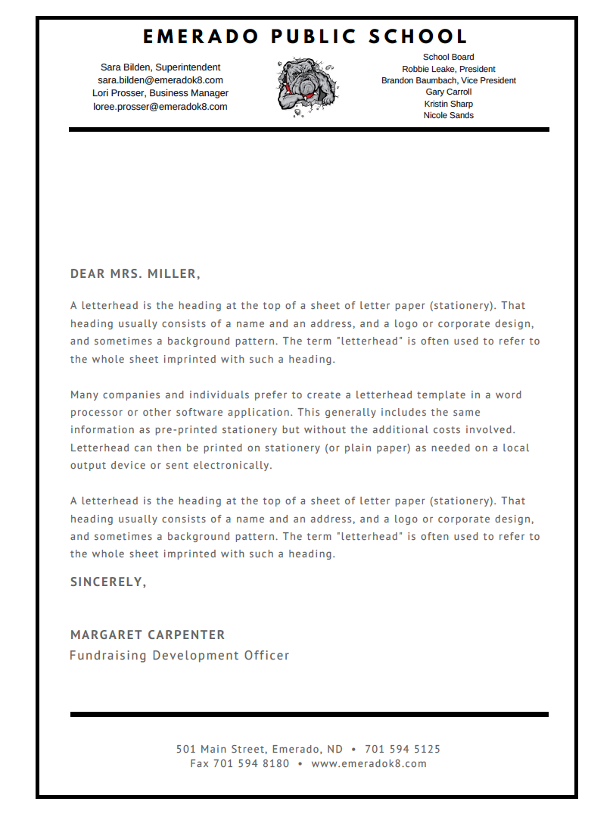

Dear Parent/Guardian,

North Dakota has launched a new website designed to help communities across the state access important information about K-12 districts and schools. [NDInsights](https://insights.nd.gov/) features easy-to-read reports on multiple measures of school success, including:

* Test scores
* Graduation rates
* English Learner progress
* Student attendance.

[NDInsights](https://insights.nd.gov/), or more commonly referred to as the “Dashboard,” is part of North Dakota’s new accountability system. It is the next step in a series of major shifts in public education that have raised the bar for student learning, transformed testing, and placed the focus on equity for all students. To learn more about the state’s accountability and continuous improvement, visit [North Dakota’s ESSA website](https://www.nd.gov/dpi/SchoolStaff/SSI/ESSA/).

To find out more information about our school, visit [NDInsights](https://insights.nd.gov/), select “Find My School,” and search alphabetically for our school.

**Why a new system and new tool?**

North Dakota is committed to informing communities about how well our schools are doing. North Dakota’s future success depends on tapping into the potential of all students, so they graduate choice ready with the knowledge, skills and disposition to be successful. For schools to reach this goal, teachers, parents, and the community need clear and useful measures of progress. As an accountability tool, the Dashboard will help the state identify schools receiving additional support and assistance.

**What is different?**

In the past, the accountability system for districts and schools relied heavily on test scores. But one test taken on one particular day does not provide a complete picture of all the ways schools are helping students succeed. The Dashboard continues to provide information on different aspects of student performance, but also includes information on school growth and other factors reflecting a more comprehensive view. The Dashboard replaces the former School District Report Card and Adequate Yearly Progress (AYP) reports.

Please note, the data made available to the public masks or hides data for groups with 10 or fewer students to protect confidential information about individual students.

1



students.

**What’s next for our district?**

We have strong plans for working to improve the educational programs at our school. We would like you and your child(ren) to continue to be active participants in our educational system. Please help support our high expectations for student achievement by participating in the school educational initiatives, offering input and support in our endeavors to raise student achievement, or volunteering at the school. Meeting our school’s goals will take a united effort, and I look forward to working with our families to ensure success for each student.

**School Support under ESSA**

All schools engage in continuous improvement for general support; therefore our school will complete an AdvancED Continuous Improvement Plan annually.

In addition, our school was selected for Targeted Support due to low performing sub groups including low income and IEP. More information regarding the selection criteria for Targeted Support is available on the [Targeted Support under ESSA](https://www.nd.gov/dpi/SchoolStaff/FTP/TitleI/SchoolImprovement/TargetedSupport/) website.

Emerado Public School is a participating Title I school, with a student membership count of 122. If you have any questions regarding this information, please contact the school at 501 Main Street, 701-594-5125, and sara.bilden@emeradok8.com.

Thank you,

Sara Bilden

Superintendent

2