Recycling Bins
Recycling bins can be picked up at the Recycling Center,
open 3 days per week:
Tuesday & Thursday: 7AM – 3PM
Saturday: 8AM – 12PM
20-gallon bin = $15.00 each
32-gallon bin = $20.00 each
EXACT CASH OR CHECK ONLY!
New Homeowners:
*NEW homeowners are entitled to 2 free (20-gallon) bins with
the purchase of the home under 1 year from the closing date.
Must show closing papers or deed reflecting the close date*
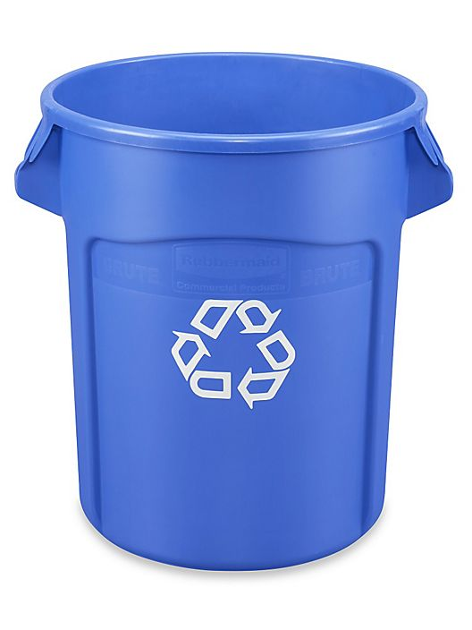
Residents can use their own bins, but County Guidelines MUST be followed:
-No bins larger than 32 gallons -No lids or wheels
-No heavier than 50 lbs. -Must be properly labeled “Recycling”

Recycling@OldBridge.com (732) 721-5600 Ext. 6107

