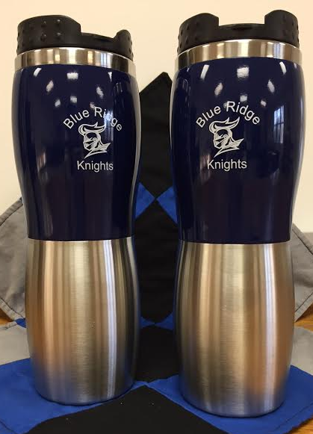
Blue Ridge Educational Foundation

Blue Ridge Educational Foundation is selling high quality 16 oz. travel mugs to support programs for Blue Ridge Schools.
Mugs feature stainless steel interior, screw on lid with locking flip spout, and perfect for hot or cold beverages! Cost is $15 each or 2 for $25.
These make great gifts for the coffee or tea lover in your life! Perfect for fall football or gift-giving! Mugs are on hand – so no waiting.
To purchase, call 309-928-9141 or mail this form to the BR District Office at 411 N. John Street, Farmer City, IL 61842. Make checks out to “Blue Ridge Educational Foundation”. Thanks so much for your support!
Buyer’s Name: ______________________________________________________
Telephone: ______________________________ Email: _____________________
# of Travel Mugs ________ Amount Enclosed $__________($15 each OR 2/$25)
Special delivery instructions (if any): ____________________________________
__________________________________________________________________
BREF INFORMATION: The Blue Ridge Educational Foundation is an independent, 501(c) (3) charitable organization founded in 2003 to enhance educational excellence for the children of Blue Ridge Schools. Although BREF is independent of the school district, it works cooperatively with the school district to ensure that BREF allocations target school district needs. BREF believes that strong schools are vital to building strong communities. At its best, public education involves community partnerships - partners in learning. The success of the schools and the communities go hand in hand.

