2018-2019
Apple Springs Elementary
School Supply List

4th, 5th, & 6th grades
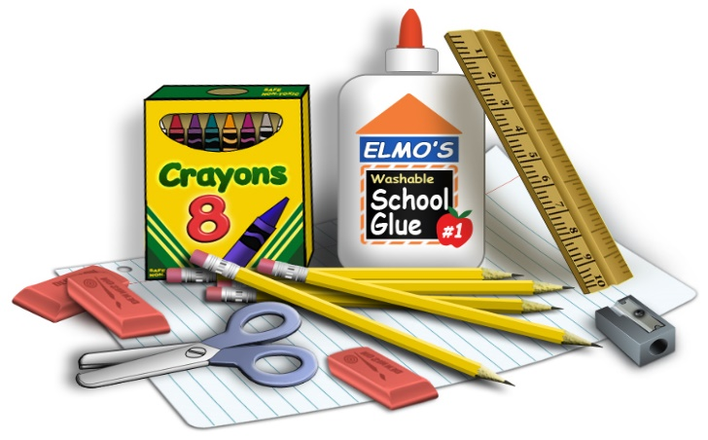

1 box of Kleenex 2 red pens
5 pkg #2 American made pencils 5 plastic pocket folders w/brads
8 plastic notebook dividers w/pockets 1 pkg notebook dividers w/pockets for binder
1 pkg lg manila paper 2 pkg pencil top erasers
1 pkg crayola markers (bold colors) 2 pkg map pencils

6 wide ruled composition notebooks 1 (3 inch) 3 ring binder
1 black sharpie 1 pencil pocket for binder
1 pkg wide ruled notebook paper 1 back pack
1 ear bud set (in ziploc baggie w/name) 1 bottle liquid glue
1 small pencil sharpener 4 glue sticks
1 pair Fiskars scissors
2 pkg dry erase markers (please write your child’s name on each marker)

Please pick 1 of the following:
1 box gallon ziploc bags
1 pkg baby wipes
Duct tape
1 pkg mini multi-temp. hot glue sticks

