Abingdon – Avon High School Principal’s Report
November 10, 2021 Board Meeting

The October students of the month were selected on the character trait: Work Ethic. They were: Anya Simmons, Matt Mimms, Asa Stegal, Allyson Pigg.

Currently, entity counts are:

Overall: 274 students in the high school. Plus 6 attending RAES. 2 attending Camelot. 2 attending Knoxville.
Number of students per class in the High School.
Freshmen: 76 Sophomore: 72 Junior: 55 Senior: 71

High School Attendance Numbers:
October - 90.85%
Freshman - 92.99%
Sophomores - 88.66%
Juniors - 90.68%
Seniors - 91.05%

Basketball practice started for the girls team on Monday, November 1st. They will open the season the week of November 15th at the R.O.W.V.A./Ridgewood Thanksgiving Tournament. The boys begin practicing on Monday November 8th. They open the season the week of November 22nd at the Orion Tip-Off Classic.

The Student Council held their fall blood drive on Thursday, October 14th. The BloodMobile was parked in front of the school for the drive. They collected 15 units of blood and had 12 first -time donors. Those will help 45 people. They are planning on holding another blood drive in March.

We held our second fire drill on Tuesday, October 26th. This one was held with the Abingdon Fire Department. We have one more fire drill to hold this year.

We held our lock-down drill with the police department on Wednesday, November 3rd.

The T.W.I.S.T.E.R. program continues to offer Remote Homework Help and Tutoring for students before and after school. They held a Free Financial Aid Workshop/FAFSA at the high school on October 19th. They are also planning a Family Event Night for late November or early December.

First trimester at the high school ends on Thursday, November 18. The second trimester began on Monday November 22nd.
Parent /Teacher Conferences are being held on November 17th and 18th from 4:30pm-7:30pm.

The FFA farm plot was harvested on October 21st. This year's crop was corn.. I will update when yield information becomes available. Thank you to Emerick Farms for volunteering the time and equipment for harvest.
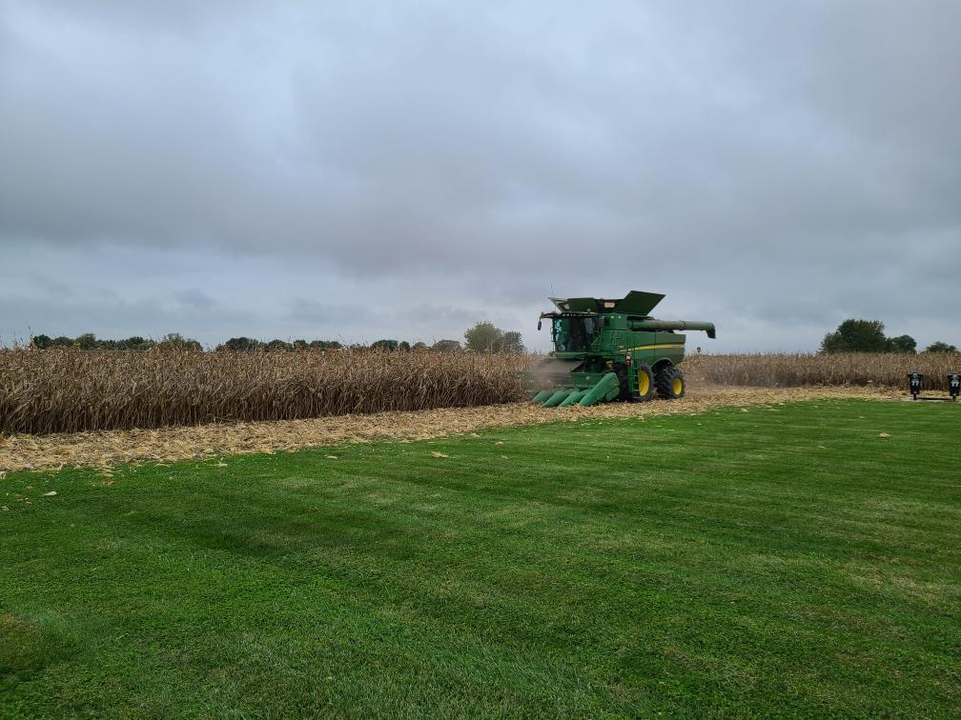

FFA members attended the National Convention Oct. 27-30
They held their Alumni Mtg Nov. 1
Agronomy Career Development Event is Nov. 10 (will co-host with Sandburg)

Members of the AAHS Spanish Club showed off their artistic ability this week by painting pumpkins for the Day of the Dead.

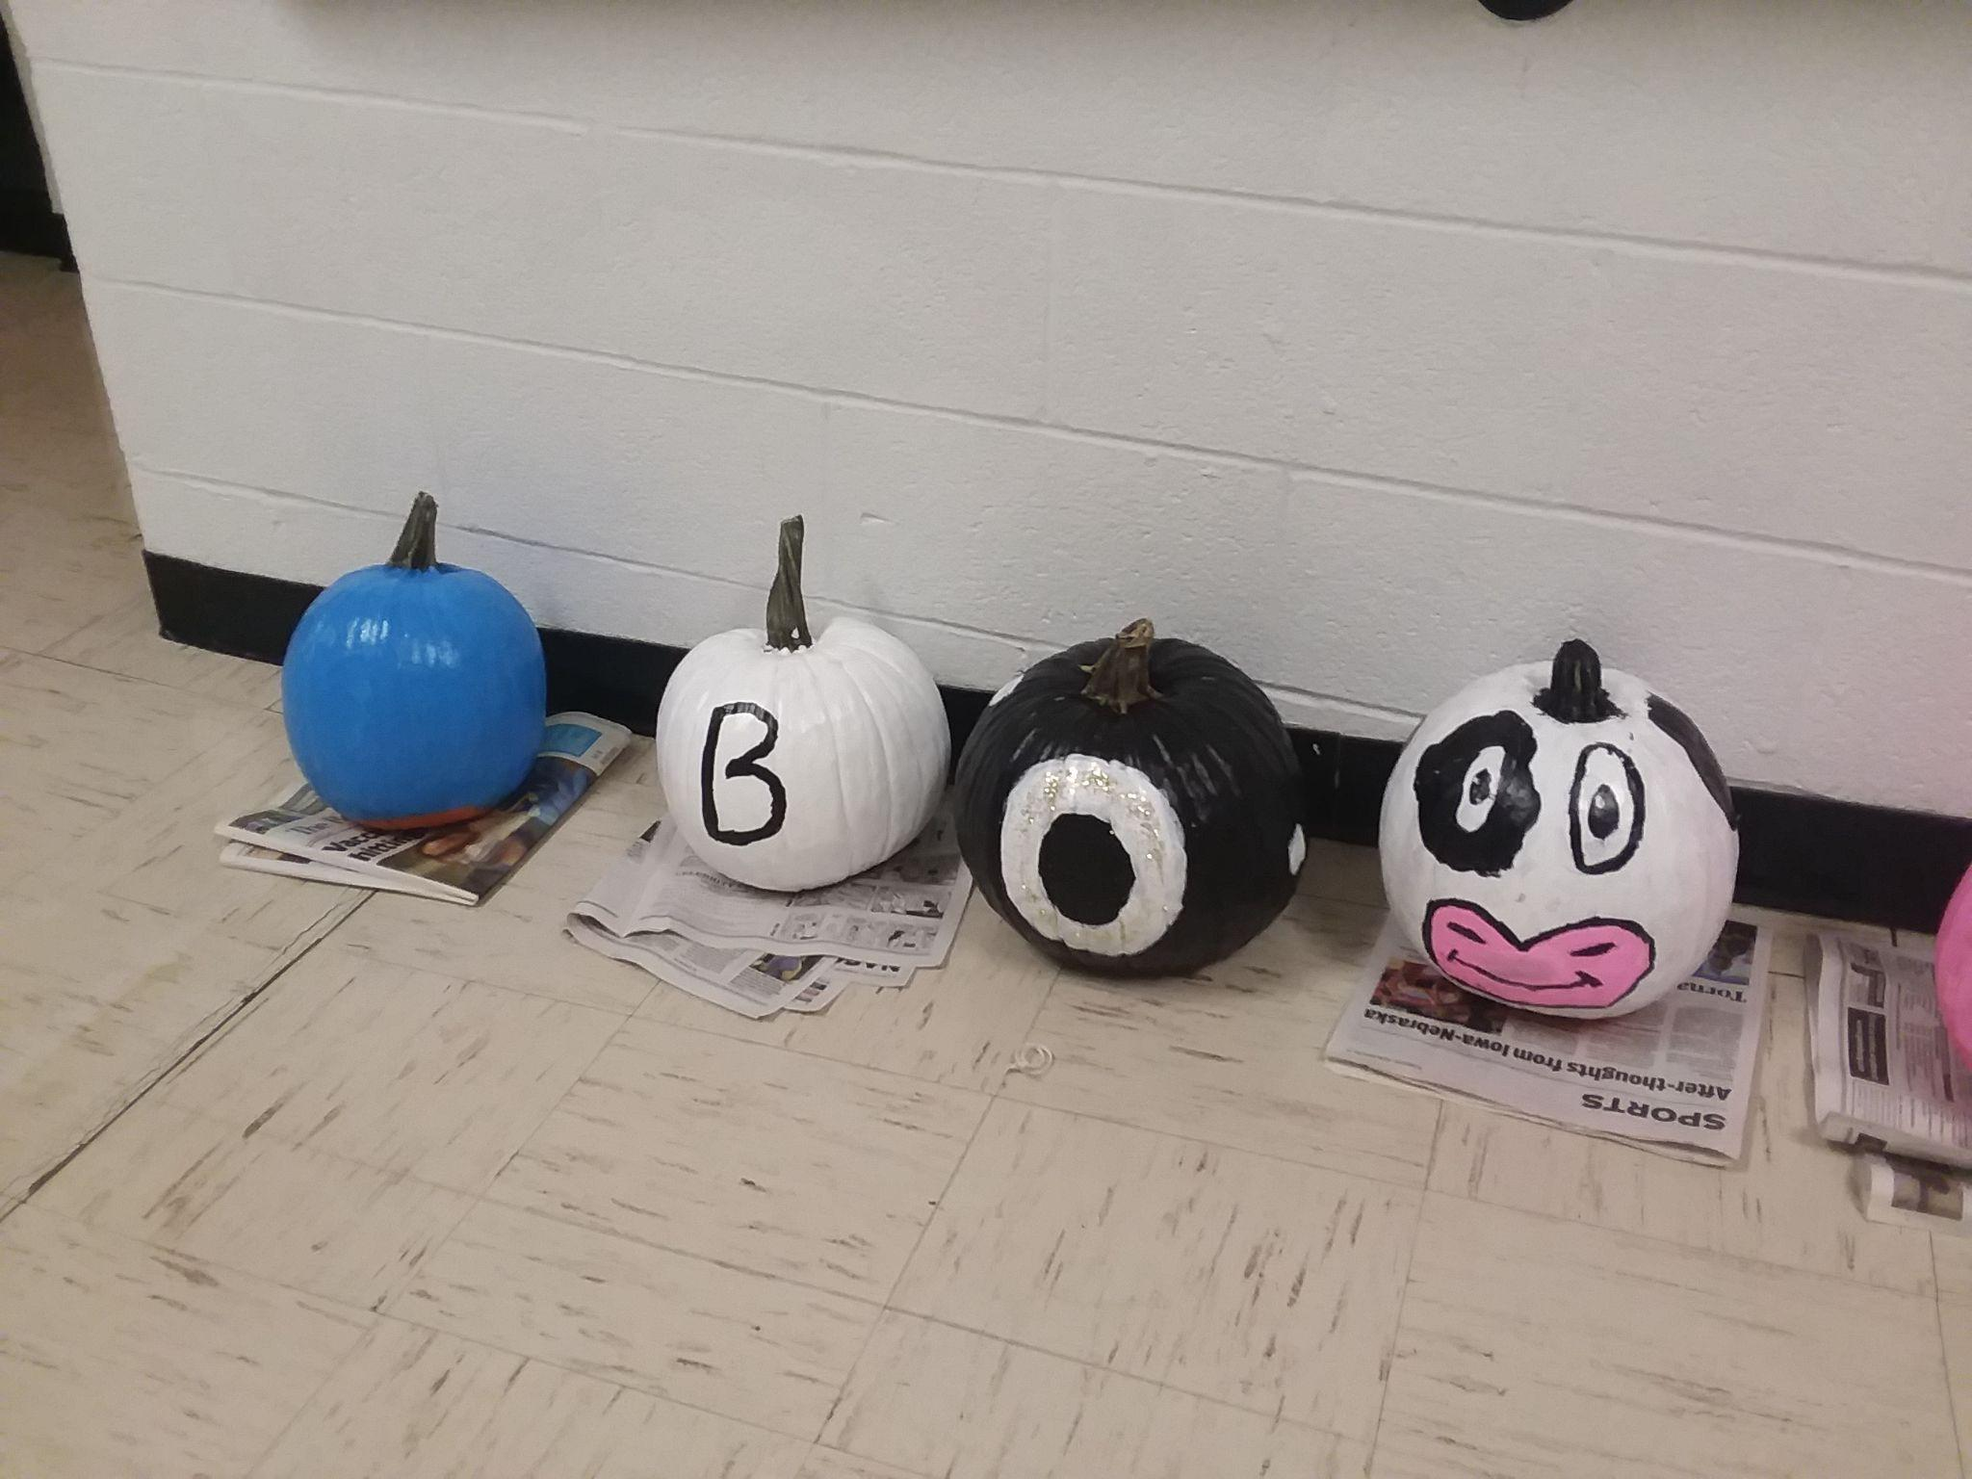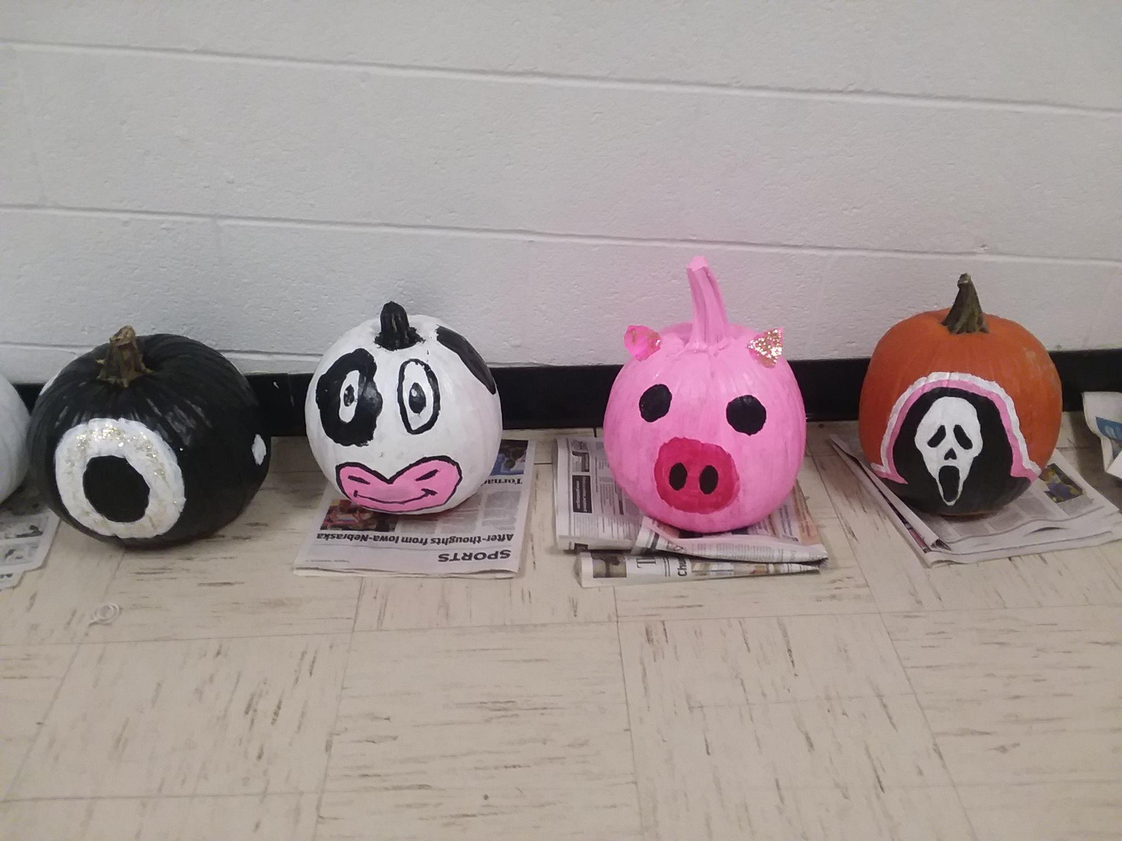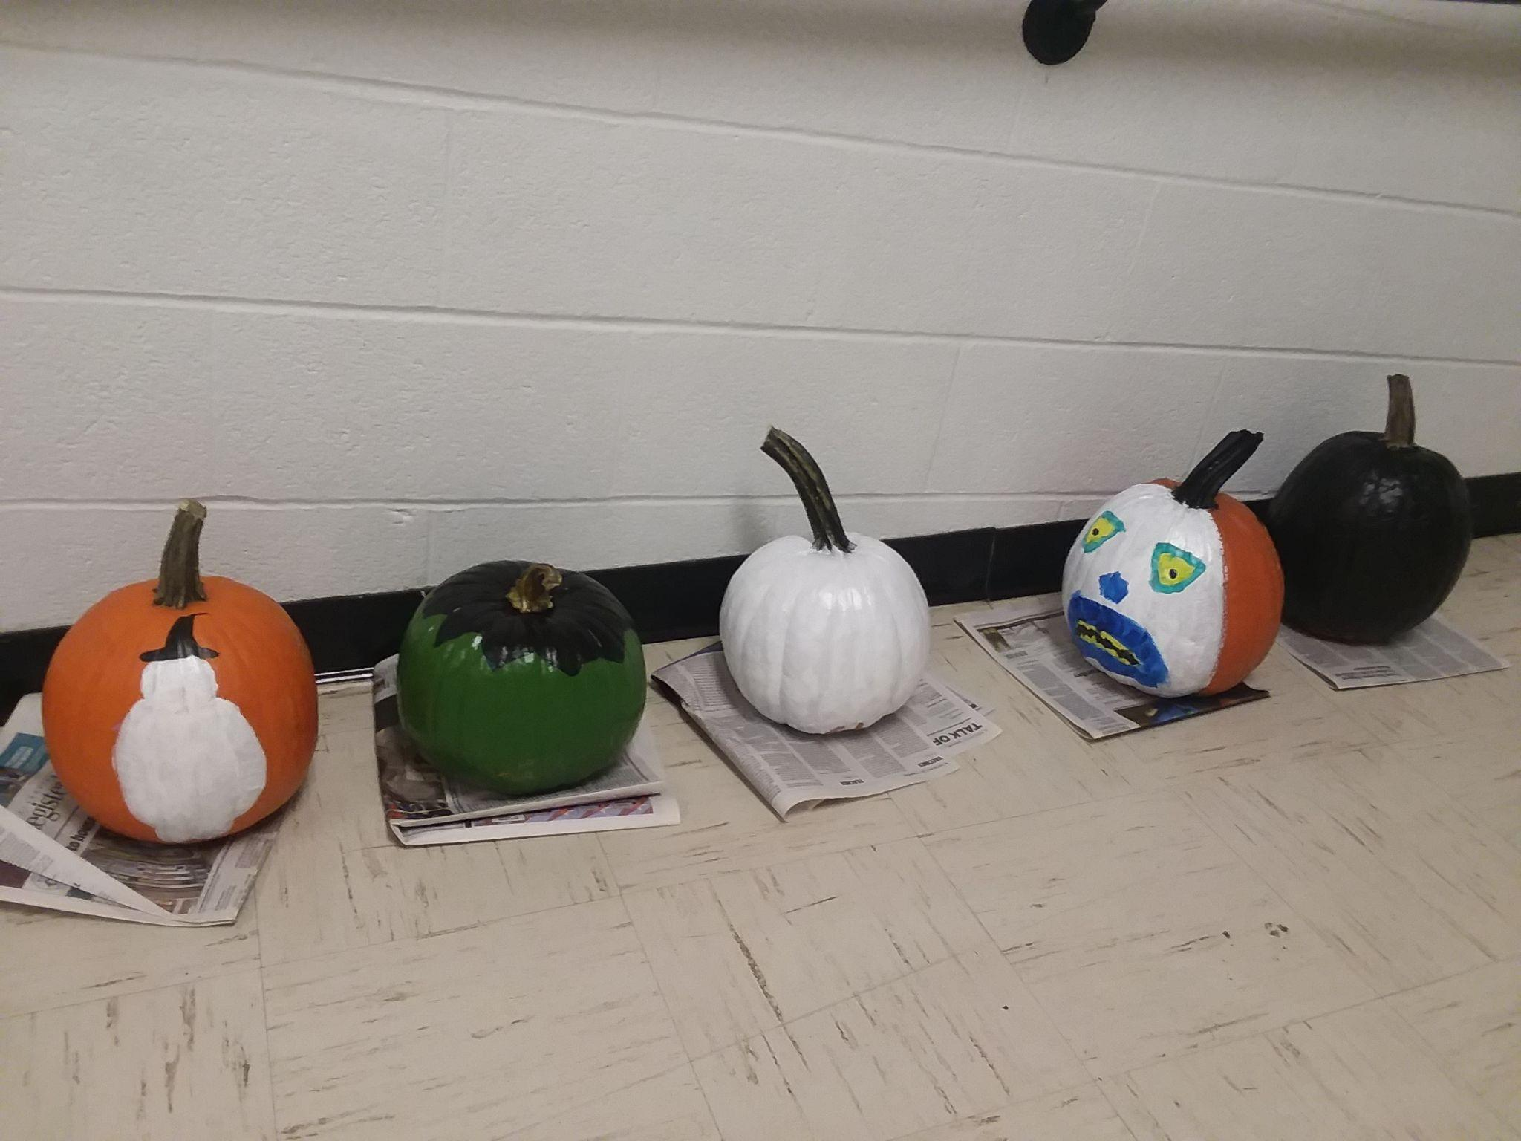
Upcoming Dates:
Veterans Day - November 11th - No School.
P/T Conferences November 17th and 18th. 4:30pm - 7:30pm
November 19th - No school
Thanksgiving Break - Nov. 24- Nov. 28th.

