Mount Vernon School District
Return to Learning Plan/Safe Return to In-Person Instruction and Continuity of Services Plan
2023-2024

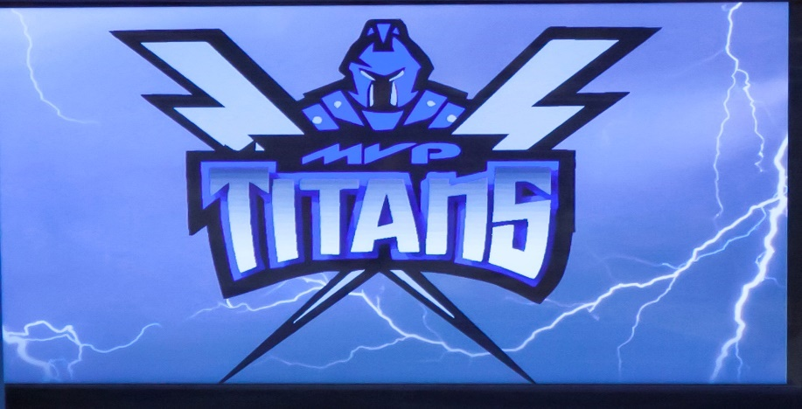

2022-23 Return to Learn Plan/Safe Return to In-Person Instruction and Continuity of Service Plan Dates
Last Revised: June 15, 2022
Board Reading May 8, 2023
Board Adoption: May 8, 2023

Message from the Superintendent
The Mount Vernon School District is committed to a safe and secure learning environment for all its students and staff. Due to the COVID-19 pandemic, our district has developed a learning plan with protocols for the 22-23 school year written with flexibility for our district to help ensure a quality learning experience for all students.
At this time, the Mount Vernon school board has adopted a position on masks. At this time masks will be a matter of personal preference. The school board retains the right to adjust provisions of the plan as needed. Our District’s plan is to begin the 23-24 school year on Wednesday, August 16, 2023, with a normal learning environment. The Mount Vernon School District’s 2023-24 Return to Learning Plan/Safe Return to In-Person Instruction and Continuity of Services Plan contains information regarding Delivery of Instruction, Online Learning, Modified Alternative School, and Extracurricular Activities. To meet the requirements of the American Rescue Plan Act Elementary and Secondary School Emergency Fund (ARP ESSER), the Mount Vernon School district needs to re-evaluate our “Safe Return to In-Person Instruction and Continuity of Services Plan” every six months. As per the United States Department of Education’s ARP ESSER requirements, our plan must include the following:
- Date of school board approval (pg. 1)
- Date of Last review (pg. 1)
- Contact person for questions (pg. 5)
- Accessible to parents who speak a language other than English and individuals with disabilities. (pg.5, website URL: https://5il.co/wvlf
- Accessible (easily) on our website (pg. 5, https://5il.co/wvlg
- Plan components to address how the district will maintain the health and safety of students, educators, and other staff; and the extent to which the district has adopted policies, and a description of such policies, on each of the Center of Disease Control and Prevention’s (CDC) safety recommendation including, at a minimum:
  - Return to Learning Procedures (pg. 3)
  - Mitigation practices and procedures school and classroom environment. (pg. 3)
  - Appropriate accommodations for children with disabilities with respect to Health and safety policies (pg. 4)
  - Diagnostic and screening testing for COVID-19 (pg. 4)
  - Efforts to provide vaccinations for eligible members of the school community. (pg. 4)
- Plan to include how the district will ensure the continuity of services for in-person, remote, and/or hybrid students as applicable, including at minimum:
  - Services to address students’ academic needs, including learning loss (pg. 4)
  - Students’ social, emotional, and mental health needs (pg.4)
  - Staff members’ social, emotional, and mental health needs (pg. 4)
Within this document, you will find the factors associated with the Learning plans from Normal Learning to Virtual Learning. The information within this document depicts how the Mount Vernon School District meets the requirements of the American Rescue Plan Act Elementary & Secondary School Emergency Relief Fund (ARP ESSER). The health and safety of our students, staff, and families will continue to drive the decision making that will go into the 2022-23 school year.
Sincerely,

Eric Denning, CEO/9-12 Principal
Mount Vernon School District
The following district plan outlines the processes the Mount Vernon School District will use to facilitate the COVID-19 pre-cautions and implementations of student learning and safety for the 2023-24 school year.
Return to School 2023-24 School Year
Close contact tracing and masking will no longer be implemented in the Mount Vernon School District.
Parents/Guardians will be contacted via the school (Apptegy) if a positive test has been confirmed in class and is than up to the jurisdiction of the parents regarding their child’s well-being.
Students who are identified as too sick to complete a school day will be sent home at the discretion of school employees.
The district asks that parents keep their student at home if they are ill or show symptoms of a specific illness.
Delivery of Instruction - Normal in person instruction day to day
The school will be in session as normal as scheduled from 8:05 – 3:37 Monday thru Thursday and 8:05-2 on Friday.
Mitigation Practices and Procedures School and Classroom Environment:
Mitigate risk by encouraging students to avoid touching their eyes, nose, and mouth.
Signage will be posted for proper hygiene practices strategically around the building, as well as hand sanitation stations.
Cleaning and sanitizing protocols will be conducted by custodial staff.
Special Education
The Mount Vernon School District Special Education Department is committed to providing necessary and appropriate educational opportunities for students with disabilities to the greatest extent in accordance with the guidance from the US Department of Education, SD Department of Education, SD Department of Health, CDC guidelines and the state of South Dakota.
Collaboration with families will continue to be an integral part of the special education process. The district will address the individual needs of each student with disabilities, special education staff will continue to work with families to provide the necessary services in the normal learning setting or when remote learning must become an option. Individual Education Plans (IEP’s) may be adjusted, as needed, for circumstances of the learning environment based on students’ needs and services. Staff will work diligently to provide special education services.

Lunch
Students will eat collaboratively together as they would on a normal school day. No restrictions will be implemented.
Extracurricular Activities
Students will engage in extracurricular activities as they would on a normal school day without any restrictions.
Safe Return to In-Person Instruction and Continuity of Services Plan
Diagnostic and Screening Testing for COVID-19
The Mount Vernon School district will not use either the Diagnostic Abbott BinaxNOW Rapid Antigen testing materials (symptomatic testing) or the Quidel QuickVue COVID-19 over the counter (OTC) testing materials (symptomatic/asymptomatic testing).
Vaccination Efforts to Eligible Members of the School Community

No vaccination efforts will be in place for eligible members of the school community.

Continuity of Services
Learning Loss
The Mount Vernon School District will track learning progression via state, local, classroom, and NWEA assessments. Learners who need additional support and services may be eligible for summer school learning opportunities, classroom interventions, and after school remediation. Provided services would take place during the school year and/or during supervised summer sessions.
Student Needs -Social, Emotional, and Mental Health
The Mount Vernon School District will continue to meet student social, emotional, and mental health needs through the following avenues: (a) district-provided school counseling, (b) character development programming appropriate to each grade-level during Titan Time, (c) relationship building between students and staff.
Staff Needs -Social, Emotional, and Mental Health
The Mount Vernon School District will address staff social, emotional, and mental health needs through the following avenues: (a) professional development activities/sessions focused on mindfulness, well-being, and gratefulness, and (b) by maintaining a work environment conducive to communication and collaboration amongst all individuals.
Accessibility
The Mount Vernon School District will post English and Spanish versions of this document online. Individuals with issues accessing information due to language or disability should contact Eric Denning via email (eric.denning@k12.sd.us) or phone (1-605-236-5237). Plan Location: https:// Documents | Mount Vernon School District (k12.sd.us)
Board Action: The School Board has been kept abreast of the plan and reserves the right to change elements of the plan at any time. The fluidity of the situation will demand changes be made. These are recommendations being made for the School Board’s consideration. The School Board will make the final decision on the plan’s implementation and restructuring. The School Board has legal right to adopt and implement all policies and procedures.
Stakeholders and Communications
The Mount Vernon School District will keep all stakeholders informed through email, district messaging systems, our website, and our social media platform – live, feed, and Facebook. The district must communicate in a timely manner about the model(s) of education delivery, procedures, and protocols that are specific to each building.

Mr. Eric Denning
9-12 Principal/Athletic Director
605-236-5237
Eric.denning@k12.sd.us

Mrs. Allison Sandland
Business Manager
605-236-5237
Allison.sandland@k12.sd.us

