Arkport Ski Club News
It is with great excitement that we share this information about the upcoming ski season! Swain Ski Resort continues to have plans in place that follow COVID-19 guidelines
so local skiers can enjoy the sport of skiing this winter.

Ski Club
Ski Club will be “In Person” this season! In Person means that the school is transporting ski club as usual (1/7, 1/14, 1/21, 1/28, 2/4, 2/11). However, your child does not need to take the bus to Swain with Ski Club to take advantage of the Ski Club prices.

How do I join Ski Club and purchase my tickets/pass?
Arkport Ski Club will continue to use the Swain website (https://swain.com/clubs/) for students to join Ski Club and make purchases. This website will track your purchase and offer the best pricing. You will not send any money to school with your child. If you make your purchases before November 15th, your tickets/passes will be sent to the school and given to your child. If you order after November 15th, you will be responsible for picking up your tickets/passes at guest services.

What do I do next?
Use the attached checklist to be sure you make your purchases, complete necessary paperwork, and meet deadlines for the best pricing and convenient delivery of your purchases.

Lessons
Swain Resort has advised us that due to staffing shortages, there will be challenges involved with scheduling lessons on Friday nights. They expect larger groups and extended wait times for lesson takers on Fridays. If you have a new skier, we highly advise you to prepare them in advance by taking them to ski and have lessons before our first club trip to Swain.

Contact us with your questions anytime by email or on Remind:
Jenny Reynolds jreynolds@arkportcsd.org and Alli Feenaughty afeenaughty@arkportcsd.org

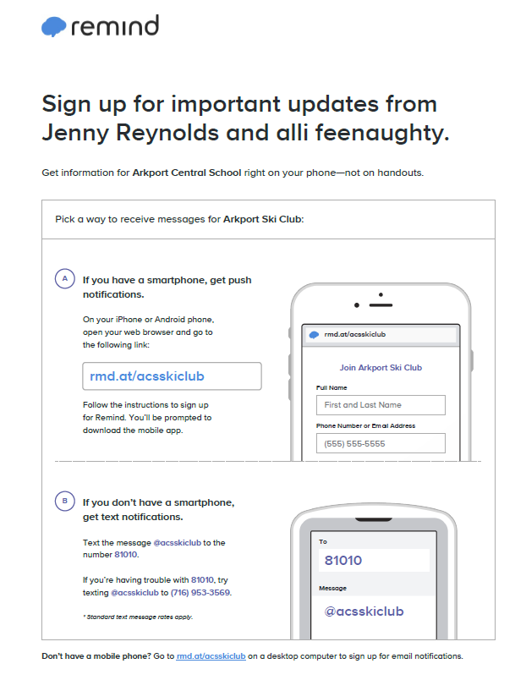

2022 Ski Club Checklist

_____Join Remind to receive important Ski Club information each week and sign up for the bus weekly.

_____Order tickets/passes online at https://swain.com/clubs/ before November 15th (BE SURE TO INDICATE YOUR SCHOOL CLUB IS ARKPORT!)
*Already bought tickets or a pass? No problem; skip this step and complete the rest of the checklist!

_____If you order a season pass, email a picture of the pass holder to photos@swain.com before November 15th.

_____ Complete the student information form online before November 15th.

_____ Complete the student medical authorization form online before November 15th.

_____Complete the helmet policy online before November 15th.

_____If you make a purchase AFTER November 15th, pick up your purchases at Swain at your convenience. Your child may not ride the bus until your purchases are picked up. If you place your order before the November 15th cut-off, they will be sent to the school and distributed to your child.

_____If your skier is renting equipment, complete a paper copy of the rental form attached and give it to Mrs. Reynolds or Mrs. Feenaughty before November 15th. You must complete a separate form for each renter. If you don’t do this by the deadline, you must deliver this form to Swain before your child can ride the bus.

