October 18, 2021

Dear Parent/Guardian,

As we continue to have in-person learning in midst of the Covid-19 Pandemic, Marion County Public Schools continues to be proactive in the event that school may be canceled on any given day; weather related circumstances, number of positive Covid-19 cases. With that said, this letter is to inform you of the protocol that is to be taken in the event an NTI Day is called in the future.

NTI will operate like we have previously on Distance Learning Days. Teachers will create a serious of assignments through Clever (Primary) and/or playlists (Secondary).
To access playlist students will:
- Log into school provided Chromebook. (If your child has not brought a Chromebook home from the previous night, your school will notify you of a designated time in which you may pick a Chromebook up)
- Select Google Chrome Browser

- Select Google Chrome Waffle. Located in the top right-hand corner of the screen.

- Select Google Classroom in the dropdown menu.

- Select your child’s teacher’s classroom.

- You will now see a STREAM that includes messages from the teacher with instructions and assignments.

- Select Classwork at the very top of the page. This will take you directly to the playlist your child is to complete.
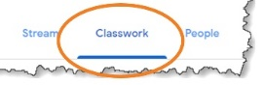
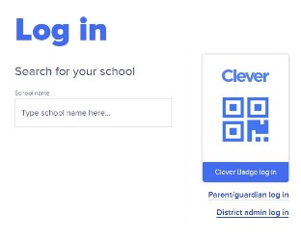

To access Clever students will:
- Go to Clever.com
- Type the name of the school your child is enrolled, i.e. Glasscock Elementary
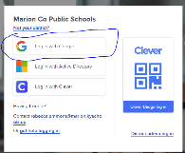

- Choose “Log-in with Google”

- Log-in with student’s school email (first.last@stu.marion.kyschools.us) and password (it is the same as the Chromebook log-in)

Primary Grades (K-5) will complete:
30 Minutes of iReady Math, 30 Minutes of iReady Reading, Social Studies (5th grade only), Science (4th grade only) and one special (P.E., library, music, art, ect). Additionally, SEL time will be built in throughout the day.

Secondary Grades (6th-12th) will complete:
Odd periods (1st,3rd, 5th) on odd days beginning with NTI Day 1. Even periods (2nd,4th,6th) on even days beginning on NTI Day 2 and SEL Time each day. This routine will continue when additional NTI Days may be called.

In the event you may have questions or need additional information you may contact your child’s school or teacher. All staff will be working in their respective school buildings on NTI days unless specified differently.

Sincerely,

Courtney Murphy
Director of Student Support Service

