**Panther Pride – October 2021 Newsletter**

Our Parent Teacher Organization is up and running. Our new officers are: Kathy Hatch, President; Megan Stankovich, Vice-President; Heather Nichols, Secretary; Jennifer Branco, Treasurer. Our meetings are schedule the first Monday of the Month so please mark your calendars.

Our first fundraiser, Worlds Finest Chocolates has been fantastic. Students are selling so much and doing a great job. We have 83 more boxes left to sell by October 25th. This means we will have sold the bonus 230 boxes of candy. I know we can do it with our great Tres Pinos students.



Halloween will be celebrated at the school on Friday, October 29th. Students will be allowed to dress up for Halloween in appropriate costumes. Again, we will not allow swords or any sharp objects. Parents can check with their child’s teacher about bringing snack for a classroom party. We will do a short parade in the playground area.

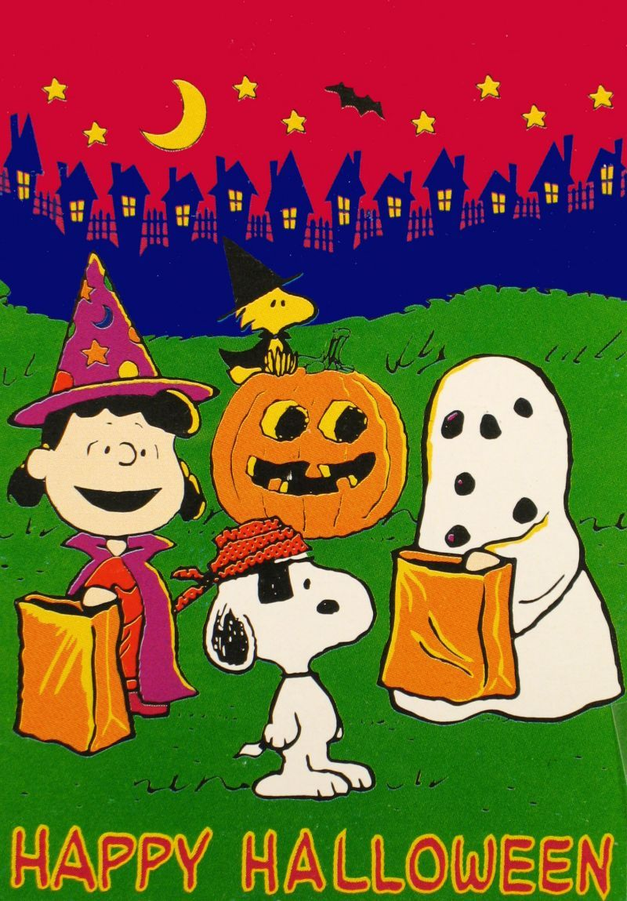

**Dismissal protocol**

Please remember to park when picking up your children at the end of the day. We need everyone to be safe. There will be no more allowing of students to get in vehicles Also remind your child to use the crosswalk.



**Upcoming Events**

**Oct. 8 – Teacher workday, NO SCHOOL**

**Oct. 11-15th – Minimum day 1:00 dismissal for Parent/Teacher conferences**

**Oct. 14 – School Board meeting**

**Oct. 20 – Awards Assembly 8:30 a.m.**

**Oct. 28 – BMX Riders for Red Ribbon Week**

**Oct. 29 – Halloween parade and dress up**

**Parent/Teacher Conferences Oct. 11-15th. 1:00 dismissal and there will be no YMCA that week.**



**Panther Sports**

Panther sports has started for the 2021/22 school year. Our boys are playing flag football games with other rural schools. Our flag football schedule is on our app or on our website at

Trespinosschool.org

