“RUN FOR THE NEEDY”

FOOD DRIVE

In recognition of the upcoming Thanksgiving holiday, we will be holding our “Run for the Needy” Food Drive on Monday , Tuesday, and Wednesday October 18th, 19th, and 20th on the Merritt Memorial School field. The run will take place during your child’s Physical Education classes. The purpose of the run is to combine the healthy aspects of fitness with charitable giving. From now until November 13th students can ask sponsors for donations of non-perishable foods (in boxes or cans) or hygiene items (such as soaps, toothpaste, etc.) for those in need. All items will be donated to the Englewood Food Pantry.

The procedure is as follows: Students can ask family or friends to sponsor them by offering to donate any non-perishable food or hygiene item. (A sponsor sheet is attached – PLEASE DO NOT LET YOUR CHILD GO ALONE DOOR-TO-DOOR SEEKING SPONSORS!) Students will run laps for 15 minutes around a designated course during Physical Education class. The total laps completed will total the number of items to be donated (i.e. 3 laps = 3 donated items).

The “Run for the Needy” Food Drive will be a fun and exciting event. No parents this year due to COVID.
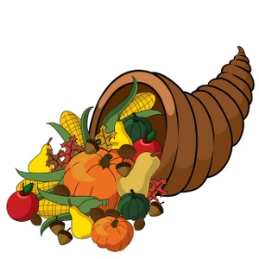
“RUN FOR THE NEEDY”
SPONSOR SHEET

NAME NUMBER OF LAPS TOTAL DONATION
(Upon completion) (i.e. 4 laps/4 items)_____

