Prairieview-Ogden Mustangs
April District News
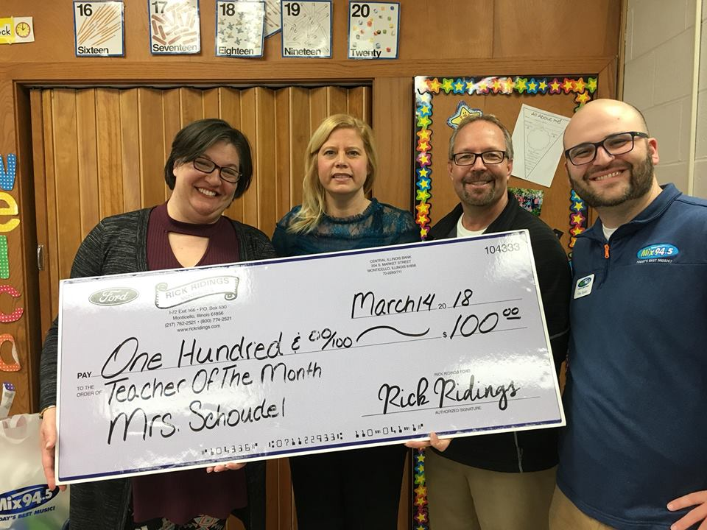
Mrs. Schoudel Recognized as MIX 94.5’s Teacher of the Month
We are so proud to have Mrs. Schoudel recognized by MIX 94.5 and Rick Ridings Ford in Monticello as April’s Teacher of the Month. This award is given to a local teacher who is “giving back to her students, school, and community.” Mrs. Schoudel was visited by members of the 94.5 radio team and several special guests who presented her with her award and gift package. Mrs. Schoudel was nominated for this award by Karen Hughes. Thank you Mrs. Schoudel for your continued dedication to your students and our district.

Volleyball Returns to the Elite Eight
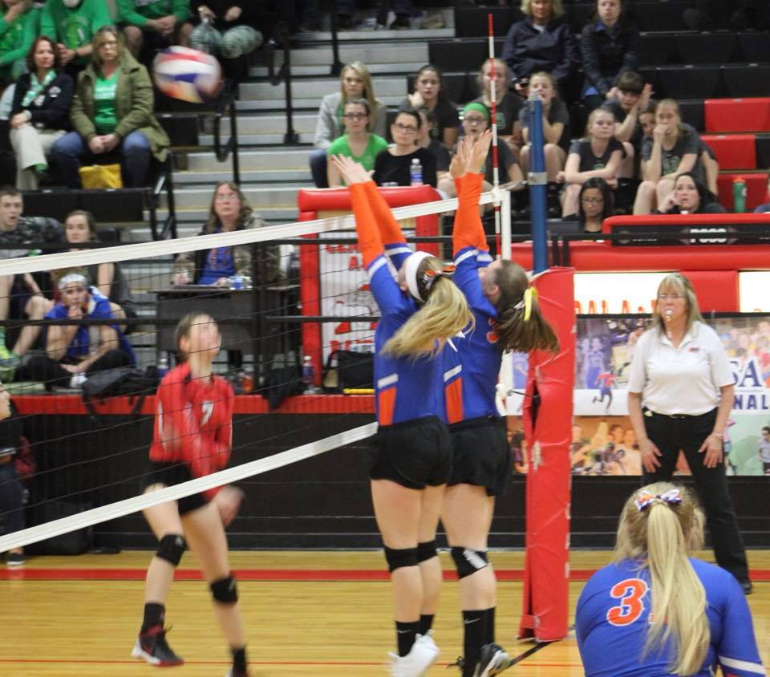
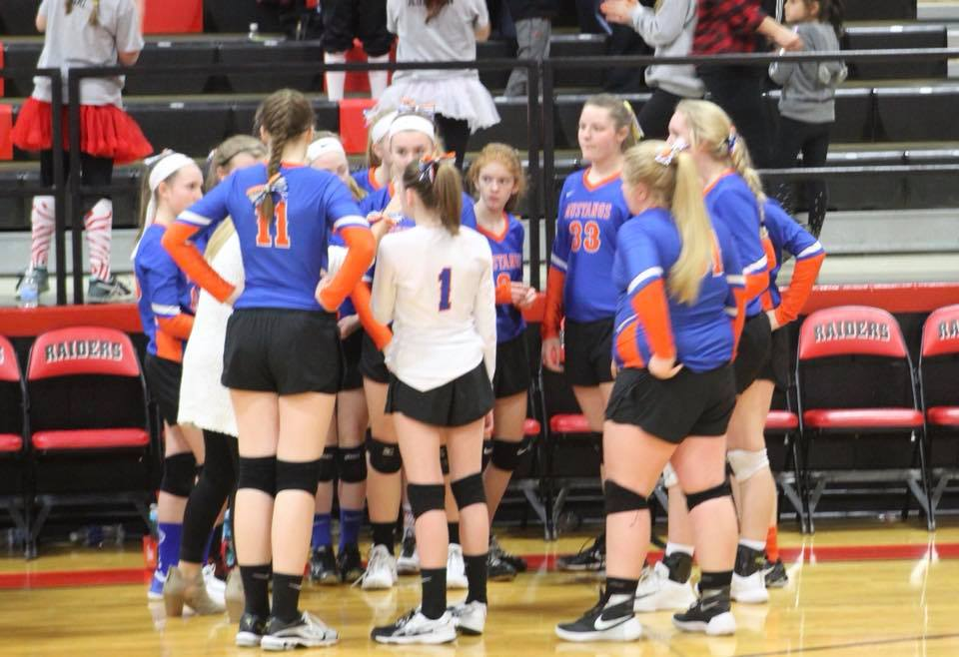
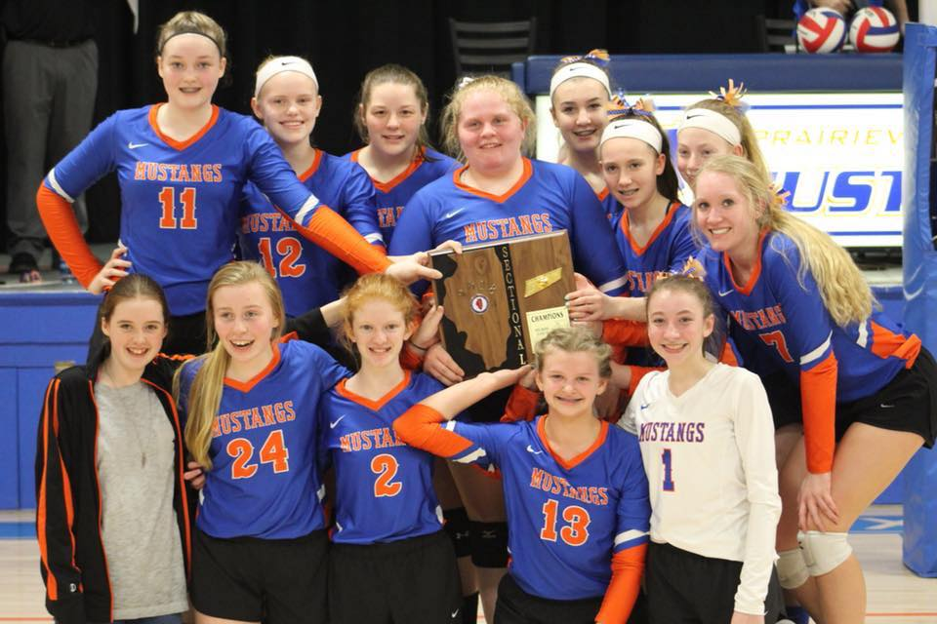
Congratulations to the PVO 8th Grade Girls Volleyball team on another successful season! The Lady Mustangs finished their season racking up another conference championship, Regional title, Sectional title, and a trip to the State Finals. After an awesome pep rally planned by the parents at the end of school on Friday, the team headed to Central A & M for their Elite Eight matchup. The team played a hard-fought match against Grayville but came up short. It was an exciting match and the girls fought to the very last point. The team would like to thank the fans who made the almost two hour drive to Assumption to watch them play! The fan support at the game was outstanding!

6th Grade with Ms. Patton
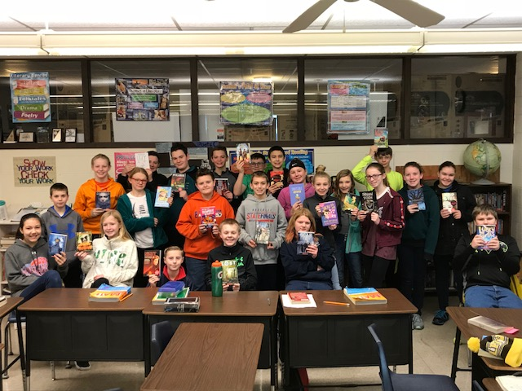
Wow, it is the beginning of 4th quarter already! This has been a fantastic school year and gone by very quickly. I am so proud of everything the 6th graders have accomplished this year, especially when I think back to when I first started working with them in fourth grade math. I know that because of their hard work, they are ready to move on to the junior high and all of the changes that entails.

In preparation for the transition to the junior high, the sixth graders have recently moved all of their things from their desk to their lockers. Most of them have done very well and have managed to get what they need to class. Sometime in May, the class will be taking the math placement test to help determine which math class they will take next year. I have a lot of faith that this class will do great next year at the junior high.

Thank you to everyone who visited the Book Fair and purchased a book or any other fun items that were sold. Because of your support, we were able to get 22 free books for our classroom. This kids are so excited to have some new titles to check out in this last quarter of school.

Junior High Social Studies
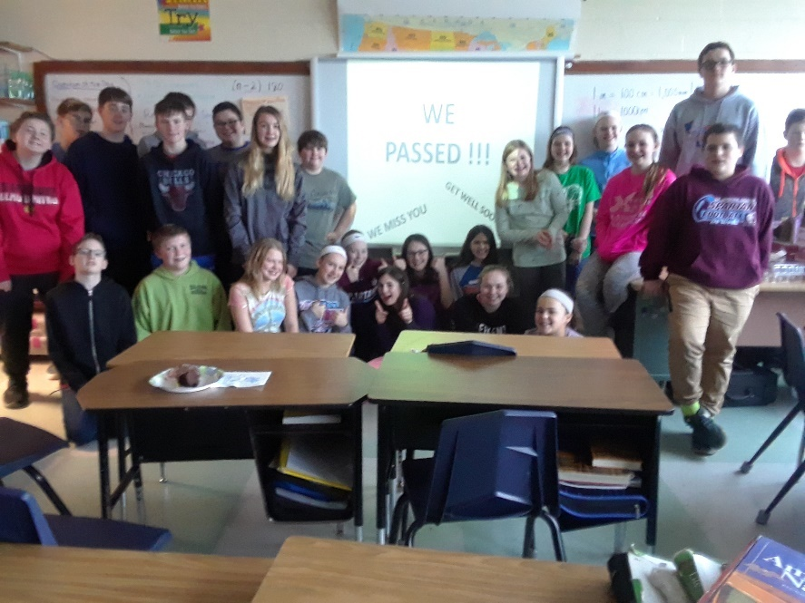
Because of Mrs. Anderson’s need for time off due to her health, Mr. Mike Pfundstein has been helping at the junior high as a permanent substitute in 7th and 8th grade social studies. The kids have been working so hard during this past quarter. The 7th graders have focused a majority of the quarter preparing for the U.S. Constitution Test. Passing this assessment is a requirement for graduation and the students took this unit very seriously. They not only completed their Constitution workbooks, but they also made flashcards, took practice tests, and did extensive review activities in the classroom. Because of their hard work EVERY 7th GRADER PASSED THEIR TEST!! The class celebrated with a pizza party and Mr. Pfundstein’s famous pie dough cookies prepared by his wife!
The 8th graders just finished studying the Spanish American War and will begin studying World War I this week. Students will be working on various presentation projects focusing on topics such as trench warfare, the Treaty of Versailles, and the life of American soldiers in battle. We are on task to finish the year through the 1960's.
Pi Day Celebration in Mrs. Bork’s Junior High Math Classroom
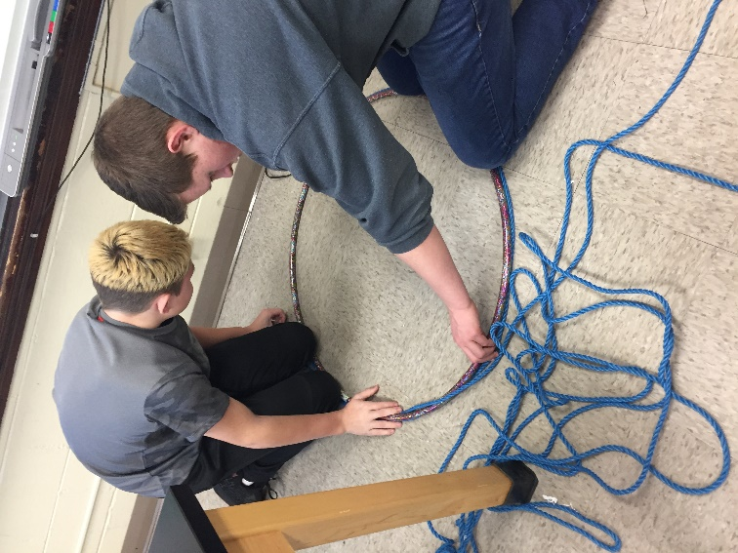
After spending time combining like terms, determining slope, graphing linear equations, and solving systems of equations in 7th and 8th grade math...we all earned a day off. The perfect “day off” arrived in the form of Pi Day on Wednesday, March 14th. Leading up to Pi Day, the students had worked on a variety of tasks during math lab to familiarize themselves with radius and diameter and how to find circumference and area of a circle.

On Pi Day, students were asked to apply these skills. Students were provided with a variety of materials: oatmeal cream pies, cookies, vanilla wafers, hula hoops, buckets, donuts, and ding-dongs to name just a few. They used rulers (and string) to measure the diameter and radius and then used those measurements to calculate the circumference and area of these items. After calculating the circumference, the students were asked to divide it by the diameter that they had measured.

“Wow, that answer is really close to 3.14….”
“When I divide, am I supposed to get something really close to Pi?”
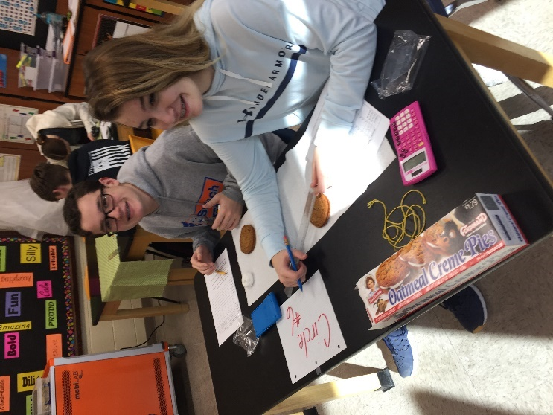
“This can’t be a coincidence...I got 3 point something for everything single value.”
“I would probably be better at measuring if I wasn’t so focused on eating this.”
“I must have not measured as accurately on that one….because when I divided, I got 4.82.”

The moral of the story is, we figured out where Pi comes from and that it proves to be the ratio of Circumference to Diameter regardless of the size of the object. All students left with a better idea of how Pi works (and some with bellyaches from too many sweets). Thank you to all of the parents for your generous circular donations!

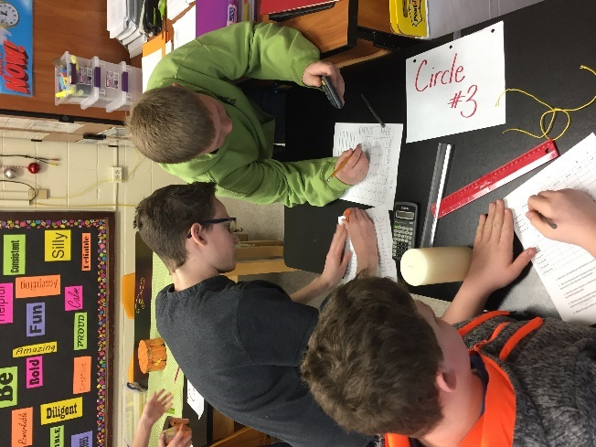

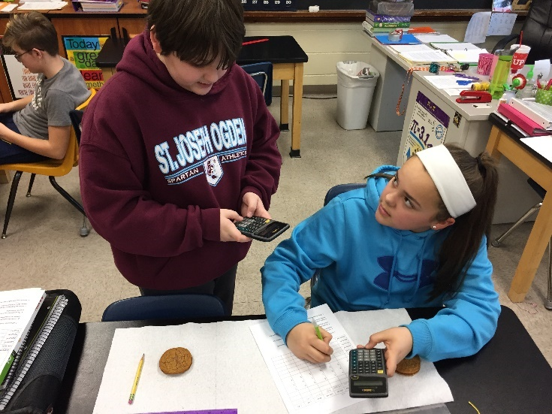

Scholastic Bowl in Full Swing

Upcoming Spring Music Concert Music Across Our Nation
When: Monday, April 23rd
Where: South Elementary Gym
Time: 6:30 p.m.
Who: All South K-4 students
Additional Info: The students at South have been working with Mrs. Susi Huls and their classroom teachers to prepare a patriotic themed concert. The night will be filled with songs that pay tribute to our country while also teaching the students important songs every kid should know! Students are asked to WEAR RED, WHITE, and BLUE to the concert!

