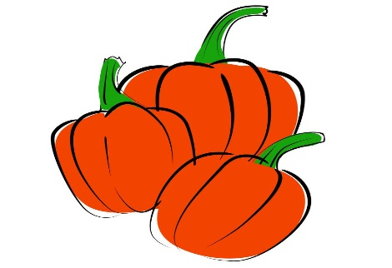
CUE Pumpkin Patch
October 12th

On Tuesday, October 12th, the CUE will be having our annual blacktop pumpkin patch. Students will attend various stations and then pick their favorite pumpkin. Pumpkins will be $2.00. Students are asked to only pick one pumpkin.
We want to make sure our blacktop pumpkin patch is a huge success. In order to see this happen, we could use some help from you. If you are able to donate money and/or packaged snacks, it would be greatly appreciated. Money will cover cost of snacks and pumpkins for students who were not able to purchase.
This day is always a memorable time for the students. Thank you for any help you may be able to give!

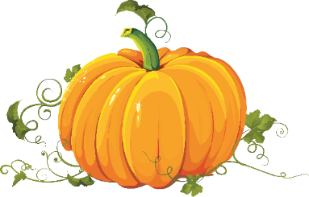
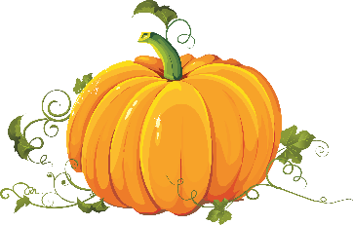
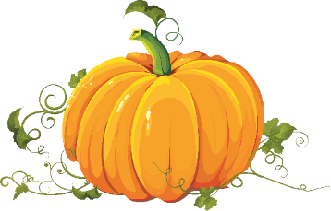

--------------------------------------------------------------detach-------------------------------------------------------------------

Parent Name______________________________Phone #___________________
Child’s Name______________________________Teacher___________________

__________ I am able to donate packaged snacks.

__________ I am able to donate money toward purchasing pumpkins and/or
snacks.

