Week of Respect
October 4 – 8, 2021
D.A. Quarles Early Childhood Center
October 4, 2021 | Show Respect for Self  Dress like a Superhero  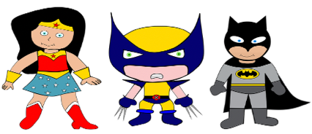  Pledge of Respect  I am smart, special and a valuable person. I respect myself and others. My words and actions are kind and honest. I accept only my best in all I do. I AM PROUD TO BE ME!
October 5, 20201 | Show Respect for Others  Wear Mix and Match Clothes  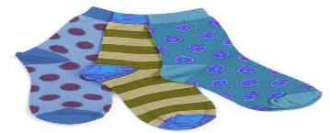  Students will share one way to show respect to others - students and teachers.
October 6, 2021 | Stomp Out Bullying  Wear Your Favorite Sneakers  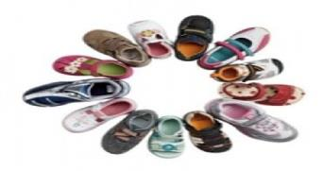  Students will say hello or compliment a student who they don’t know.
October 7, 2021 | Show Respect for Family  Wear Sweatpants and Sweatshirt  Say or do something kind for your family.
October 8, 2021 | Show Respect for School and Community  Wear School Colors  Recycle cans, bottles and paper at school and home.

